Support information

Theoretical study of novel B₂CO compounds with high hardness

Chao LIU^{a,b} *, Lingyu LIU^{c}, Pan YING^{d}

a College of Rare Earths, Faculty of Materials Metallurgy and Chemistry, Jiangxi University of Science and Technology, Ganzhou 341000, China
b State Key Laboratory of Metastable Materials Science and Technology, Yanshan University, Qinhuangdao 066004, China
c School of Physics and Optoelectronic Engineering, Guangdong University of Technology, Guangzhou 510006, China
d Hebei Key Laboratory of Microstructural Material Physics, School of Science, Yanshan University, Qinhuangdao 066004, China

Author to whom correspondence should be addressed. E-mail address: liuchao198967@126.com.

Table S1 The elastic matrix of two reported B₂CO phases at different pressure, the numerical unit is unified with GPa.
oP8’ |  |  |  |  |  | mP16
792.2 | 52.4 | 98.7 |  |  |  | 566.1 | 182.9 | 134.3 |  | -3.5
…… | 358.7 | 141.7 |  |  |  | …… | 561.4 | 123.6 |  | -1.5
…… | …… | 258.1 |  |  |  | …… | …… | 704.7 |  | 45.7
 |  |  | 208.2 |  |  |  |  |  | 253.1 |  | 9.3
 |  |  |  | 204.5 |  | …… | …… | …… |  | 239.8
 |  |  |  |  | 163.4 |  |  |  | …… |  | 193.5
10 GPa |  |  |  |  |  | 10 GPa
1045.2 | 121.6 | 243.3 |  |  |  | 808.8 | 230.7 | 201.4 |  | -7.5
…… | 399.5 | 230.6 |  |  |  | …… | 839.1 | 250.3 |  | 15.6
…… | …… | 531.3 |  |  |  | …… | …… | 949.5 |  | 36.2
 |  |  | 320.7 |  |  |  |  |  | 318.6 |  | 26.0
 |  |  |  | 327.3 |  | …… | …… | …… |  | 284.6
 |  |  |  |  | 212.7 |  |  |  | …… |  | 204.4
50 GPa |  |  |  |  |  | 50 GPa
1262.1 | 192.7 | 430.6 |  |  |  | 1022.3 | 337.8 | 300.1 |  | -15.3
…… | 860.4 | 384.9 |  |  |  |  | 1080.8 | 395.9 |  | 24.4
…… | …… | 871.4 |  |  |  |  |  | 1197.0 |  | 35.8
 |  |  | 471.0 |  |  |  |  |  | 361.1 |  | 41.1
 |  |  |  | 490.6 |  |  |  |  |  | 315.6
 |  |  |  |  | 255.0 |  |  |  |  |  | 207.8
100 GPa |  |  |  |  |  | 100 GPa
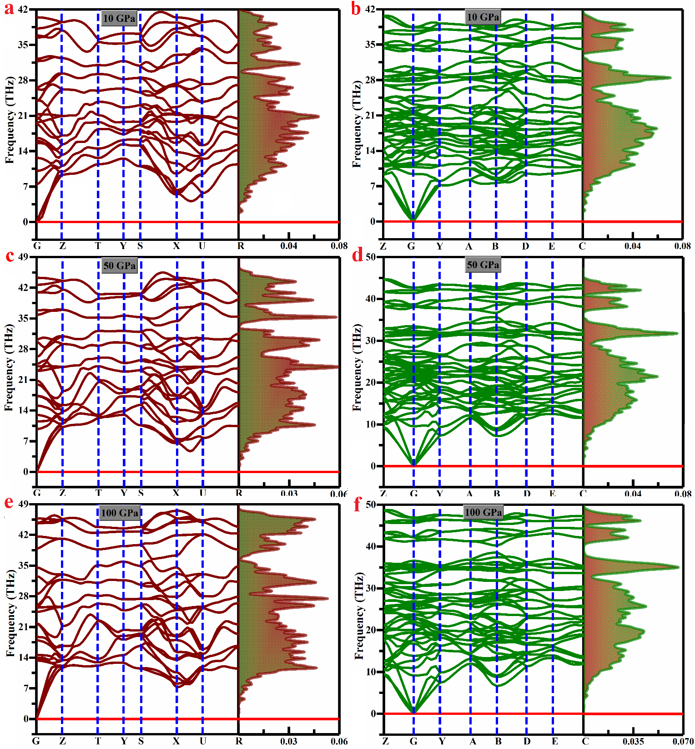
Fig S1 Phonon dispersion spectra (left panel) and phonon DOS (right panel) at different HP, a, c and e represent oP8’-B₂CO, b, d and f represent mP16-B₂CO, respectively.
Fig. S2 Calculated formation enthalpies ΔH_{f} via pressure of several IED B-C-O with the critical pressures all below 30 GPa, a and b represents B₂CO and B₂C_{X}O (x=2, 3, 5), respectively.
Fig. S3 The relationship of (a) pressure and volume per formula, (b) pressure and band gap of all B₂C_{X}O (X=2, 3, 5) phases at AP to 100 GPa.
Table S2 The independent elastic constant C_{ij}s of oP8’ at HP, the numerical units of pressure P and C_{ij}s are unified with GPa.
P  C_{ij} | 20 | 30 | 40 | 60 | 70 | 80 | 90
C₁₁ | 865.0 | 931.7 | 993.0 | 1093.3 | 1136.9 | 1175.7 | 1218.6
C₂₂ | 376.4 | 391.1 | 410.0 | 416.2 | 489.0 | 615.2 | 749.7
C₃₃ | 325.9 | 395.2 | 466.8 | 611.9 | 691.3 | 761.7 | 822.1
C₄₄ | 236.6 | 268.0 | 296.3 | 346.1 | 372.4 | 407.3 | 442.5
C₅₅ | 229.3 | 258.5 | 290.4 | 370.0 | 409.6 | 441.1 | 468.5
C₆₆ | 177.0 | 189.4 | 202.0 | 224.9 | 235.8 | 243.0 | 249.2
C₁₂ | 69.0 | 88.9 | 109.2 | 136.7 | 151.6 | 163.9 | 177.5
C₁₃ | 131.8 | 169.6 | 207.5 | 285.8 | 326.9 | 363.7 | 398.4
C₂₃ | 168.7 | 198.7 | 226.9 | 237.9 | 259.5 | 299.0 | 344.5

Table S3 The elastic matrix of mP16 B₂CO phases at different pressure, the numerical unit is unified with GPa.
638.9 | 184.5 | 147.5 |  | -4.2 |  | 701.1 | 196.1 | 163.9 |  | -5.4
…… | 650.2 | 158.5 |  | 4.8 |  | …… | 720.2 | 190.1 |  | 9.4
…… | …… | 773.6 |  | 41.4 |  | …… | …… | 836.5 |  | 38.9
 |  |  | 275.8 |  | 14.5 |  |  |  | 292.9 | 0 | 18.9
…… | …… | …… |  | 254.0 |  | …… | …… | …… |  | 265.6
 |  |  | …… |  | 197.1 |  |  |  | …… |  | 200.0
20 GPa |  |  |  |  |  | 30 GPa
758.3 | 212.3 | 182.3 | 0 | -6.4 | 0 | 856.6 | 250.7 | 221.4 |  | -8.5
…… | 782.9 | 220.5 |  | 13.0 |  | …… | 891.5 | 280.1 |  | 18.2
…… | …… | 894.8 |  | 37.3 |  | …… | …… | 1002.8 |  | 36.0
 |  |  | 306.9 |  | 22.7 |  |  |  | 329.0 |  | 29.4
…… | …… | …… |  | 275.8 |  | …… | …… | …… |  | 292.5
 |  |  | …… |  | 202.6 |  |  |  | …… |  | 205.7
40 GPa |  |  |  |  |  | 60 GPa
901.6 | 271.4 | 241.3 |  | -10.4 |  | 942.6 | 292.9 | 260.7 |  | -11.2
…… | 941.5 | 308.7 |  | 19.7 |  | …… | 989.4 | 338.4 |  | 21.6
…… | …… | 1053.5 |  | 35.4 |  | …… | …… | 1102.5 |  | 35.4
 |  |  | 337.1 |  | 32.6 |  |  |  | 345.5 |  | 35.4
…… | …… | …… |  | 299.3 |  | …… | …… | …… |  | 305.3
 |  |  | …… |  | 206.6 |  |  |  | …… |  | 207.3
70 GPa |  |  |  |  |  | 80 GPa
984.0 | 315.7 | 280.7 |  | -13.3
…… | 1036.4 | 367.8 |  | 23.1
…… | …… | 1151.2 |  | 35.5
 |  |  | 354.3 |  | 38.3
…… | …… | …… |  | 311.1
 |  |  | …… |  | 207.9
90 GPa

