Supplementary Materials for
Tailoring chirality in van der Waals crystals for circular polarization encoded pattern recognition
Han Wang^{1#}, Quan Chen^{1,2#}, Wenyu Songlu^{3,4}, Gan Yang¹, Zheng Ren^{3,4}, Zhou Xin^{3,4}, Yukang Chen^{3,4}, Shuti Li², Bo Peng^{5,6}, Zuxin Chen²*, Du Xiang^{3,7}*, Tao Liu¹*

Affiliations
¹Shanghai Frontiers Science Research Base of Intelligent Optoelectronics and Perception, Institute of Optoelectronics and Department of Materials Science, Fudan University, Shanghai, China
²School of Electronic Science and Engineering (School of Microelectronics), South China Normal University, Foshan, 528225, China
³State Key Laboratory of Integrated Chips and Systems, Frontier Institute of Chip and System, Fudan University, Shanghai, China
⁴School of Microelectronics, Fudan University, Shanghai 200433, China
⁵National Engineering Research Center of Electromagnetic Radiation Control Materials, School of Electronic Science and Engineering, University of Electronic Science and Technology of China, Chengdu 611731, China
⁶Key Laboratory of Multi Spectral Absorbing Materials and Structures of Ministry of Education, University of Electronic Science and Technology of China, Chengdu 611731, China
⁷Zhangjiang Fudan International Innovation Center, Fudan University, Shanghai 200433, China

# These authors contributed equally to this work
*Authors to whom correspondence should be addressed: chenzuxin@m.scnu.edu.cn (Zuxin Chen); xiang_du@fudan.edu.cn (Du Xiang); liu_tao@fudan.edu.cn (Tao Liu)

Supplementary Note 1. Polarized Raman mapping of both the intrinsic and R-MBA/MoS₂ crystals
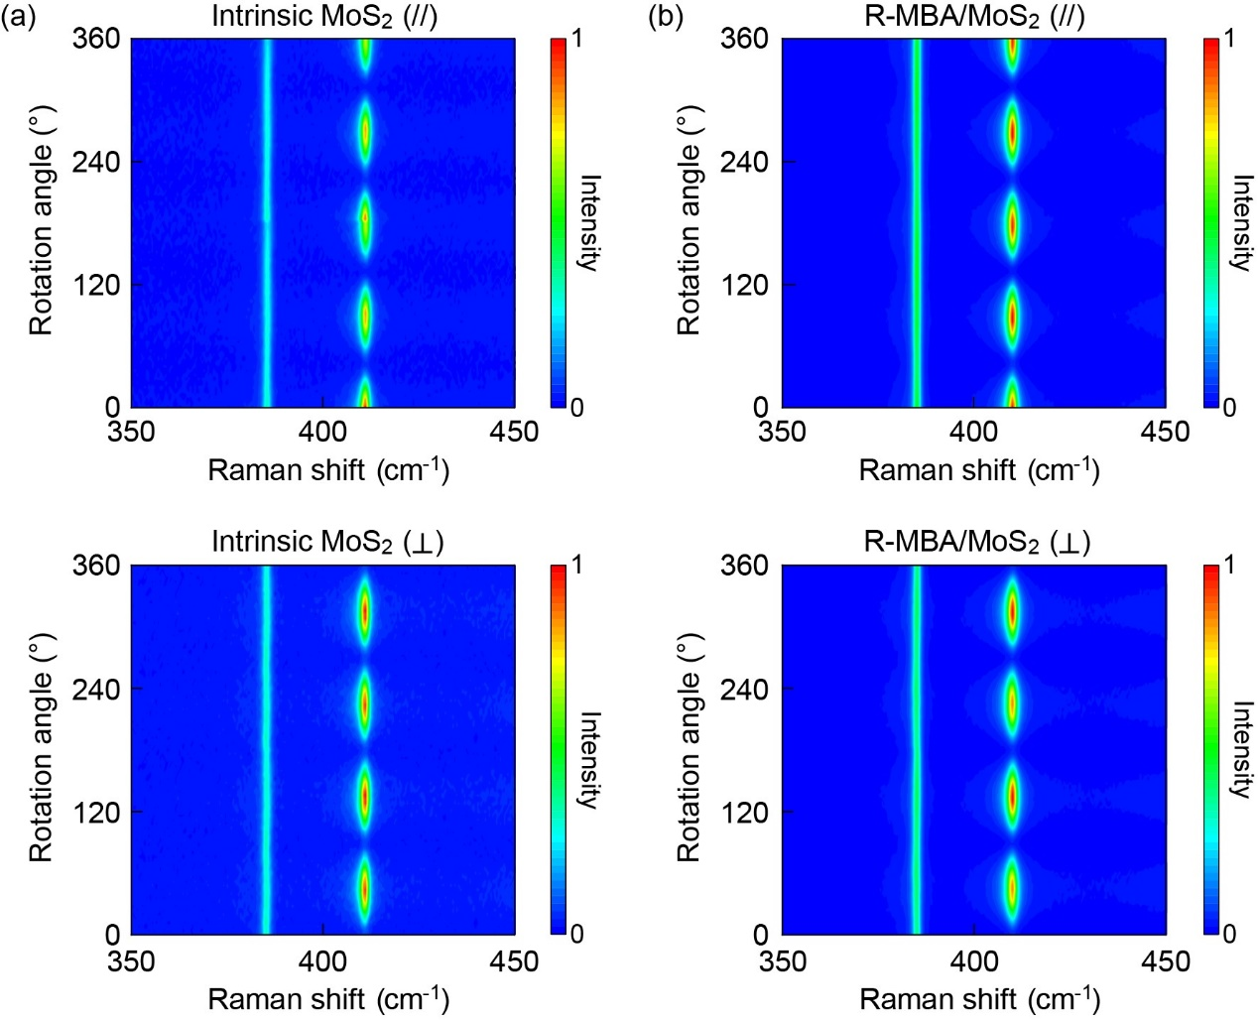
Figure S1. Polarized Raman intensity mapping of (a) intrinsic and (b) R-MBA/MoS₂ in parallel and perpendicular configurations, respectively. The 4-lobe features remain unchanged before and after intercalation, indicating that the chiral molecules have negligible imapct on the intrinsic lattice vibration modes in MoS₂, thus confirming the preservation of lattice ordering and in-plane optical anisotropy.

Supplementary Note 2. Polarized Raman mapping of R-MBA intercalated MoSe₂, WS₂, and WSe₂
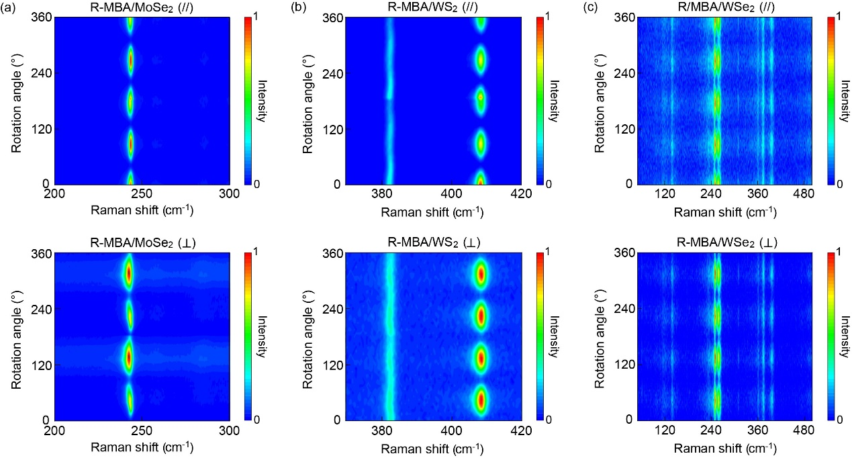
Figure S2. Polarized Raman intensity mapping of (a) R-MBA/MoSe₂, (b) R-MBA/WS₂, and (c) R-MBA/WSe₂ in both the parallel and perpendicular configurations. All the materials exhibit similar 4-lobe features, demonstrating consistent in-plane lattice ordering after the intercalation treatment.

Supplementary Note 3. Power dependent SHG intensity in intercalated TMDCs
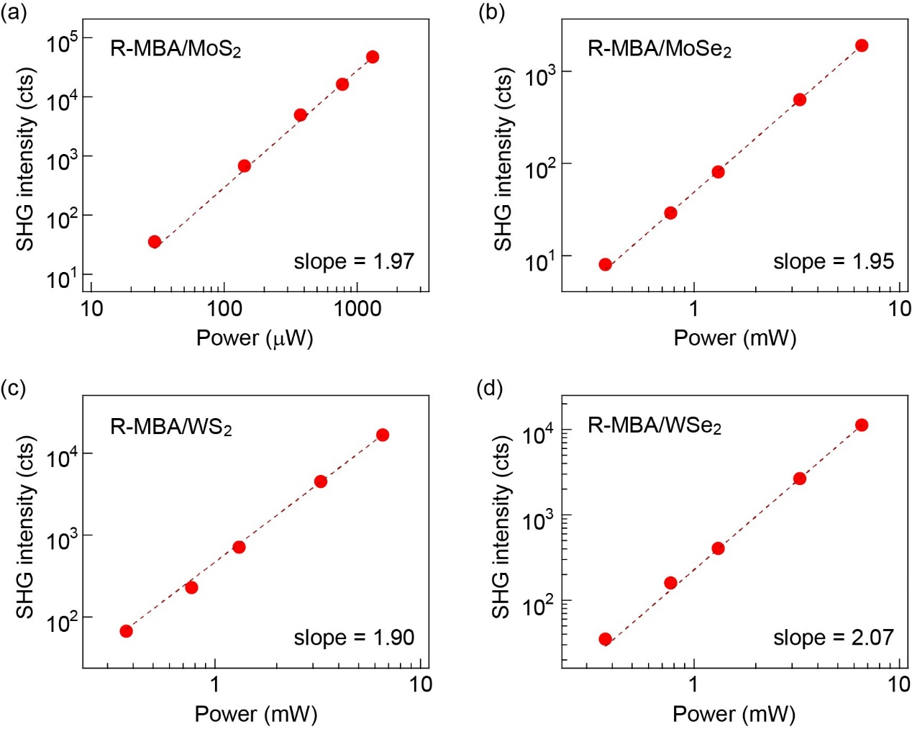
Figure S3. Power dependent SHG intensity of (a) R-MBA/MoS₂, (b) R-MBA/MoSe₂, (c) R-MBA/WS₂, and (d) R-MBA/WSe₂, respectively. The excitation wavelength is 1064 nm. All the results demonstrate a quadratic scaling relationship between SHG intensity and excitation power, confirming their second order nature.

Supplementary Note 4. Polarized SHG intensity of intrinsic monolayer MoS₂
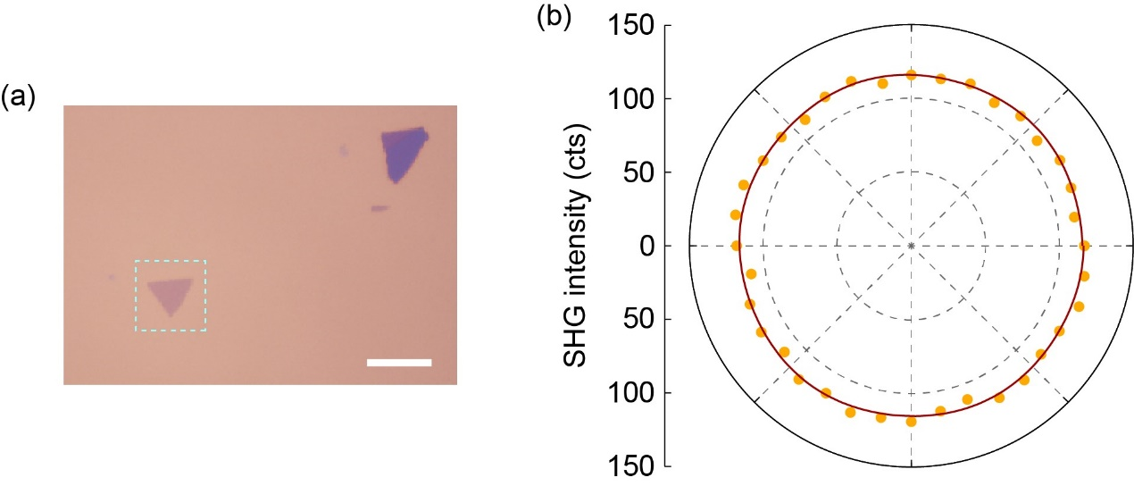
Figure S4. (a) Optical image of the intrinsic monolayer MoS₂. Scale bar is 10 μm. (b) Angle resolved SHG intensity of the intrinsic monolayer MoS₂, showing negligible polarization dependence due to its isotropic nature.

Supplementary Note 5. Optical and AFM images of the R-MBA/MoS₂ flakes with different thicknesses
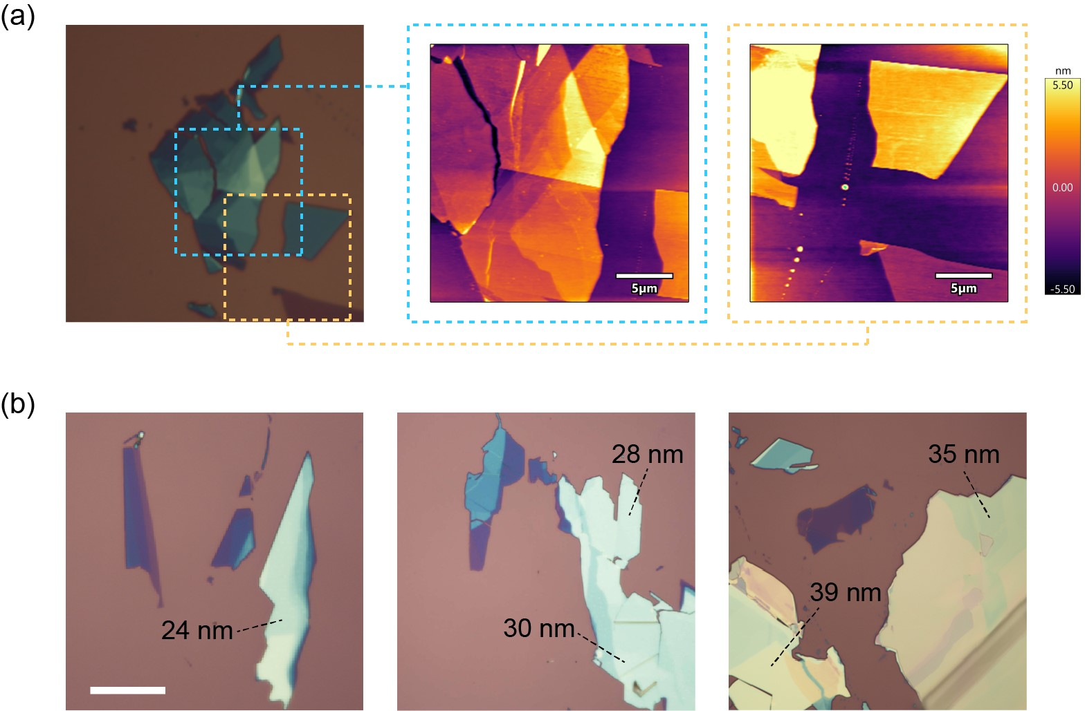
Figure S5. (a) Optical image and the corresponding AFM images of the as-exfoliated 2D R-MBA/MoS₂ flakes with various thicknesses. (b) Optical images of additional flakes with even larger thicknesses. Scale bar is 10 μm.

Supplementary Note 6. Thickness dependent Raman spectra of R-MBA/MoS₂
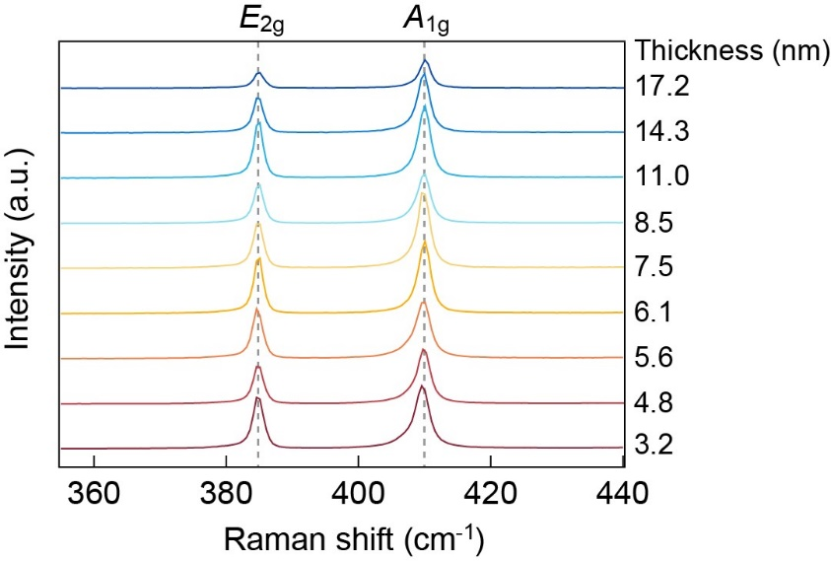
Figure S6. Raman spectra of 2D R-MBA/MoS₂ flakes with different thicknesses. The peak positions remain unchanged as increasing the thickness, suggesting the equivalent interlater coupling strength that is almost independet of the sample thickness.

Supplementary Note 7. Thickness dependent SHG characterizations of pristine MoS₂
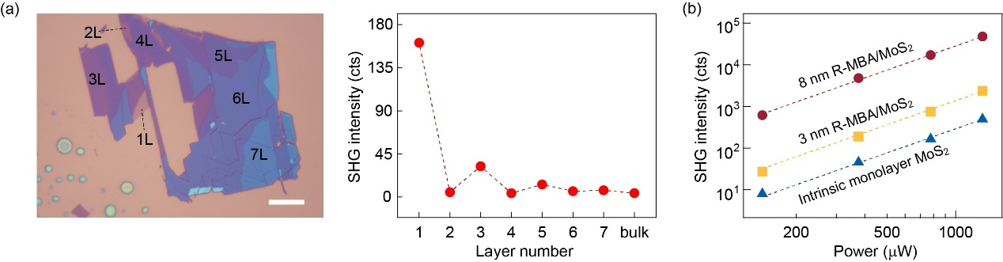
Figure S7. (a) Optical image and the corresponding SHG intensity of pristine MoS₂ crystals with different thicknesses. Scale bar is 10 μm. The SHG intensity decreases rapidly with increasing thickness. (b) Comparison of SHG intensity between the R-MBA/MoS₂ and intrinsic monolayer MoS₂ as increasing the laser power.
It is important to note that for practical applications, the absolute SHG response is of true technical relevance, since it determines the signal-to-noise ratio of the optical elements. The intercalated MoS₂ flakes demonstrate significant enhancemnt of SHG intensity comparing to that obtained in the pristine monolayer, thus validating their reliability in acting as the building blocks for functional units.

Supplementary Note 8. Circular polarized SHG, Raman, and PL spectra of MoSe₂ , WS₂, and WSe₂, respectiely
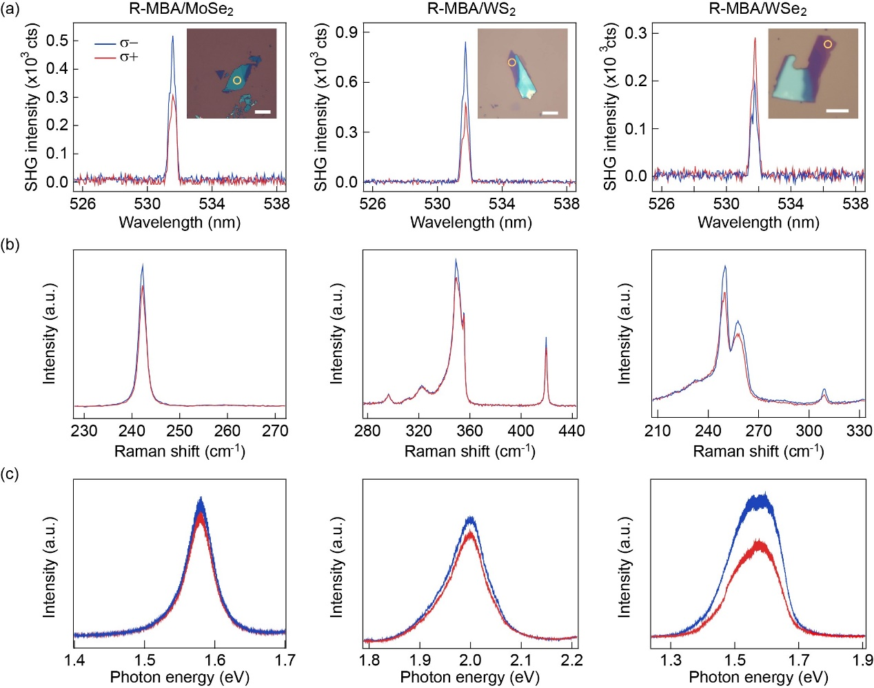
Figure S8. Circular polarization dependent (a) SHG response, (b) Raman spectra, and (c) PL spectra of R-MBA/MoSe₂, R-MBA/WS₂, and R-MBA/WSe₂, respectively. Insets show the optical images of the measured flakes. Scale bars are 10 μm.
For the intercalated MoSe₂, the CD spectra in Figure 2b reveals lower absorption of LCP at wavelength > 1000 nm, which is consistent with the higher SHG response udner LCP excitation (1064 nm). The Raman and PL spectra are related to the CD characteristics in the visible band (532 nm), where more significant absorption implies higher Raman and PL intensities. The superlattice exhibits stronger LCP absorption at 532 nm, thus giving rise to higher Raman and PL intensities under LCP excitation. Similar analysis can be applied to the intercalated WS₂ and WSe₂. It is noted that the CD spectra of intercalated WSe₂ feature a tendency of absorption crossover at wavelength > 1000 nm, which could be the reaon for its higher RCP-SHG response.

Supplementary Note 9. Ambient stability of the R-MBA/MoS₂
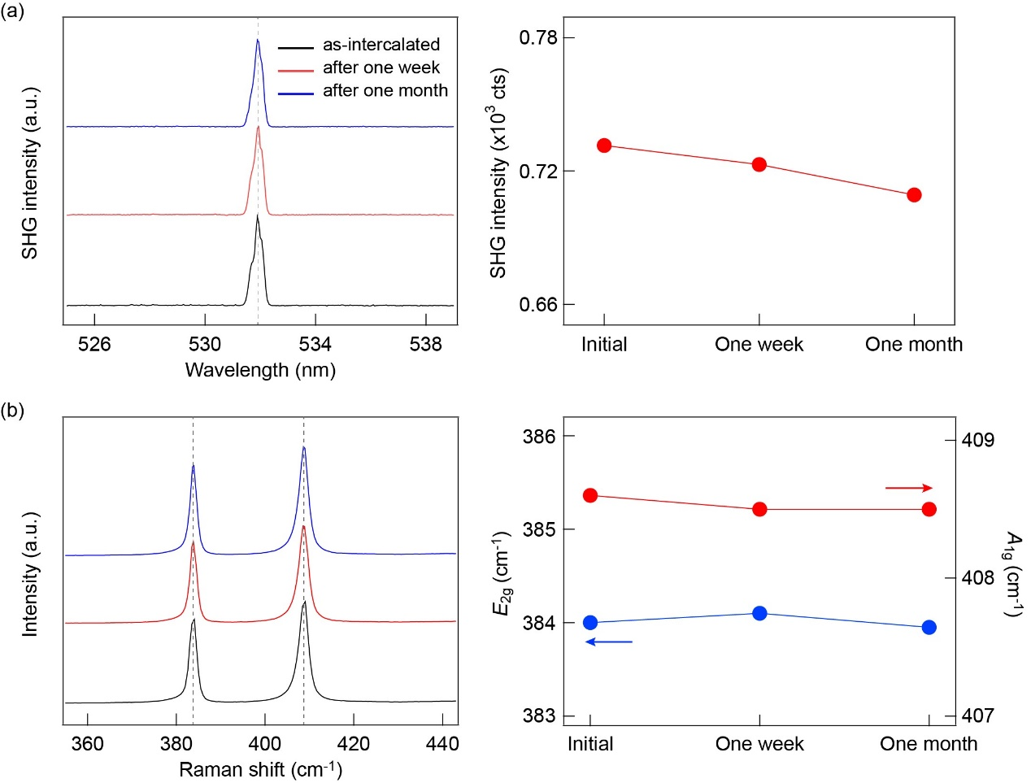
Figure S9. Time evolution of (a) SHG response and (b) Raman spectra of the R-MBA/MoS₂. Both the SHG and Raman characteristic peaks are nearly maintained within a month under ambient condition, indicating the robust stability of the intercalated superlattices.

Supplementary Note 10. Nearly ideal Ohmic contacts of the R-MBA/MoS₂
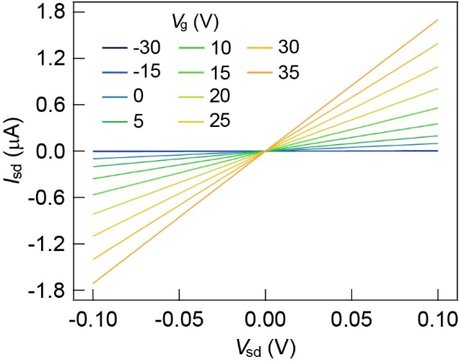
Figure S10. Output characteriations of the R-MBA/MoS₂ at different gate voltages. The output curves exhibit high linearity at different V_{g}, indicating the nearly ideal ohmic contacts of the R-MBA/MoS₂ transistor.

Supplementary Note 11. Paramtric validation of the CNN based pattern recognition.
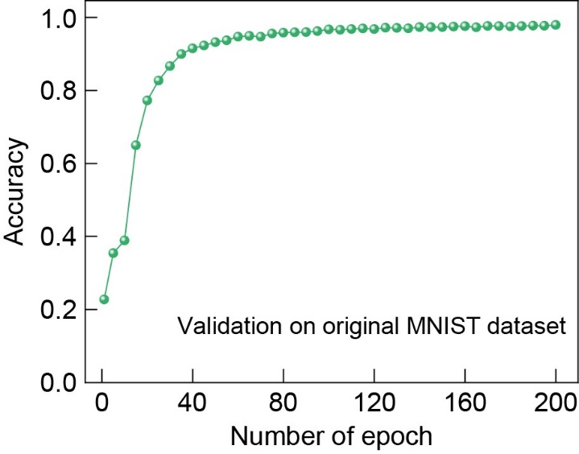
Figure S11. The validation accuracy as a function of epoch number obtained using the original MNIST dataset. The recognition acuracy reaches 97.9% on the test set, confirming the parametric reliability of our computational scheme.

Supplementary Note 12. Pattern recognition based on LCP preprocessing.
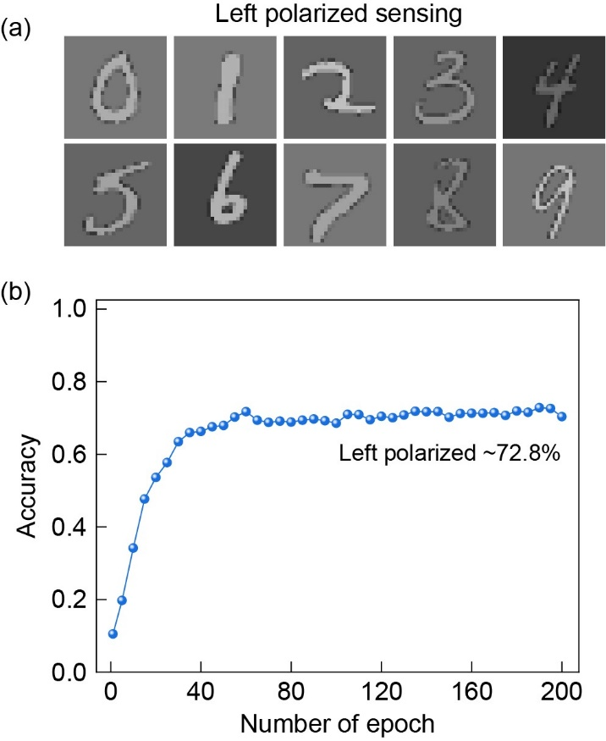
Figure S12. (a) Typical patterns produced by chiral-active sensing array. The light source is set at LCP. (b) The recognition accuracy as a function of epoch number based on the input patterns after LCP pre-processing. The accuracy reaches 72.8% on the test set, demonstrating moderate improvement comparing to that obtained using the unpolarized set (~50%).
The discrepancy between the recognition accuracy obtained from LCP/RCP preprocessing (72.8%/93.6%) is due to the physical parameters of the devices. Based on our polarization virtual imaging scheme, the contrast of the polarization processed patterns is mainly determined by the high-respond polarization state in the band with stronger photoresponse. In our device, the photoresponse in the visible band (532 nm) is significantly stronger than that in the NIR band (1064 nm), whereas the former exhibits higher activity under RCP state. For this reason, the illumination of RCP light generates higher contrast in the preprocessed patterns, giving rise to higher recognition accuracy comparing to that obtained under LCP condition.

