Supplement Figure 1. Restricted cubic splines curves of blood lipid indexes.

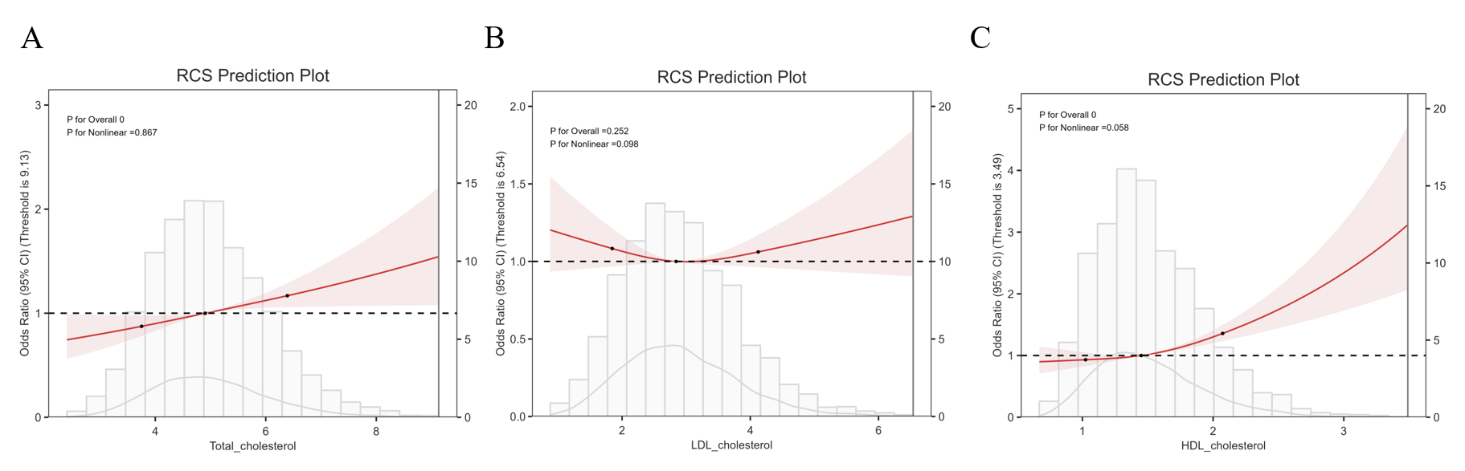
A. Restricted cubic splines curves of total cholesterol
B. Restricted cubic splines curves of LDL-cholesterol
C. Restricted cubic splines curves of HDL-cholesterol

Supplement Figure 2. Logistic Regression Forest Plot of physical activity

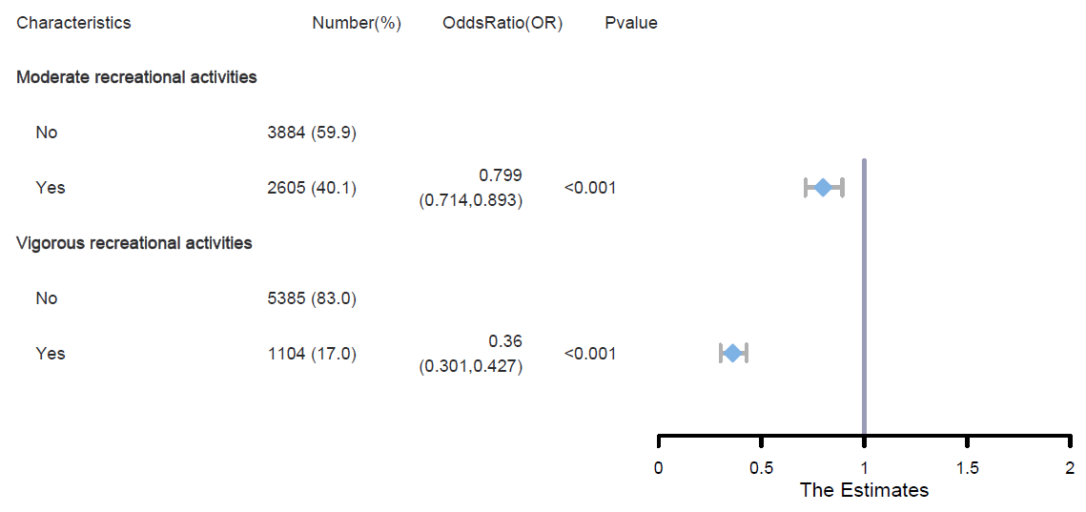

Supplement Figure 3. Restricted cubic splines curves of moderate recreational activities.

