Supplementary figure 1.

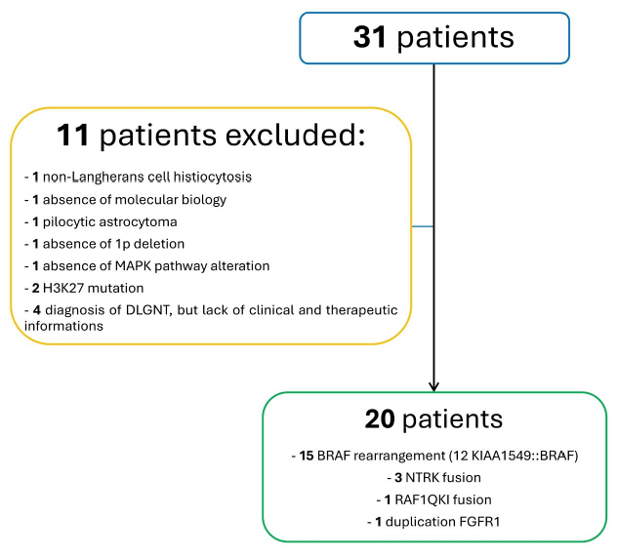
Supplementary figure 1. Flow chart patients’ inclusion
Starting with 31 patients with a confirmed or presumptive diagnosis of DLGNT, patients who did not meet the molecular criteria, who had different molecular alterations (ex: H3K27) or who received alternative definitive diagnoses were excluded.

Supplementary table 1

PATIENT | SEX | AGE AT DIAGNOSIS | CLINICAL SYMPTOMS | TUMOUR LOCALIZATION | LEPTOMENINGEAL CONTRAST ENHANCEMENT | SYSTEMIC THERAPY -> Best radiological response | RADIOTHERAPY | STATUS at last follow up | DISEASE STATUS at last follow up | NEUROLOGICAL IMPAIRMENT at last follow up | MOLECULAR BIOLOGY
1 | F | 4y 6m | Hydrocephalus | Spinal + Intracranial | Present | - Trametinib: PD  - SIOP LGG: PR  - Vinblastine: PD  - Temozolomide: PD | NO | Alive | PD | Motor disorders  Facial paralysis | KIAA1549::BRAF, Del 1p  NO gain 1q
2 | F | 13y | Hydrocephalus  Lombosacral pain | Spinal + Intracranial | Present | - SIOP LGG: SD  - Vinblastine: SD  - Vinorelbine: SD  - Trametinib: PR  - Temozolomide: SD  - Olaparib+irinotecan: SD  - Bevacizumab+lomustine: SD | YES : PR  (after treatment 2) | Dead of disease | PD | Motor disorders | KIAA1549::BRAF, Del 1p  Gain 1q
3 | M | 11y 9m | Dorsal pain | Spinal | Absent | NO | YES : PR | Alive | SD | NO | KIAA1549::BRAF, Del 1p  Gain 1q
4 | M | 2y 9m | Hydrocephalus | Spinal + Intracranial | Present | - Temozolomide: PD  - SIOP LGG+bevacizumab: PR | NO | Alive | PR | NO | BRAF rearrangement, Del 1p  NO gain 1q
5 | F | 1y 7m | Nystagmus | Intracranial | Absent | - SIOP LGG+Bevacizumab: PR  - Vinblastine: PR  - Temozolomide: PD  - Larotrectinib: PD  - Selitrectinib: PD  - Entrectinib: PD | NO | Dead of disease | PD | Motor disorders | NTRK1::BCAN, Del 1p  Gain 1q
6 | M | 5y 8m | Lombar pain | Spinal | Present | - SIOP LGG: SD  - Irinotecan+bevacizumab: PR  - Trametinib: PD  - Temozolomide: PD | YES : PR  (after SIOP LGG) | Dead of disease | PD | Sphincter function disorders  Motor disorders | KIAA1549::BRAF, Del 1p  NO gain 1q
7 | F | 6y 10m | Neck pain  Headache | Spinal + Intracranial | Absent | - Larotrectinib: PR  - Repotrectinib: PR  - Repotrectinib^{(*)}: PD | YES : PD  (after treatment 2) | Alive | SD | Sphincter function disorders  Motor disorders | NTRK2::TNS3, Del 1p  NO gain 1q
8 | M | 5y | Hydrocephalus  Seizures | Spinal + Intracranial | Present | - SIOP LGG: SD  - Vinblastine: SD  - Irinotecan+bevacizumab: SD  - Trametinib: SD | YES : PR  (after treatment 3) | Dead of disease | PD | Balance disorders  Motor disorders | KIAA1549::BRAF, Del 1p  Gain 1q
9 | M | 17y 3m | Diplopia | Spinal + Intracranial | Present | - Temozolomide: SD  - Clinical trial: SD | NO | Alive | PD | NO | KIAA1549::BRAF, Del 1p  Gain 1q
10 | M | 15y | Hydrocephalus | Spinal + Intracranial | Absent | - Trametinib: SD  - Temozolomide: SD | YES : PR  (after treatment 2) | Alive | PR | Motor disorders | KIAA1549::BRAF, Del 1p  Status 1q unknown
11 | M | 16y 4m | Hydrocephalus  Balance disorders | Spinal | Present | - Temozolomide: PR  - Trametinib: SD  - Temozolomide: SD | NO | Alive | SD | Motor disorders | KIAA1549::BRAF, Del 1p  NO gain 1q
12 | M | 3y 11m | Cervical pain | Spinal | Absent | - SIOP LGG : SD | NO | Alive | SD | Motor disorders | KIAA1549::BRAF, Del 1p  NO gain 1q
13 | M | 2y | Hydrocephalus,  Strabismus, ataxia | Spinal + Intracranial | Present | - SIOP LGG: PR  - Vinblastine: PR  - Trametinib: PR  - Temozolomide: SD | NO | Alive | SD | NO | KIAA1549::BRAF, Del 1p  NO gain 1q
14 | F | 1y 11m | Back pain | Spinal | Absent | - SIOP LGG: PR  - Temozolomide: SD | NO | Alive | PR | Sensitive disorders | RAF1::QKI, Del 1p  Gain 1q
15 | F | 5y 5m | Decreased visual acuity  Left hemiparesis | Spinal + Intracranial | Present | - Vinorelbine: SD  - SIOP LGG: PR  - Trametinib: PD  - Vp16: PD  - Temozolomide: PR  - Bevacizumab: PD | NO | Dead of disease | PR | Facial paralysis  Visual impairment | BRAF rearrangement, Del 1p  Gain 1q
16 | M | 10y 9m | Spastic paraplegia | Spinal | Absent | - Larotrectinib: SD  - Temozolomide: SD | YES : SD  (after treatment 1) | Alive | PR | Motor disorders | NTRK2 ::AGAP1, Del 1p  NO gain 1q
17 | F | 4y 5m | Weight loss | Spinal + Intracranial | Present | - SIOP LGG + Bevacizumab : PR | NO | Alive | SD | NO | Duplication FGFR1, Del 1p  Gain 1q
18 | M | 12y | Seizures | Intracranial | Present | - PCV: PR  - Trametinib: SD  - Temozolomide: SD | YES : SD  (after treatment 1) | Dead (suicide) | SD | Motor disorders | BRAF rearrangement, Del 1p  NO gain 1q
19 | M | 17y 9m | Deficit upper limb | Spinal | Absent | - Vinblastine: PD  - Trametinib: PD  - Temozolomide: PD  - Binimetinib | YES : PR  (before treatment 1) | Dead (pulmonary infection) |  | Motor disorders | KIAA1549::BRAF, Del 1p  Gain 1q
20 | M | 12y 6m | Hydrocephalus | Intracranial | Present | - PACKER: SD  - Temozolomide: PD | YES : PR  (after treatment 2) | Alive | PR | NO | KIAA1549::BRAF, Del 1p  Gain 1q

Supplementary table 1.
This table shows the characteristics at diagnosis of each patient (sex, age, clinical symptoms, localization, leptomeningeal contrast enhancement, and molecular biology) and the characteristics at last follow up (status, disease status and neurological impairment). All treatments received by each patient with the best radiological response (PR, SD or PD) are reported. Patient #7^{(*)} received 2 months of temozolomide during repotrectinib but the treatment was discontinued because of lack of clinical and radiological improvement.

Supplementary Figure 2.
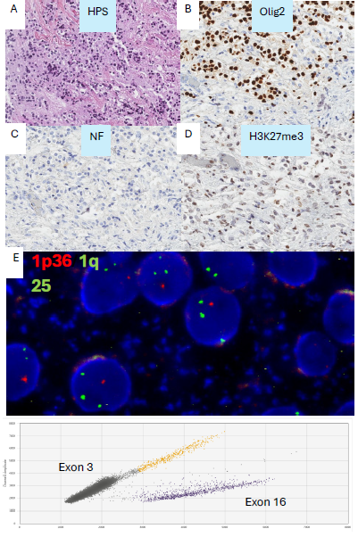
Supplementary figure 2. FGFR1 duplication
Microscopic examination showed fragments of leptomeninge invaded by a moderately cellular oligodendroglial-like tumor proliferation (A, C). A fibrillar substance infiltrating the leptomeninge was present, on which small oligodendrocyte-like cells were arranged. There was no obvious cytonuclear atypia. No mitotic activity was observed. Rosenthal fibres, granular bodies and ganglion neurons were absent. Tumor cells expressed Olig2 (B) and retained H3K27me3 (D). FISH analysis showed loss of locus 1p36 and gain of 1q25 (E). The case was classified as DLGNT subtype 1 by DNA methylation profiling using the NIH classifier version 2. Multiplexed Droplet Digital PCR Assays demonstrating FGFR1 exon 16 duplication (F). Each dot on the figure represents one droplet. The black cluster on the plot represents the negative droplets. The purple cluster in the plot corresponds to the droplets containing FGFR1 exon 16 and is more prominent than the orange cluster, which represents the droplets containing FGFR1 exon 3, used as a reference, indicating the presence of a duplication. No droplets were positive for FGFR1 N546K nor K656E targets.

Supplementary Figure 3.
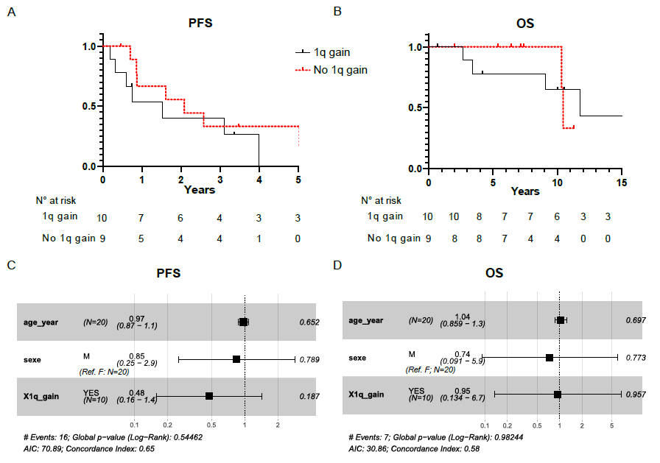

Supplementary figure 3. 1q gain impact on outcome
The Kaplan-Meier method was used to evaluate the progression-free survival (A) and the overall survival (B) by comparing patients with chromosome 1 q gain (dashed red line) and patients without chromosome 1 q gain (black line). There were no significant differences in PFS or OS between the two groups despite a trend in OS. Forest plot representing multivariable analysis for PFS (C) and OS (D). PFS: Progression free survival. OS: Overall survival.

