SUPPLEMENTARY INFORMATION

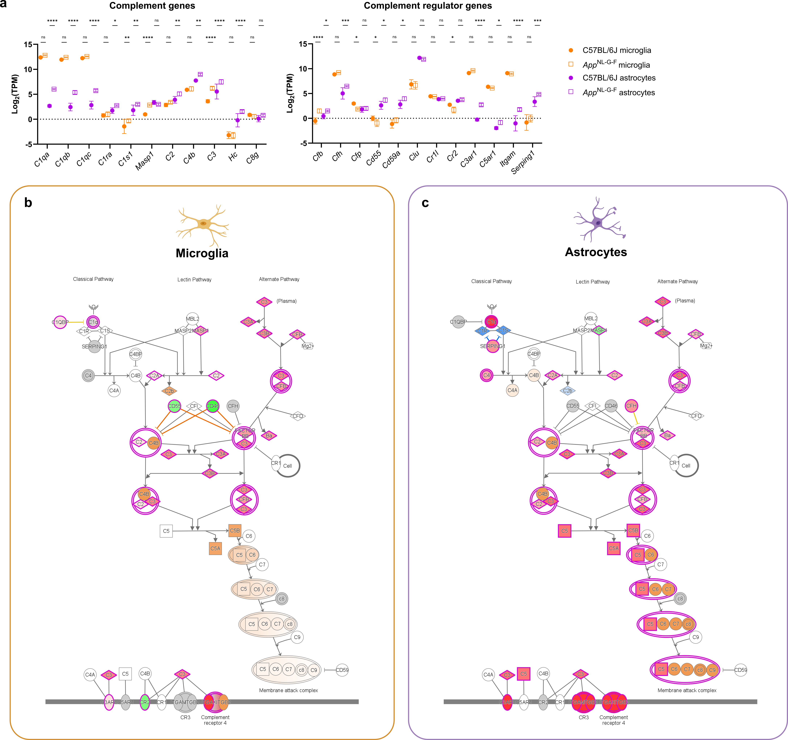
Supplementary Figure S1. Complement is upregulated in microglia and astrocytes from 40 weeks old App^{NL-G-F} mice. (a) log₂(TPM) expression levels of complement and complement regulator genes in isolated microglia and astrocytes from App^{NL-G-F} (n=5) and age-matched C57BL/6J (n=4) mice. Statistics: the mean ± SD are shown with two-way ANOVA with post-hoc Tukey’s multiple comparison test. *p < 0.05, **p < 0.01, ***p < 0.001, ****p < 0.0001. (b,c) Visualization of the complement pathway changes in App^{NL-G-F} microglia (b) and astrocytes (c) annotated by Ingenuity Pathway Analysis (IPA). Red: increased measurement, green: decreased measurement, orange: predicted activation, blue: predicted inhibition.

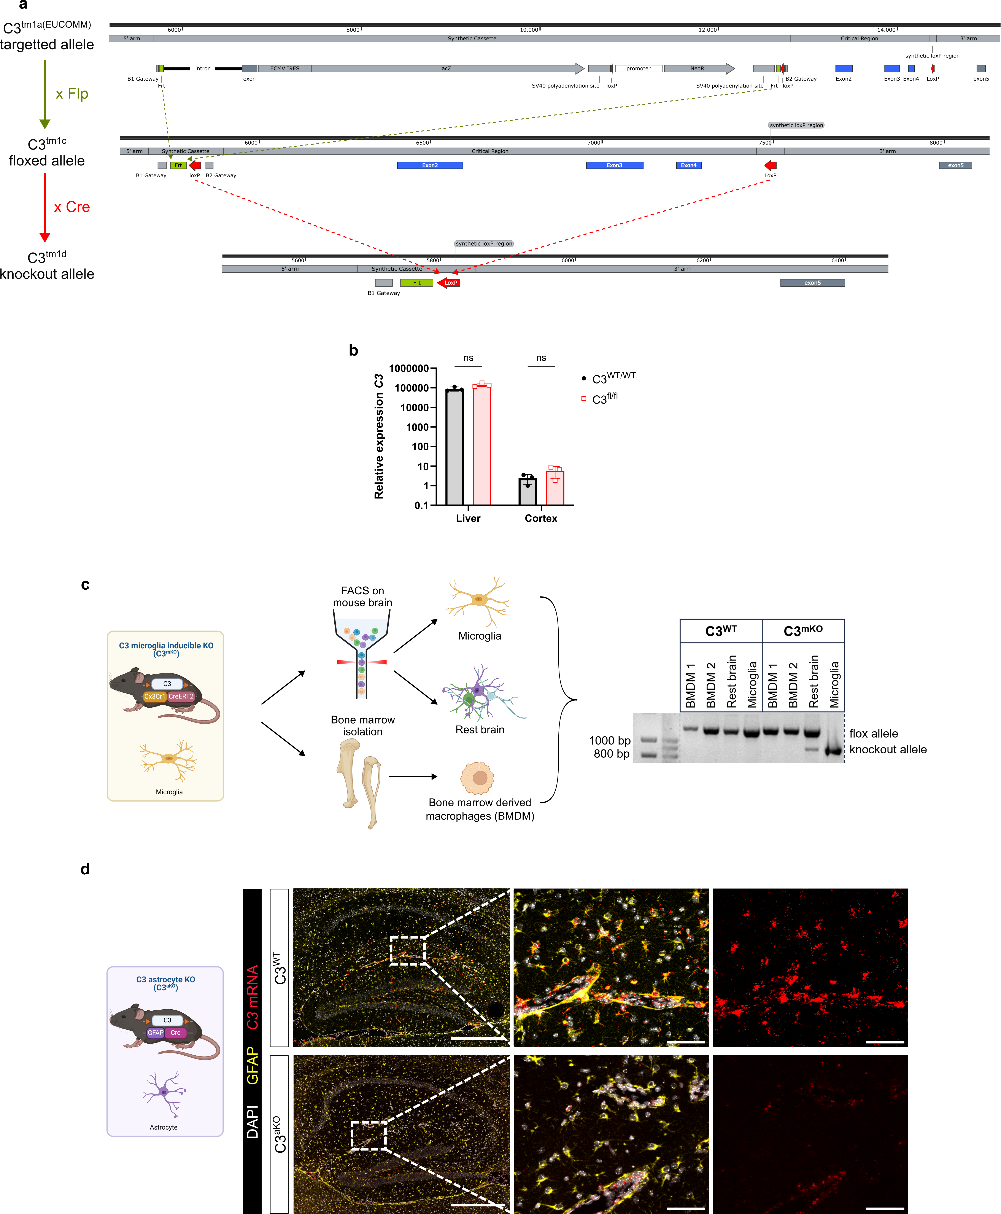
Supplementary Figure S2. Generation and validation of microglia- and astrocyte- specific C3 knockout mice. (a) Schematic of the C3 targeting European Conditional Mouse Mutagenesis Program (EUCOMM) vector. The tm1a targeted allele contains an IRES:lacZ trapping cassette and a floxed promoter-driven neo cassette inserted into intron 1 of the C3 gene. Flp converts the tm1a allele to a conditional floxed allele (tm1c), with loxP sites surrounding exon 2-4 of the C3 gene. Cre deletes the floxed exons of the C3^{tm1c} allele to generate the C3 knockout allele (tm1d). (b) qRT-PCR analysis of C3 expression in the liver and cortex of C3^{fl/fl} versus age-matched WT mice. Statistics: the mean ± SD are shown with two-way ANOVA with post-hoc Tukey’s multiple comparison test. (c) Validation of microglial specific knockout in 12 weeks old C3^{fl/fl}; Cx3Cr1^{CreERT2/+} (C3^{mKO}) mice 8 weeks following tamoxifen treatment. Microglia were sorted out from C3^{mKO} and C3^{WT} littermates similar to Figure 1 and compared to the rest brain ‘non-microglia’ cell population. Isolated cells were pooled from 5 mice. As an additional negative control, 2 bone marrow-derived macrophage (BMDM) cultures were derived. gDNA was extracted from the different cell populations to perform deflox PCR. The presence of the knockout allele band (888 bp) and absence of the flox allele band (1156 bp) shows effective Cre mediated defloxing. (c) Validation of astrocyte specific knockout in 12 weeks old C3^{fl/fl}; Gfap^{Cre/+} (C3^{aKO}) mice by C3 RNAScope. Representative images of C3 mRNA in sagittal brain section containing hippocampus from C3^{aKO} and C3^{WT} littermates 3 days after ICV LPS injection to boost C3 expression. Scale bars: 500 µm (overview), 50 µm (zoom-ins).

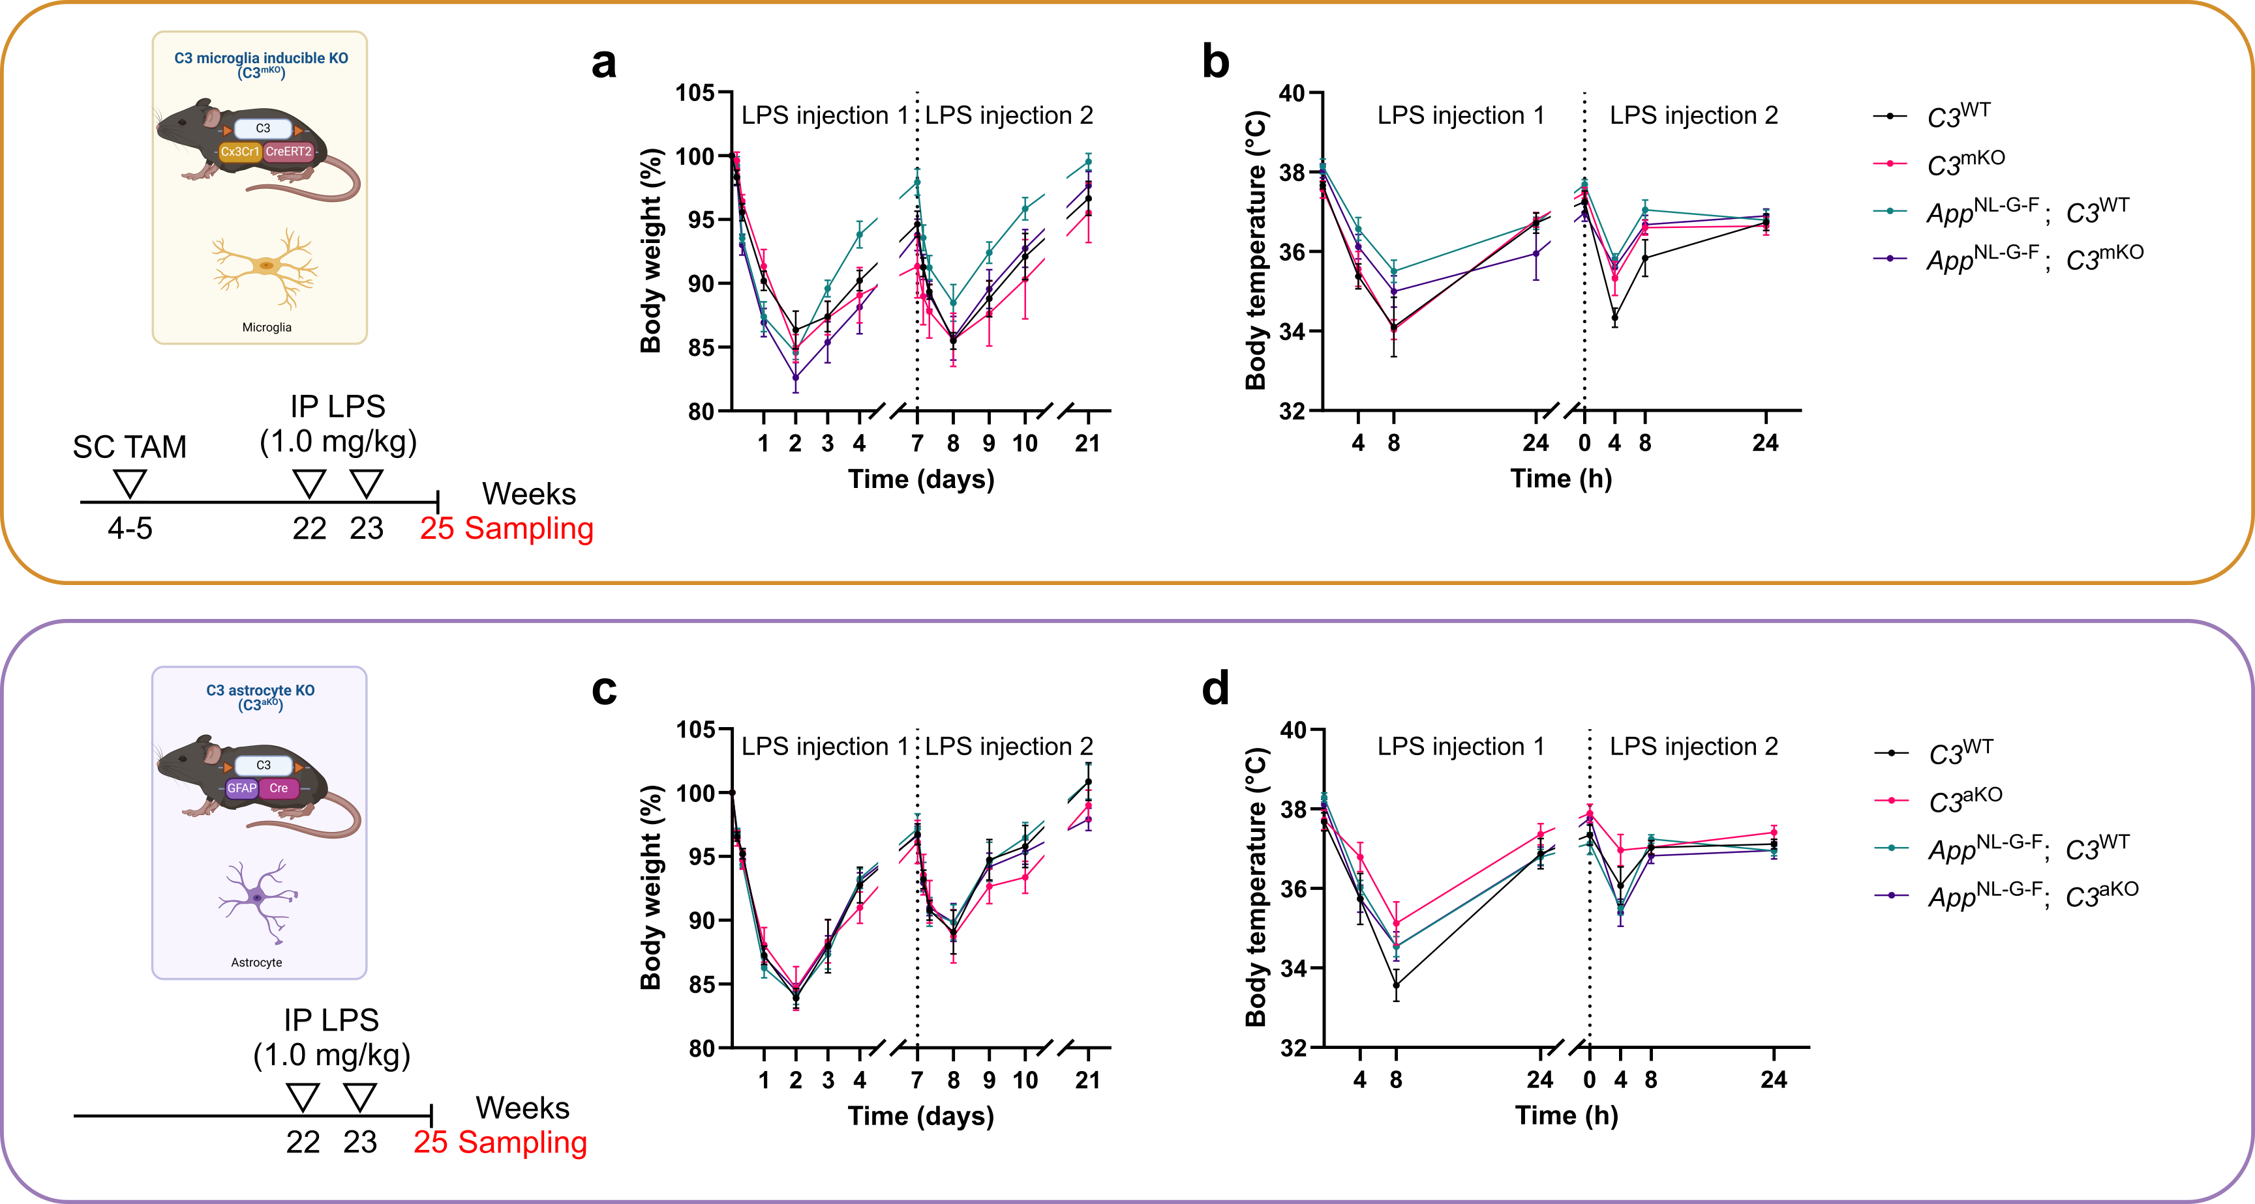
Supplementary Figure S3. Microglial and astrocytic C3 deficiency, as well as App^{NL-G-F} background, do not affect the systemic response to mild peripheral inflammation. Mice were subjected to mild peripheral inflammation by two IP injections of 1.0 mg/kg LPS at 22 and 23 weeks following analysis at 25 weeks. (a, b) Changes in body weight (a) and body temperature (b) over time in App^{NL-G-F}; C3^{mKO} versus App^{NL-G-F}; C3^{WT} littermates and versus aged-matched non-AD C57BL/6J controls. (c, d) Changes in body weight (c) and body temperature (d) over time in App^{NL-G-F}; C3^{aKO} versus App^{NL-G-F}; C3^{WT} littermates and versus aged-matched non-AD C57BL/6J controls. Statistics: the mean ± SD are shown with two-way ANOVA with post-hoc Tukey’s multiple comparison test performed for each timepoint.
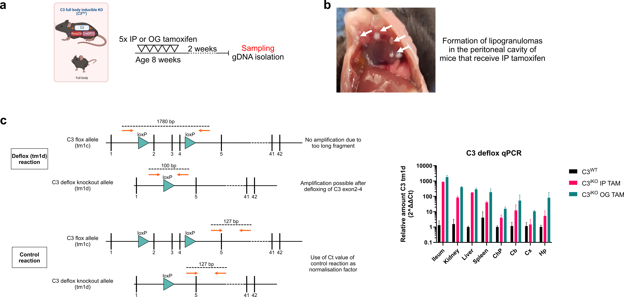
Supplementary Figure S4. Oral gavage is the preferred method of tamoxifen administration in C3^{iKO} mice. (a) Experimental setup to determine the optimal tamoxifen (TAM) administration protocol for knockout induction in C3^{iKO} mice. 8 weeks old C3^{iKO} mice were administered tamoxifen (50 mg/mL) daily for 5 days via either intraperitoneal (IP) injection or oral gavage (OG). Knockout efficiency was determined 2 weeks later. (b) Representative image of the formation of lipogranulomas in mice that received IP tamoxifen. Lipogranulomas are indicated by white arrows. (c) Deflox qPCR on extracted gDNA from ileum, kidney, liver, spleen, choroid plexus (ChP), cerebellum (Cb), cortex (Cx), and hippocampus (Hp) from C3^{WT}, IP tamoxifen TAM C3^{iKO} and OG TAM C3^{iKO} mice. Mean ± SD are shown (n=2).

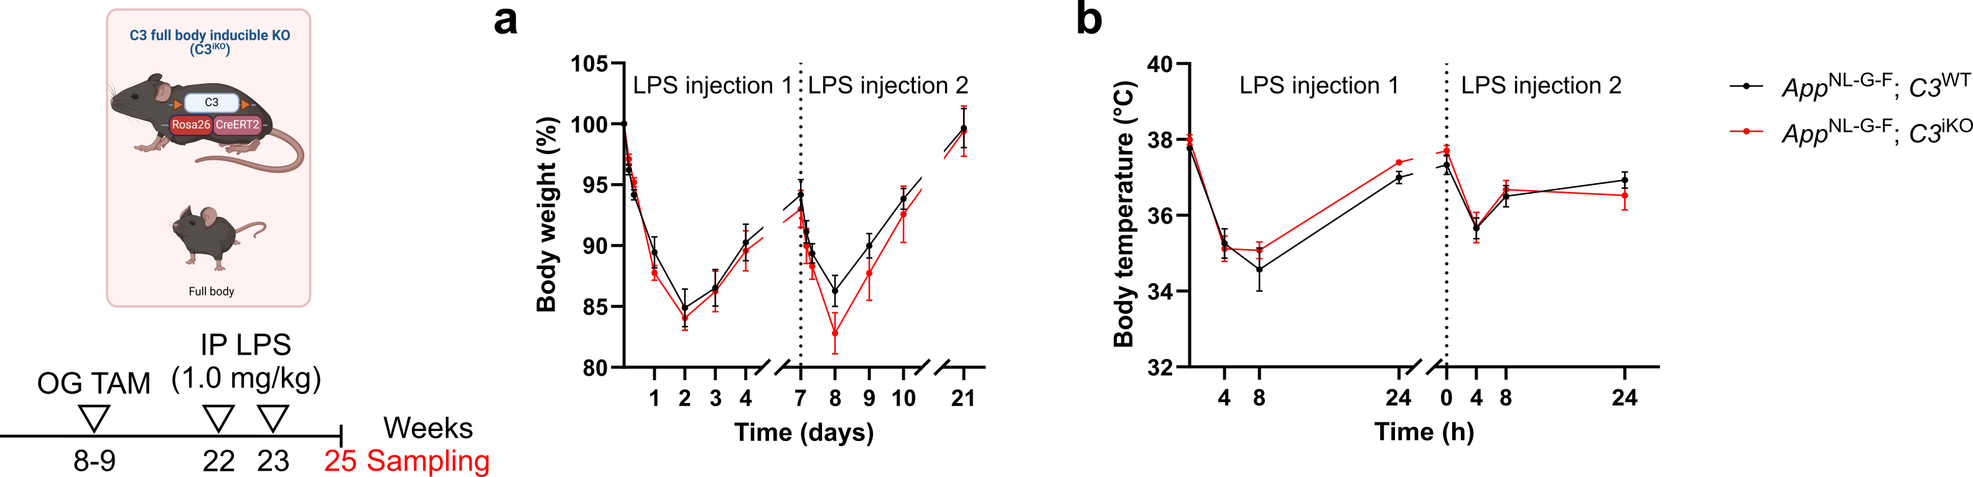
Supplementary Figure S5. Inducible full-body C3 deficiency does not affect the systemic response to mild peripheral inflammation. Mice were subjected to mild peripheral inflammation by two IP injections of 1.0 mg/kg LPS at 22 and 23 weeks followed by analysis at 25 weeks. Changes in body weight (a) and body temperature (b) over time in App^{NL-G-F}; C3^{miKO} versus App^{NL-G-F}; C3^{WT} littermates. Statistics: the mean ± SD are shown with 2-tailed Student’s t-test performed for each timepoint.

