Myelination modulates BOLD signal characteristics in white matter
Yurui Gao, Lyuan Xu, Kurt G. Schilling, Soyoung Choi, Ran Chen, Yikang Li, Muwei Li, Zhongliang Zu, Zhaohua Ding, Adam W. Anderson, John C. Gore

Supplementary Material

Methods

Reassign WM streamlines to bundles
For each streamline, we determined the affiliation of WM tract endpoints with specific GM ROI regions based on the relative geometric relationship between the starting and ending point coordinates and the corresponding GM ROIs. Specifically, for a given streamline, we first determined whether its endpoints fell within any GM ROI. If they did, we marked them accordingly. If not, we then checked if the neighboring areas formed by extending each endpoint by one voxel along the three coordinate axes individually fell within any ROI region. If they still did not, we further assessed whether the points at an extended or contracted distance (approximately 4 mm) from the endpoints along the streamline's local direction fell within any GM ROI region. After these steps, we identified the corresponding GM ROI regions for the endpoints of each streamline. We retained only the streamlines with both endpoints assigned to specific ROI regions. These streamlines were then categorized based on the different ROI regions to which their endpoints belong, resulting in a series of new, distinct WM bundles, each corresponding to connections between specific pairs of GM ROI regions.

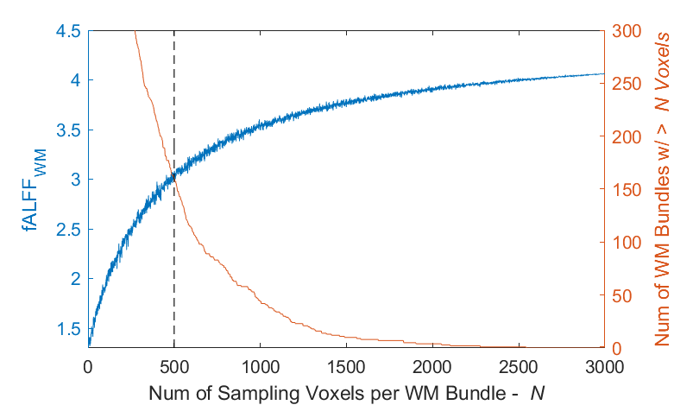
Fig. S1. Bundle-wise fALFF (left y-axis) and the number of qualified WM bundles (right y-axis) as functions of the number of sampling voxels per bundle (N). As N increases, fALFF (blue line) rises rapidly before gradually plateauing, while the number of WM bundles with sufficient voxels (> N) decreases. To ensure both stable fALFF estimation and adequate bundle coverage, we selected N = 500 for our analyses.
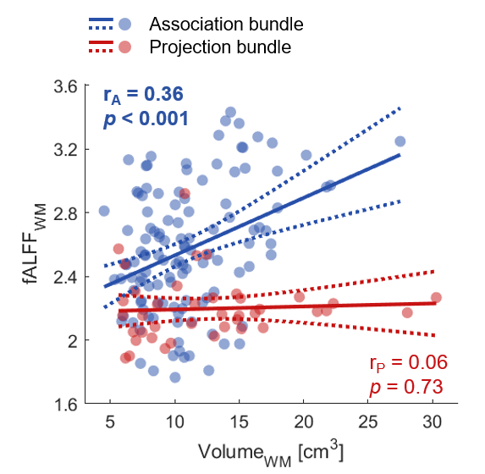
Fig. S2. Relationship of bundle-wise fALFF with bundle volume in association and projection groups. Relationship between fALFF and bundle volume in association bundles (blue; r_{A} = 0.36, p < 0.001) and projection bundles (red; r_{P} = 0.08, p = 0.73), indicating bundle volume as a potential confounding factor.

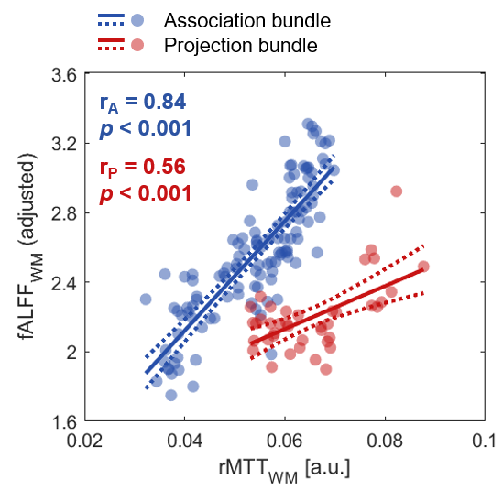
Fig. S3. Relationship of bundle-wise fALFF with relative mean transient time (rMTT) in association and projection groups.

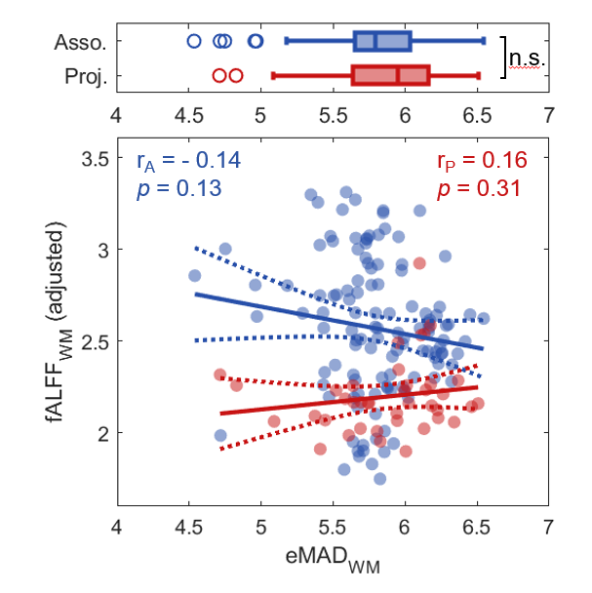
Fig. S4. Relationship of bundle-wise fALFF with estimated mean axon diameter (eMAD) in association and projection groups. Top: group comparison of eMAD between association bundles (blue) and projection bundles (red). Bottom: Scatter plot showing correlations between fALFF and eMAD across association bundles (blue) and projection bundles (red).
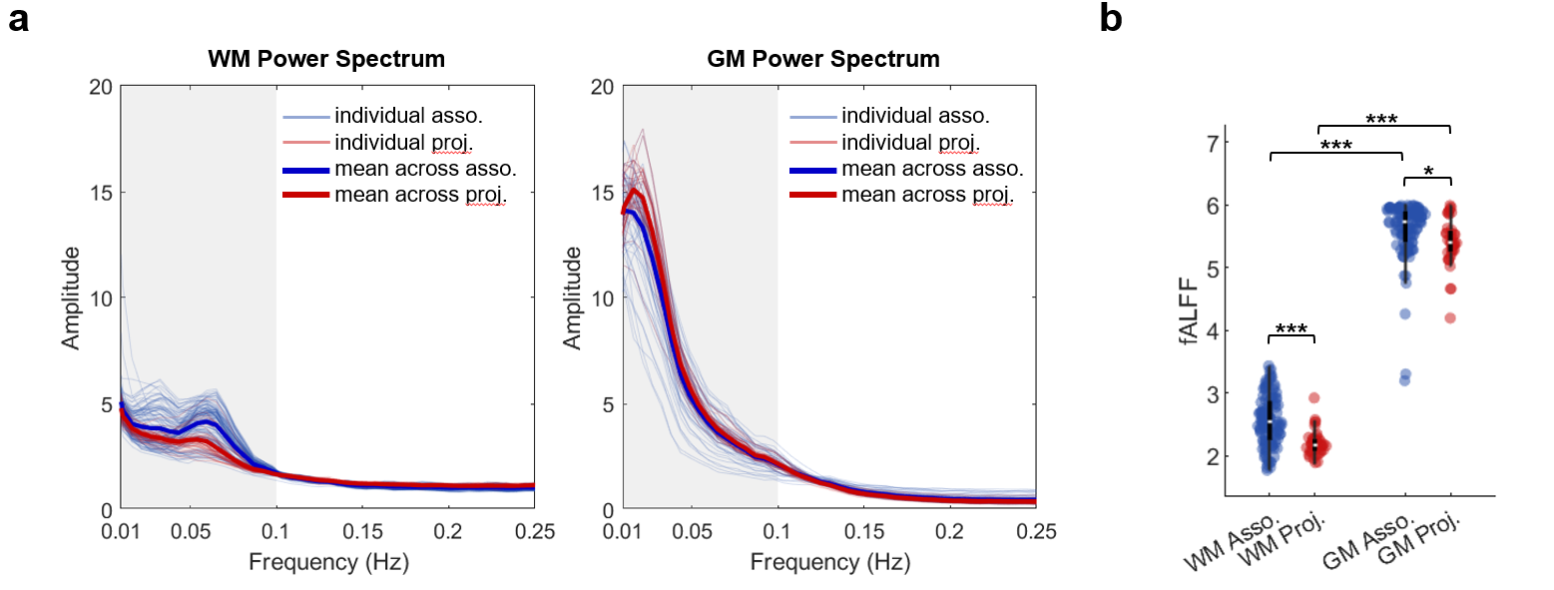
Fig. S5. Comparisons of power spectra and fALFF between WM bundles and connected GM parcels. a, Power spectra of WM bundles (left) and their connected GM parcels (right); thin lines represent individual spectra, and thick lines denote group averages. b, Group comparison of fALFF between WM bundles and connected GM parcels.

Table S1. Moderation effect of eMAD on relationship between each predictor and fALFF (z-scored variables).
Predictor | Main effect of predictor,  $β_{1}$ | Main effect of eMAD,  $$β_{2}$$ | Moderation effect of eMAD,  $$β_{3}$$ | Moderation threshold of eMAD
rCBV | 0.61 (p = 2e⁻¹⁵) *** | -0.11 (p = 0.08) | -0.49 (p = 2e⁻⁶) *** | 6.3
CBF | -0.46 (p = 1e⁻⁹) *** | 0.01 (p = 0.88) | 0.32 (p = 3e⁻⁴) *** | 6.3
OEF | 0.40 (p = 3e⁻⁷) *** | 0.01 (p = 0.86) | -0.06 (p = 0.39) | 8.3
CMRO₂ | -0.38 (p = 5e-7) *** | -0.10 (p = 0.15) | 0.40 (p = 1e⁻⁵) *** | 6.2

Table S2. Moderation effect of FA on relationship between each predictor and fALFF (z-scored variables).
Predictor | Main effect of predictor, $β_{1}$ | Main effect of FA,  $$β_{2}$$ | Moderation effect of FA,  $$β_{3}$$ | Moderation threshold of FA
rCBV | 0.60 (p = 3e⁻¹²) *** | -0.19 (p = 0.011) * | -0.13 (p = 0.09) | 0.30
CBF | -0.42 (p = 7e⁻⁸) *** | -0.005 (p = 0.95) | 0.02 (p = 0.74) | 0.57
OEF | 0.45 (p = 7e⁻⁸) *** | -0.09 (p = 0.25) | 0.07 (p = 0.21) | 0.08
CMRO₂ | -0.32 (p = 4e⁻⁵) *** | 0.02 (p = 0.77) | 0.11 (p = 0.22) | 0.28

