Table of Contents (ToC)
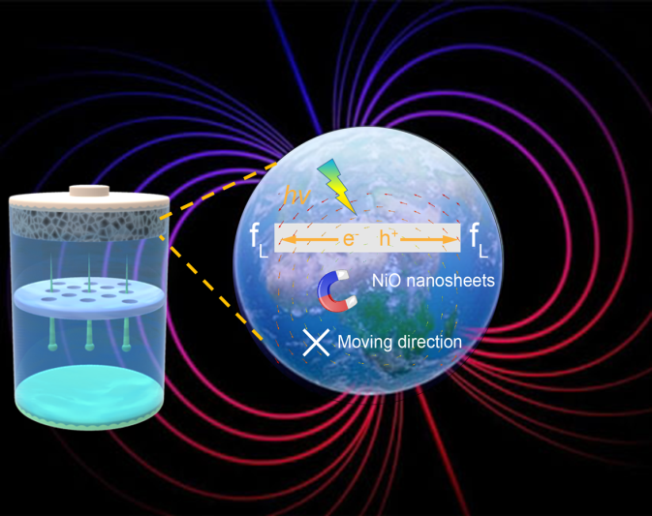
A magnetic and optical field multi-assisted Li-O₂ battery is constructed for the first time. By introducing the external magnetic field, the Lorentz force acts oppositely on the photogenerated electrons and holes, achieving the suppression of the recombination of charge carriers. The magnetic field (MF) can cope with the obstacle of rapid recombination of electrons and holes in the photo-assisted Li-O₂ batteries, leading to greatly improved battery performance. The magnetic and optical field multi-assisted Li-O₂ battery with NiO/FNi photoelectrode achieves an ultra-low charge potential of 2.73 V, a high energy efficiency of 96.7%, as well as a good cycling stability of 200 h.

