Supporting Information

Magnetic Field and Optical Multi-Assisted Li-O₂ Batteries with Self-Regulated Charge and Discharge
Xiao-Xue Wang,ª De-Hui Guan,ª Fei Li,ª Ma-Lin Li,^{a,b} Li-Jun Zheng,ª Ji-Jing Xu ^{a,b,}*
ªState Key Laboratory of Inorganic Synthesis and Preparative Chemistry, College of Chemistry, Jilin University, Changchun 130012, P. R. China
^{b}International Center of Future Science, Jilin University, Changchun 130012, P. R. China
E-mail: jijingxu@jlu.edu.cn

Figure S1. The EDS element mappings of Ni and O. Scale bars are 5 μm.
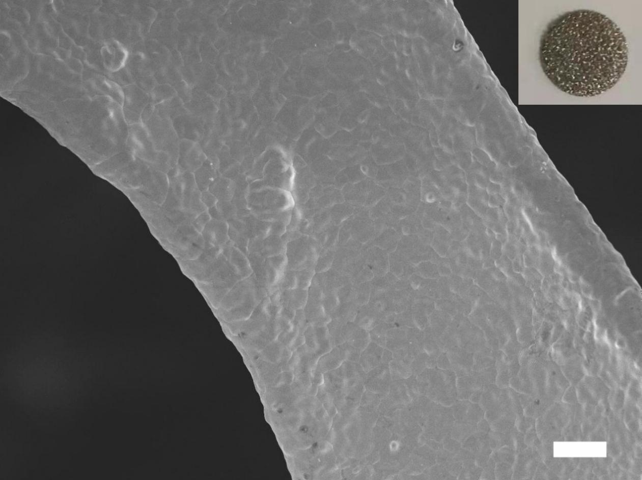
Figure S2. SEM image and photograph (inset) of the Ni foam. Scale bars are 10 μm.
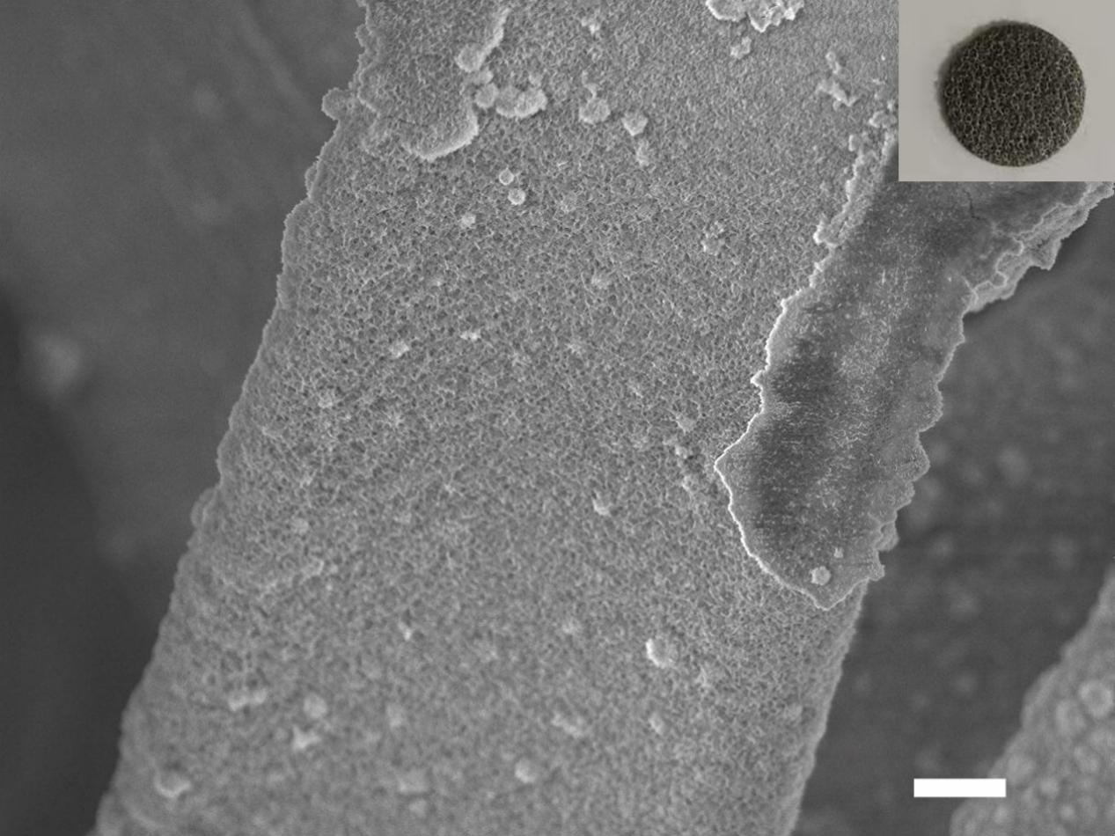
Figure S3. SEM image and photograph (inset) of the NiO/FNi cathode. Scale bars are 10 μm.
Figure S4. (αhν)² versus hν curve of NiO/FNi. The red line is the tangent of the curve. The intersection value is the band gap.

Figure S5. LSV curves of NiO/FNi in O₂ and Ar-saturated 0.5 M Na₂SO₄ solution.
Figure S6. EIS of NiO/FNi in dark and under light in O₂-saturated 0.5 M Na₂SO₄ solution.

Figure S7. SEM images of the NiO/FNi cathodes after 1st discharged in the dark (a) and the optical field (b). SEM images of the NiO/FNi cathodes after 1st recharged in the dark (c) and the optical field (d). Scale bars are 1 μm.
Figure S8. SEM images of the NiO/FNi cathodes after 20th recharged in the dark (a) and the optical field (b). Scale bars are 1 μm.
Figure S9. Discharge voltage variation of Li-O₂ batteries with NiO/FNi at different current densities in the dark and the optical field.
Figure S10. The polarization gap of Li-O₂ batteries with NiO/FNi in the dark and the optical field.
Figure S11. The first discharge and charge profiles of the magnetic and optical multi-assisted Li-O₂ battery with NiO/FNi at 0.01 mA cm⁻² under 5 mT magnetic field (MF).

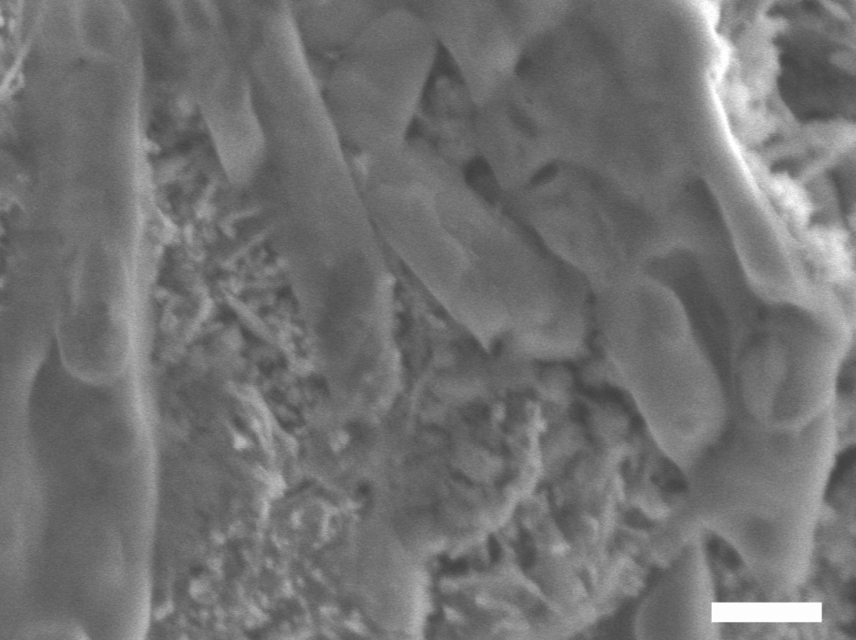
Figure S12. SEM images of the NiO/FNi cathodes after 30th discharged under 5 mT magnetic field (MF) and optical field. Scale bar is 500 nm.
Figure S13. Li 1s XPS spectrum of the 30th recharged cathodes under optical field and MF 0 mT and 5 mT.

Figure S14. Gas chromatography (GC) signals of O₂ and CO₂ released after charging and corresponding charge curves at a current density of 0.01 mA cm⁻² of the 30th recharged cathodes under optical field and MF 0 mT and 5 mT.

