Supplementary material

Table S 1: Characteristics of VOC Sampling at Domestic Fire and Traffic Sites in Abidjan for Diurnal Monitoring on January 08, 2016.
Measurement sites | Sample No. | Sample Code | Cartridge Reference | Sampling Times | Number of samples | Air volume (mL)
Domestic fire site | 1 | AFD1 | P-E GO107665 | 08:00 - 09:30 | 4 | 2400
Domestic fire site | 2 | AFD2 | Tera env 009240 | 10:00 - 11:30 | 4 | 2400
Domestic fire site | 3 | AFD3 | Tera env 007623 | 12:00 - 13:30 | 4 | 2400
Domestic fire site | 4 | AFD4 | Tera env 007636 | 14:00 - 15:30 | 4 | 2400
Domestic fire site | 5 | AFD5 | Tera env 008562 | 16:00 - 17: 30 | 4 | 2400
Domestic fire site | 6 | AFD6 | Tera env 009243 | 18:00 - 19:30 | 4 | 2400
Traffic site | 7 | ATT1 | Tera Env 008564 | 08:00 - 09:45 | 8 | 2400
Traffic site | 8 | ATT2 | Tera Env 009239 | 10:00 - 11:45 | 8 | 2400
Traffic site | 9 | ATT3 | Tera Env 113859 | 12:00 - 13:45 | 8 | 2400
Traffic site | 10 | ATT4 | P-E GO95888 | 14:00 - 15:45 | 8 | 2400
Traffic site | 11 | ATT5 | P-E GO141905 | 16:00 - 17:45 | 8 | 2400
Traffic site | 12 | ATT6 | P-E GO94456 | 18:00 - 19:45 | 8 | 2400

Table S 2: List of Volatile Organic Compounds identified, their chemical formulas and molar masses
VOC family | VOCs | Molecular formula | Structural formula | Molar mass (g/mol)
Monoterpenes | Limonene | C₁₀H₁₆ | 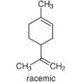 | 136.23
Monoterpenes | β-Pinene | C₁₀H₁₆ | 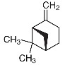 | 136.23
Monoterpenes | α-Pinene | C₁₀H₁₆ | 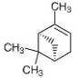 | 136.23
Aromatics | 1,2,3-trimethylbenzene | C₉H₁₂ | 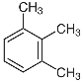 | 120.19
Aromatics | 1,2,4-trimethylbenzene | C₉H₁₂ | 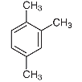 | 120.19
Aromatics | 1,3,5-trimethylbenzene | C₉H₁₂ | 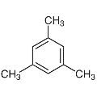 | 120.19
Aromatics | o-xylene | C₈H₁₀ | 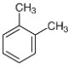 | 106.165
Aromatics | p-xylene | C₈H₁₀ | 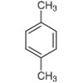 | 106.165
Aromatics | ethylbenzene | C₈H₁₀ | 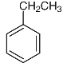 | 106.165
Aromatics | toluene | C₇H₈ | 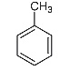 | 92.138
Aromatics | benzene | C₆H₆ |  | 78.111
Alkanes | octane | C₈H₁₈ | 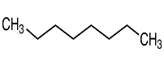 | 114.228
Alkanes | heptane | C₇H₁₆ | 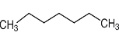 | 100.201
Alkanes | 2,2,4-trimethylpentane | C₈H₁₈ | 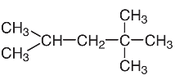 | 114
Alkene | pentene | C₅H₈ | 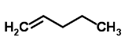 | 70.132
Alkene | isoprene | C₅H₈ | 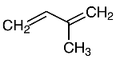 | 68.117

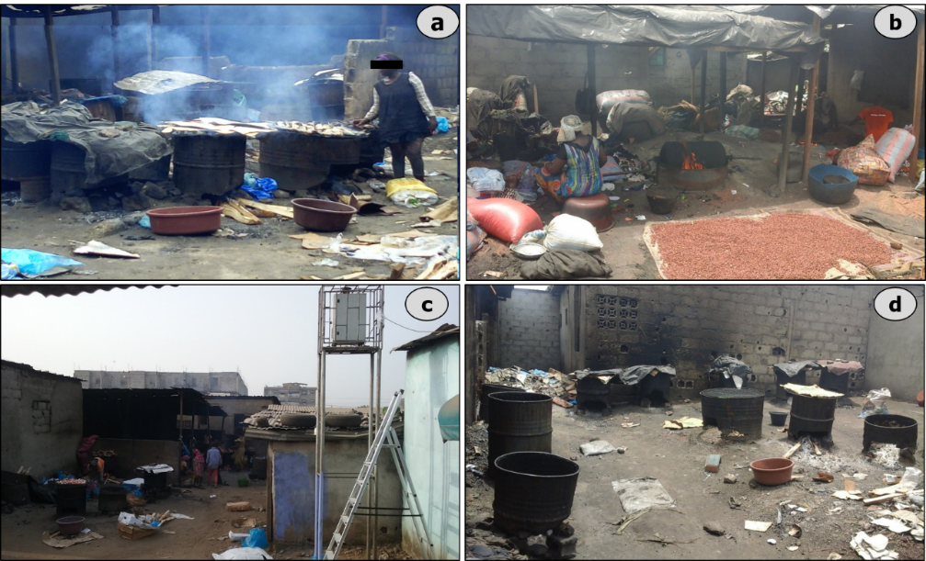
Fig.S 1: Activities using firewood at the domestic fire site in Yopougon: a) fish smoking, b) peanut roasting, c) a view of the installed equipment, d) a view of the smoking hearths (Bahino, 2018).
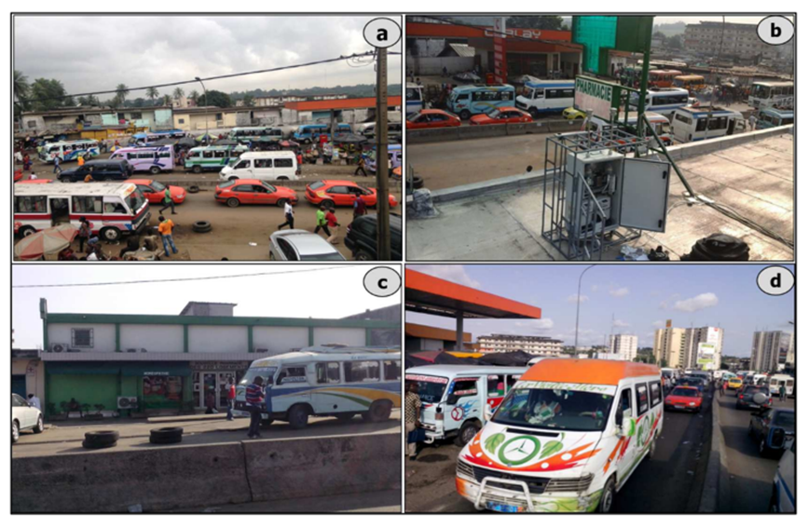
Fig.S 2. Traffic site in Adjamé Liberté (Abidjan) (a) View of traffic consisting of metered taxis, gbakas and private vehicles, (b) Measuring instruments on the roof of the 220 logements pharmacy, (c) Front view of the 220 logements pharmacy, (d) gbakas in circulation (Bahino, 2018)
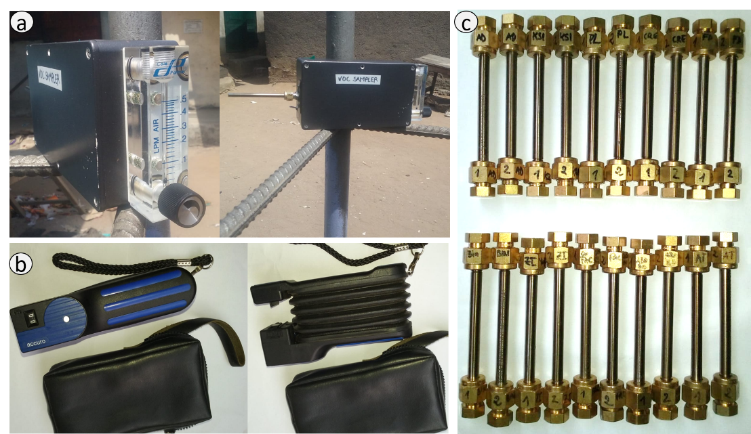
Fig.S 3 Air sample collection at the Abidjan sites using pumps: (a) electric and (b) manual and (c) VOC cartridge

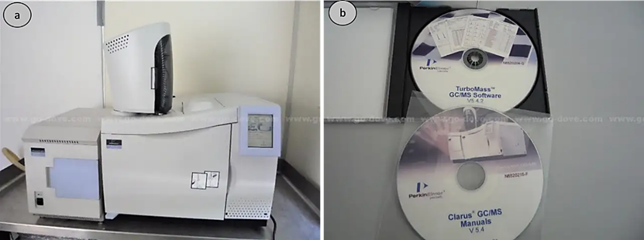
Fig.S 4. Analytical setup used for the VOC analysis, showing a) the GC/MS system used for the separation and identification of VOCs and b) the software interface for data acquisition and processing with the Perkin Elmer Clarus system

