Table 1a. WPM and Comprehension Scores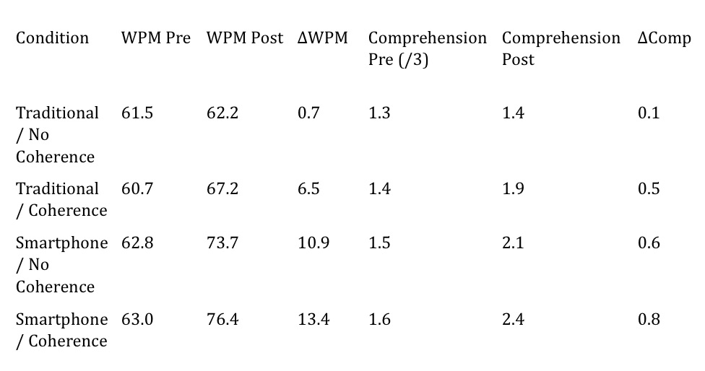
Table 1b. Reading Errors