Supplementary File:

Low Dose Rapamycin Alleviates Clinical Symptoms of Fatigue and PEM in ME/CFS Patients via Improvement of Autophagy

Brian T. Ruan¹, Sarojini Bulbule², Amy Reyes², Bela Chheda³, Lucinda Bateman⁴, Jennifer Bell⁴, Braydon Yellman⁴, Maureen Hanson², Stephanie Grach⁵, Jon Berner⁶, Daniel L. Peterson⁷, *David Kaufman ³, *Avik Roy^{2,9}, *C. Gunnar Gottschalk^{2,8}

Affiliations:
^{1.} Cornell EIND Center, Cornell University, Ithaca, NY
^{2.} Simmaron Research Inc. Research and Development Lab, University of Wisconsin Milwaukee
^{3.} Centers for Complex Diseases, Palo Alto, CA and Seattle, Washington
^{4.} The Bateman Horne Center, Salt Lake City, UT
^{5.} The Mayo Clinic, Rochester, NY
^{6.} Woodinville Psychiatry, Woodinville, WA
^{7.} Sierra Internal Medicine, Incline Village, NV
^{8.} Simmaron Research Center for Translational Science, ICBI at Indiana University Methodist Hospital, Indianapolis, IN
^{9.} Milwaukee Institute for Drug Discovery, University of Wisconsin-Milwaukee, 2000 E Kenwood Blvd, Milwaukee, WI 53211

*Correspondence to

C. Gunnar Gottschalk PhD
Simmaron Research Center for Translational Science,
ICBI
Indiana University Methodist Hospital
Indianapolis, IN
ggottschalk@simmaron.com

David Kaufman, MD
Avik Roy, PhD
Simmaron Research & Development Laboratory,
Milwaukee Institute for Drug Discovery
University of Wisconsin-Milwaukee
2000 E Kenwood Blvd
SBIR suite # 320
Milwaukee, WI 53211
aroy@simmaron.com

Center for Complex Diseases, CA
Center for Complex Diseases
Email: david@centerforcomplexdiseases.com
Legends to Supplementary Figures:
Supplement Figure 1. Low-dose rapamycin therapy schema and analysis of metabolic panel at different milestones of rapamycin treatment. (A) A schema represents timepoints (T) of rapamycin treatment. T1 represents the first thirty-six (36) days of treatment with increasing doses of rapamycin starting from 1 (6 days) → 2 (6 days) → 3 (6 days) → 4 (6 days) → 5 (6 days) → 6 mg (6 days). After ramping period, the treatment enters T2 (60 days) phase with constant dosing of 6mg/week, then, finally, to T3 (90 days) phase. (B) The table itemized important documentation such as acquisitions of consent, detailed medical history, disease onset before the treatment began at BSL stage. Improvement of daily activity, fatigue, the overall quality of health, metabolic changes associated with lipid, sugar, and inflammatory metabolic processes were monitored at the end of each milestones.
Supplement Figure 2. A flow-chart for the participants. Response criteria was set based on the positive, no change, and/or negative reports of symptoms as reported on the SSS, MFI, and SF-36 inventories. Twenty (17) responders reported positive changes in selected symptoms from the SSS, all domains of the MFI, and the PCS of the SF-36. Nine (18) partial responders reported positive changes in some SSS symptoms and either the MFI or SF-36, whereas eleven (5) non-responders reported no change/negative reports in the SSS symptoms, MFI aggregate score, and SF-36 PCS aggregate.
Supplementary Figure 3. Development of pSer258ATG13 ELISA. (A) The peptide sequence was used as a substrate antigen to elicit immunogenic response in rabbit. Anti-sera were collected after 90 and 120 days of immunization and then affinity purified as per the protocol optimized by ThermoFisher Scientific. (B) Dose and time optimization of signal intensity were performed followed by the (C) derivation of standard curve. Results are mean ± SD after 3 different experiments.
Supplement Figure 4. Analysis of BECLIN-1 and pSer258ATG13 in plasma samples of ME/CFS subjects stratified by responder status. (A) The plasma level of BECLIN-1 was measured by ELISA and plotted in a log scale as a dotted bar chart for each milestone. Each bar was annotated with sample size underneath. (B) MFI aggregate vs BECLIN-1 curve relationship shown. (C) pSer258ATG13 ELISA was performed and plotted in a log scale as a dotted bar chart for each milestone. Each bar was annotated with sample size underneath. (D) MFI RA vs pSer258ATG13 curve relationship shown for each responder group. Spearman coefficients for (E) BECLIN-1 and (F) pSer258ATG13 for each questionnaire. A, C: Comparisons are from a (A) two-way ANOVA or (C) stacked mixed-effects model. ****: p < 0.0001, ***: p < 0.001, **: p < 0.01, *: p < 0.05. 95% CI unavailable because of insufficient number of Spearman pairs. Horizontal line = perfectly zero correlation between the groups.
Supplementary Figure 5. The effect of rapamycin on blood cell count in ME/CFS subjects. Quantifications of (A) WBC (10³/µL), (B) RBC (10⁶/µL), (C) hemoglobin (g/dL), (D) hematocrit (%), (E) platelet (10³/µL), and (F) hemoglobin A1C (%) were performed in all subjects at BSL, T1-T3 stages. No significant change was observed among different groups in any of these measurement criteria.
Supplementary Figure 6. The effect of rapamycin on the metabolic status of ME/CFS subjects. Glucose and lipid metabolic status of the cohort was evaluated by measuring (A) glucose (mg/dL, (B) creatine (mg/L), (C) triglyceride (mg/dl), (D) total cholesterol (mg/dL), (E) HDL (mg/dL), and (F) LDL (mg/dL) at different stages of rapamycin treatment. No significant change was observed among different groups in any of these measurement criteria.
Supplementary Figure 7. Sample tree from the random forest machine learning model. Data were imputed using KNN with 2 nearest neighbors. Hyperparameter-tuned (optimal) parameters were used with max_depth = 3, max_features = sqrt, min_samples_leaf = 1, min_samples_split = 2, and n_estimators = 200.
Supplementary Figure 8. Confusion matrix shows high fidelity and accuracy for the responder subset.
Supplementary Figure 9. AUC receiver operator curve (ROC) of each responder subset.

Supplementary Fig. 1.

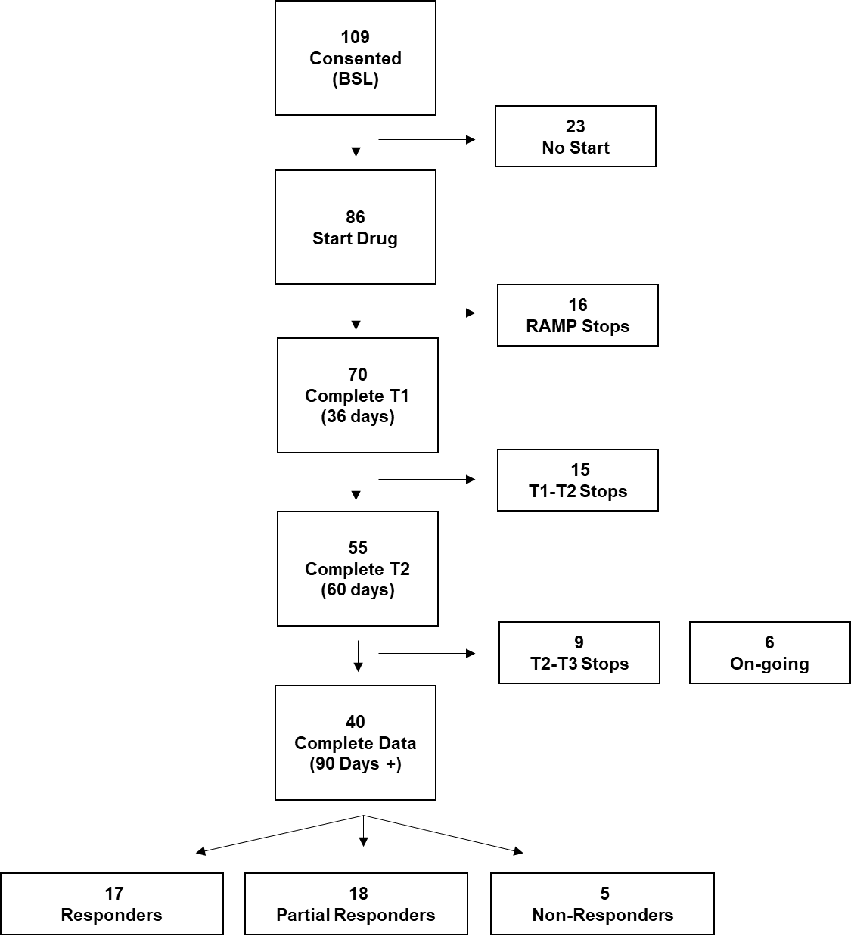
Supplementary Fig. 3.

Supplementary Fig. 4.

Supplementary Fig. 5.

Supplementary Fig. 6.
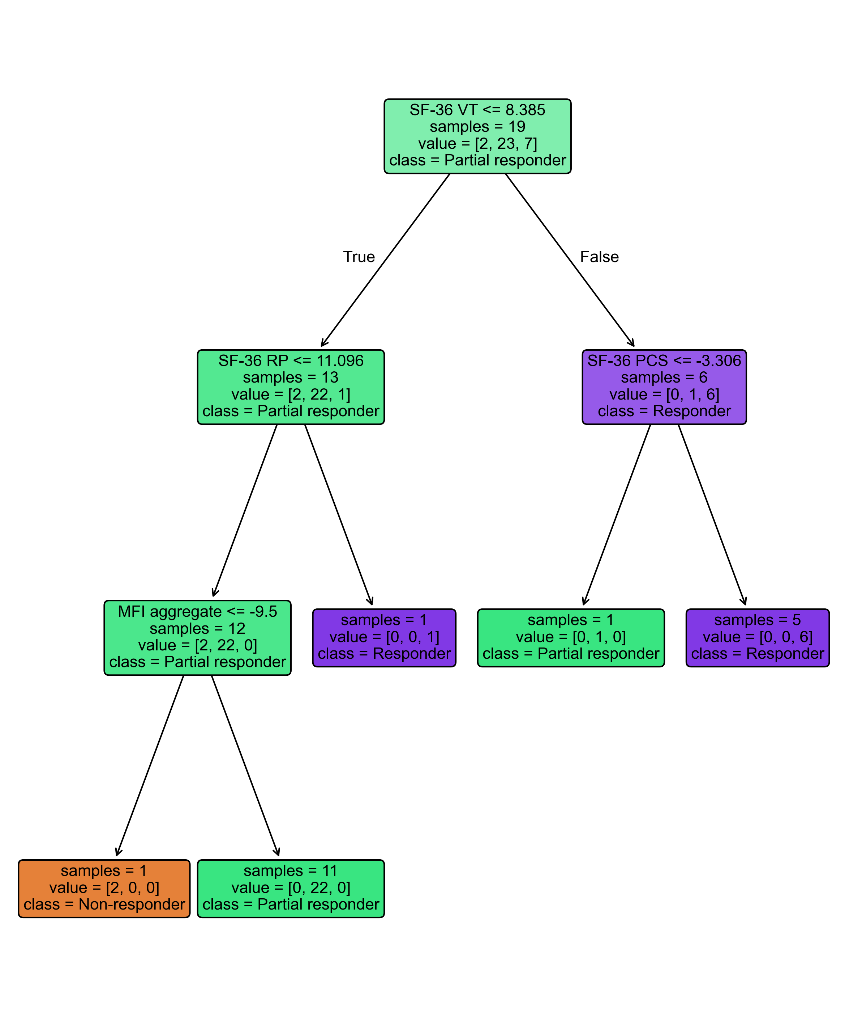
Supplementary Fig. 7.

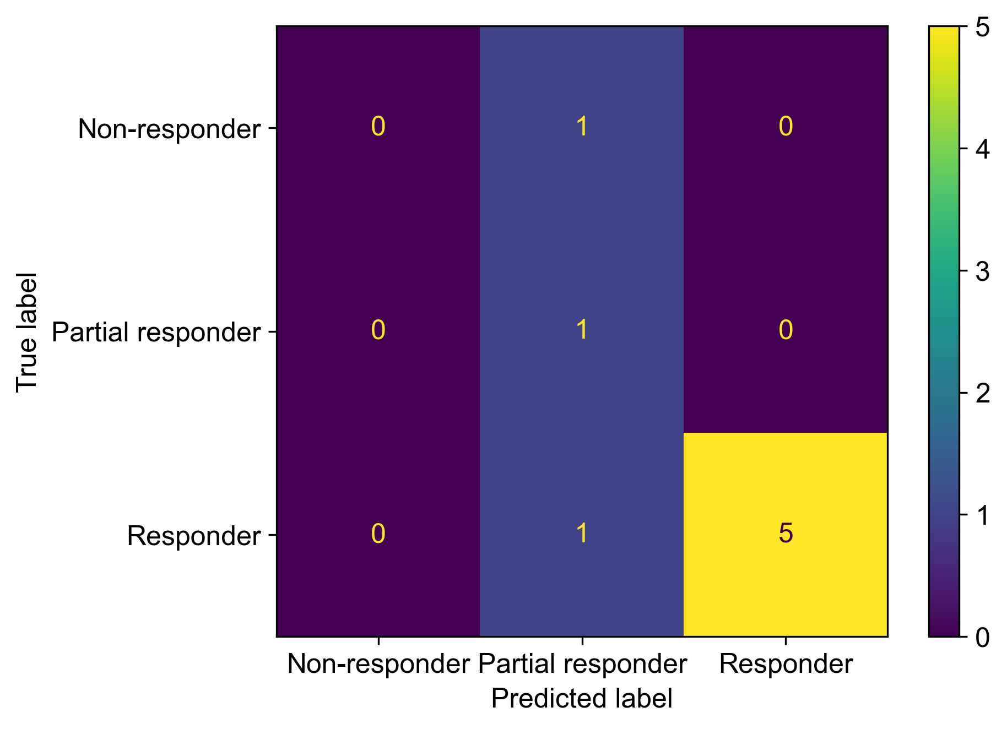
Supplementary Fig. 8.

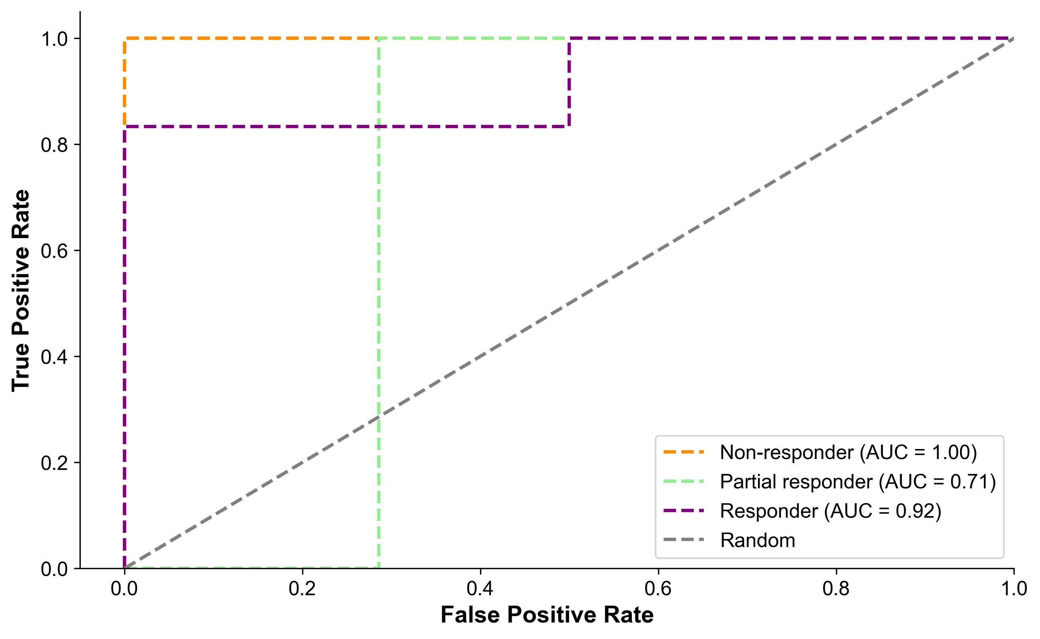
Supplementary Fig. 9.

