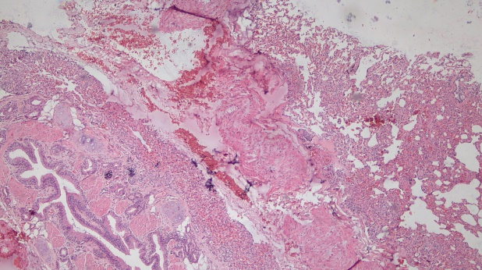  A: Severe bleeding area in the lungs, 4x, H-E | 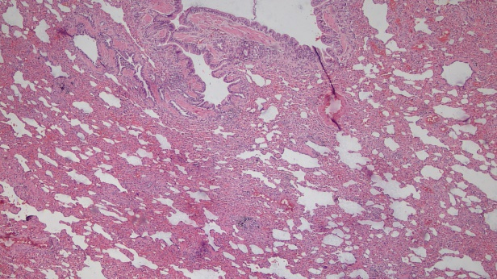  B: Interstitial thickening and hyperemia in the lung, 4x, H-E
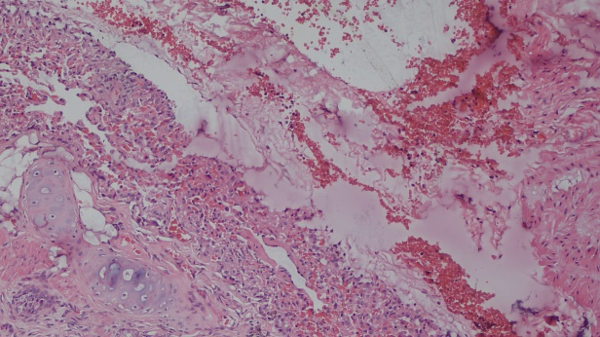  C: Severe interstitial bleeding area in the lung, 10x, H-E | 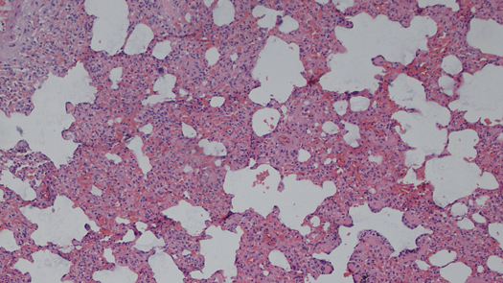  D: Thickening and hyperemia in the interstitial area of ​​the lung,10x, H-E
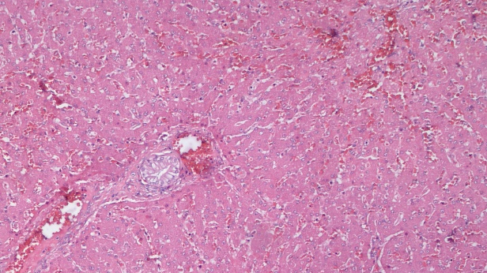  E: Bleeding areas in the liver, 4x, H-E | 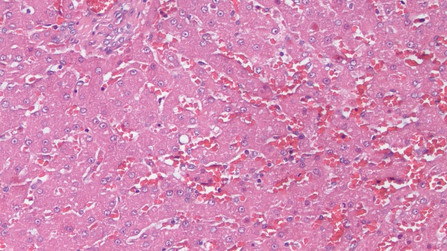  F: Bleeding and degeneration in the liver, 10x, H-E
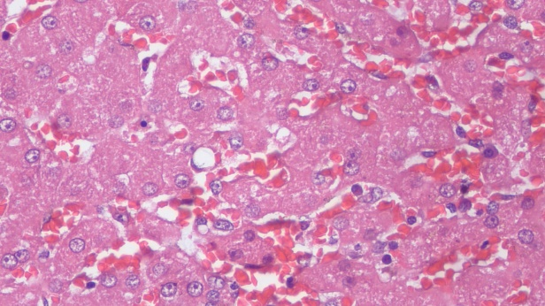  F: Extensive liver degeneration, 40x, H-E | 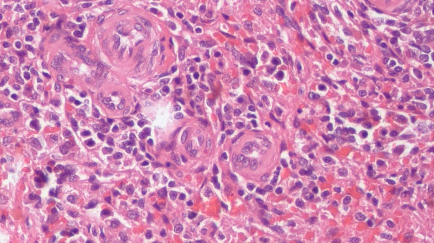  G: Hassal corpuscular in the spleen, 40x, H-E
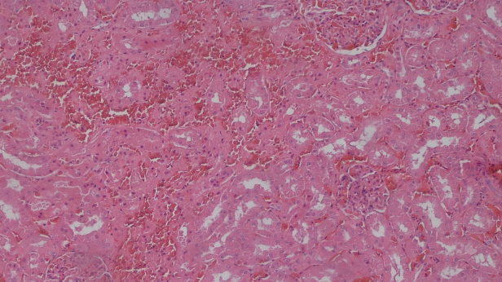  H: Severe bleeding areas in the kidney, 10x, H-E | 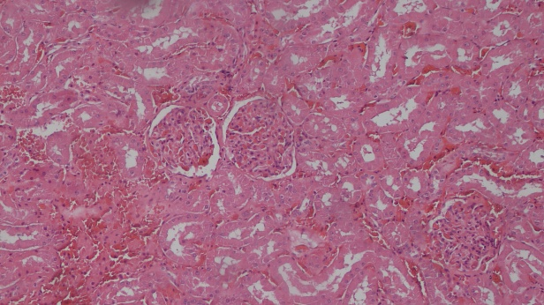  I: Severe bleeding and glomerular hemorrhage in the interstitial area of ​​the kidney 10x, H-E
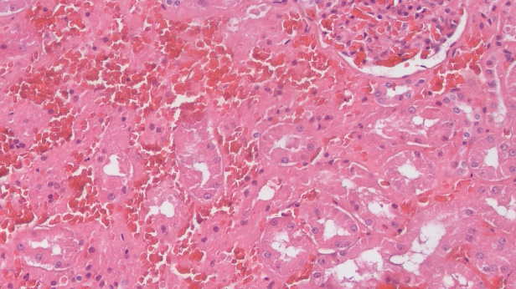  J: Severe bleeding and tubular degeneration in the interstitial area and glomerulus of the kidney 20x, H-E | 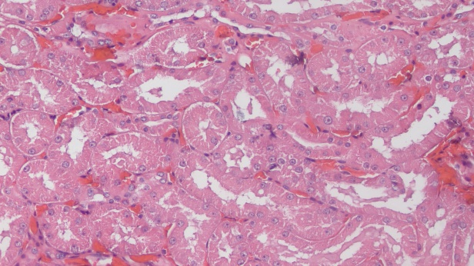  K: Severe degeneration of tubular epithelium in the kidney 20x, H-E
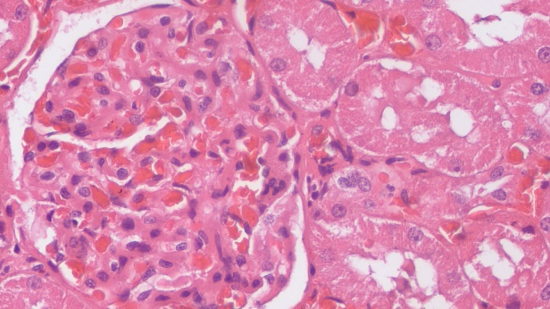  L: Hemorrhage in kidney glomeruli, degeneration in tubular epithelium 40 x, H-E | 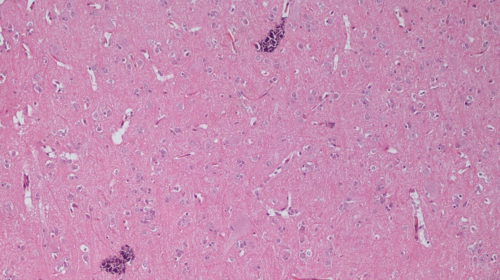  M: Calcification areas in the brain tissue10x, H-E

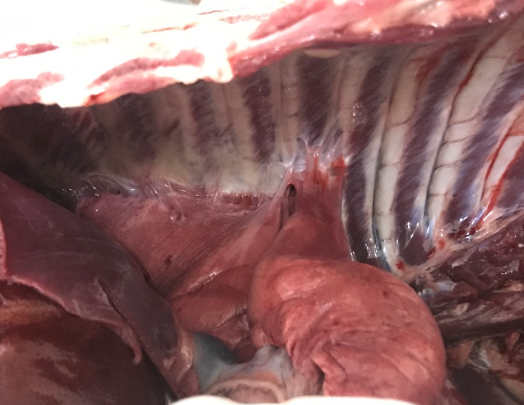  A: Pleural adhesion | 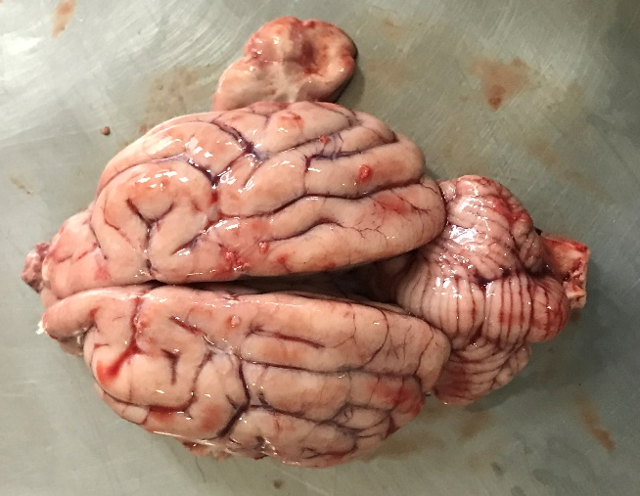  B: Meningeal congestion

Further Post-Mortem and Histopathological Findings:
In necropsy, the submandibular lymph nodes of the animal were edematous and hyperplasic on external examination. Subcapsular adhesions in the right kidney and vibices-like bleeding in the intestines, especially in the duodenum mucosa, were observed. Examination of the thoracic cavity revealed; diffuse bleeding areas showing a multifocal distribution in the lungs and adherence of the cranial and caudal lobes of the right lung to the pleura. On examination of the skull, bleeding was noted in two focal areas in the cerebrum and cerebellum, the meningeal vessels were congested. In histopathological examination (Figures); bleeding areas were observed in; interstitial vessels in the lung, liver parenchyma, white pulp in spleen, cortex and medulla of kidney. In addition, severe mononuclear cell infiltration was observed in the interstitial area of ​​the lung and kidney glomerulus. Mild-moderate vacuolar degeneration was observed in liver hepatocytes. Numerous iron-loaded macrophages (hemosiderophages) with a multifocal distribution were found in the splenic parenchyma, and numerous hassall corpuscles were seen in the white pulp. Moderate mononuclear cell infiltrates in a focal area and degeneration of tubule epithelium were observed in ​​the kidney. Some areas of demyelination were found in white matter. Meningeal vessels were hyperemic. Basophilic stained foci (calcification) were noted in the neuropils.

