Supplementary Materials for

Recent significant drying in the Central Congo Basin linked to the weakening of the Walker circulation in a warmer Atlantic

Sly Wongchuig et al.

* Corresponding author: Sly Wongchuig (sly.wongchuig-correa@univ-tlse3.fr)

This PDF file includes:
Figures S1 to S9

Figure S1. a, Spatial distribution of the Mann-Kendall trend coefficient of annual Precipitation (P) from ERA5, MSWEP and MERRA-2 datasets. b, Climatology of accumulated precipitation by season from CHIRPS database during the period 1981-2022. The contribution to variation for increase (decrease) is indicated in blue (red) between the last and first decade of the study period.

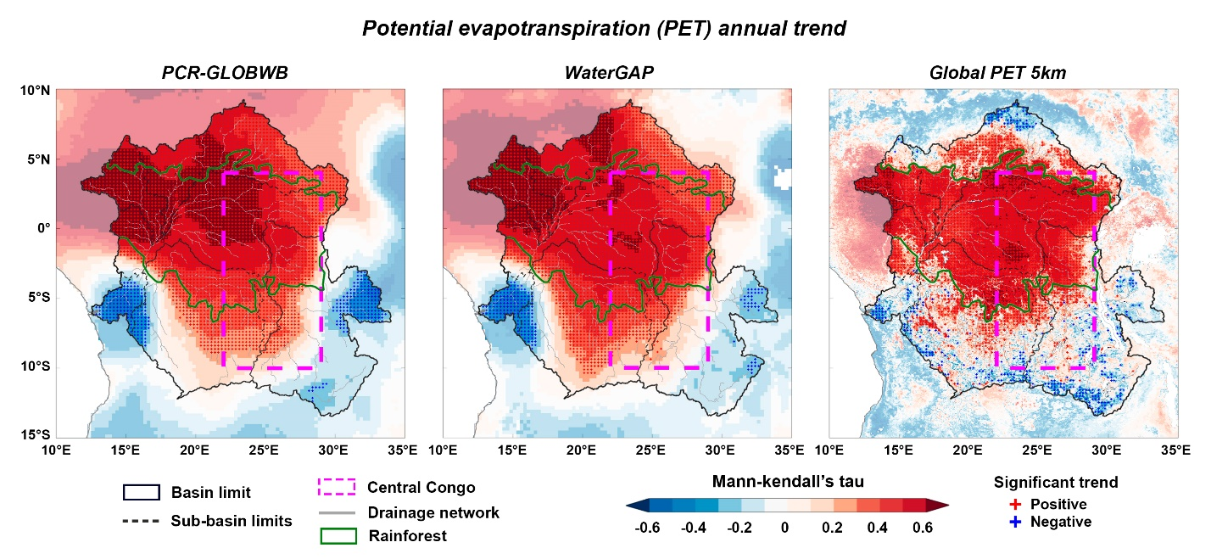
Figure S2. Spatial distribution of the Mann-Kendall trend coefficient of annual Potential evapotranspiration (PET) from PCR-GLOBWB, WaterGAP3 and Global PET 5km datasets.

Figure S3. a, Map of non-forest vegetation up to 1992 (grey) and deforested areas (yellow-red-blue bar colours) for the 1992–2020 period in the Congo Basin. b, Zoom of panel A in the northern Central Congo region. c, Map of land use in 2020 from ESA CCI Land Cover dataset.

Figure S4. a, Spatial distribution of the Mann-Kendall trend coefficient of annual Root-zone soil moisture (SM) from GLEAM, PCR-GLOBWB, HTESSEL and ORCHIDEE datasets. b, Time series of annual values and linear slopes of SM from GLEAM (-1.8% decade⁻¹), PCR-GLOBWB (-1.8% decade⁻¹), HTESSEL (-1.8% decade⁻¹), ORCHIDEE (-1.8% decade⁻¹) and their mean Ensemble.

Figure S5. Spatial distribution of the Mann-Kendall trend coefficient of the seasonal mean values of vertically integrated moisture flux convergence from ERA5 for the period 1981 to 2022. Significant pixel values (p<0.05) are indicated by red and blue crosses. Annual trends of wind speed at 850 hPa are plotted as black and gray arrows for significant and non-significant values, respectively.

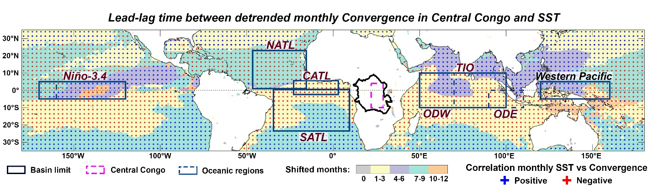
Figure S6. Map of the time lag in the maximum decorrelation between the monthly detrended values of convergence in the Central Congo and the SST anomalies. The oceanic regions are delimited by dark blue rectangles.

Figure S7. Map of regions connected by the atmospheric circulation to the vertical winds of the Central Congo. Areas in orange (blue) indicate regions negatively (positively) correlated with the Central Congo, i.e. regions with wind subsidence (uplift of winds) during a, Annual, b, DJF, c, MAM and d, JJA. Regions with a significant trend of decreasing subsidence and uplift of winds, i.e. a weakening of the atmospheric circulation, are represented by black crosses. The east-central Atlantic Ocean is outlined around this region in a red rectangle. The green dotted line indicates the cross-section for vertical flow analysis. An opaque white layer is superimposed and indicates regions with maximum correlation over periods longer than 3 months. A zoom has been added to this region for a more detailed view in the right column.

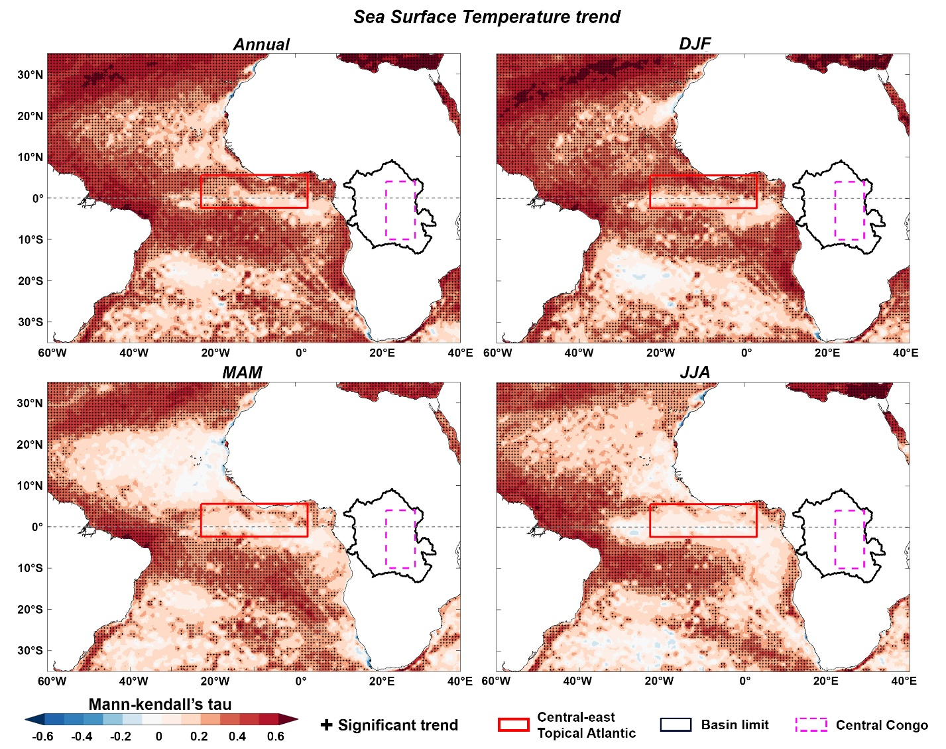
Figure S8. Map of the SST Mann-Kendall trend during the Annual, DJF, MAM and JJA periods.

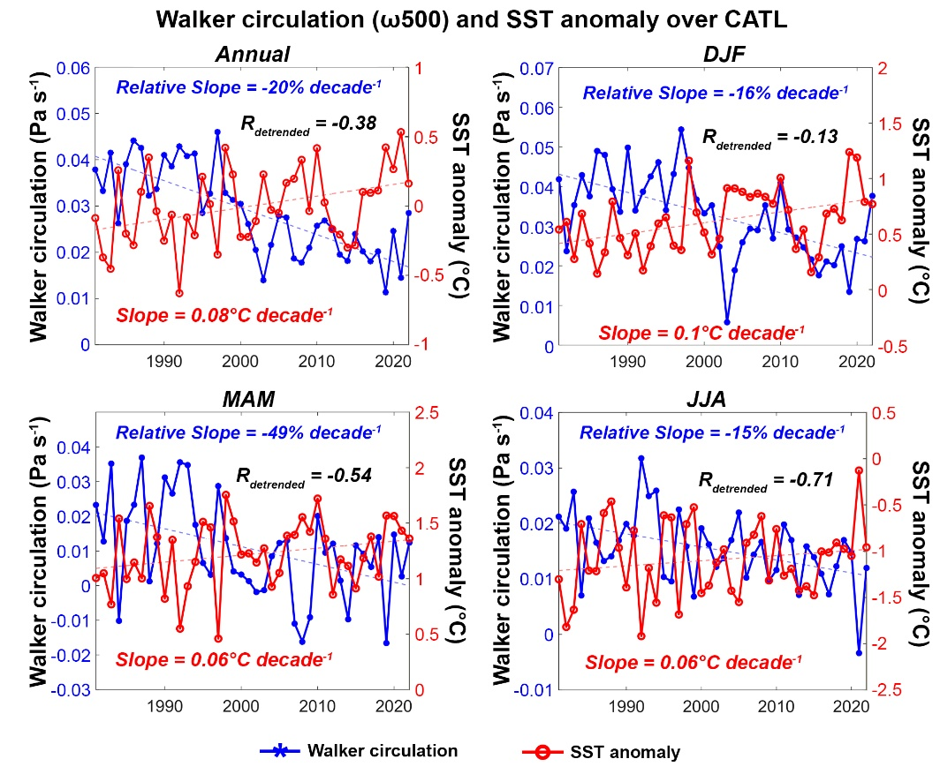
Figure S9. Time series of the Walker circulation (ω500, blue line) between the Central Congo and the Central-east Tropical Atlantic, along with its SST anomaly (red line) during Annual, DJF, MAM and JJA, for the period 1981-2022.

