SUPPLEMENTARY MATERIAL

ROC of the TyG index to predict intermediate to high cardiovascular risk in ten years assessed by the Framingham score, Cut offs, sensitivity and specificity.

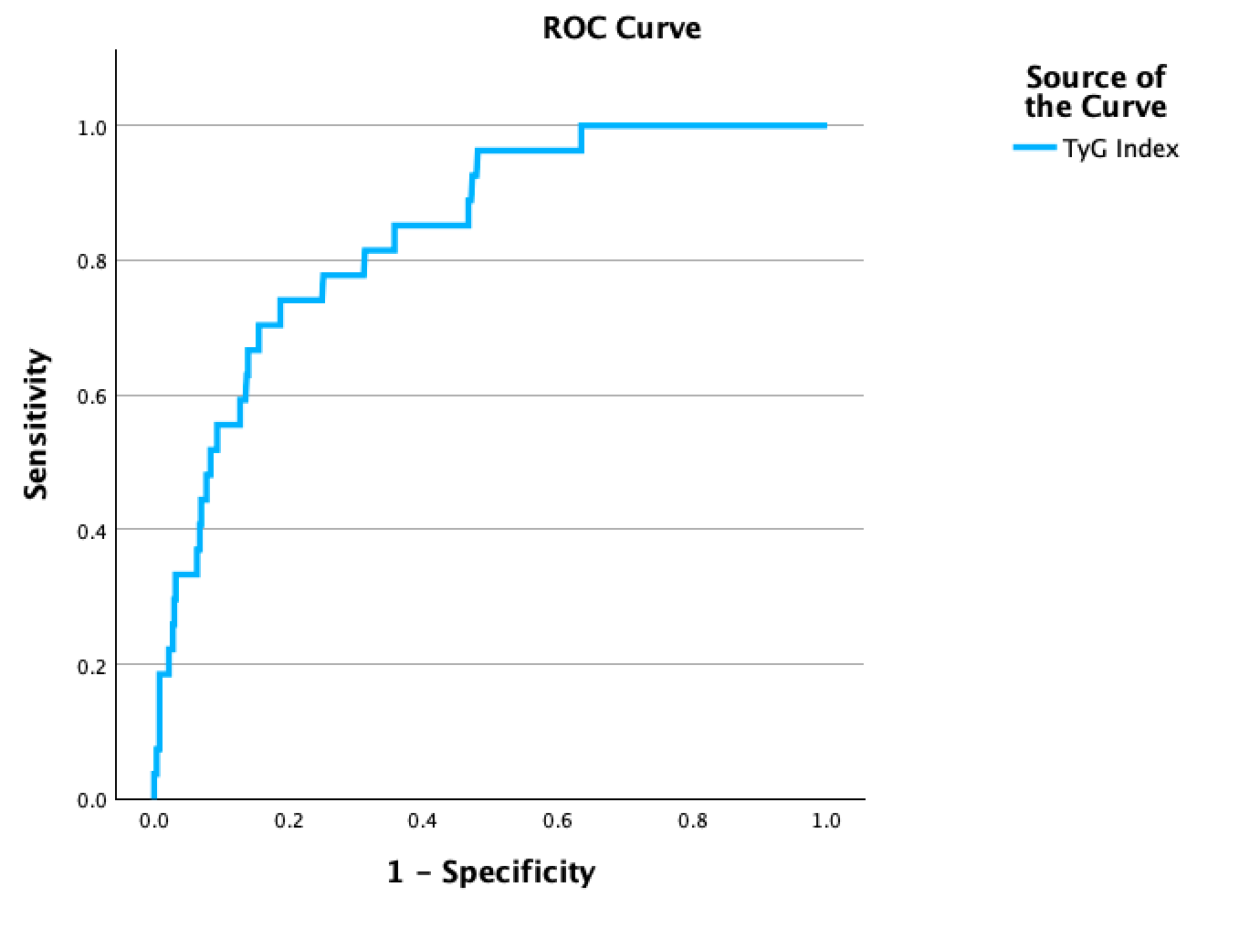
AUC 0.840
Standard error 0.035
Asymptomatic sig. 0.000
95% Confidence interval (0.772-0.909)
Youden Index for cut off Tyg Index

Best Cut-off for Intermediate to high-risk cardiovascular risk | Sensitivity | - specificity | Youden Index
4.74 | 0.741 | 0.188 | 0.553

ROC of the TyG index to predict metabolic syndrome as defined by the 2009 harmonized criteria.

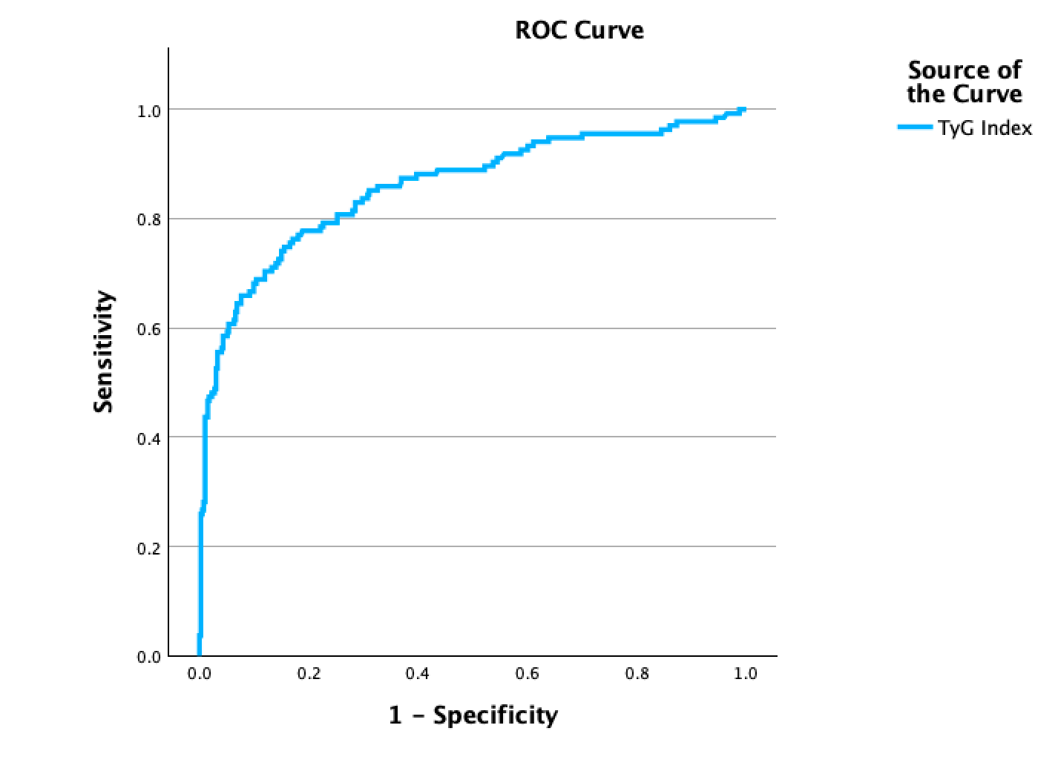Youden Index for cut off Tyg Index
AUC = 0.858
Standard error 0.021
Significance 0.000
95% Confidence interval (0.817-0.900)

Positive if Greater Than or Equal To | Sensitivity | 1 - Specificity | Youden's Index
4.637 | 0.748 | 0.155 | 0.593

