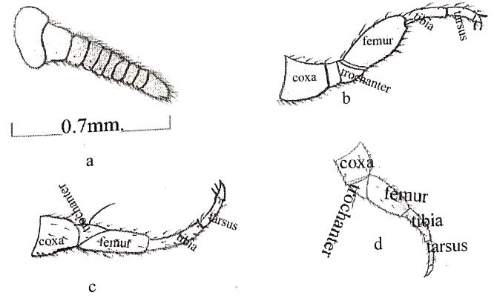
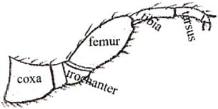
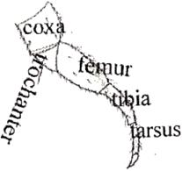
Plate 1 Morphological structure of adult P. ferox : a Antenna; b Leg of 1st pair; c Leg of 2nd pair; d Leg of
3rd pair
a
b
c
d

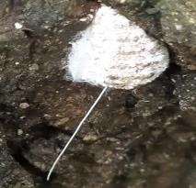
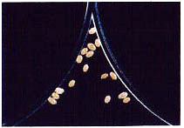
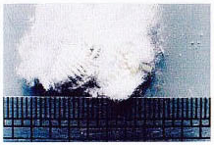
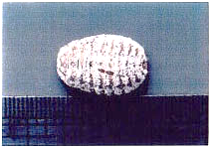
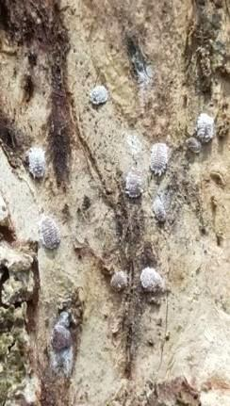
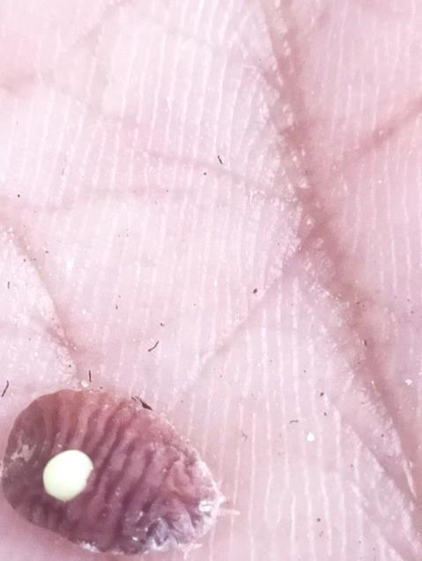
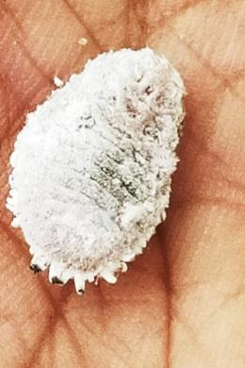
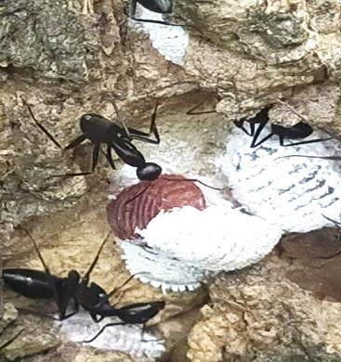
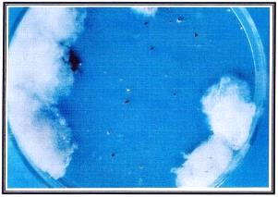
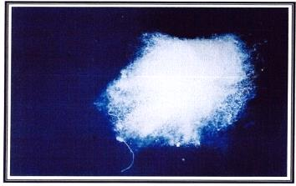
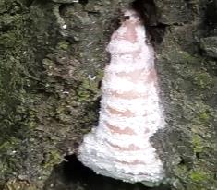
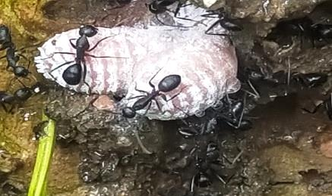
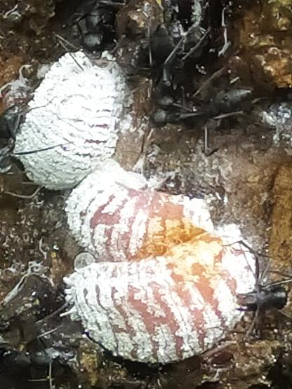
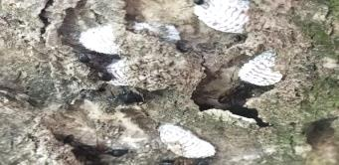
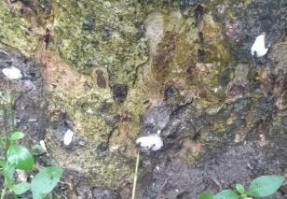
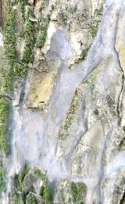
a b c d e
f g h i j
k l m n o

Plate 2 Life stages of P. ferox : a Laboratory rearing; b White cottony ovisac; c Adult (Dorsal view); d Adult (Ventral view); e Adults in host’s cracks; f Oviposition; g Eggs; h 1st instar in A. procera; i 2nd instar & their molting; j Injured 3rd instar after molting; k Honeydew discharge by adult; l Mutualism with ants; m Adult insect in ant nest made by clay in L. speciosa’s bark; n Adult insect on A. procera; o Sooty mold fungi on A. lebbeck’s stem

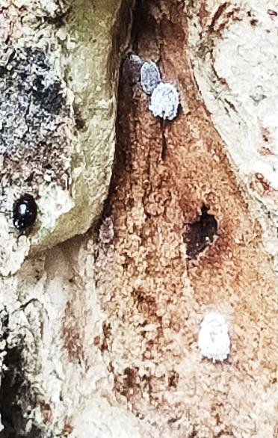
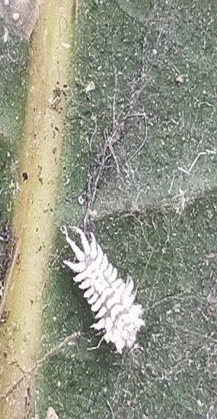
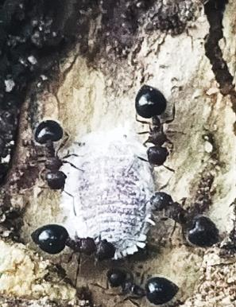
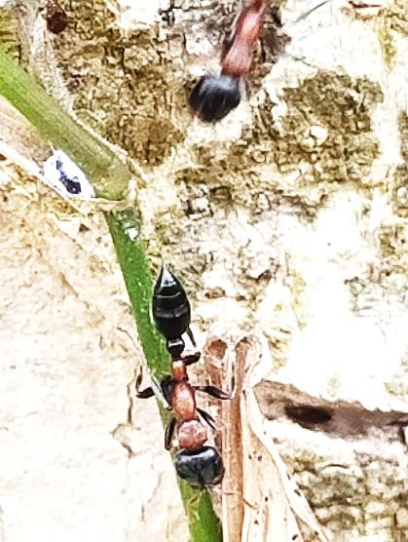
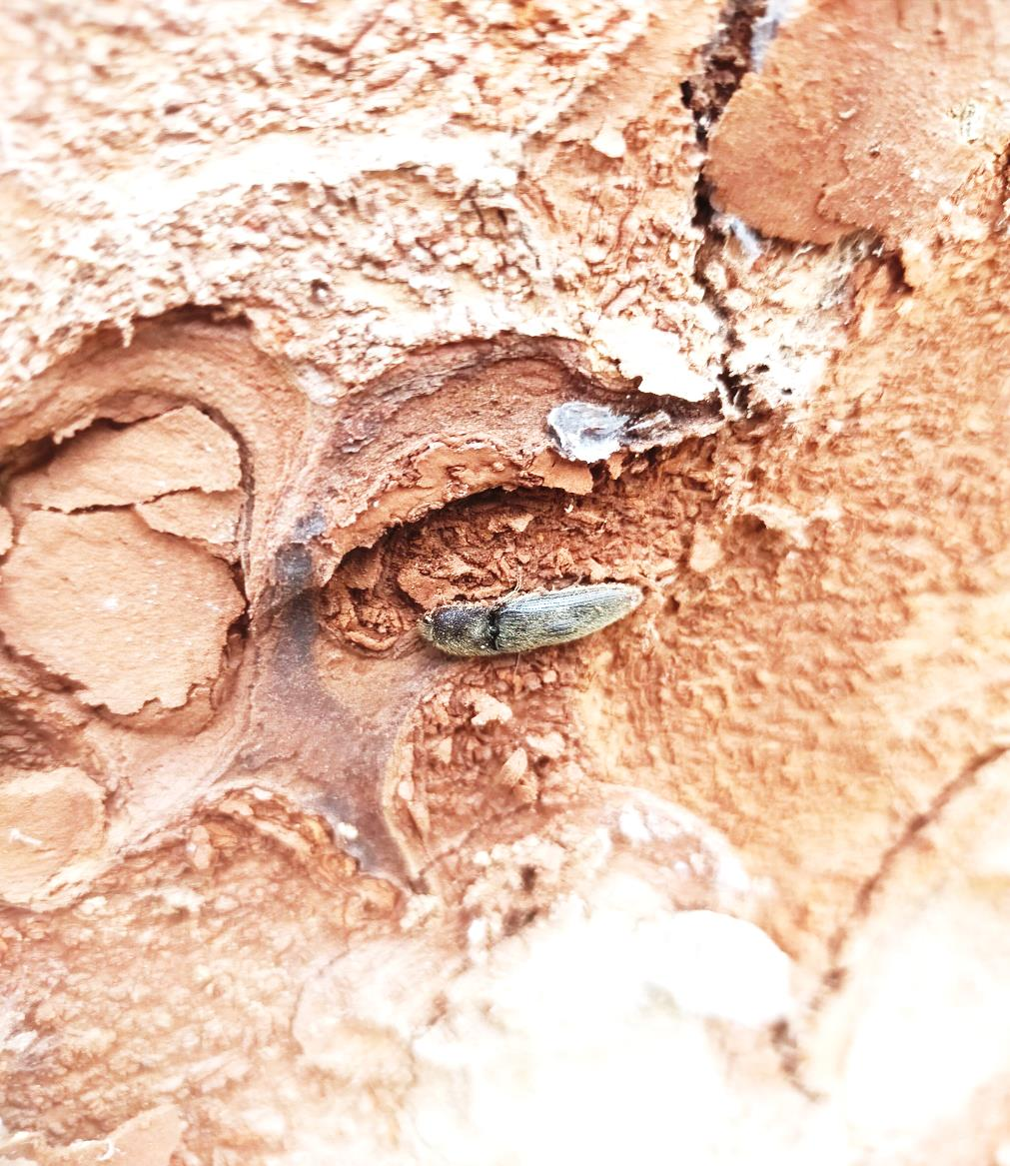
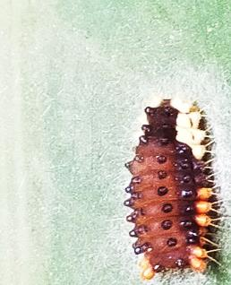
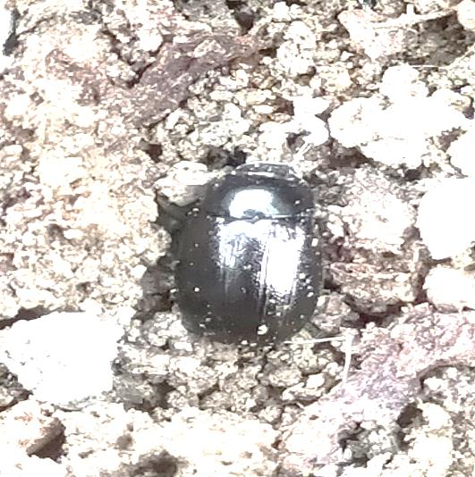
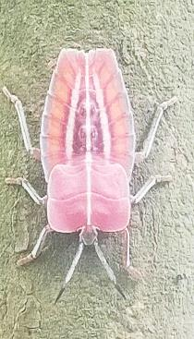
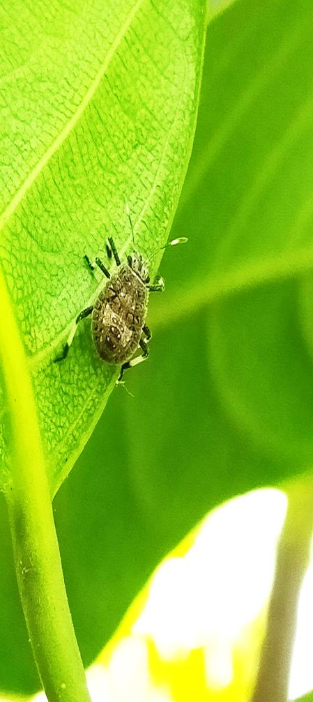
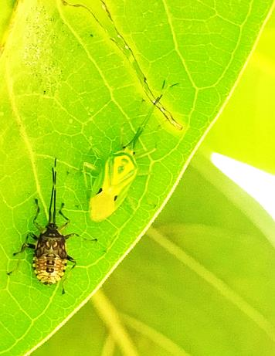
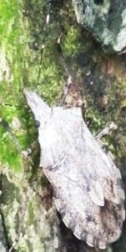
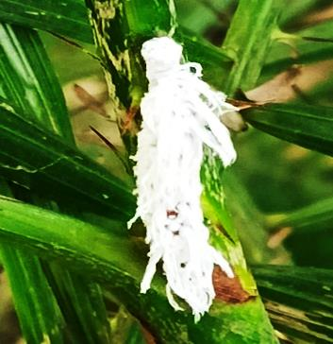
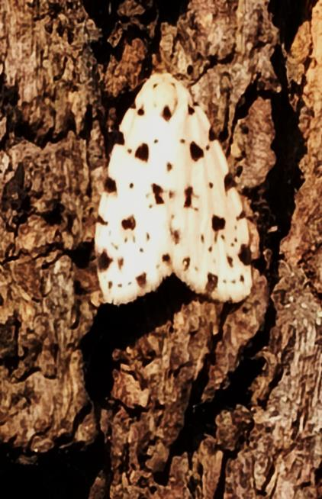
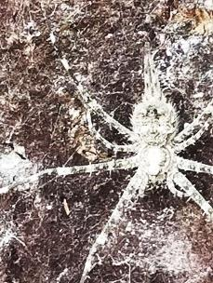
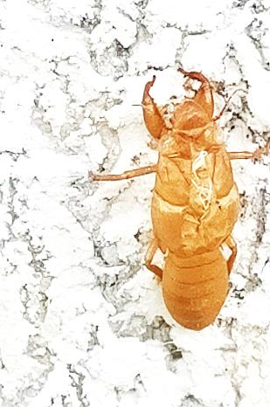
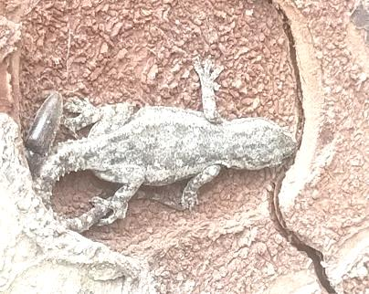
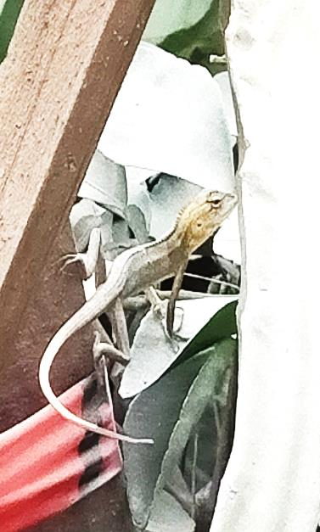
Plate 3 Various organisms available with P. ferox: a-b Ants (C. cerasi, C. vicinus); c-g Beetles (Coccinellidae, C. montrouzieri larva, Melanotus sp., Ladybird beetle larva, Apogonia sp. respectively); h-l Sting bug (T. papillosa, 4th instar nymph of H. halys, U. histrionica, Pentatomidae, Brochymena sp. respectively); m Caterpillar (G. thyrsis); n Moth (S. guttulosana); o Two Tailed Spider’s camouflage; p Cicada wasp exuviae (Specius sp.); q C. versicolor (camouflage with bark); r Hemidactylus sp. (Camouflage with bark)

a
b
c
d
e
f
g
h
i
j
k
l
m
n
o
p
q
r

