Table 1.Demographic comparison between the two groups
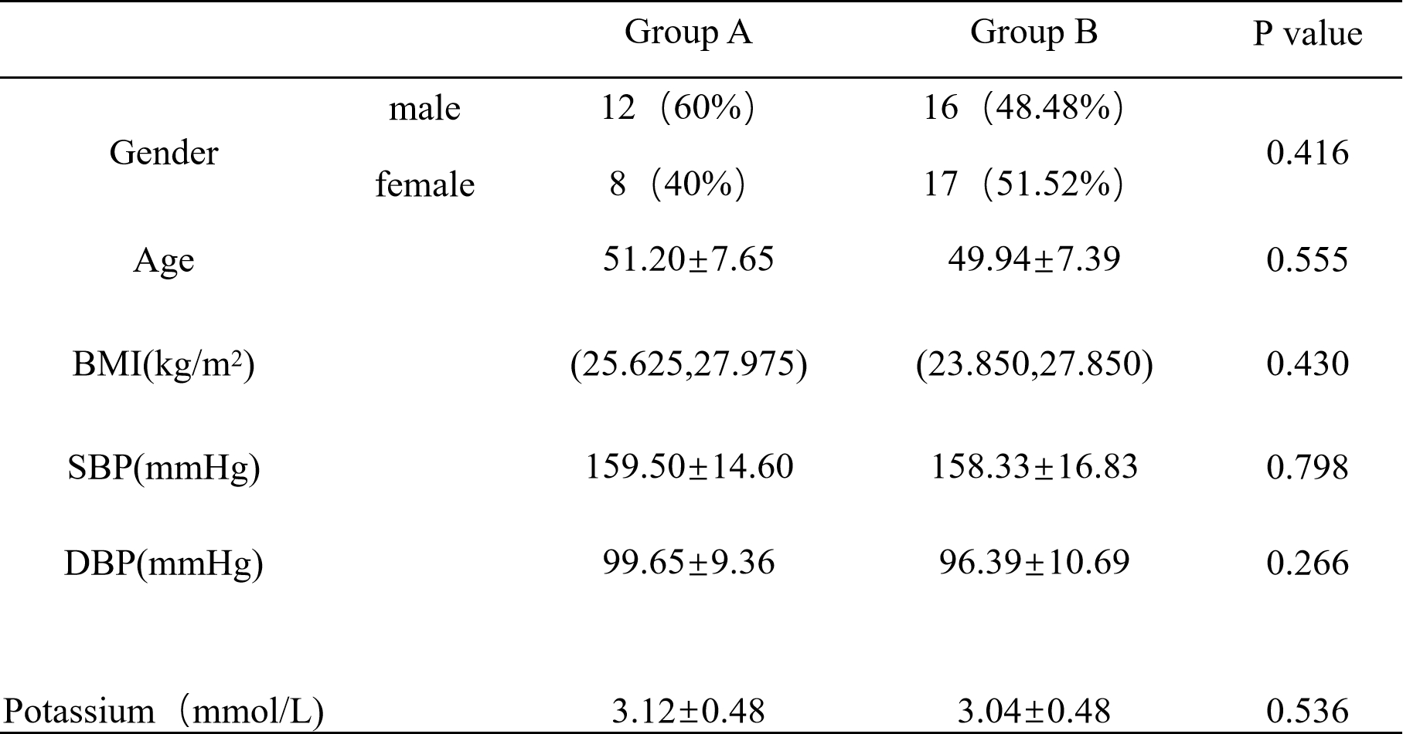

Table 2. Preliminary screening test results for both groups
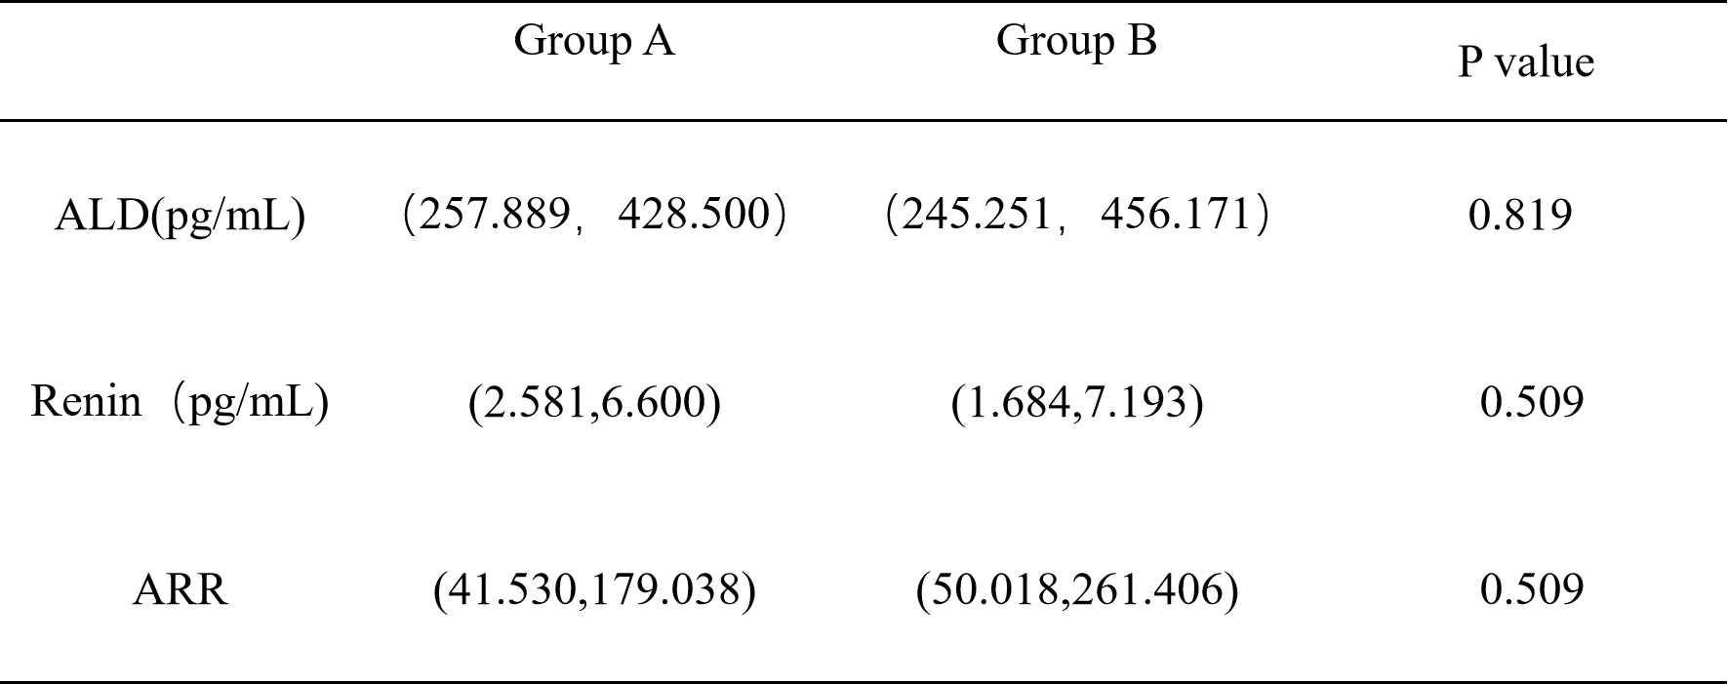
Table 3.Comparison of AVS results of the right adrenal vein between the two groups
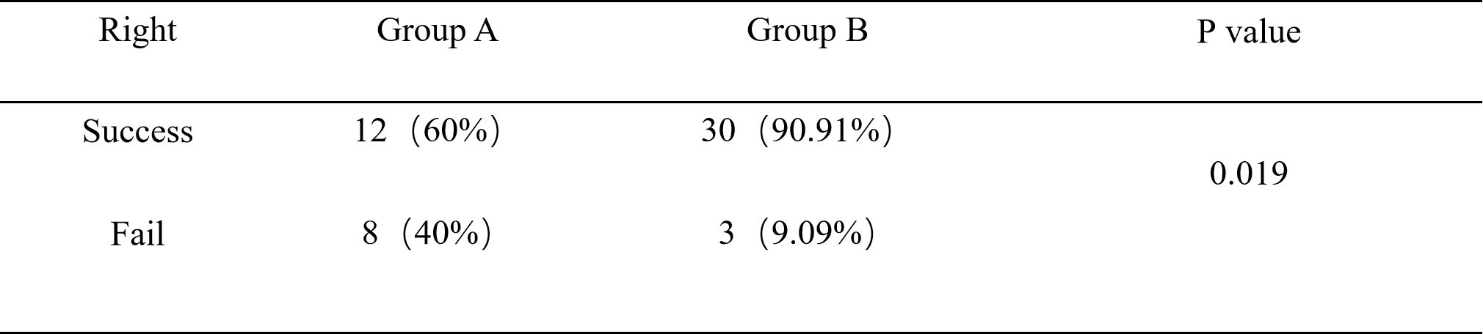
Table 4.Comparison of AVS results of the left adrenal vein between the two groups
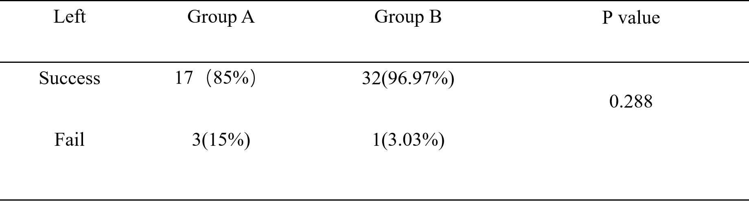
Table 5.The selection index, subtype, consistency between AVS results and CT results, and clinical treatment decisions were compared between the two groups
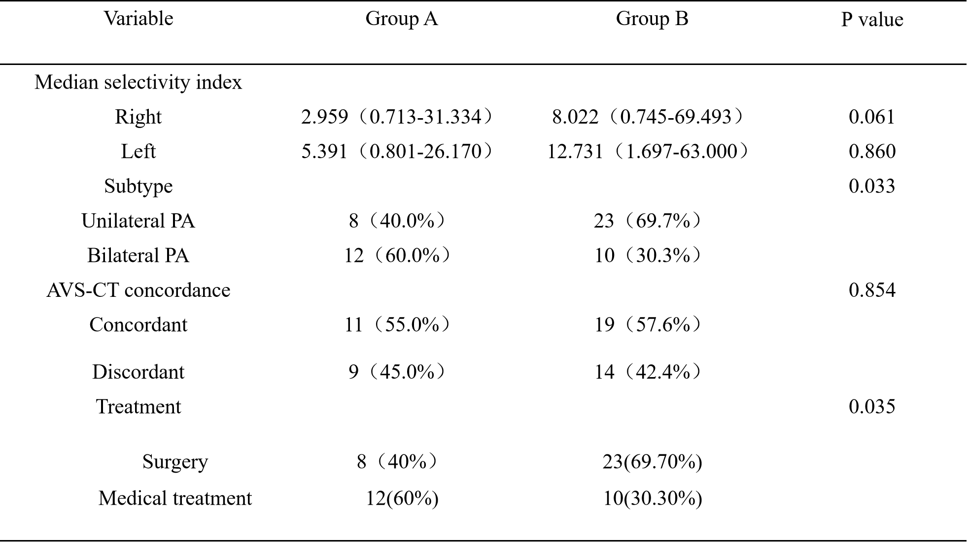

Tbale 6.The radiation dose, operation time and contrast agent dosage were compared between the two groups
