Appendix A: Analytical Diagrams
Figure A1: Venn Diagram of Research Topic Overlaps (2015–2025)
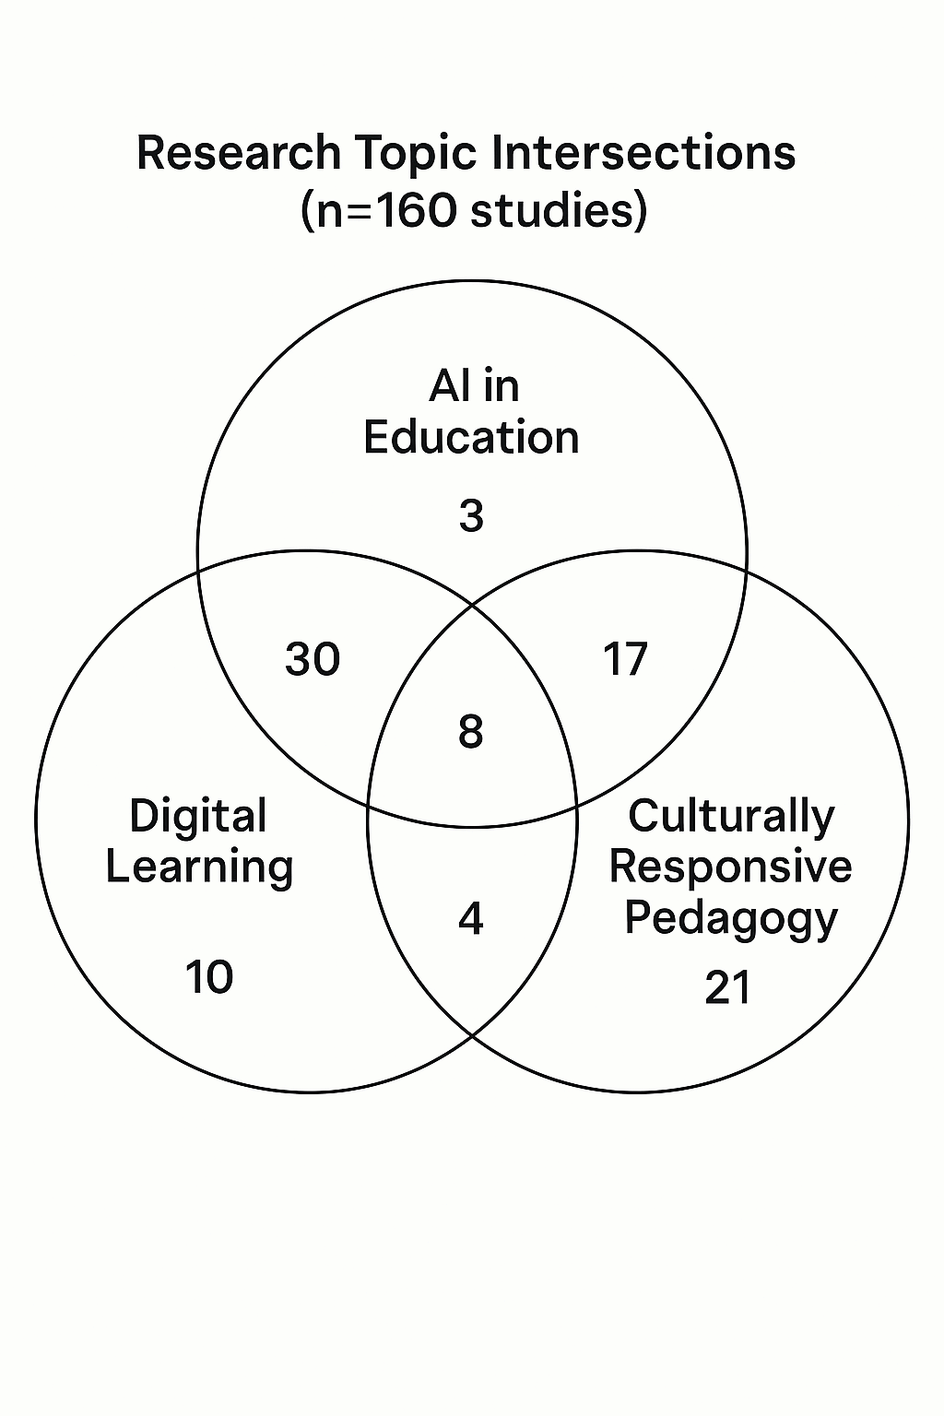
Caption: Proportional overlap between key research themes. Circle sizes reflect publication volume. The central intersection (8%) represents studies addressing all three themes simultaneously.
Recommended Export: 600 dpi TIFF/PDF with editable vector layers (for journal formatting).
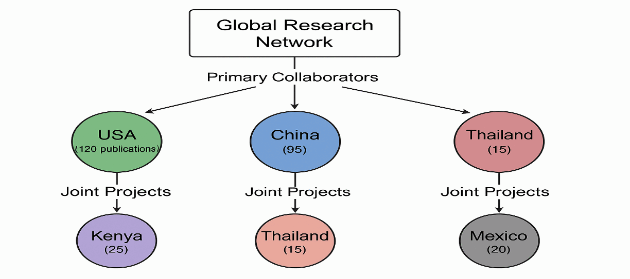
Figure A2: Geospatial Collaboration Network

Caption: International research partnerships. Node sizes correspond to publication output, with line weights indicating collaboration intensity. Color coding:
- Green: High-output countries (>100 publications)
- Purple: Emerging research regions (<30 publications)
Recommended Formatting:
- Include coordinate metadata (Lat/Long) for GIS compatibility
- Add scale bar and legend in final version

