Supplementary Information

Volcanism and basalt weathering drove Ordovician climatic cooling

He Zhao¹, Lei Zhang²*, Thomas J. Algeo^{2, 3, 4, 5}, Zhengyi Lyu², Xiangdong Wang², Fang Hao⁶

¹ College of Marine Science and Technology, China University of Geosciences, Wuhan 430074, China
² State Key Laboratory of Geological Processes and Mineral Resources, China University of Geosciences, Wuhan 430074, China
³ State Key Laboratory of Biogeology and Environmental Geology, China University of Geosciences, Wuhan 430074, China
⁴ Department of Geosciences, University of Cincinnati, Cincinnati, OH 45221-0013, USA
⁵ State Key Laboratory of Oil and Gas Reservoir Geology and Exploitation, Chengdu University of Technology, Chengdu 610059, China
⁶ National Key Laboratory of Deep Oil and Gas, China University of Petroleum (East China), Qingdao, Shandong, 266580, China

*Corresponding author: zhanglei_cug@sina.com (Lei Zhang)

This PDF file includes:

Supplementary Text S1 to S5

Figs. S1 to S7

References

Data S1. Element content and their ratios of study samples.
Data S2. Hg isotopes of study samples.
Data S3. In-situ oxygen isotopes of conodont samples.
Data S4. In-situ oxygen isotopes of international reference materials Durango during SIMS analysis.
Data S5. In-situ strontium isotopes of conodont samples.
Data S6. Linear sedimentation rate of the study sections.

Text S1 Preservation of conodont oxygen isotopes
The color alteration indices (CAI) of the study specimens range from 1 to 3, indicating limited thermal alteration in the bioapatite structure and its oxygen isotopic composition¹⁻⁷. Besides, the densest albid crown of each specimen was selected for the oxygen isotopic analyses to minimize tissue-related effects^{1,2}. The newly generated δ¹⁸O_{conodont} curve exhibits positive excursions of ~2-3‰ during the LFCE and LDCE, which are consistent with global published data^{2,3,6} (Fig. 1A).
Another factor may be a major change of conodont taxa and their preferred habitats through the study interval. For conodont taxa, there is a shift in dominance from Drepanodus sp. in the Lower Ordovician to more diverse genera (including Drepanoistodus sp., Scolopodus sp., Pesiodus sp., Tripodus sp., and Pasoistodus sp. in the Middle Ordovician, followed by a return to more limited diversity dominated by Belodella sp. in the Upper Ordovician (Fig. S3A). Drepanodus sp. lived in the surface mixed layer of continental shelf watermasses⁸ and was more widely distributed geographically than Drepanoistodus sp., which inhabited deeper subtidal areas⁹. Scolopodus generally lived nearby carbonate shoals of inner to outer platform facies¹⁰, Periodon was most abundant in slope and outer platform deposits, and species such as Tripodus laevis were typical of shallow-marine inner-shelf facies¹¹. Pasoistodus sp. was adapted to cold and/or deep waters, being found mainly in outer-platform deposits¹⁰. Belodella sp. was relatively small and lived in ecologically restricted, shallow inner-shelf settings. Overall, there is a change toward deeper-water habitats correspond to decline in conodont-based SSTs, potentially accounting for the observed increase of ~4‰ in the δ¹⁸O_{conodont} profile during the Early to Middle and Middle to Late Ordovician. However, given that our newly generated δ¹⁸O_{conodont} profile matches global data well (Fig. 1A), it is likely that ecological influences were limited and (near-)primary δ¹⁸O_{conodont} signals were preserved in the study sections.
Overall, our newly acquired δ¹⁸O_{conodont} data preserve (near-)primary changes in paleotemperature. The positive excursions of δ¹⁸O_{conodont} record a protracted (25-Myr-long) climatic cooling trend that aligns with global data. This trend occurred in multiple stages, beginning around the Lower/Middle Ordovician boundary (~470 Ma), reinforced around the Middle/Late Ordovician boundary (~460 Ma), and culminating in the Hirnantian Glaciation (~445-444 Ma).

Text S2 Preservation of mercury isotopes
The preservation of primary Hg isotope signatures in these sections is supported by multiple lines of evidence. Experimental constraints demonstrate that Hg-MDF and -MIF values remain stable below ~250°C, with pressure enhancing Hg retention in sediments, and temperatures >250°C may induce δ²⁰²Hg enrichment (>0.1‰) through preferential light isotope loss, while MIF signatures persist even at 800°C^{12,13}. For the study samples, burial temperature < 200°C was revealed from 1 to 3 in CAI values for conodont taxa from the study sections¹⁴, suggesting limited thermal alterations of Hg isotopes. This thermal resilience validates the Hg-MDF and -MIF signals in study sections as primary seawater records. In addition, diagnostic consistency also emerges from: 1) Strong covariations between δ²⁰²Hg and Δ¹⁹⁹Hg across the Middle-Upper Ordovician (Fig. S5), patterns incompatible with temperature/pressure-driven remobilization^{12,13}; 2) Stratigraphic coherence between Hg isotope cyclicity and independent proxies (δ¹⁸O_{conodont} and ⁸⁷Sr/⁸⁶Sr _{conodont}) from equivalent horizons (Fig. 1), whose synchronicity was attributed to depositional rather than diagenetic controls.

Text S3 Regional seawater redox conditions
We explore changes in regional seawater redox conditions using C_{org}/P ratios and U_{EF} and Mo_{EF}. C_{org}/P ratios are particularly valuable for evaluating redox conditions in carbonate facies, where the scarcity of organic matter generally restricts absorption of trace metals, with values of <50, ∼50–100, and >100 indicative of oxic, suboxic, and anoxic environments, respectively¹⁵. Under reducing conditions, U and Mo remain insoluble and are preferentially enriched in the sediment (¹⁶ and references therein). In comparison, the enrichment of U begins at the Fe(III)/Fe(II) redox threshold, which corresponds to suboxic conditions. Meanwhile, Mo becomes reactive and binds to particles in the presence of aqueous hydrogen sulfide, indicating euxinic conditions. As a result, under suboxic to anoxic conditions, we observe lower U_{EF} and Mo_{EF} values, approximately 3–10 and 5–50 respectively, while under euxinic conditions, these values are significantly higher, exceeding 10 and 50 respectively.
In the present study, stratigraphic variations in U_{EF} and Mo_{EF} values decrease from relatively higher values ~5–45 and ~20–100, respectively, at 0–75 m, to < 15 for both proxies at 100–175 m, suggesting an overall improvement in seawater oxidation conditions, from dominantly anoxic-sulfidic conditions during the early Tremadocian to oxic-suboxic conditions during the late Tremadocian (Fig. S4F-G). Subsequently, U_{EF} and Mo_{EF} values increase to ~5–15 and ~20–30, respectively, at ~190-210 m, implying gradually shifted in seawater redox states to anoxic-suboxic conditions during the Floian. Both U_{EF} and Mo_{EF} values shifted to lower values (mostly < 3) at ~210-300 m, indicating a gradual shift to an oxic state during early Dapingian and a maintenance of the oxic state during the remaining Dapingian to the middle Katian. Both U_{EF} and Mo_{EF} values show larger fluctuations, ~5–60 and ~5–120, respectively, at the Ordovician-Silurian transition, suggesting a more reducing seawater to anoxic-sulfidic conditions during the LOME. The overall pattern of oceanic oxygenation during the Early to Late Ordovician is further supported by a decreasing trend in C_{org}/P profile from ~50 to <10 mol/mol in the Nanjinguan to Honghuayuan formations, and overall low values <10 mol/mol in the Dawan to Linxiang formations (Fig. S4H).

Text S4 ⁸⁷Sr/⁸⁶Sr reveals hydrothermal versus granite weathering fluxes
The ⁸⁷Sr/⁸⁶Sr_{conodont} profile of the present study is consistent with coeval data from Laurentia (United States)¹⁷ and a global database¹⁸, marked by an initial value of ~0.709 with a slightly decreasing trend during the earliest Tremadocian to middle Darriwilian, followed by an accelerated decline during the late Darriwilian to late Sandbian, stabilizing at ~0.708 in the Katian.
Continental weathering and marine hydrothermal activity are the dominant influences on seawater ⁸⁷Sr/⁸⁶Sr composition. The ⁸⁷Sr/⁸⁶Sr proxy is commonly used to infer the relative inputs of mantle versus continental crustal strontium¹⁷. The marine hydrothermal flux lowers seawater ⁸⁷Sr/⁸⁶Sr, whereas the continental weathering flux increases it, depending on the type of rock being weathered. If granitic sources are dominant, the input flux from continental weathering will elevate seawater ⁸⁷Sr/⁸⁶Sr values, whereas a larger flux from basaltic rocks will decrease them. Furthermore, if there is no major change in the composition of the continental rocks, intensified weathering generally corresponds to rising seawater ⁸⁷Sr/⁸⁶Sr values.
The shift in the type of the exposed terrestrial rocks could have been a determining factor for the decline of ⁸⁷Sr/⁸⁶Sr during the Ordovician. The secular trends of decreasing ⁸⁷Sr/⁸⁶Sr suggest slightly stronger hydrothermal versus granite weathering fluxes into the ocean during the Tremadocian to middle Darriwilian, intensification hydrothermal versus granite weathering fluxes during the late Darriwilian to late Sandbian, and a steady condition during the late Sandbian to late Katian⁵. Hg geochemistry in this study indicates that volcanic activity was relatively subdued in the Early Ordovician but began to escalate during the Early-Middle Ordovician, which may reflect minor exposure of basalt during the Early Ordovician, followed by a pronounced increase at the transition to the Middle Ordovician, offering a coherent explanation for the two distinct declines in amplitude of marine ⁸⁷Sr/⁸⁶Sr records.

Text S5 Early land plant evolution in the Ordovician
Spatiotemporal changes of the earliest plants during the Ordovician were reviewed by¹⁹: (1) Earliest cryptospores from the Zanjon Fm of Argentina, dating to the Dapingian (early Middle Ordovician) at ~470-467 Ma; Slightly younger cryptospore finds from the Czech Republic (mid-Darriwilian; ~464 Ma) and Saudi Arabia (late Darriwilian; ~460 Ma); Other younger cryptospore comes from Sweden (Katian) in the Baltica; The oldest known glomalean fungus is from Wisconsin, dating to the late Sandbian (~454 Ma); The oldest known mesofossils of sporangia are from the Ghaba-1 borehole in Oman and Saudi Arabia, dating to the mid-Katian (~449 Ma); The oldest known laevigate trilete spores are from Turkey, dating to the Hirnantian (~445 Ma). Although the fossil record of early bryophytes is highly incomplete, these finds suggest that bryophytes appeared around the beginning of the Middle Ordovician and subsequently spread and diversified during the Middle to Late Ordovician, establishing a community of photosynthesizers and decomposers by the end of the Ordovician.

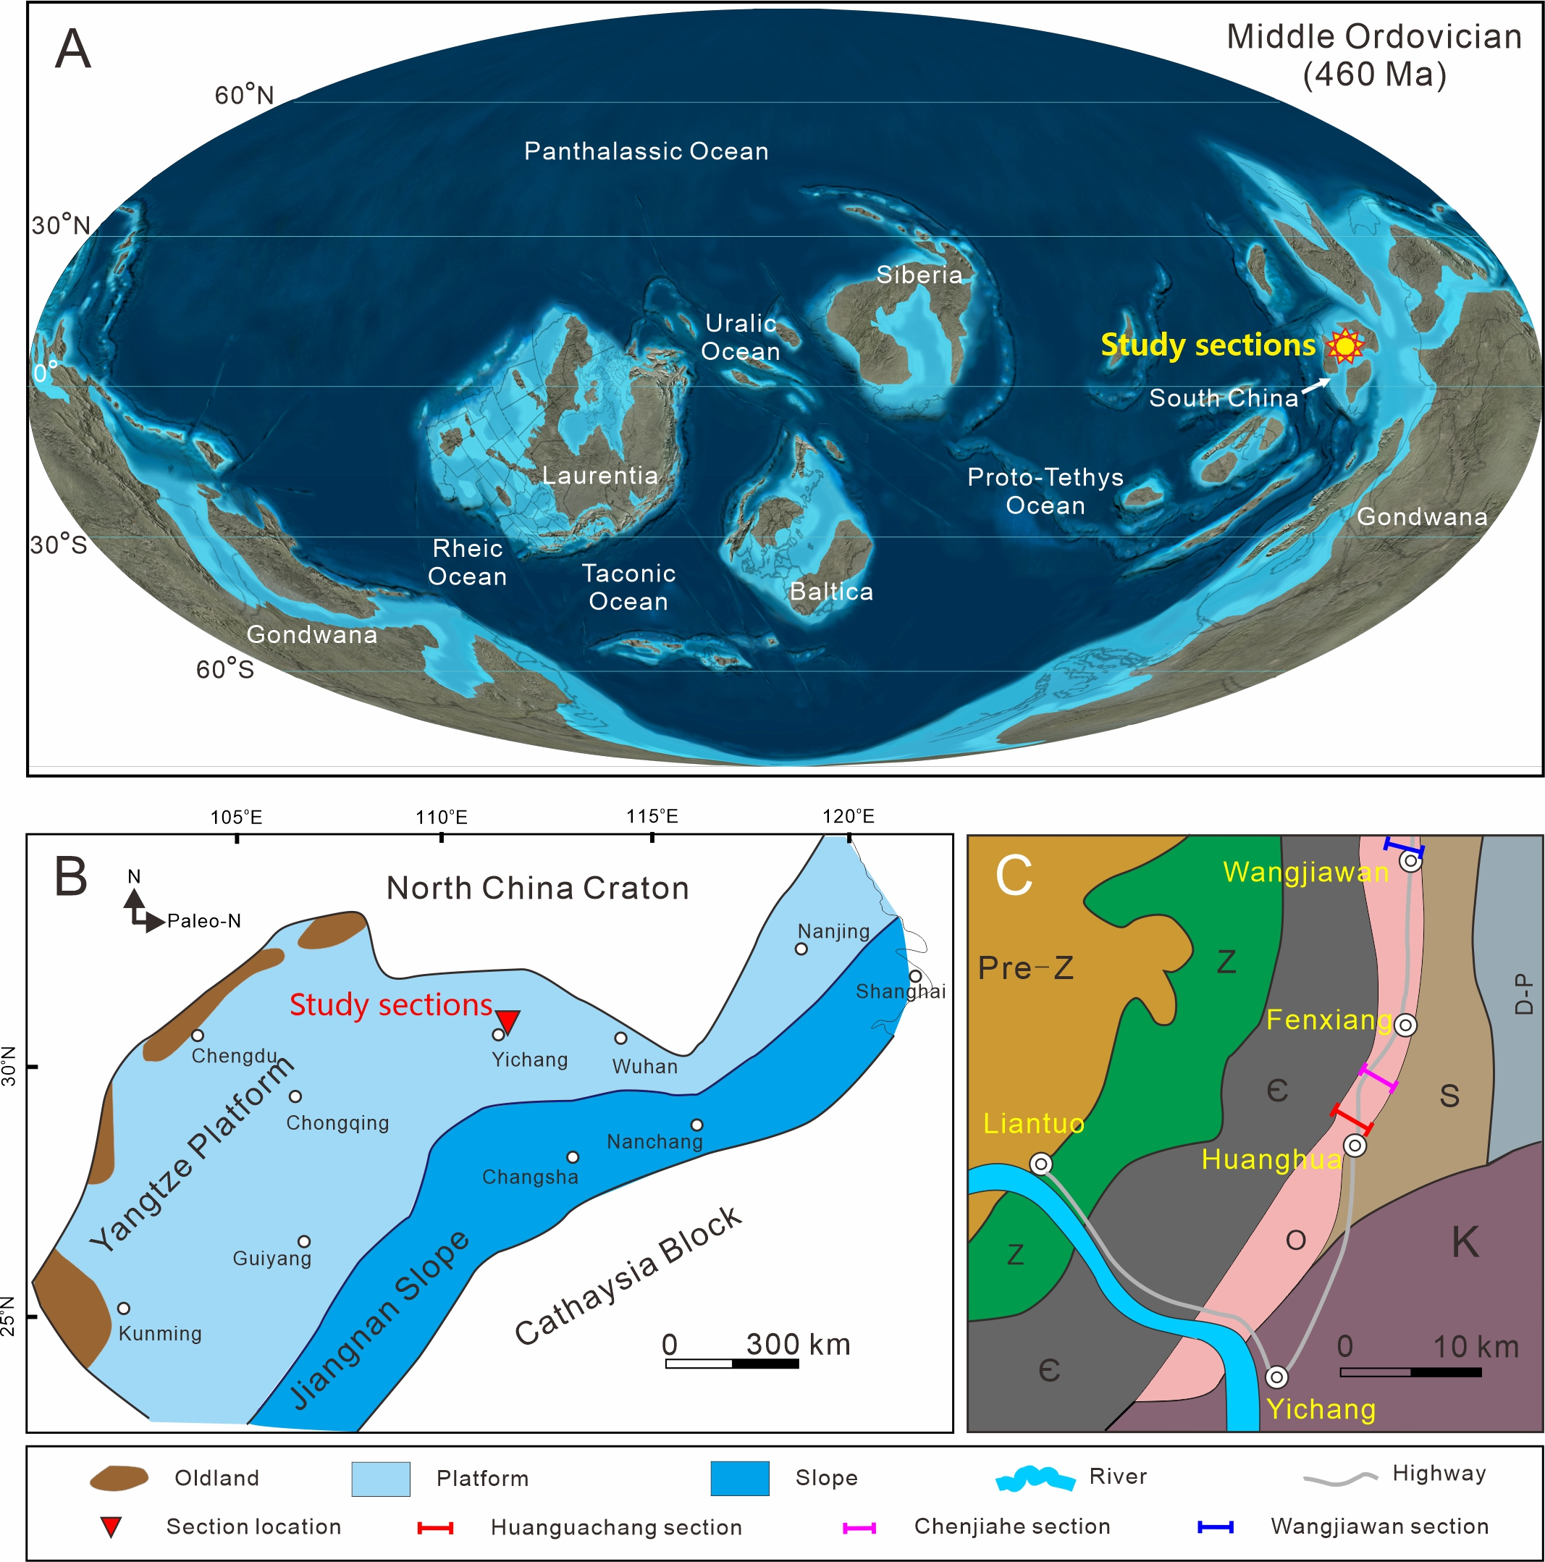

Figure S1. Location of study sections. (A) Paleogeographic maps of the Middle Ordovician world showing the location of the study sections. (B) Early to Middle Ordovician paleogeography of the South China Craton; (C) Geological map of Yichang area, showing the locations of the Huanghuachang, Chenjiahe and Wangjiawan sections. Panel A is from https://deeptimemaps.com authorized by Colorado Plateau Geosystems Inc. Panels B and C is modified from¹⁴. Z = Sinian, Є = Cambrian, O = Ordovician, S = Silurian, D = Devonian, P = Permian, K = Cretaceous.

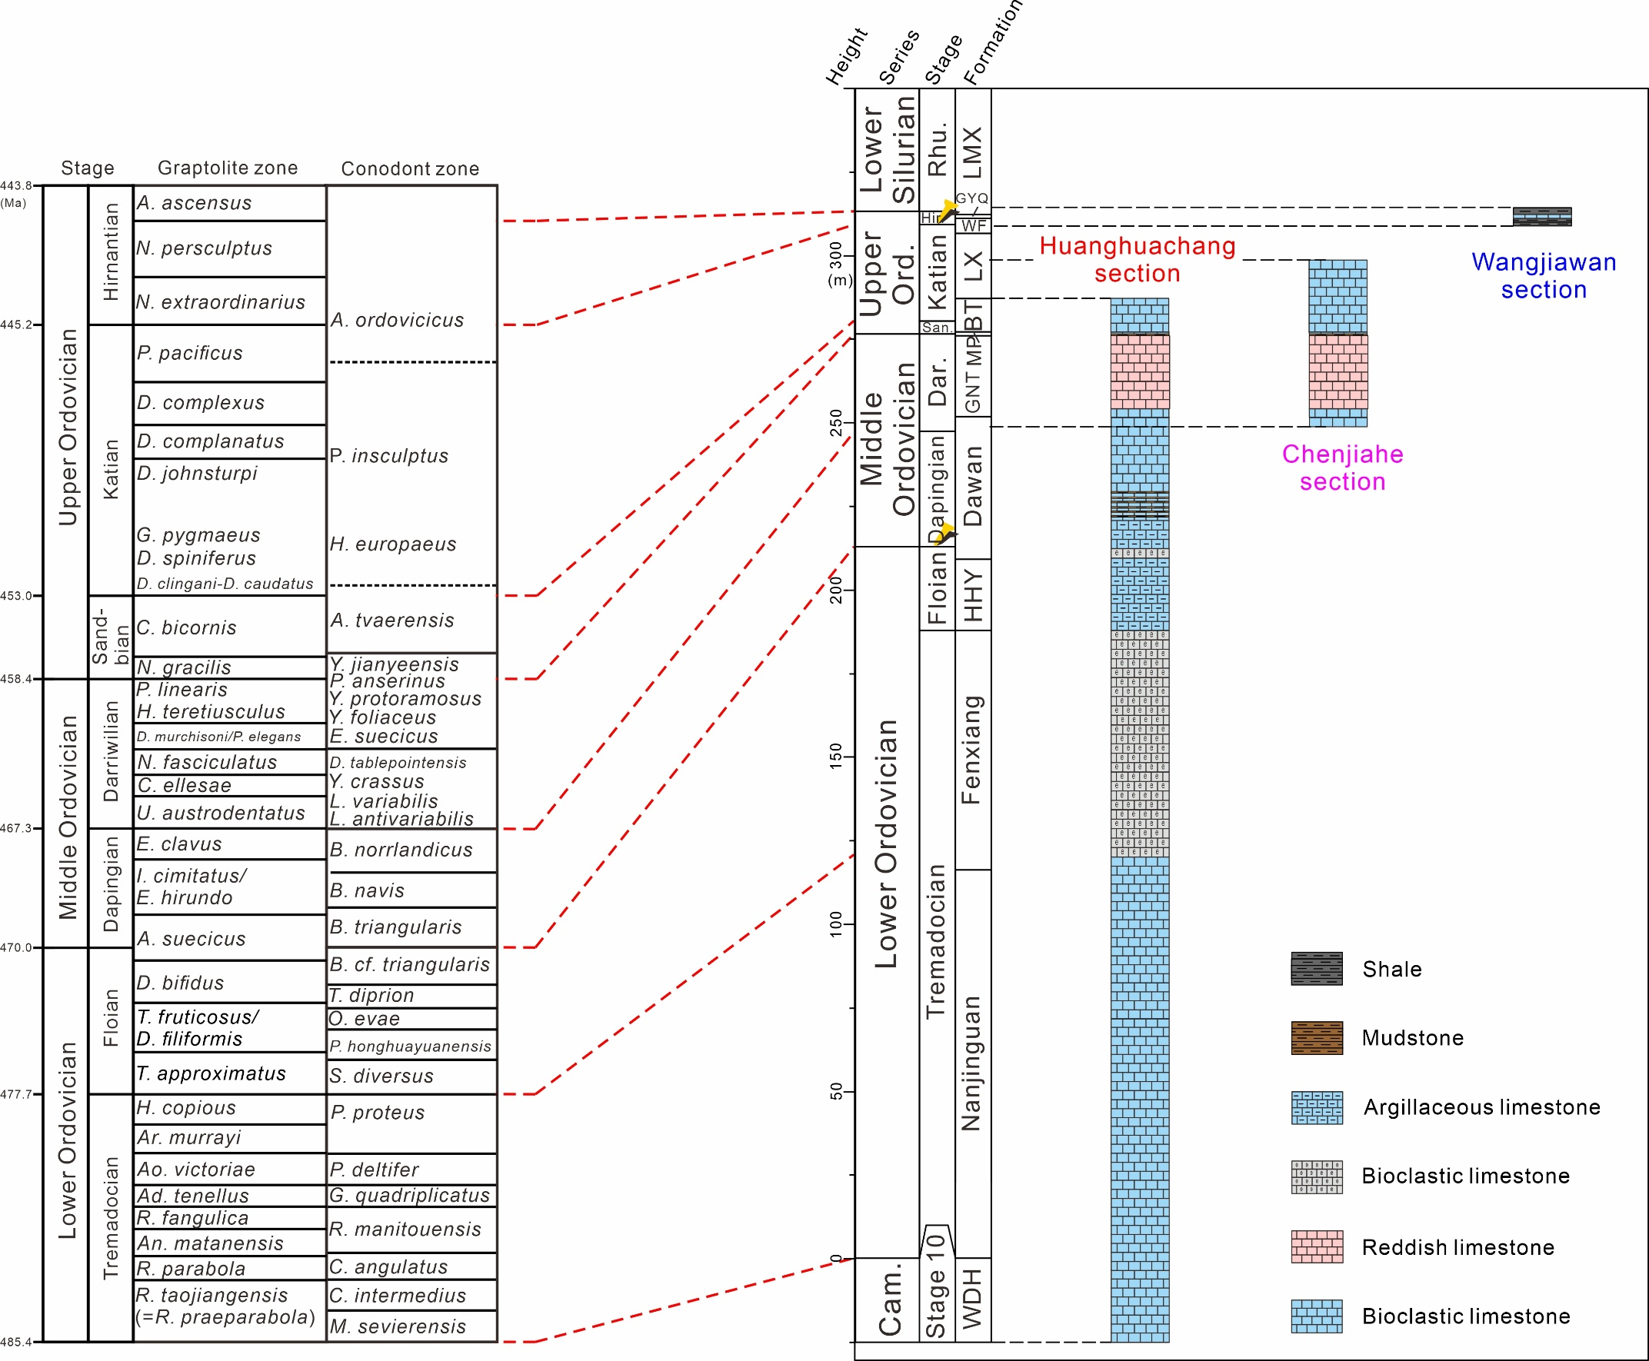

Figure S2. Biozonation and lithostratigraphy of the Huanghuachang, Chenjiahe and Wangjiawan sections. Data comes from¹⁴ and references therein. Cam. = Cambrian; Dar. = Darriwilian; Hir. = Hirnantian; Ord. = Ordovician; San. = Sandbian; HHY = Honghuayuan; GNT = Guniutan; MP = Miaopo; BT = Baota; LX = Lingxiang; WF = Wufeng; GYQ = Guanyinqiao. The “Golden Spikes” show the locations of GSSPs in the Huanghuachang and Wangjiawan sections.
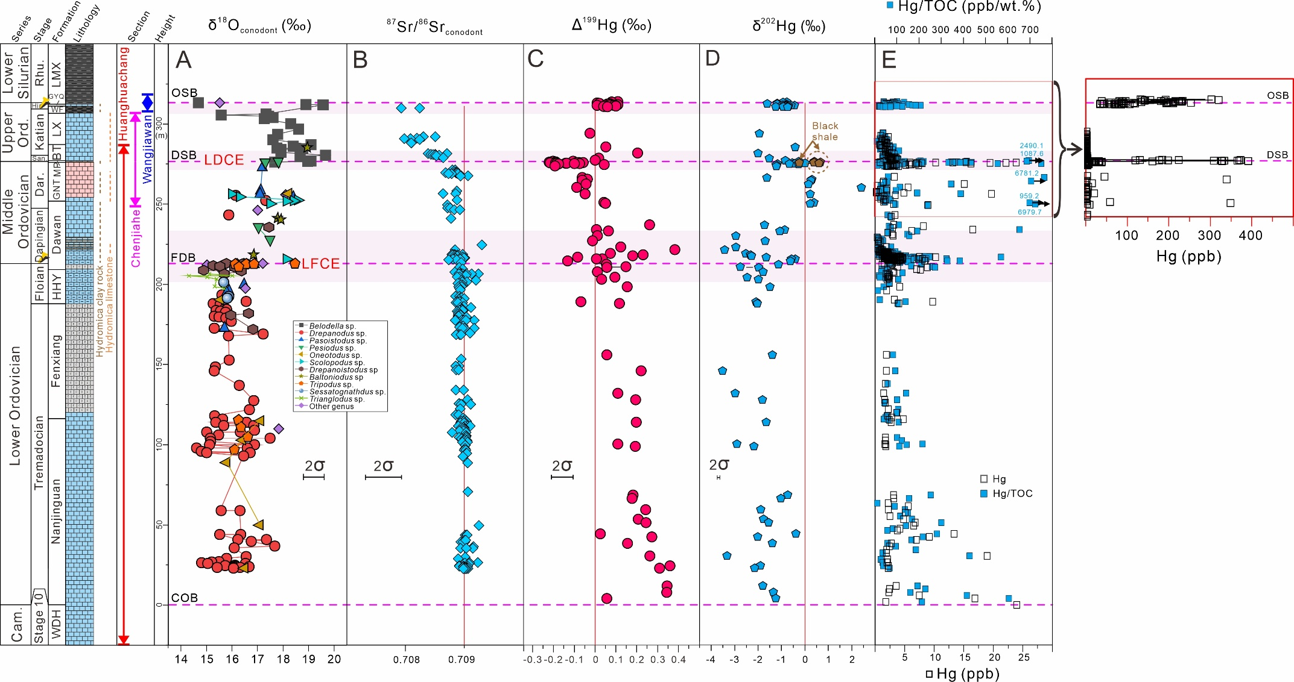

Figure S3. Geochemical profiles of study sections. (A) In-situ oxygen isotope of conodont (δ¹⁸O_{conodont}). (B) In-situ strontium isotope of conodont (⁸⁷Sr/⁸⁶Sr_{conodont}). (C-D) Mercury isotopes (Δ¹⁹⁹Hg and δ²⁰²Hg). (E) Hg content and its ratio to total organic carbon (Hg/TOC). COB = Cambrian-Ordovician boundary; FDB = Floian-Dapingian boundary; DSB = Darriwilian-Sandbian boundary; OSB = Ordovician-Silurian boundary. About a third of Hg/TOC data of upper part of Honghuayuan to Longmaxi Formation, and all Δ¹⁹⁹Hg and δ²⁰²Hg data of Wangjiawan section source from²⁰ (Supplementary Data). Light pink fields represent cooling episodes as revealed from Figure 1: LFCE = Late Floian cooling event, LDCE = Late Darriwilian cooling event.

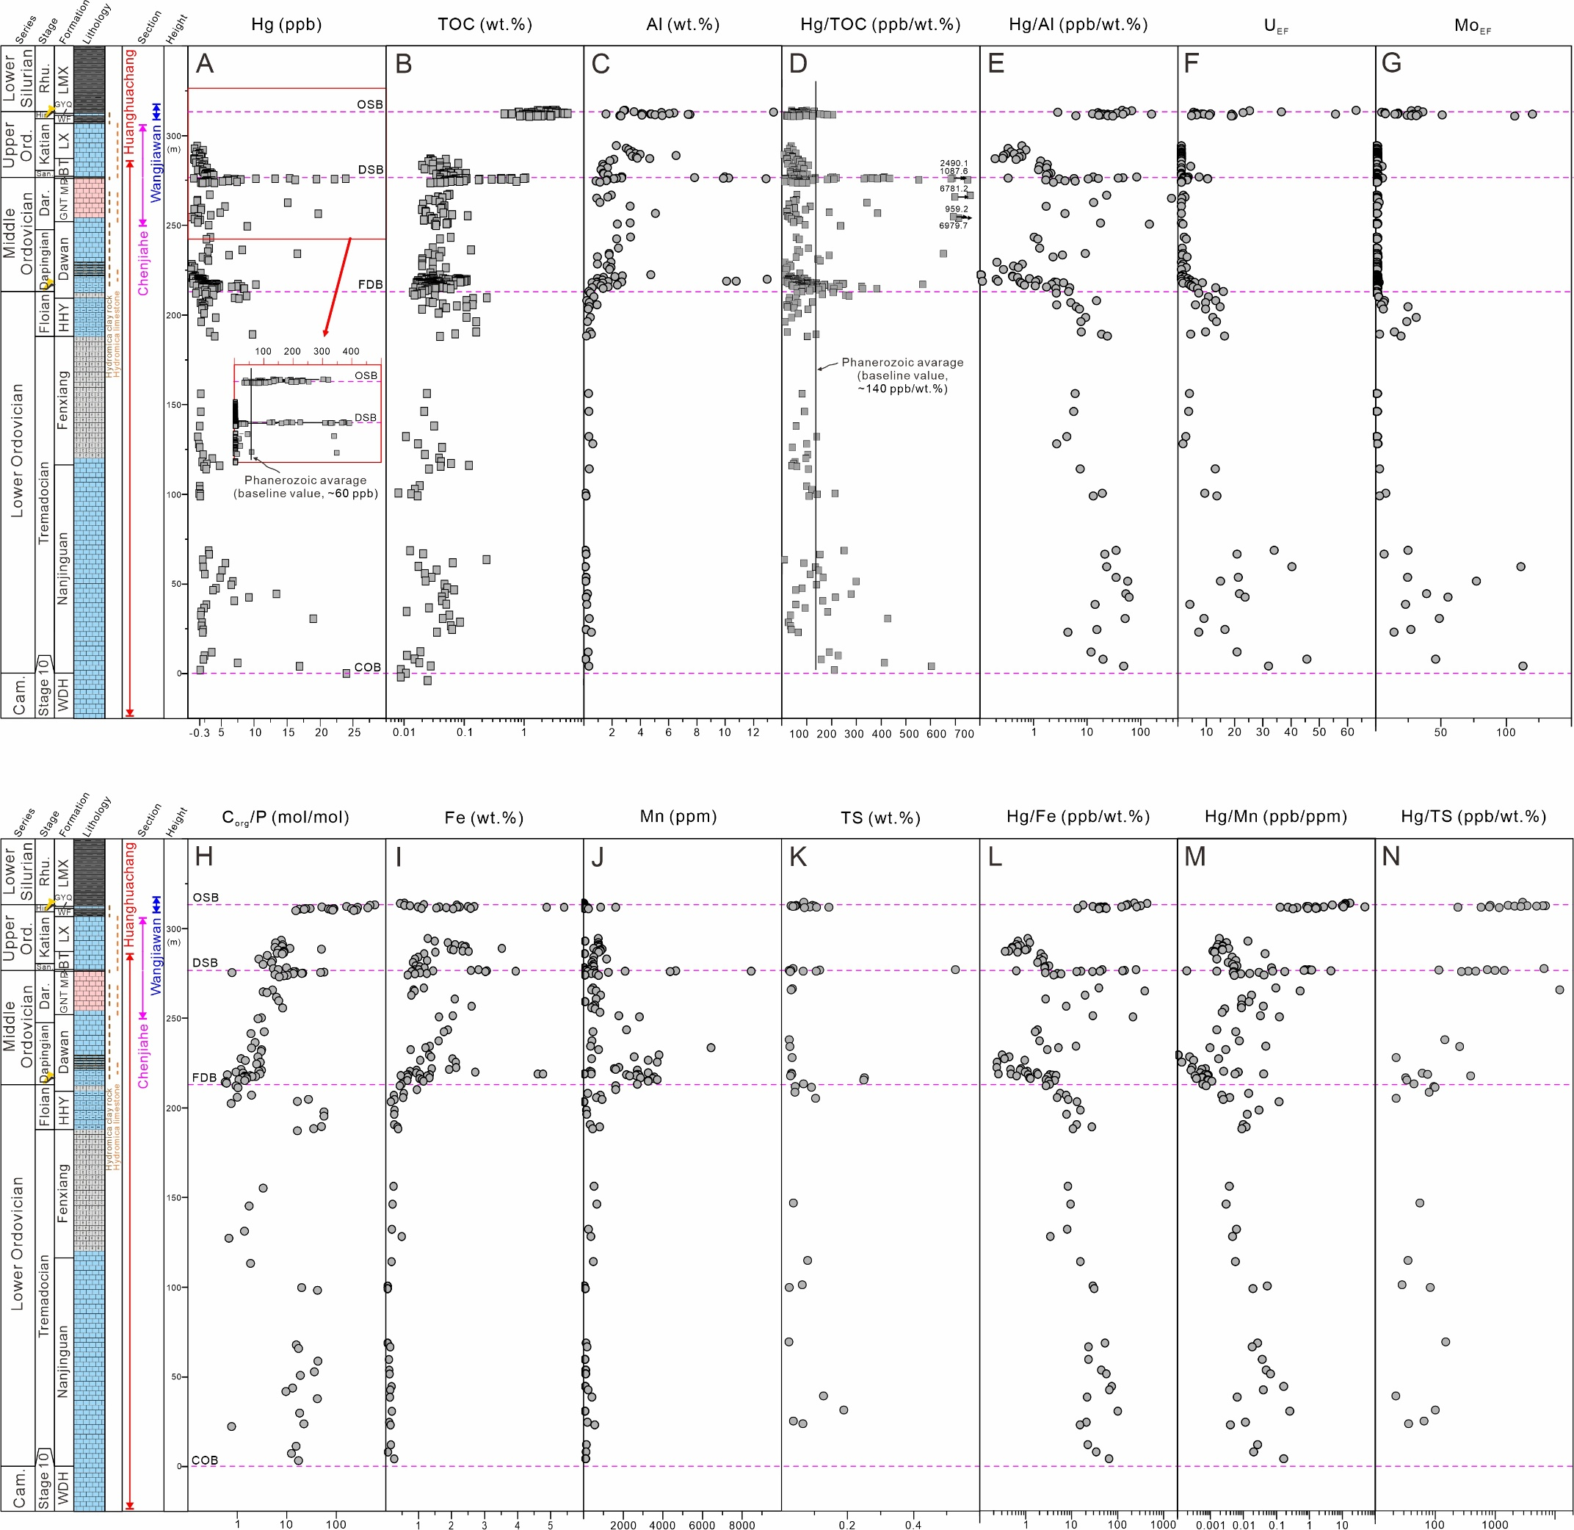

Figure S4. Geochemical profiles of the study sections. (A) Mercury content (Hg, ppb); (B) total organic carbon content (TOC, wt.%); (C) aluminum content (Al, wt.%); (D) ratio of mercury to total organic carbon content (Hg/TOC, ppb/wt.%); (E) ratio of mercury to aluminum content (Hg/Al, ppb/ wt.%); enrichment factors of (F) uranium (U_{EF}) and (G) molybdenum (Mo_{EF}); (H) ratio of organic carbon content to phosphorus content (C_{org}/P, mol/mol); (I) iron content (Fe, wt.%); (J) manganese content (Mn, wt.%); (K) total sulfur content (TS, wt.%); (L) ratio of mercury to iron content (Hg/Fe, ppb/wt.%), (M) manganese content (Hg/Mn, ppb/wt.%), and (N) total sulfur content (TS, wt.%). COB = Cambrian-Ordovician boundary; FDB = Floian-Dapingian boundary; DSB = Darriwilian-Sandbian boundary; OSB = Ordovician-Silurian boundary. In panels A and D, Phanerozoic average Hg content (~60 ppb) and Hg/TOC ratio (~140 ppb/%) are adopted as baseline values for evaluation of Hg enrichment episodes²¹.

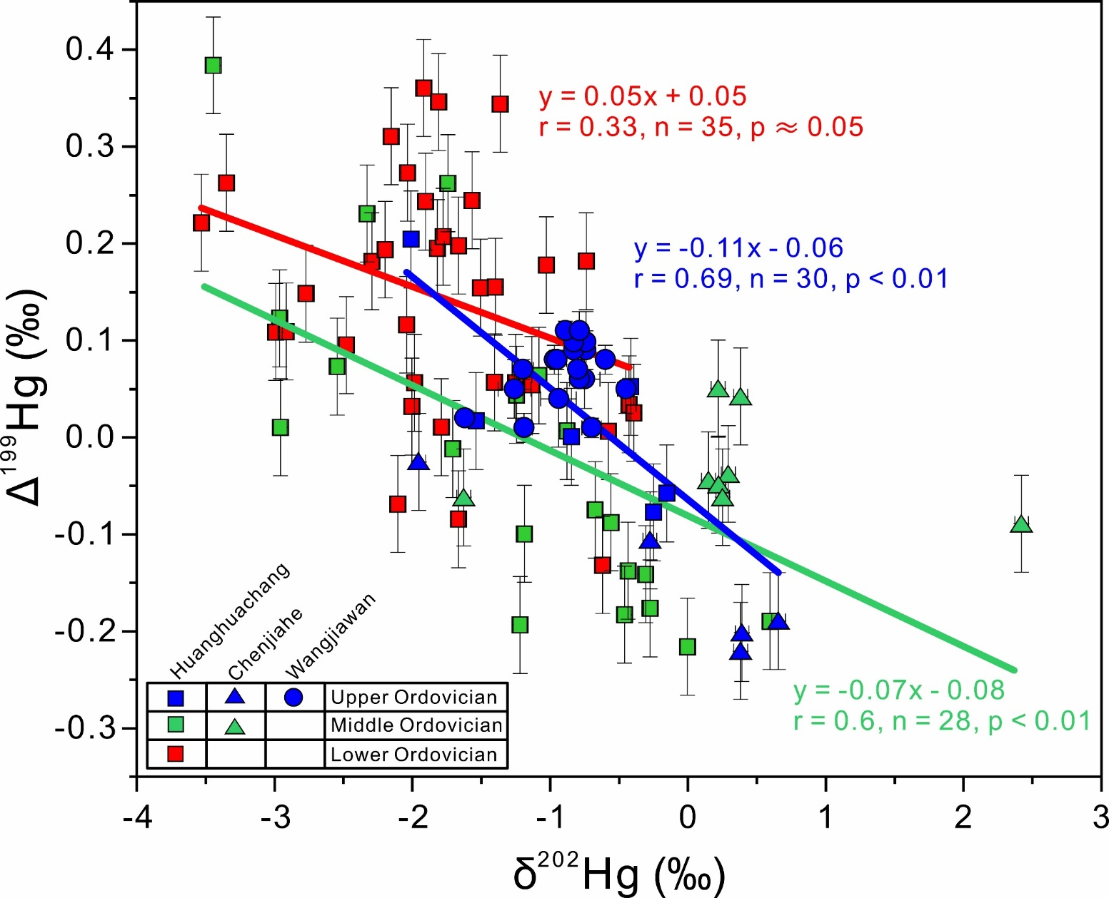

Figure S5. Crossplots of Δ¹⁹⁹Hg vs. δ²⁰²Hg for the study sections. The vertical bars represent standard deviations (2SD) for Δ¹⁹⁹Hg, and 2SD for δ²⁰²Hg is smaller than symbol size. Regression lines are shown in red, green and blue colors for the Lower, Middle and Upper Ordovician, respectively. All Δ¹⁹⁹Hg and δ²⁰²Hg data of Wangjiawan section from²⁰ (Supplementary Data).

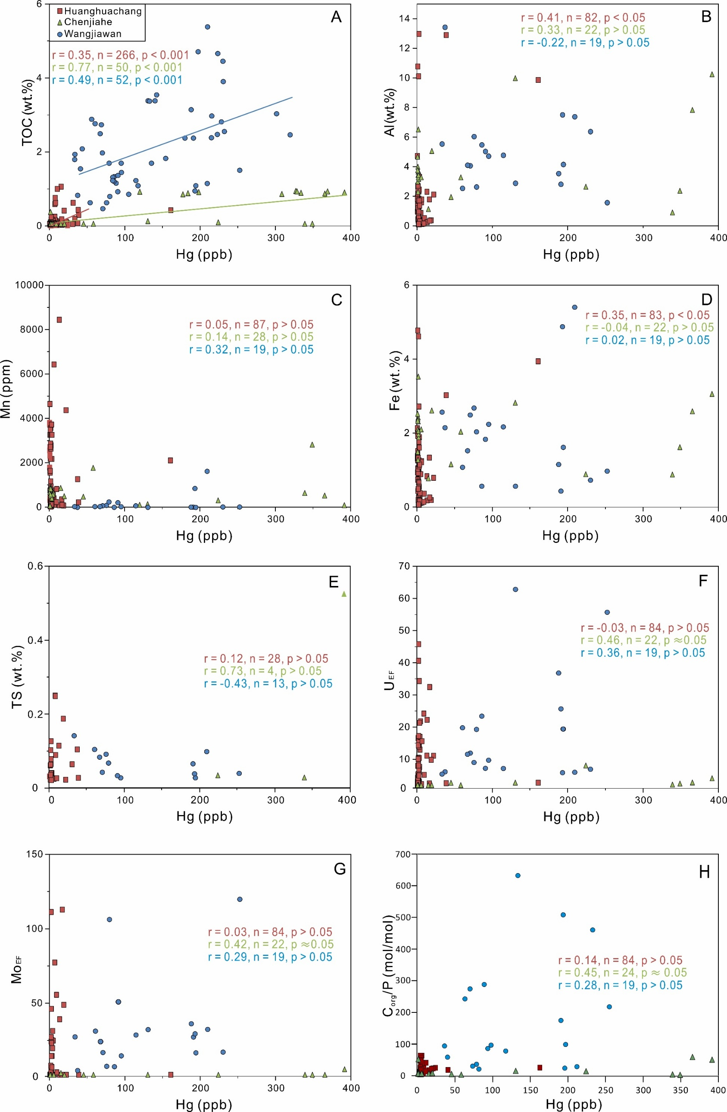
Figure S6. Crossplots of (A) TOC vs. Hg, (B) Al vs. Hg, (C) Mn vs. Hg, and (D) Fe vs. Hg, (E) TS vs. Hg, (F) U_{EF} vs. Hg, (G) Mo_{EF} vs. Hg, and (H) C_{org}/P vs. Hg for the study sections. r represents Pearson’s correlation coefficient, p is the significance level, and n is the number of samples for each site. In panels B and D, the relatively high r values in the Huanghuachang section are ascribed to a single sample with high Hg content (161 ppb), and excluding this sample from the statistical analysis reduces the r values to 0.28 (p < 0.05) and 0.05 (p > 0.05), respectively.

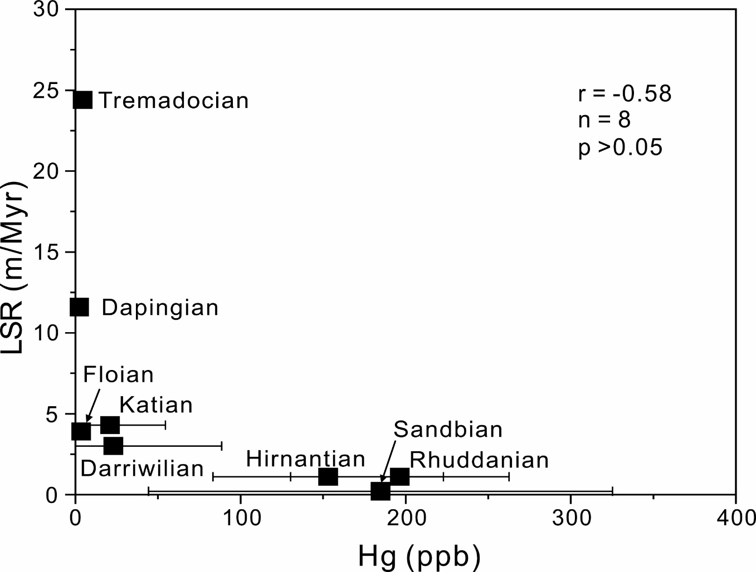
Figure S7. Crossplots of linear sedimentation rates (LSR) vs. Hg for the study sections. r represents Pearson’s correlation coefficient, p is the significance level, and n is the number of samples for each site. Both LSR and Hg concentration data are average values of each Ordovician formation based on three study sections.

Supplementary References

1 Zhang, L. et al. Raman spectral, elemental, crystallinity, and oxygen-isotope variations in conodont apatite during diagenesis. Geochimica et Cosmochimica Acta 210, 184-207 (2017).
2 Edwards, C. T., Jones, C. M., Quinton, P. C. & Fike, D. A. Oxygen isotope (δ18O) trends measured from Ordovician conodont apatite using secondary ion mass spectrometry (SIMS): Implications for paleo-thermometry studies. GSA Bulletin 134, 261-274 (2022).
3 Albanesi, G. L., Barnes, C. R., Trotter, J. A., Williams, I. S. & Bergström, S. M. Comparative Lower-Middle Ordovician conodont oxygen isotope palaeothermometry of the Argentine Precordillera and Laurentian margins. Palaeogeography, Palaeoclimatology, Palaeoecology 549, 109115 (2020).
4 Männik, P., Lehnert, O., Nolvak, J. & Joachimski, M. M. Climate changes in the pre-Hirnantian Late Ordovician based on δ18Ophos studies from Estonia. Palaeogeography, Palaeoclimatology, Palaeoecology 569, 110347 (2021).
5 Avila, T. D. et al. Role of seafloor production versus continental basalt weathering in Middle to Late Ordovician seawater 87Sr/86Sr and climate. Earth and Planetary Science Letters 593, 117641 (2022).
6 Liu, K., Jiang, M., Zhang, L. & Chen, D. A new high-resolution palaeotemperature record during the Middle–Late Ordovician transition derived from conodont δ 18O palaeothermometry. Journal of the Geological Society 179, jgs2021-2148 (2022).
7 Trotter, J. A., Williams, I. S., Barnes, C. R., Lécuyer, C. & Nicoll, R. S. Did cooling oceans trigger Ordovician biodiversification? Evidence from conodont thermometry. Science 321, 550-554 (2008).
8 Wheeley, J. R., Jardine, P. E., Raine, R. J., Boomer, I. & Smith, M. P. Paleoecologic and paleoceanographic interpretation of δ18O variability in Lower Ordovician conodont species. Geology 46, 467-470 (2018). https://doi.org:10.1130/g40145.1
9 Löfgren, A. M. & Tolmacheva, T. J. Taxonomy and distribution of the Ordovician conodont Drepanodus arcuatus PANDER, 1856, and related species. Palaontologische Zeitschrift (2003).
10 Stouge, S. S. Conodonts of the Middle Ordovician Table Head Formation, western Newfoundland. Fossils and Strata 16 (1984).
11 Pohler, S. Conodont biofacies of lower to lower middle ordovician megaconglomerates, Cow Head group, western Newfoundland. (1994).
12 Chen, D., Ren, D., Deng, C., Tian, Z. & Yin, R. Mercury loss and isotope fractionation during high-pressure and high-temperature processing of sediments: Implication for the behaviors of mercury during metamorphism. Geochimica et Cosmochimica Acta: Journal of the Geochemical Society and the Meteoritical Society (2022).
13 Liu, Z., Tian, H., Yin, R., Chen, D. & Gai, H. Mercury loss and isotope fractionation during thermal maturation of organic-rich mudrocks. Chemical geology (2022).
14 Zhang, L. et al. Diagenetic uptake of rare earth elements by conodont apatite. Palaeogeography, Palaeoclimatology, Palaeoecology 458, 176-197 (2016).
15 Algeo, T. J. & Ingall, E. Sedimentary Corg: P ratios, paleocean ventilation, and Phanerozoic atmospheric pO2. Palaeogeography, Palaeoclimatology, Palaeoecology 256, 130-155 (2007).
16 Algeo, T. J. & Li, C. Redox classification and calibration of redox thresholds in sedimentary systems. Geochimica et Cosmochimica Acta 287, 8-26 (2020).
17 Saltzman, M. R. et al. Calibration of a conodont apatite-based Ordovician 87Sr/86Sr curve to biostratigraphy and geochronology: Implications for stratigraphic resolution. Bulletin 126, 1551-1568 (2014).
18 McArthur, J., Howarth, R., Shields, G. & Zhou, Y. in Geologic time scale 2020 211-238 (Elsevier, 2020).
19 Algeo, T. J., Marenco, P. J. & Saltzman, M. R. Co-evolution of oceans, climate, and the biosphere during the `Ordovician Revolution': A review. Palaeogeography Palaeoclimatology Palaeoecology 458 (2016).
20 Gong, Q. et al. Mercury spikes suggest volcanic driver of the Ordovician-Silurian mass extinction. Scientific Reports 7, 5304 (2017).
21 Grasby, S. E., Them II, T. R., Chen, Z., Yin, R. & Ardakani, O. H. Mercury as a proxy for volcanic emissions in the geologic record. Earth-Science Reviews 196, 102880 (2019).

