Supplementary Information for

Views of EU citizens on economic growth and implications for climate policy

Contents
Supplementary Figures S1–4
Supplementary Tables S1–6

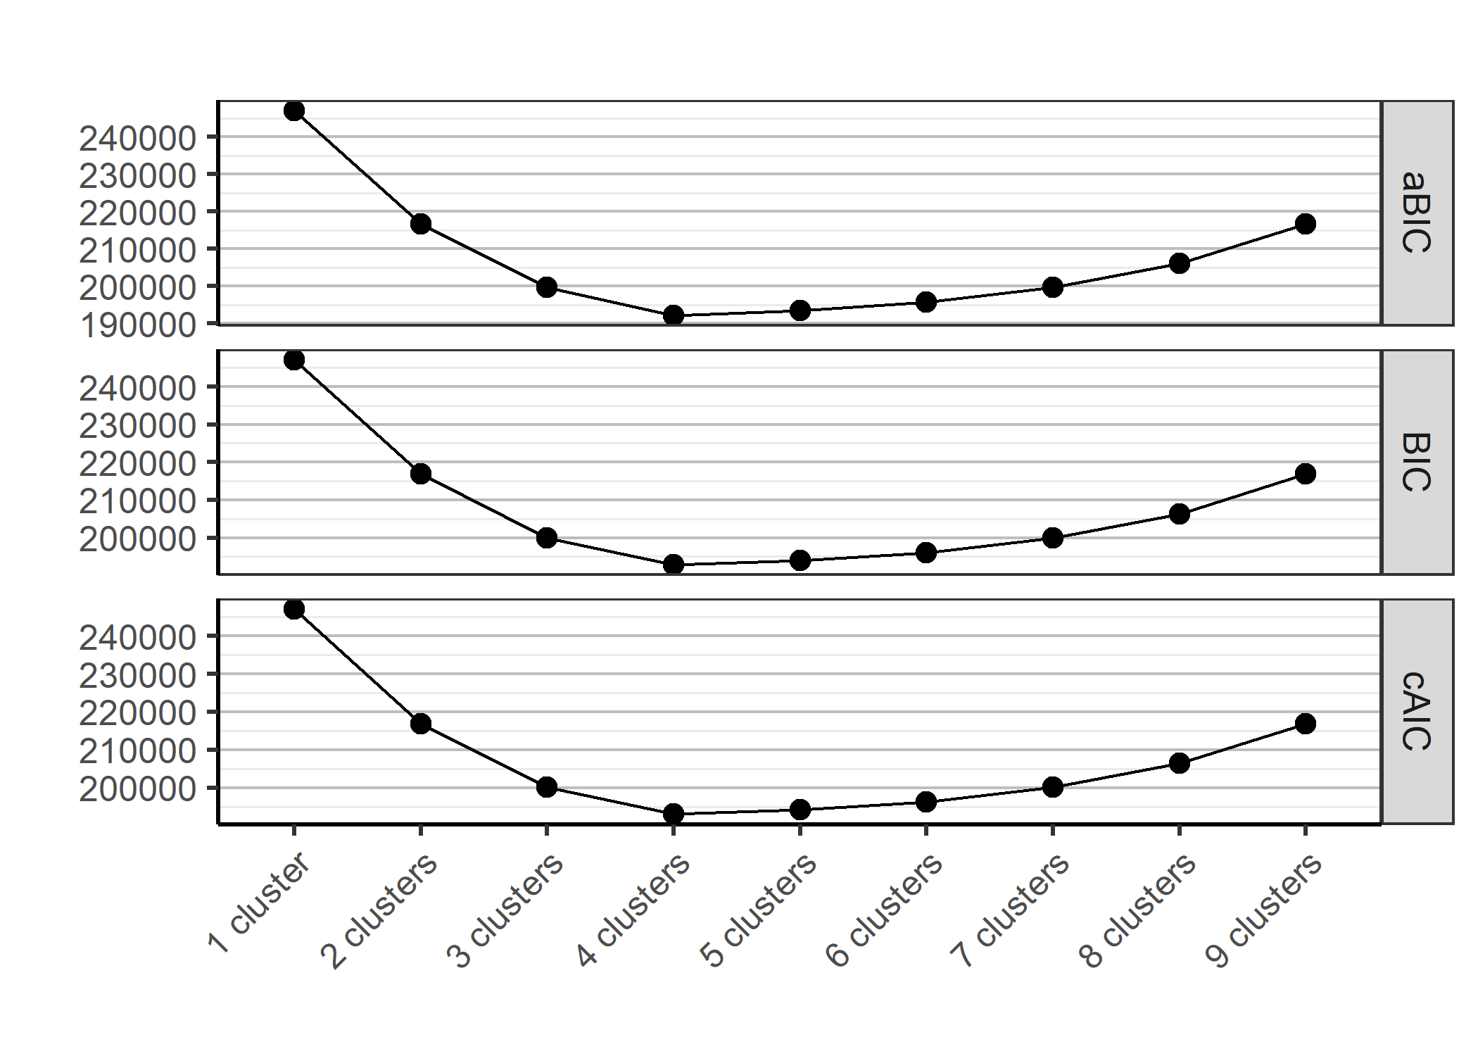
Fig. S1. Plot of information criteria for 1- to 9-cluster solutions for the growth-vs-environment debate

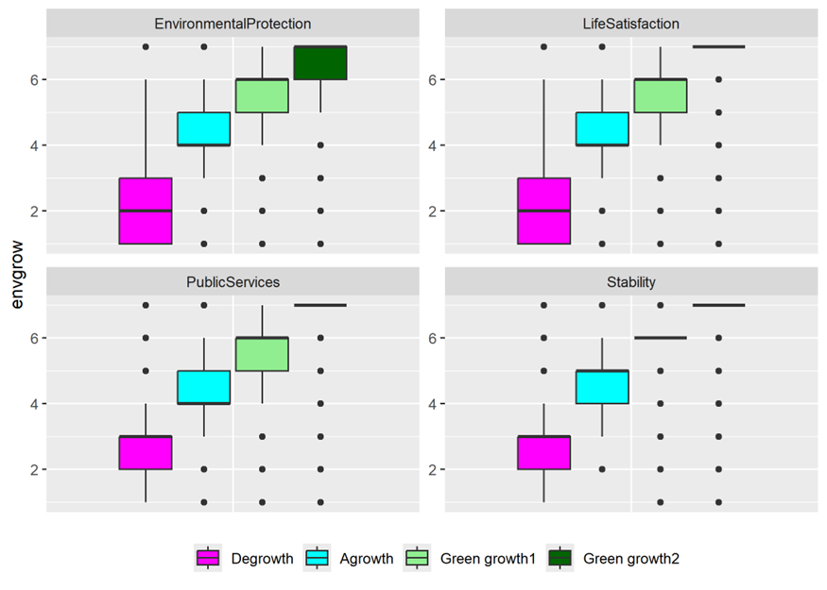
Fig. S2. Opinion clusters based on responses to the GEM statements on economic growth. Y-axis corresponds to respondents’ answers on a 7-point Likert scale from “strongly disagree” (1) to “strongly agree” (7).
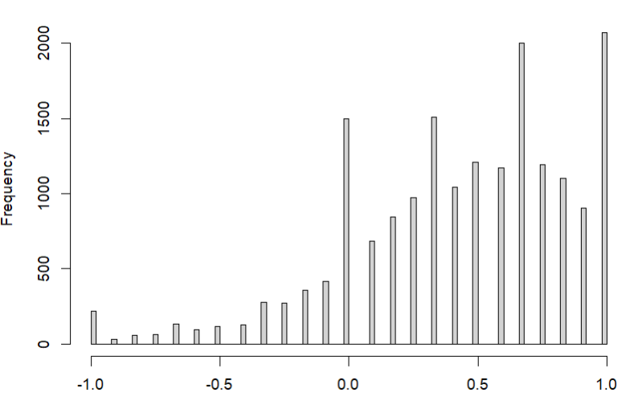
Fig S3. Histogram of Growth Support.
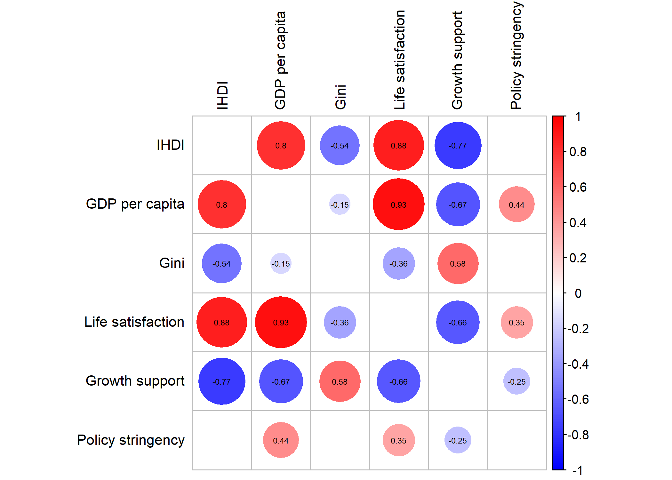
Fig S4. Correlation plot presenting Pearson correlations of variables presented in Figure 3 that are significant at the 5% level.

Table S1. OLS and Multiple Logit Regression Results. OLS results are reported in the second column, while the other three are for multiple logit. For multinomial logit, the pro-growth moderate cluster is used as a baseline. Standard errors are reported in parentheses. *p<0.1; **p<0.05; ***p<0.01.
 | OLS | Multinomial model
Variable | Growth Support | Degrowth | Agrowth | Green Growth (strong)
Sociodemographics
Gender | -0.009 (0.006) | -0.170*** (0.063) | 0.192*** (0.042) | -0.044 (0.045)
Age | 0.044*** (0.002) | -0.127*** (0.025) | -0.107*** (0.017) | 0.165*** (0.018)
Education | 0.018*** (0.005) | 0.030 (0.048) | -0.087*** (0.032) | 0.040 (0.033)
Household income | 0.005*** (0.001) | -0.010 (0.012) | -0.019** (0.008) | 0.018** (0.009)
Urban | 0.002 (0.003) | 0.027 (0.027) | -0.039** (0.018) | -0.018 (0.019)
Household size | -0.005** (0.003) | 0.059** (0.026) | 0.044** (0.018) | 0.040** (0.020)
Car use | 0.007*** (0.002) | -0.035* (0.021) | -0.028** (0.014) | -0.021 (0.016)
Flight frequency | -0.001 (0.001) | 0.007 (0.005) | -0.014*** (0.005) | -0.010* (0.005)
Political and climate views
Climate concern | -0.001 (0.004) | 0.192*** (0.037) | 0.071*** (0.026) | 0.097*** (0.027)
Right-wing political orientation | 0.016*** (0.001) | -0.045*** (0.014) | -0.042*** (0.009) | 0.057*** (0.010)
Trust in national government | 0.004* (0.002) | -0.110*** (0.026) | -0.012 (0.017) | -0.076*** (0.017)
Trust in EU government | 0.023*** (0.002) | -0.128*** (0.026) | -0.072*** (0.017) | 0.034** (0.017)
Climate policy knowledge | 0.009*** (0.002) | -0.005 (0.020) | -0.028** (0.014) | 0.055*** (0.014)
Support for climate policies | 0.003 (0.003) | -0.107*** (0.030) | -0.050** (0.021) | -0.073*** (0.021)
Perceived climate action | 0.026*** (0.002) | -0.152*** (0.023) | -0.023 (0.016) | 0.075*** (0.017)
Climate policy instruments
ETS support | -0.001 (0.003) | -0.074*** (0.027) | -0.031* (0.018) | -0.067*** (0.019)
Mandatory Insulation | 0.013*** (0.002) | -0.132*** (0.020) | -0.029** (0.014) | 0.036** (0.014)
Fossil Fuel Profits Tax | 0.002 (0.002) | -0.001 (0.021) | -0.022 (0.014) | 0.009 (0.014)
Intensive cattle farming ban | -0.012*** (0.002) | 0.094*** (0.023) | 0.031** (0.016) | -0.031** (0.016)
Private jet ban | 0.002 (0.002) | -0.053** (0.023) | -0.034** (0.016) | -0.041** (0.016)
Advertising ban | -0.002 (0.002) | 0.034 (0.025) | -0.020 (0.017) | 0.021 (0.017)
ETS II for transport | 0.005 (0.003) | -0.092*** (0.029) | 0.014 (0.020) | -0.005 (0.021)
ETS II for heating | 0.004 (0.003) | -0.002 (0.030) | 0.004 (0.020) | 0.008 (0.021)
ETS II for agriculture | 0.001 (0.003) | 0.001 (0.028) | -0.044** (0.019) | -0.019 (0.020)
CBAM support | -0.001 (0.002) | 0.044* (0.024) | -0.022 (0.016) | -0.002 (0.016)
Beef Tax | -0.014*** (0.002) | 0.032 (0.023) | 0.087*** (0.015) | -0.034** (0.016)
Flight Tickets Tax | -0.015*** (0.002) | 0.132*** (0.019) | 0.061*** (0.013) | -0.010 (0.013)
EU rail fund | 0.028*** (0.002) | -0.093*** (0.024) | -0.076*** (0.016) | 0.077*** (0.018)
ICE car ban | -0.014*** (0.002) | 0.086*** (0.021) | 0.078*** (0.014) | 0.012 (0.014)
Values
Power (wealth) | -0.020 (0.028) | 0.002 (0.019) | 0.088*** (0.019) | -0.018 (0.020)
Universalism (equality) | 0.001 (0.028) | -0.010 (0.019) | 0.097*** (0.021) | 0.022 (0.022)
Security (personal) | -0.082*** (0.028) | -0.036* (0.020) | 0.129*** (0.022) | 0.012 (0.023)
Security (national) | -0.165*** (0.027) | -0.156*** (0.019) | 0.197*** (0.021) | 0.048*** (0.022)
Hedonism | 0.004 (0.027) | -0.065*** (0.018) | 0.029 (0.019) | 0.005 (0.019)
Self-direction | -0.122*** (0.028) | -0.111*** (0.020) | 0.185*** (0.023) | 0.035*** (0.024)
Benevolence | -0.004 (0.030) | -0.047** (0.020) | 0.037* (0.022) | 0.008** (0.023)
Achievement | -0.128*** (0.028) | -0.015 (0.019) | 0.043** (0.019) | 0.016*** (0.020)
Stimulation | -0.063** (0.027) | 0.014 (0.018) | -0.077*** (0.018) | -0.005* (0.019)
Conformity | 0.013*** (0.003) | -0.069*** (0.027) | 0.008 (0.018) | 0.022 (0.019)
Tradition | -0.133*** (0.024) | -0.040** (0.016) | 0.025 (0.017) | 0.014*** (0.018)
Universalism (nature) | -0.003 (0.003) | 0.094*** (0.031) | -0.082*** (0.021) | -0.018 (0.023)
Constant | -0.940* (0.031) | 3.918*** (0.326) | 4.273*** (0.222) | -5.023*** (0.254)
Country Fixed Effects | Included | Included
Observations | 16,781 | 16,781
R² / AIC | 0.242 | 38,669.19
Table S2. Survey questions and statements corresponding to sociodemographic, political views, and climate views variables.
Variable | Survey question/statement
Sociodemographics
Gender | What is your gender?
Age | How old are you?
Education | What is the highest level of education that you have completed?
Household income | Which letter describes your household's total income, after tax and compulsory deductions, from all sources?
Urban | Which phrase best describes the area where you live?
Household size | Including yourself, how many people – including children – live regularly with you as members of this household?
Car use | How often do you use a car as a driver or a passenger?
Flight frequency | In total, how many flights did you take for private and personal travel in 2023 (not including business travel)?
Political and climate views
Climate concern | How worried are you about climate change?
Right-wing political orientation | In politics, people sometimes talk of “left” and “right”. Where would you place yourself on this scale, where 1 means the left and 11 means the right?
Trust in national government | On a scale from 1 to 7, how much do you personally trust [country adjective] parliament?
Trust in EU government | On a scale from 1 to 7, how much do you personally trust the European parliament?
Perceived climate policy knowledge | Before today, how informed would you say you were about “Fit for 55” policies?
Personal support for climate policies | How much opposed, or in favour, are you of climate policies in general?
Perceived climate action | And how much opposed, or in favour, do you think an average politician in [country] is of climate policies in general?

Table S3. Interview statements relating to basic human values. Respondents were asked to think about how much each person is or is not like them on a six-point scale from “not at all like me” to “very much like me”.
Motivational group | Value | Interview statement
Conservation | Conformity | It is important for this person to always behave properly. They want to avoid doing anything people would say is wrong.
 | Security (national) | It is important to this person that the government ensures their safety against all threats. They want the state to be strong so it can defend its citizens.
 | Security (personal) | It is important to this person to live in secure surroundings. They avoid anything that might endanger their safety.
 | Tradition | Tradition is important to this person. They try to follow the customs handed down by their religion or their family.
Openness to change | Self-direction | It is important to this person to make their own decisions about what they do. They like to be free and not depend on others.
 | Stimulation | This person looks for adventures and likes to take risks. They want to have an exciting life.
Self-enhancement | Achievement | Being very successful is important to this person. They hope people will recognize their achievements.
 | Hedonism | Having a good time is important to this person. They like to “spoil” themselves.
 | Power (wealth) | It is important to this person to be rich. They want to have a lot of money and expensive things.
Self-transcendence | Benevolence | It's very important to this person to help the people around them. They want to care for their well-being.
 | Universalism (equality) | This person thinks it is important that every person in the world be treated equally. They believe everyone should have equal opportunities in life.
 | Universalism (nature) | It is important to this person to respect nature. They want to be connected to nature.

Table S4. Survey descriptions of climate policy instruments. Respondents were asked how much they were opposed or in favour of the policies on a 7-point Likert scale from “strongly opposed” to “strongly in favour”.
Variable | Survey description of policy instrument
ETS support | The EU-ETS is the world's largest carbon market. It sets limits on the amount of greenhouse gas emissions for various sectors of the economy, and forces companies to pay a price for their emissions. In turn, this leads to higher prices for consumers for high emission products, while also generating additional funds for governments across the EU.
ETS II for transport | A new ETS for fuels used for road transport? Road transport is the movement of people and goods on roads.
ETS II for heating | A new ETS for fuels used to heat buildings and homes?
ETS II for agriculture | A new ETS for agricultural production?
CBAM support | The EU will introduce a tax on imported goods that are made outside of the EU based upon how much greenhouse gases were emitted to produce them (Carbon Border Adjustment Mechanism).  If companies want to sell products made outside the EU, they must pay approximately the same fees for emitting greenhouse gases that the company would have had to pay if the products were made inside the EU.
Beef tax | An increase in taxes on beef so that the price of beef products doubles in [country].
Fossil fuel profits tax | An increase in the taxes paid by energy companies on profits earned from fossil fuels in [country].
Flight tickets tax | A tax on flights, increasing ticket prices by 50% in [country].
EU rail fund | The creation of an EU Rail Fund which may be used to expand the rail network and lower the cost of rail ticket prices within Europe by 50%.
Mandatory insulation | Mandatory insulation of residential buildings by 2040 to meet a minimum energy efficiency standard on the condition that the government pays at least half of the cost for low-income households in [country].
ICE car ban | The EU would ban the sale of all new petrol- and diesel-cars after 2035.
Intensive cattle farming ban | An EU-wide ban on intensive cattle (beef) farming by 2035.
Private jet ban | An EU-wide ban on private planes using fossil fuels departing from or arriving within the EU after 2035.
Advertising ban | An EU-wide ban on public advertisements of emissions-heavy products and services, such as flights and fossil fuel vehicles.

Table S5. Descriptive statistics
Variable | Mean | Standard deviation | Min | Max
Growth Support Index | 0.428 | 0.433 | -1 | 1
Environmental protection | 5.14 | 1.51 | 1 | 7
Lie Satisfaction | 5.33 | 1.47 | 1 | 7
Public services | 5.45 | 1.45 | 1 | 7
Stability | 5.22 | 1.50 | 1 | 7
Position in the growth-vs-environment | 2.77 | 0.919 | 1 (degrowth) | 4 (strong pro-growth)
Sociodemographics
Gender | 1.51 | 0.5 | 1 | 2
Age | 3.20 | 1.41 | 1 | 5
Education | 2.25 | 0.705 | 1 | 3
Household income | 5.01 | 2.76 | 1 | 11
Urban | 3.58 | 1.19 | 1 | 5
Household size | 2.56 | 1.32 | 1 | 25
Car use | 3.46 | 1.57 | 0 | 5
Flight frequency | 1.44 | 5.06 | 0 | 100
Political and climate views
Climate concern | 3.29 | 1.07 | 1 | 5
Right-wing political orientation | 6.25 | 2.42 | 1 | 11
Trust in national government | 3.42 | 1.76 | 1 | 7
Trust in EU government | 3.53 | 1.75 | 1 | 7
Climate policy knowledge | 2.85 | 1.61 | 1 | 7
Support for climate policies | 4.53 | 1.66 | 1 | 7
Perceived climate action | 4.28 | 1.36 | 1 | 7
Climate policy instruments
ETS support | 3.98 | 1.59 | 1 | 7
Mandatory Insulation | 4.51 | 1.82 | 1 | 7
Fossil Fuel Profits Tax | 4.37 | 1.89 | 1 | 7
Intensive cattle farming ban | 3.74 | 1.92 | 1 | 7
Private jet ban | 4.71 | 1.82 | 1 | 7
Advertising ban | 4.41 | 1.74 | 1 | 7
ETS II for transport | 4.20 | 1.63 | 1 | 7
ETS II for heating | 4.16 | 1.63 | 1 | 7
ETS II for agriculture | 4.20 | 1.67 | 1 | 7
CBAM support | 4.42 | 1.65 | 1 | 7
Beef Tax | 2.96 | 1.86 | 1 | 7
Flight Tickets Tax | 3.44 | 1.97 | 1 | 7
EU rail fund | 5.25 | 1.57 | 1 | 7
ICE car ban | 3.22 | 1.94 | 1 | 7
Values
Power (wealth) | 2.78 | 1.40 | 1 | 7
Universalism (equality) | 4.55 | 1.29 | 1 | 7
Security (personal) | 4.41 | 1.25 | 1 | 7
Security (national) | 4.34 | 1.31 | 1 | 7
Hedonism | 3.72 | 1.34 | 1 | 7
Self-direction | 4.68 | 1.18 | 1 | 7
Benevolence | 4.29 | 1.19 | 1 | 7
Achievement | 3.24 | 1.41 | 1 | 7
Stimulation | 3.08 | 1.42 | 1 | 7
Conformity | 3.90 | 1.32 | 1 | 7
Tradition | 3.68 | 1.48 | 1 | 7
Universalism (nature) | 4.51 | 1.23 | 1 | 7

Table S6. Distribution of GS values across the four clusters
 | Min | Median | Mean | Max
Degrowth | -1.00 | -0.42 | -0.50 | 0.25
Agrowth | -0.25 | 0.17 | 0.13 | 0.50
Pro-growth moderate | 0.00 | 0.58 | 0.58 | 0.83
Pro-growth strong | -0.08 | 0.92 | 0.89 | 1.00

