SUPPLEMENTARY MATERIALS

Impact of Alirocumab on Neoatherosclerosis Formation and Vessel Healing after Drug-eluting Stent Implantation in Patients with Acute Myocardial Infarction: a Substudy of the PACMAN-AMI Trial

Ryota Kakizaki, Yasushi Ueki, Konstantinos C Koskinas, Hiroki Shibutani, Sylvain Losdat, Flavio G Biccirè, Tatsuhiko Otsuka, Jonas D Häner, Jacob Lønborg, Christoph Kaiser, Juan F Iglesias, Anna S Ondracek, David Spirk, George C M Siontis, Joost Daemen, Thomas Engstrøm, Irene M Lang, Lorenz Räber

Supplementary tables 1-5
Supplementary figures 1-3
Supplementary Table 1. Baseline patient, lesion, and procedural characteristics in patients with and without OCT imaging for culprit lesions at 1 year

 | Overall  n = 300 | Patients with OCT  n = 191 | Patients without OCT  n = 109 | P value
Age, years | 58.5 (9.7) | 58.1 (9.5) | 59.2 (10.0) | 0.38
Men, n (%) | 244 (81.3) | 160 (83.8) | 84 (77.1) | 0.17
Body mass index | 27.8 (4.3) | 27.9 (4.3) | 27.6 (4.4) | 0.62
Medical history, n (%)
Arterial hypertension | 130 (43.3) | 81 (42.4) | 49 (45.0) | 0.72
Dyslipidemia | 238 (79.3) | 162 (84.8) | 76 (69.7) | 0.003
Diabetes | 31 (10.3) | 16 (8.4) | 15 (13.8) | 0.17
Current smoking | 142 (47.3) | 87 (45.5) | 55 (50.5) | 0.47
Previous myocardial infarction | 7 (2.3) | 2 (1.0) | 5 (4.6) | 0.10
Previous PCI | 7 (2.3) | 3 (1.6) | 4 (3.7) | 0.26
Peripheral arterial disease | 6 (2.0) | 3 (1.6) | 3 (2.8) | 0.67
Family history of CAD | 98 (32.7) | 59 (30.9) | 39 (35.8) | 0.44
Type of acute myocardial infarction, n (%) |  |  |  | 0.23
NSTEMI | 142 (47.3) | 85 (44.5) | 57 (52.3)
STEMI | 158 (52.7) | 106 (55.5) | 52 (47.7)
Peak CK, IU/L | 622 (967) | 687 (1061) | 505 (759) | 0.13
Peak hs-cTnT, ng/mL | 1132 (2804) | 1189 (2734) | 1026 (2939) | 0.64
LVEF, % | 53 (10) | 53 (11) | 53 (9) | 0.87
Medication, n (%)
Statin | 37 (12.3) | 26 (13.6) | 11 (10.1) | 0.47
High-intensity statin therapy | 20 (6.7) | 13 (6.8) | 7 (6.4) | 1.00
Ezetimibe | 1 (0.3) | 0 (0.0) | 1 (0.9) | 0.36
Antiplatelet therapy
Aspirin | 28 (9.3) | 13 (6.8) | 15 (13.8) | 0.06
P2Y12 inhibitor | 11 (3.7) | 3 (1.6) | 8 (7.3) | 0.020
Anti-coagulant | 6 (2.0) | 2 (1.0) | 4 (3.7) | 0.19
β-Blocker | 24 (8.0) | 13 (6.8) | 11 (10.1) | 0.38
ACEI | 41 (13.7) | 20 (10.5) | 21 (19.3) | 0.037
ARB | 29 (9.7) | 15 (7.9) | 14 (12.8) | 0.16
Target vessel location, n (%) |  |  |  | 0.14
Left anterior descending | 134 (44.8%) | 93 (48.7%) | 41 (38.0%)
Left circumflex | 73 (24.4%) | 42 (22.0%) | 31 (28.7%)
Right coronary artery | 91 (30.4%) | 56 (29.3%) | 35 (32.4%)
Final TIMI flow |  |  |  | 0.30
0 | 0 (0.0%) | 0 (0.0%) | 0 (0.0%)
1 | 0 (0.0%) | 0 (0.0%) | 0 (0.0%)
2 | 3 (1.0%) | 1 (0.5%) | 2 (1.9%)
3 | 296 (99.0%) | 190 (99.5%) | 106 (98.1%)
Number of stents | 1.0 [0.0] | 1.0 [0.0] | 1.0 [0.0] | 0.73
Total stent length, mm | 26.0 [20.0] | 28.0 [20.0] | 26.0 [20.0] | 0.45
Stent diameter, mm | 3.5 [1.0] | 3.5 [1.0] | 3.5 [1.5] | 0.33
Post balloon dilatation, n (%) | 227 (75.9%) | 160 (83.8%) | 67 (62.0%) | <0.001
Polymer type, n (%)
Biodegradable polymer | 126 (42.1%) | 69 (36.1%) | 57 (52.8%)
Durable polymer | 161 (53.8%) | 118 (61.8%) | 43 (39.8%) | 0.001
Bifurcation lesion, n (%) | 40 (13.4%) | 30 (15.7%) | 10 (9.3%) | 0.16
Multivessel PCI, n (%) | 29 (9.7%) | 19 (9.9%) | 10 (9.3%) | 1.00
GP IIb/IIIa inhibitors, n (%) | 40 (13.4%) | 33 (17.3%) | 7 (6.5%) | 0.008
Values are count (percentage), mean (SD), or median [interquartile range]. Abbreviations: ACEI: angiotensin coverting enzyme inhibitor, ARB: angiotensin receptor blocker, BMI: body mass index, CAD: coronary artery disease, CK: creatine kinase, cTnT: cardiac troponin T, GP: glycoprotein, LVEF: left ventricular ejection fraction, NSTEMI: non-ST-segment elevation myocardial infarction, PCI: percutaneous coronary intervention, STEMI: ST-segment elevation myocardial infarction, TIMI: thrombolysis in myocardial infarction

Supplementary Table 2. List of patients with neoatherosclerosis

No. | Group | Age | Vessel | Sex | DM | Smoking | Dx | In-stent  fibroatheroma | In-stent  fibrocalcific plaque | In-stent  macrophage | In-stent  Cholesterol crystal | LDL-C |  | hsCRP
 |  |  |  |  |  |  |  |  |  |  |  | Baseline | Week 52 | Baseline | Week 52
1 | Alirocumab | 64 | LAD | Male | No | yes | STEMI | Yes | No | Yes | Yes | 164.09 | 24.32 | 1.40 | 2.80
2 | Alirocumab | 57 | RCA | Male | No | yes | NSTEMI | Yes | No | No | No | 178.76 | 9.27 | 2.00 | 0.00
3 | Alirocumab | 56 | LCx | Male | No | no | STEMI | Yes | No | No | No | 158.30 | 17.76 | 1.00 | 0.00
4 | Alirocumab | 60 | LAD | Male | Yes | yes | NSTEMI | Yes | No | No | No | 192.28 | 3.86 | 4.10 | 0.80
5 | Placebo | 53 | RCA | Male | No | yes | NSTEMI | Yes | No | No | Yes | 115.06 | 44.02 | 1.10 | 0.00
6 | Placebo | 72 | RCA | Female | Yes | no | STEMI | Yes | No | Yes | No | 211.58 | 60.23 | 9.70 | 0.00
7 | Placebo | 56 | RCA | Male | No | yes | STEMI | Yes | No | No | No | 141.31 | 49.81 | 10.10 | 0.80
8 | Placebo | 61 | RCA | Male | No | no | STEMI | Yes | Yes | No | No | 125.10 | 48.65 | 2.70 | 2.20
9 | Placebo | 41 | RCA | Male | No | yes | NSTEMI | Yes | No | No | No | 130.50 | 76.45 | 9.90 | 1.50
10 | Placebo | 54 | LAD | Male | No | no | NSTEMI | Yes | No | No | No | 156.37 | 61.39 | 33.80 | 2.30
11 | Placebo | 54 | RCA | Male | No | no | STEMI | Yes | Yes | No | No | 152.12 | 66.02 | 0.90 | 0.00
12 | Placebo | 62 | Diagonal | Male | No | no | NSTEMI | No | No | No | Yes | 100.00 | 76.06 | 0.00 | 0.00
13 | Placebo | 60 | RCA | Male | No | yes | STEMI | No | No | No | Yes | 167.95 | 71.43 | 5.40 | 1.90
Values are raw (LDL-C) or mean per patient across vessels (IVUS, NIRS, OCT). Abbreviations: DM: diabetes mellitus, Dx: diagnosis, FCT: fibrous cap thickness, hsCRP: high sensitive C-reactive protein, IRA: infarct-related arteries, IVUS: intravascular ultrasound, LAD: left anterior descending, LCBI: lipid core burden index, LCx: Left circumflex, LDL-C: low density lipoproteinn cholesterol, OCT: optical coherence tomography, RCA: Right coronary artery

Supplementary Table 3. Biochemical measures and intracoronary imaging findings in patients with and without neoatherosclerosis

 | Neoatherosclerosis (+)  N = 13 | Neoatherosclerosis (-)  N = 178
Biochemical measures
Total cholesterol, mg/dL
Baseline | 203.1 (29.6) | 206.4 (33.2)
1 year | 108.4 (33.9) | 112.1 (41.4)
Absolute change | -94.7 (-125.3 to -64.2) | -94.3 (-101.4 to -87.3)
LDL- cholesterol, mg/dL
Baseline | 153.3 (31.2) | 153.4 (33.5)
1 year | 46.9 (25.4) | 49.1 (37.9)
Absolute change | -106.5 (-135.4 to -77.5) | -104.3 (-111.0 to -97.6)
HDL- cholesterol, mg/dL
Baseline | 37.6 (6.7) | 42.3 (9.9)
1 year | 45.1 (10.1) | 47.6 (11.5)
Absolute change | 7.5 (3.1 to 12.0) | 5.4 (4.3 to 6.5)
Non-HDL- cholesterol, mg/dL
Baseline | 165.7 (32.7) | 164.4 (33.9)
1 year | 63.3 (32.2) | 64.6 (42.2)
Absolute change | -102.5 (-133.3 to -71.6) | -99.8 (-106.9 to -92.7)
Triglycerides, mg/dL
Baseline | 124.4 (81.1) | 105.5 (77.3)
1 year | 122.1 (56.2) | 103.6 (61.2)
Absolute change | -2.3 (-33.2 to 28.6) | -1.9 (-10.9 to 7.2)
Lipoprotein(a), mg/dL
Baseline | 29.9 (39.3) | 31.1 (39.8)
1 year | 36.4 (46.6) | 33.5 (45.5)
Absolute change | 6.6 (-3.3 to 16.4) | 2.4 (0.3 to 4.6)
Apolipoprotein AI, mg/dL
Baseline | 108.5 (13.2) | 115.1 (18.7)
1 year | 130.0 (19.3) | 130.8 (20.7)
Absolute change | 21.5 (12.0 to 30.9) | 15.7 (13.4 to 18.0)
Apolipoprotein B, mg/dL
Baseline | 116.2 (21.5) | 114.1 (22.0)
1 year | 52.5 (21.5) | 51.8 (28.6)
Absolute change | -63.7 (-84.1 to -43.3) | -62.2 (-66.9 to -57.6)
High-sensitivity CRP, mg/L
Baseline | 6.3 (9.0) | 6.0 (11.8)
1 year | 0.9 (1.1) | 2.4 (4.3)
Absolute change | -5.4 (-10.6 to -0.1) | -3.6 (-5.4 to -1.8)
Intracoronary imaging findings
Non-IRA PAV in IVUS
Baseline | 42.9 (6.4) | 42.0 (8.0)
1 year | 41.3 (6.8) | 40.4 (8.2)
Absolute change | -1.6 (-3.0 to -0.3) | -1.7 (-2.0 to -1.3)
Non-IRA max LCBI 4mm in NIRS
Baseline | 379.4 (191.4) | 262.9 (147.2)
1 year | 331.0 (186.6) | 207.2 (160.4)
Absolute change | -48.4 (-108.1 to 11.2) | -55.7 (-75.3 to -36.0)
Non-IRA minimum FCT in OCT
Baseline | 78.0 (24.8) | 108.8 (60.5)
1 year | 128.9 (78.6) | 153.8 (79.2)
Absolute change | 50.9 (13.0 to 88.8) | 45.1 (33.8 to 56.3)
Values are mean (SD) or mean (95% CI). Abbreviations: CRP: C-reactive protein, eGFR: estimated glomerular filtration rate, FCT: fibrous cap thickness, HbA1c: hemoglobin A1c, HDL: high density lipoprotein, IRA: infarct-related arteries, IVUS: intravascular ultrasound, LCBI: lipid core burden index, LDL: low density lipoproteinn, OCT: optical coherence tomography

Supplementary Table 4. OCT parameters in patients with and without neoatherosclerosis

 | Neoatherosclerosis (+)  N = 13 | Neoatherosclerosis (-)  N = 178
Duration from Implantation, day | 369 (11) | 376 (15)
Analysed cross section per lesion, n | 107 (39) | 76 (34)
Analysed stent length, mm | 42.9 (15.4) | 30.2 (13.7)
Minimal lumen area, mm2 | 3.41 (1.83) | 4.92 (2.21)
Minimal stent area, mm2 | 6.26 (3.14) | 6.04 (2.40)
Neointimal area, mm2 | 2.11 (1.08) | 1.06 (0.79)
Rate of cross section with mean neointimal thickness>100, % | 79.4 (21.0) | 56.3 (33.2)
Rate of cross section with any uncovered struts, % | 4.3 (6.0) | 14.3 (16.3)
Rate of cross section with any malapposed struts, % | 3.7 (10.1) | 2.7 (7.6)
Analysed struts per lesion, n (%) | 921 (362) | 751 (362)
Mean neointimal thickness, μm | 241.41 (96.72) | 136.70 (82.96)
Rate of uncovered struts, % | 0.75 (1.04) | 2.84 (4.00)
Rate of malapposed struts, % | 1.79 (5.06) | 0.66 (2.13)
Values are mean (SD) or count (%). Abbreviations: OCT: optical coherence tomography
Supplementary Table 5. Clinical outcomes

 | Overall  n = 191 | Neoatherosclerosis (+)  N = 13 | Neoatherosclerosis (-)  N = 178
Any revascularization n (%) | 35 (18.3) | 3 (23.1) | 32 (18.0)
Ischemia driven revascularization n (%) | 30 (15.7) | 3 (23.1) | 27 (15.2)
Ischemia driven target lesion revascularization n (%) | 11 (5.8) | 2 (15.4) | 9 (5.1)
Ischemia driven non-target lesion revascularization n (%) | 19 (9.9) | 1 (7.7) | 18 (10.1)
Values are count (percentage).

Supplementary Table 6. Stent type
 | Overall  n = 187 | Alirocumab  n = 92 | Placebo  n = 95
Xience (Abbott) | 51 (26.7) | 24 (25.3) | 27 (28.1)
Resolute (Medtronic) | 38 (19.9) | 19 (20.0) | 19 (19.8)
Orsiro (BIOTRONIK) | 39 (20.4) | 21 (22.1) | 18 (18.8)
Synergy (Boston Scientific) | 25 (13.1) | 12 (12.6) | 13 (13.5)
Ultimaster (Terumo) | 29 (15.2) | 14 (14.7) | 15 (15.6)
Biomatrix (Biosensors) | 4 (2.1) | 2 (2.1) | 2 (2.1)
Firehawk (MicroPort) | 1 (0.5) | 0 (0.0) | 1 (1.0)
Values are count (percentage).
Supplementary Figure 1. Study flow chart

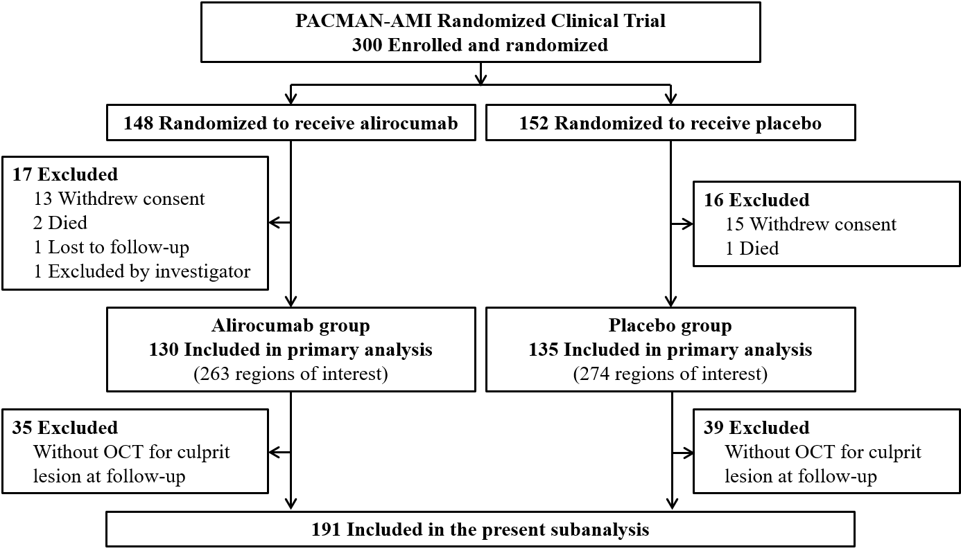
OCT: optical coherence tomography

Supplementary Figure 2. Correlation between neointimal area and absolute change of LDL-C

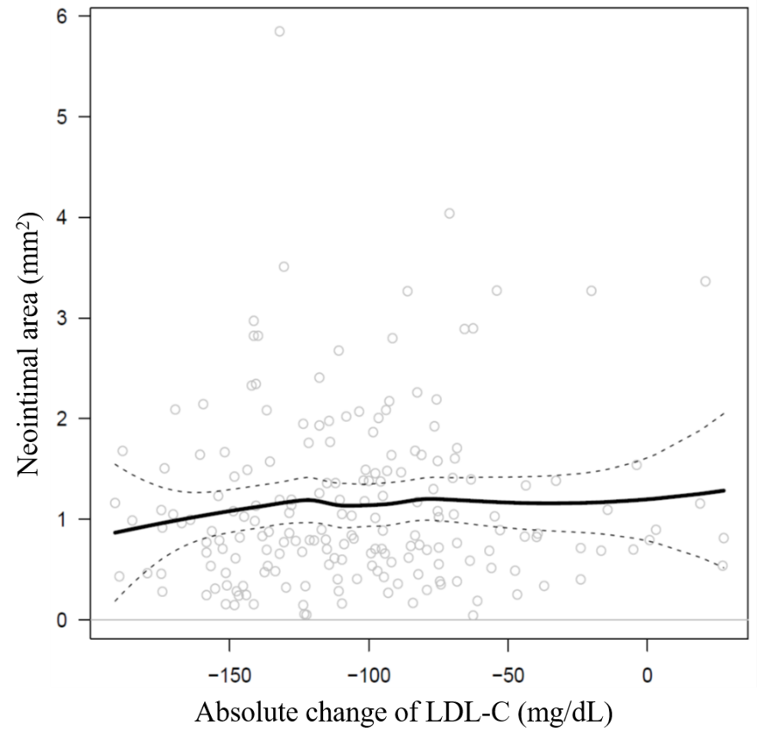
LDL-C: low density lipoprotein cholesterol

Supplementary Figure 3. Correlation between percentage of uncovered struts and absolute change of LDL-C

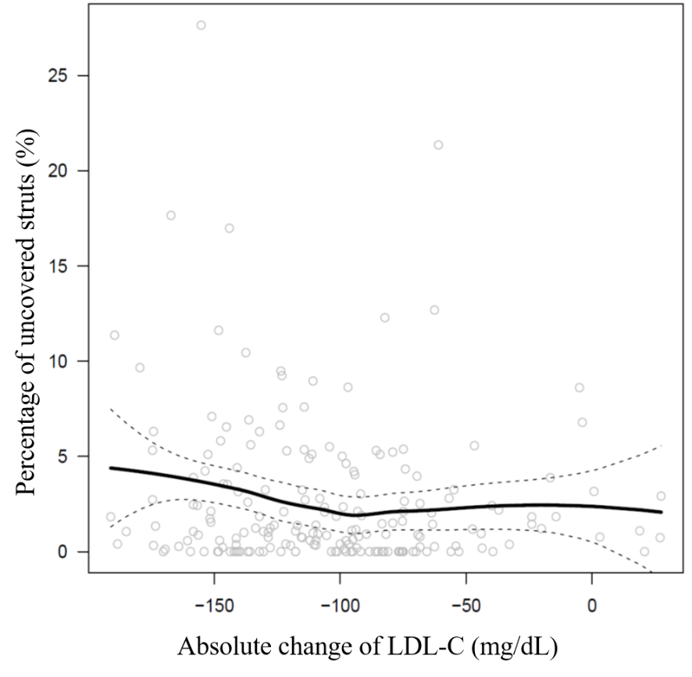
LDL-C: low density lipoprotein cholesterol

