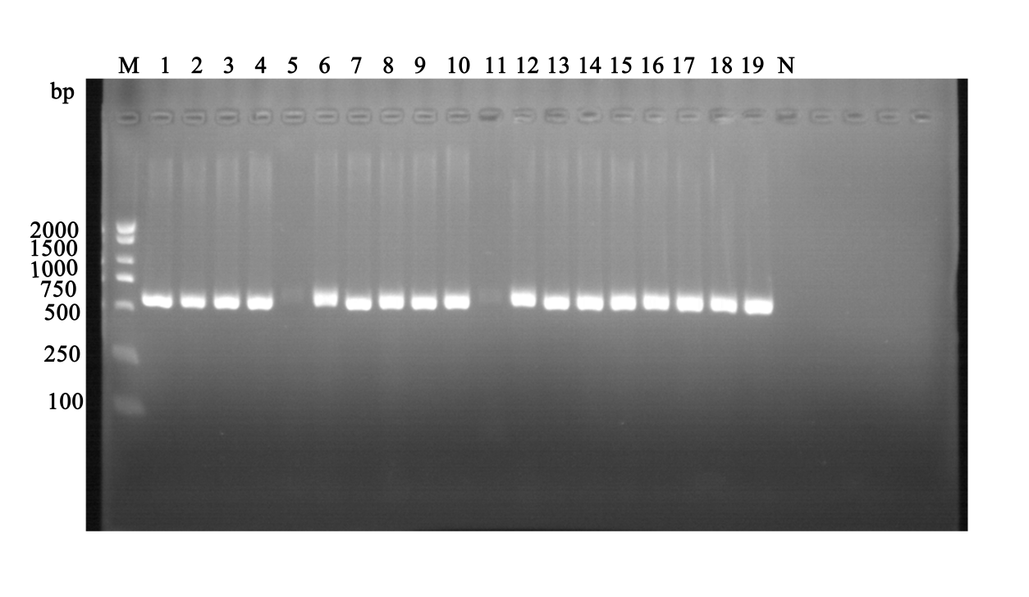Figure 3. Molecular confirmation of Proteus mirabilis isolates by PM gene PCR amplification
Note: Agarose gel (1.0%) electrophoresis of PM gene PCR products (expected size: 539 bp). Lanes: M, DL2000 DNA marker; 1-19, representative P. mirabilis isolates; N, negative control (no template). All test strains showed the target amplicon, confirming their identity as P. mirabilis. It should be noted that the positive control was unfortunately missing in this gel run. However, the negative control remained blank, demonstrating assay specificity.

