Paired Samples T-Test
Paired Samples T-Test
 |  |  |  |  |  | statistic |  | df |  | p |  |  |  | Effect Size
Post Test |  | Pretest |  | Student's t |  | 5.97 |  | 19.0 |  | < .001 |  | Cohen's d |  | 1.34
Note. Hₐ μ _{Measure 1 - Measure 2} ≠ 0

Descriptives
 |  | N |  | Mean |  | Median |  | SD |  | SE
Post Test |  | 20 |  | 14.25 |  | 14.0 |  | 2.92 |  | 0.652
Pretest |  | 20 |  | 9.80 |  | 10.0 |  | 2.57 |  | 0.574

Plots
Post Test - Pretest
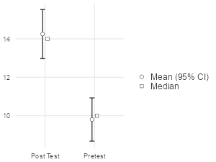

One-Way ANOVA
One-Way ANOVA (Welch's)
 |  | F |  | df1 |  | df2 |  | p
Pretest |  | 0.4157 |  | 2 |  | 15.7 |  | 0.667
Post Test |  | 0.2114 |  | 2 |  | 10.6 |  | 0.813
Difference |  | 0.0247 |  | 2 |  | 10.9 |  | 0.976

Group Descriptives
 |  | Year of MBBS |  | N |  | Mean |  | SD |  | SE
Pretest |  | MBBS 4th year |  | 9 |  | 10.33 |  | 2.40 |  | 0.799
 |  | MBBS 2th year |  | 10 |  | 9.50 |  | 3.72 |  | 1.176
 |  | MBBS 3th year |  | 8 |  | 9.25 |  | 2.60 |  | 0.921
Post Test |  | MBBS 4th year |  | 6 |  | 14.50 |  | 1.64 |  | 0.671
 |  | MBBS 2th year |  | 7 |  | 14.71 |  | 3.25 |  | 1.229
 |  | MBBS 3th year |  | 7 |  | 13.57 |  | 3.64 |  | 1.378
Difference |  | MBBS 4th year |  | 6 |  | 4.67 |  | 2.16 |  | 0.882
 |  | MBBS 2th year |  | 7 |  | 4.29 |  | 4.23 |  | 1.599
 |  | MBBS 3th year |  | 7 |  | 4.43 |  | 3.64 |  | 1.378

Plots
Pretest
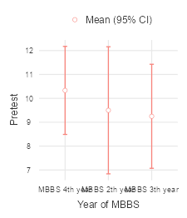
Post Test
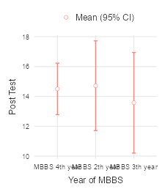
Difference
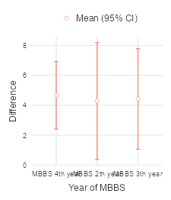
Descriptives analysis of gender-based differences:
Descriptives
 |  | Gender |  | Pretest |  | Post Test |  | Difference
N |  | F |  | 16 |  | 13 |  | 13
 |  | M |  | 11 |  | 7 |  | 7
Missing |  | F |  | 0 |  | 3 |  | 3
 |  | M |  | 0 |  | 4 |  | 4
Mean |  | F |  | 9.50 |  | 13.5 |  | 3.54
 |  | M |  | 10.0 |  | 15.7 |  | 6.14
Median |  | F |  | 10.0 |  | 14.0 |  | 4
 |  | M |  | 9.00 |  | 17.0 |  | 7
Standard deviation |  | F |  | 3.25 |  | 3.10 |  | 3.45
 |  | M |  | 2.53 |  | 1.98 |  | 2.48
Minimum |  | F |  | 1.00 |  | 7.00 |  | -3
 |  | M |  | 6.00 |  | 13.0 |  | 3
Maximum |  | F |  | 14.0 |  | 18.0 |  | 7
 |  | M |  | 13.0 |  | 18.0 |  | 9

One-Way ANOVA (Welch's)
 |  | F |  | df1 |  | df2 |  | p
Pretest |  | 0.4157 |  | 2 |  | 15.7 |  | 0.667
Post Test |  | 0.2114 |  | 2 |  | 10.6 |  | 0.813
Difference |  | 0.0247 |  | 2 |  | 10.9 |  | 0.976

Descriptive analysis of Phase wise differences:
Group Descriptives
 |  | Year of MBBS |  | N |  | Mean |  | SD |  | SE
Pretest |  | MBBS 4th year |  | 9 |  | 10.33 |  | 2.40 |  | 0.799
 |  | MBBS 2th year |  | 10 |  | 9.50 |  | 3.72 |  | 1.176
 |  | MBBS 3th year |  | 8 |  | 9.25 |  | 2.60 |  | 0.921
Post Test |  | MBBS 4th year |  | 6 |  | 14.50 |  | 1.64 |  | 0.671
 |  | MBBS 2th year |  | 7 |  | 14.71 |  | 3.25 |  | 1.229
 |  | MBBS 3th year |  | 7 |  | 13.57 |  | 3.64 |  | 1.378
Difference |  | MBBS 4th year |  | 6 |  | 4.67 |  | 2.16 |  | 0.882
 |  | MBBS 2th year |  | 7 |  | 4.29 |  | 4.23 |  | 1.599
 |  | MBBS 3th year |  | 7 |  | 4.43 |  | 3.64 |  | 1.378

Plots
Pretest
Post Test
Difference
Gender based analysis of One-Way ANOVA
One-Way ANOVA (Welch's)
 |  | F |  | df1 |  | df2 |  | p
Pretest |  | 0.202 |  | 1 |  | 24.5 |  | 0.657
Post Test |  | 3.914 |  | 1 |  | 17.3 |  | 0.064
Difference |  | 3.777 |  | 1 |  | 16.2 |  | 0.069

Group Descriptives
 |  | Gender |  | N |  | Mean |  | SD |  | SE
Pretest |  | F |  | 16 |  | 9.50 |  | 3.25 |  | 0.811
 |  | M |  | 11 |  | 10.00 |  | 2.53 |  | 0.763
Post Test |  | F |  | 13 |  | 13.46 |  | 3.10 |  | 0.859
 |  | M |  | 7 |  | 15.71 |  | 1.98 |  | 0.747
Difference |  | F |  | 13 |  | 3.54 |  | 3.45 |  | 0.958
 |  | M |  | 7 |  | 6.14 |  | 2.48 |  | 0.937

Plots
Pretest
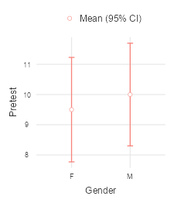
Post Test
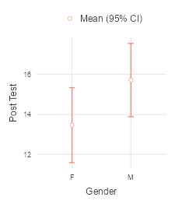
Difference
