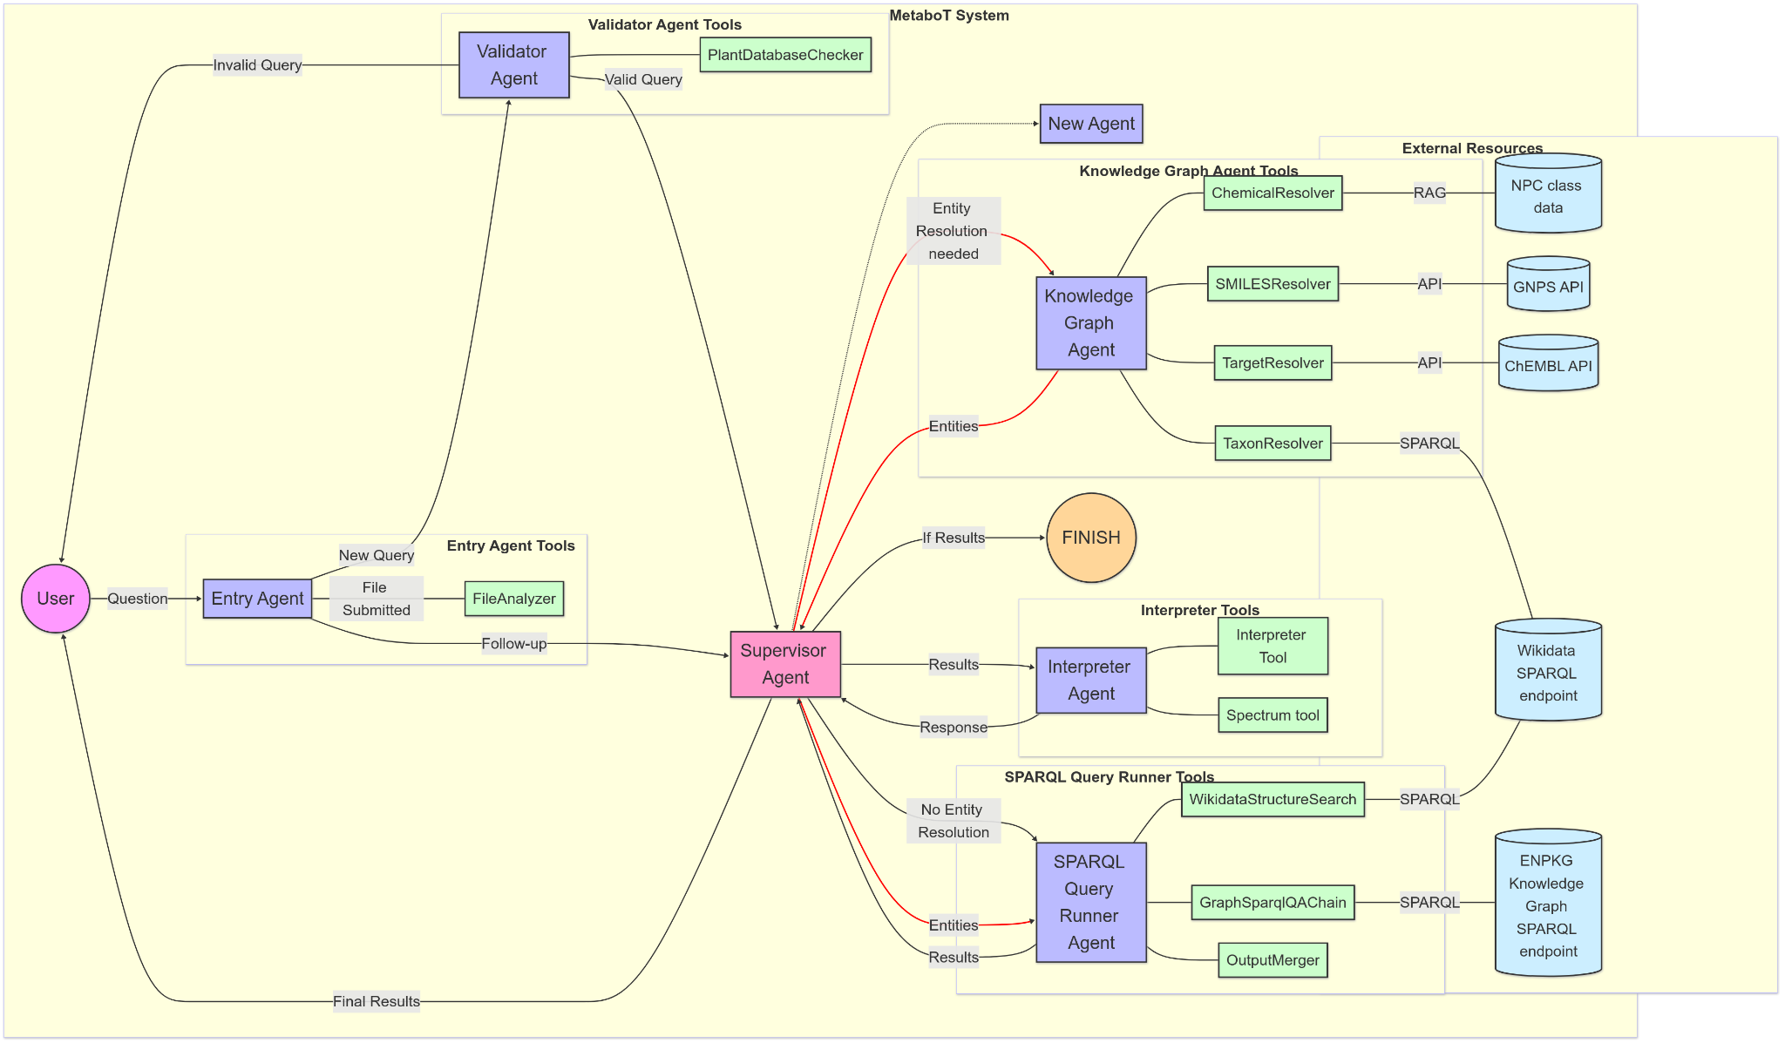
Extended Data Fig. 1: MetaboT System Architecture. The diagram illustrates the comprehensive structure of the multi-agent framework. Purple nodes denote the core agents—Entry, Validator, Supervisor (highlighted in light pink), Knowledge Graph, SPARQL Query Runner, and Interpreter—while green nodes represent supporting tools (e.g., FileAnalyzer, ChemicalResolver, GraphSparqlQAChain). Light blue nodes indicate external resources. Additionally, a New Agent node (from the Supervisor) with a dashed edge demonstrates possible modular expansion. Directional arrows trace the flow of information from the user’s natural-language query through the processing pipeline to the final SPARQL-derived response.
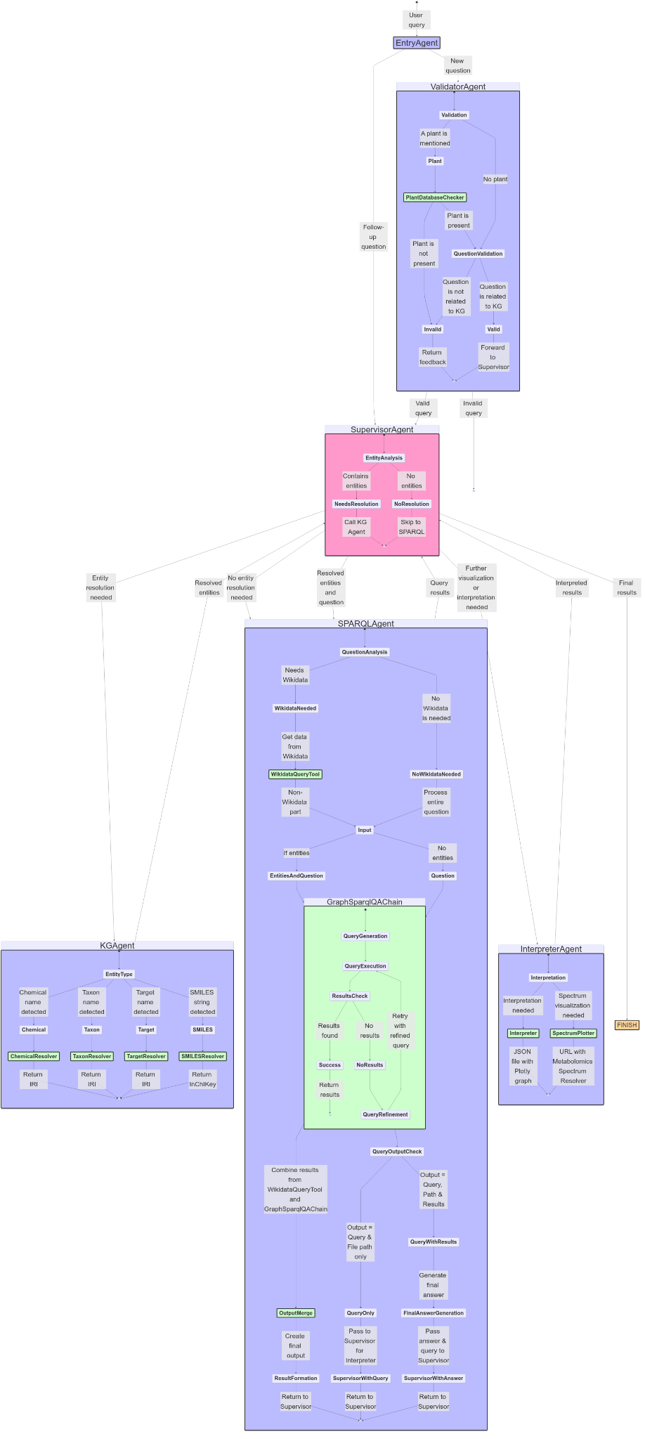

Extended Data Fig. 2: Agent Interaction Workflow with Decision Points. The diagram depicts the sequential decision-making process within MetaboT. A user query initiates the workflow at the Entry Agent, which classifies the question as either a new question (routed to the Validator Agent) or a follow‐up (directly to the Supervisor Agent). Valid questions proceed from the Validator to the Supervisor Agent, where an initial entity analysis determines whether to invoke entity resolution via the KG Agent or bypass it for direct SPARQL query generation. The SPARQL Agent (i.e., the SPARQL Query Runner Agent described in the main text) generates and executes the SPARQL query as needed, then passes its output back to the Supervisor Agent. Finally, the SPARQL Agent’s outputs are processed by the Interpreter Agent, which produces the final response. This structured, directed graph ensures that each agent’s output becomes the input for subsequent processes, enabling adaptive routing based on query content and intermediate outcomes.
Supplementary Table 1: Evaluation results.
System | Overall Accuracy (49 questions) (%) | Low Complexity (11 questions) |  | Medium Complexity (19 questions) |  | High Complexity (19 questions)
System | Overall Accuracy (49 questions) (%) | Accuracy (%) | Error Type | Accuracy (%) | Error Type | Accuracy (%) | Error Type
GPT- 4o(one shot) | 8.16 | 18.18 | Type 2 | 10.52 | Type 2 | 0.00 | Type 2
MetaboT GPT-4o mini | 12.24 | 0.00 | Type 1 (6),  Type 2 (5) | 15.78 | Type 1 (7), Type 2 (7), Type 3 (1), Type 4 (1) | 15.78 | Type 1 (7), Type 2 (8), Type 4 (1)
MetaboT GPT-4o | 83.67 | 81.81 | Type 1 | 89.47 | Type 2 (1), Type 3 (1) | 78.95 | Type 2

