Supplementary Material
The Association of Irritant Administration Via Midline Catheters with Catheter-related Complications: A Longitudinal Cohort Study

CONTENTS
Table S1. Phlebitis scale.
Table S2. Infiltration scale.
Table S3. List of irritants identified in the included patients.
Table S4. Multivariable logistic regression analyses of factors associated with catheter-related complication after propensity score matching.
Table S5. Sensitivity analyses of orthopedic patients.

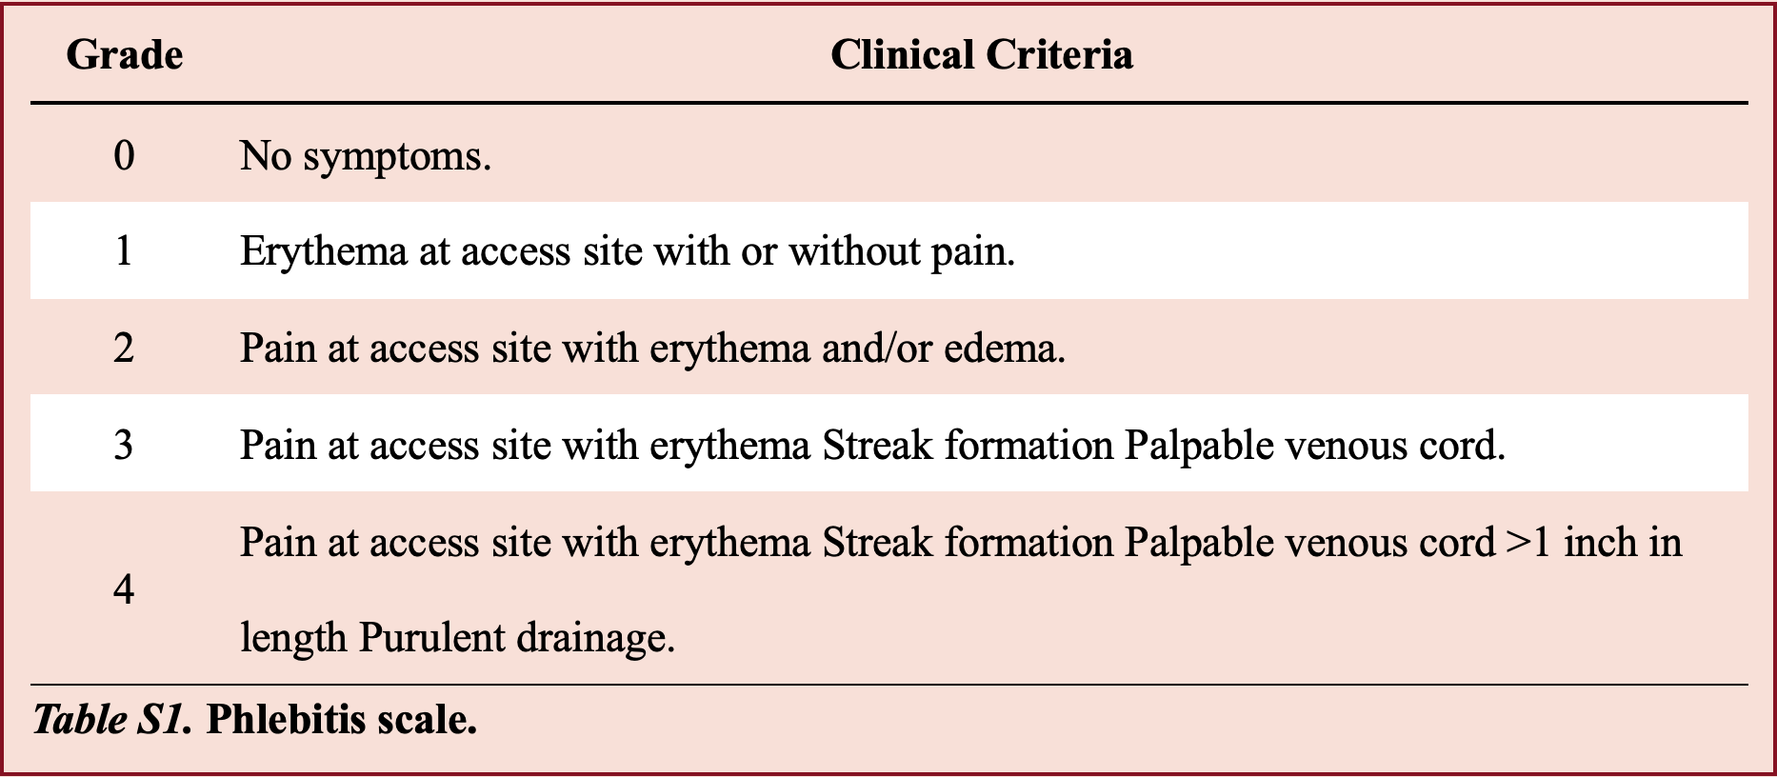

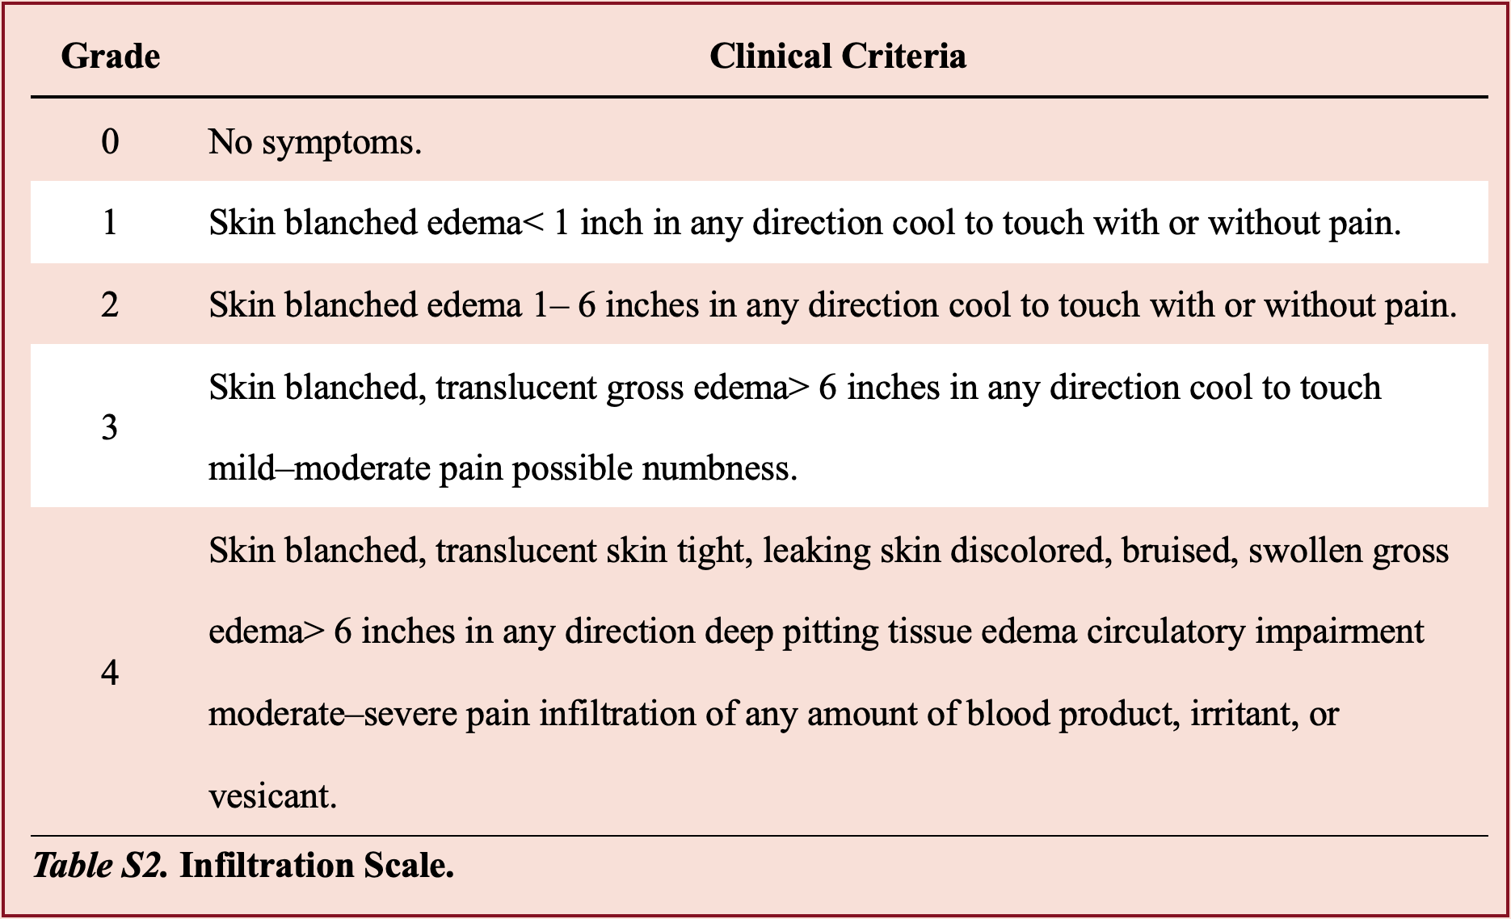

Table S3. List of irritants identified in the included patients.
Classification | Drug (Brand Name) | Diluent | Basis for inclusion | Reference(s)
Anti-infective drugs | Acyclovir | NS | PH> 9 | 20, 21
Anti-infective drugs | Amikacin | NS | PH< 5 | 20
Anti-infective drugs | Cefepime | NS | PH< 5 | 20
Anti-infective drugs | Cefazolin | NS | PH< 5 | 20
Anti-infective drugs | Ciprofloxacin | NA | PH< 5 | 20, 21
Anti-infective drugs | Cisatracurium | NS | PH< 5 | 20
Anti-infective drugs | Daptomycin | NS | PH< 5 | 20
Anti-infective drugs | Ganciclovir | NS | PH> 9 | 20
Anti-infective drugs | Linezolid | NA | PH< 5 | 20
Anti-infective drugs | Vancomycin | NS/ 5% GS | PH< 5 | 20, 21
Antiarrhythmics | Amiodarone | 5% GS | PH< 5 | 20, 21
Antiarrhythmics | Esmolol | NA | pH＜5 | 22
Digestive-related drugs | Omeprazole | NS | PH> 9 | 20
Digestive-related drugs | Ondansetron | NS | PH< 5 | 20
Vasoactive drugs | Milrinone | NS | PH< 5 | 20
Vasoactive drugs | Urapidil | NS | Osmolarity > 600 mOSM/L | 20
Vasoactive drugs | Dobutamine | NS | PH< 5 | 20, 21
Vasoactive drugs | Dopamine | NS | PH< 5 | 20, 21
Vasoactive drugs | Epinephrine | 5% GS | PH< 5 | 20, 21
Vasoactive drugs | Nimodipine | NA | Osmolarity > 600 mOSM/L | 20
Vasoactive drugs | Nitroglycerin | NS | Osmolarity > 600 mOSM/L | 20
Vasoactive drugs | Norepinephrine | 5% GS | PH< 5 | 20, 21
Vasoactive drugs | Remifentanil | NS | PH< 5 | 20
Vasoactive drugs | Nicardipine | NS | NA | 21
Sedatives and analgesics | Valproic acid | NS | Osmolarity > 600 mOSM/L | 20
Sedatives and analgesics | Midazolam | NS | PH< 5 | 20
Sedatives and analgesics | Diazepam | NA | NA | 21
Other drugs | Iron sucrose | NS | PH> 9 | 20
Other drugs | Vasopressin (mannitol et.c) | NA | Osmolarity > 600 mOSM/L | 20, 21
Other drugs | Potassium chloride | NS | PH< 5 | 20, 21
Other drugs | Rocuronium | NS | PH< 5 | 20
Other drugs | Sodium Bicarbonate | NA | Osmolarity > 600 mOSM/L | 20, 21
Other drugs | Calcium chloride | NS | PH< 5 | 20, 21
Other drugs | Insulin human regular | 5% GS | PH< 5 | 20
Other drugs | Sodium Chloride (≥2%) | NA | NA | 21
Other drugs | PN | NA | NA | 21
Abbreviation: 5%GS, 5% glucose solution; NA, not available; NS, normal saline; PN, parenteralnutrition; Osmolarity expressed in mOsm/L.
