SUPPLEMENTARY IMAGES-

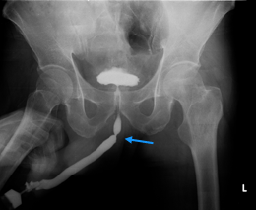
Supplementary Figure 1: Preoperative RGU showing a short segment bulbar stricture – patient underwent H-M Urethroplasty

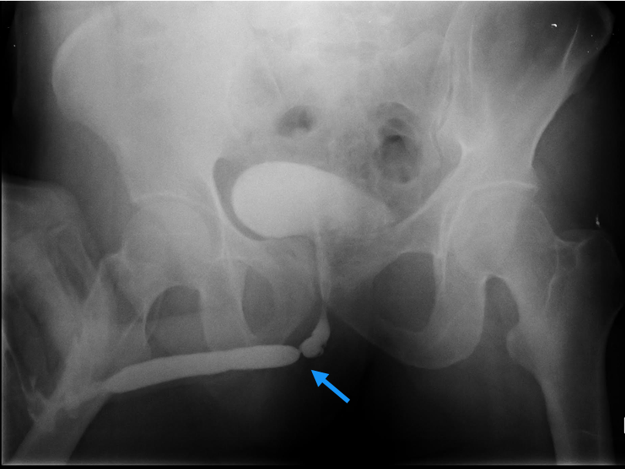
Supplementary Figure 2: Preoperative RGU showing a short segment bulbar stricture – patient underwent NTABU

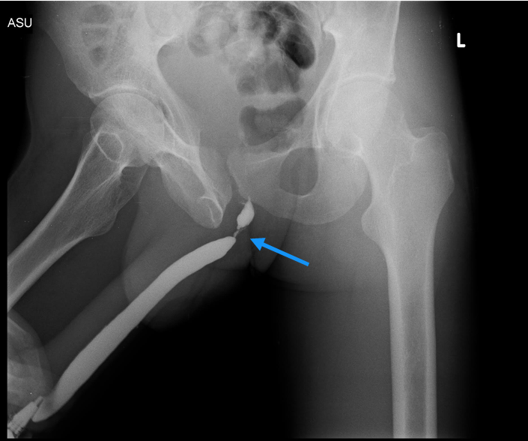
Supplementary Figure 3: Preoperative RGU of a patient with history of DVIU showing a short segment bulbar stricture – patient underwent ANTABU

Supplementary tables-
SUPLEMENTARY TABLE 1: Surgical Satisfactory Rates - Cross Tabulation
 | Treatment satisfaction in Non transecting Urethroplasty group and DVIU Cross-tabulation
 |  |  |  | Nontransecting Urethroplasty_group |  |  | Total | DVIU
 |  |  |  | H-M | NTABU | ANTABU/Dorsal Onlay BMG |  | DVIU
Treatment satisfaction |  | Satisfied | Count | 1 | 8 | 6 | 15 | 5
 |  | Unsatisfied | Count | - | - | - | - | 7
 |  | Very satisfied | Count | 3 | 9 | 1 | 13 | 8
 |  | Very unsatisfied | Count | - | - | 1 | 1 | 4

SUPPLEMENTARY TABLE 2: Luts And Sexual Function Domain Subgroup Analysis – Non Transecting Urethroplasty Group With And With Out Prior Interventions
 |  | Urethroplasty group with no previous interventions | Urethroplasty group with previous interventions
LUTS score | BASELINE | 17.09 | 16.37
LUTS score | 6 MONTHS | 3.23 | 3.5
LUTS score | 1 YEAR | 1.38 | 3.37
Peeling voiding picture  score | BASELINE | 3.42 | 3.37
Peeling voiding picture  score | 6 MONTHS | 1.47 | 1.87
Peeling voiding picture  score | 1 YEAR | 1.23 | 1.8
Erectile function score | BASELINE | 20.14 | 17.37
Erectile function score | 6 MONTHS | 23.85 | 20.75
Erectile function score | 1 YEAR | 25.14 | 22.375
Ejaculatory function score | BASELINE | 11.33 | 11.25
Ejaculatory function score | 6 MONTHS | 13.38 | 13.5
Ejaculatory function score | 1 YEAR | 14.09 | 13.75
Ejaculatory function- bother score | BASELINE | 2.33 | 2.12
Ejaculatory function- bother score | 6 MONTHS | 0.95 | 1.12
Ejaculatory function- bother score | 1 YEAR | 0.38 | 1
Qmax | BASELINE | 5.04 | 5.01
Qmax | 6 MONTHS | 26.54 | 23.9
Qmax | 1 YEAR | 28.11 | 23.07

