Supplementary Material 1

Figure S1. Kaplan-Meier survival curves of rainbow trout from populations A (left) and B (right) after intramuscular injection with F. psychrophilum bacterial suspensions with doses ranging over five orders of magnitude. Groups of 10 fish (average body weight of 5.3 g) were used for each bacterial dose and population. 2
Figure S2. Specific and overlapping QTLs detected in this study by using GWAS on four datasets. All QTLs detected at least once are indicated. The 11 QTLs detected with high occurrence (> 50%) at least in one GWAS are in bold. 3
Figure S3. Comparative analysis of logBF values in the 4 QTL regions detected in population A across the two rainbow trout populations. Values represented on the left side of y-axis are logBF values from GWAS ‘Pop. A’ or ‘Pop. A 10 dpi’, and values on the right side are from GWAS ‘Pop. B’. The positions of key candidate genes (see Table 4) are marked on the right side of each graph. 4
Figure S4. Comparative analysis of logBF values in QTL regions detected in population B across the two rainbow trout populations. Values represented on the left side of y-axis are logBF values from GWAS ‘Pop. A’, and values on the right side are from GWAS ‘Pop. B’. The positions of key candidate genes (see Table 4) are marked on the right side of each graph. 5
Figure S5. Comparative analysis of logBF values in QTL regions detected when the two populations were combined (GWAS ‘Comb. A+B’) across the rainbow trout populations. Values represented on the left side of y-axis are logBF values from GWAS ‘Comb. A+B’, and values on the right side are either from GWAS ‘Pop. A’ and ‘Pop. B’. The positions of key candidate genes (see Table 4) are marked on the right side of each graph. 6
Table S1. Water quality parameters during 24-h bacterial exposure in Trial III. 7

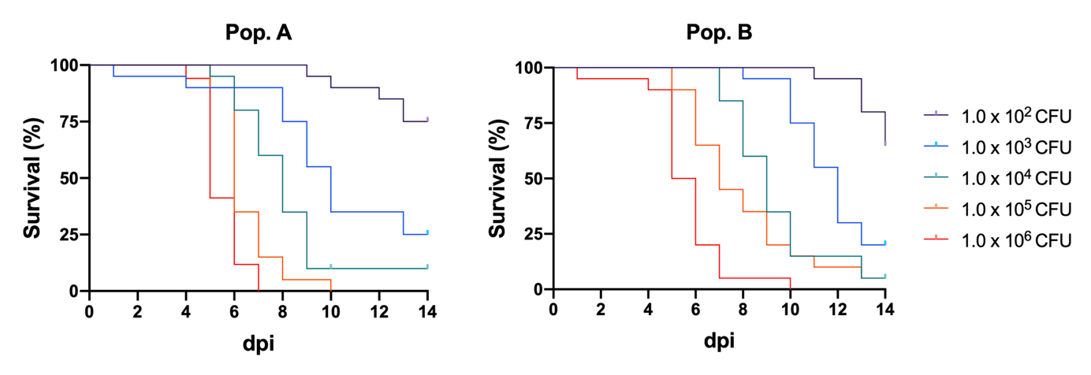

Figure S1. Kaplan-Meier survival curves of rainbow trout from populations A (left) and B (right) after intramuscular injection with F. psychrophilum bacterial suspensions with doses ranging over five orders of magnitude. Groups of 10 fish (average body weight of 5.3 g) were used for each bacterial dose and population.

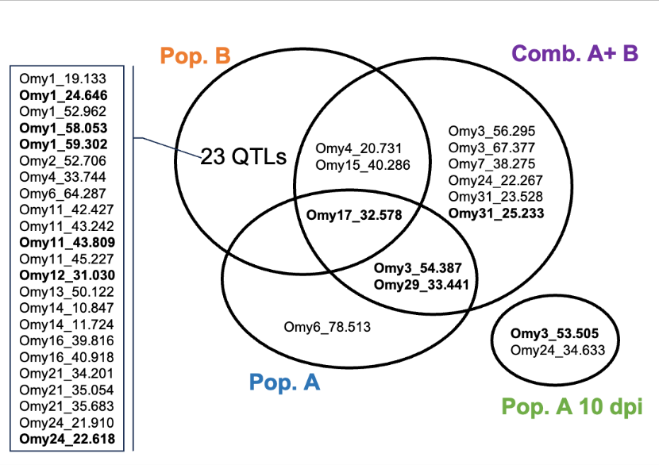

Figure S2. Specific and overlapping QTLs detected in this study by using GWAS on four datasets. All QTLs detected at least once are indicated. The 11 QTLs detected with high occurrence (> 50%) at least in one GWAS are in bold.

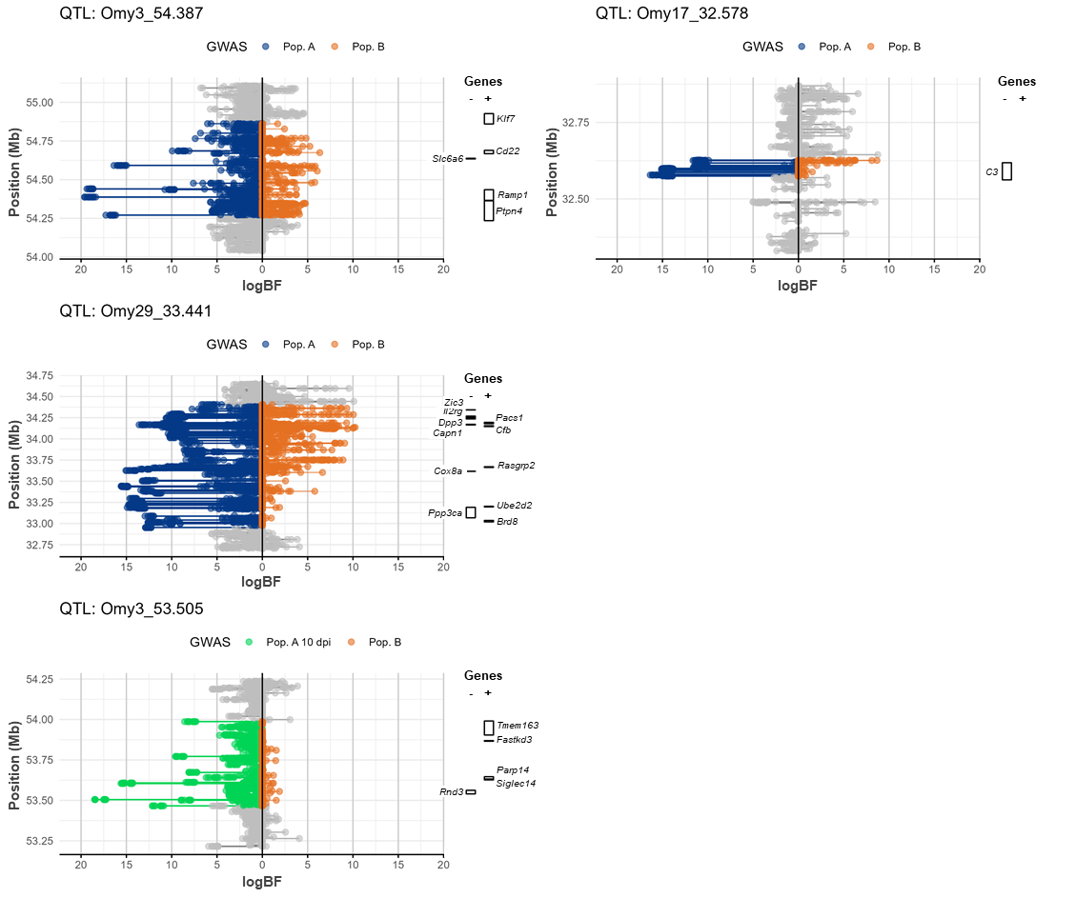
Figure S3. Comparative analysis of logBF values in the 4 QTL regions detected in population A across the two rainbow trout populations. Values represented on the left side of y-axis are logBF values from GWAS ‘Pop. A’ or ‘Pop. A 10 dpi’, and values on the right side are from GWAS ‘Pop. B’. The positions of key candidate genes (see Table 4) are marked on the right side of each graph.

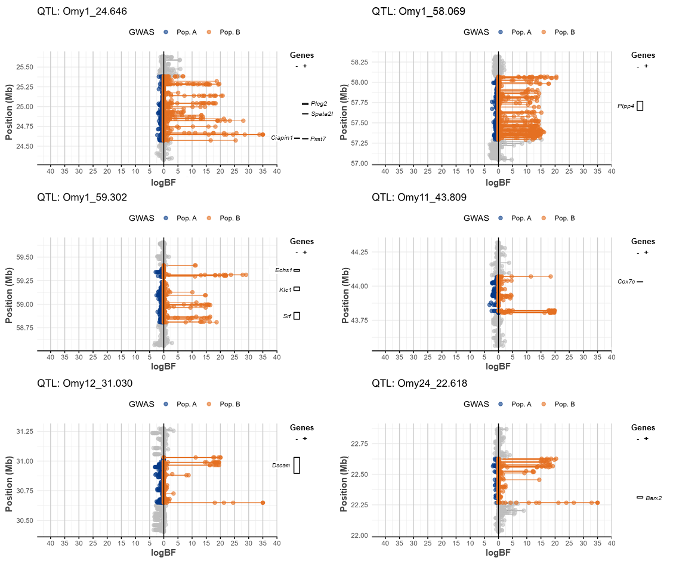
Figure S4. Comparative analysis of logBF values in QTL regions detected in population B across the two rainbow trout populations. Values represented on the left side of y-axis are logBF values from GWAS ‘Pop. A’, and values on the right side are from GWAS ‘Pop. B’. The positions of key candidate genes (see Table 4) are marked on the right side of each graph.

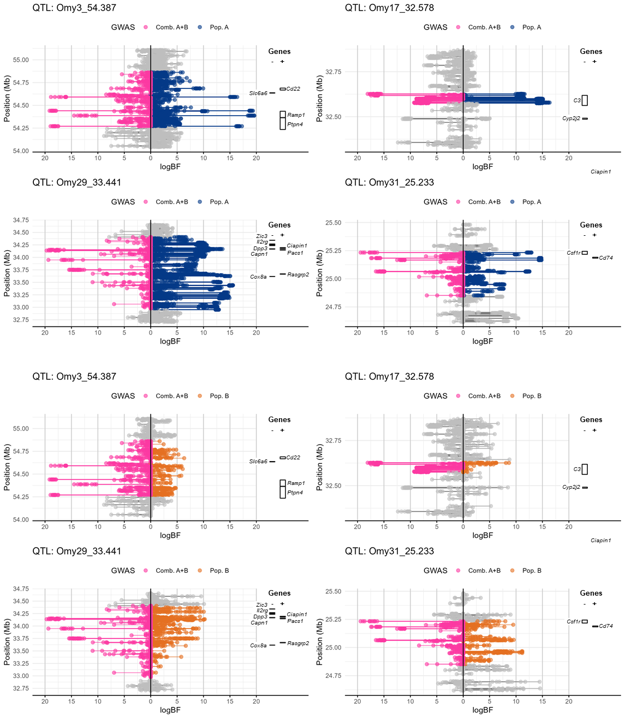
Figure S5. Comparative analysis of logBF values in QTL regions detected when the two populations were combined (GWAS ‘Comb. A+B’) across the rainbow trout populations. Values represented on the left side of y-axis are logBF values from GWAS ‘Comb. A+B’, and values on the right side are either from GWAS ‘Pop. A’ and ‘Pop. B’. The positions of key candidate genes (see Table 4) are marked on the right side of each graph.

Table S1. Water quality parameters during 24-h bacterial exposure in Trial III.

Population | Time (h) | T°C | NH4⁺ (mg/L) | pH | O₂ (mg/L)
A | 0 | - | 0.31 | 7.64 | 9.29
 | 7 | 10.8 | 1.1 | 7.55 | 8.67
 | 24 | 11.2 | 2.9 | 7.82 | 8.75
B | 0 | - | 0.25 | 7.48 | 8.91
 | 7 | 10.8 | 0.86 | 7.42 | 8.66
 | 24 | 11.2 | 2.6 | 7.91 | 8.69

