Supplementary Information
Application of Deep Learning to Predict Human Oral Bioavailability of Pharmaceuticals

Lin Wei^{a,1}, Yihe Fang^{a,1}, Peng Chenª, Zigong Wei^{a,b,*}

ªState Key Laboratory of Biocatalysis and Enzyme Engineering, School of Life Sciences, Hubei University, Wuhan, Hubei, PR China
^{b}Hubei Province Key Laboratory of Biotechnology of Chinese Traditional Medicine, National & Local Joint Engineering Research Center of High-throughput Drug Screening Technology, School of life sciences, Hubei University, Wuhan, Hubei, PR China

*Corresponding author: Zigong Wei, E-mail: weizigong@163.com; weizigong@hubu.edu.cn
¹These authors contributed equally to this work.

Table S1. The AUC, PRC, ACC, F1 for 20-ensemble learning.
ID | AUC | PRC | ACC | F1
0 | 0.804 | 0.857 | 0.759 | 0.795
1 | 0.817 | 0.874 | 0.787 | 0.828
2 | 0.826 | 0.878 | 0.794 | 0.836
3 | 0.83 | 0.875 | 0.759 | 0.779
4 | 0.847 | 0.891 | 0.801 | 0.849
5 | 0.827 | 0.882 | 0.773 | 0.816
6 | 0.827 | 0.883 | 0.759 | 0.819
7 | 0.831 | 0.892 | 0.773 | 0.816
8 | 0.822 | 0.876 | 0.780 | 0.829
9 | 0.831 | 0.892 | 0.773 | 0.812
10 | 0.829 | 0.891 | 0.773 | 0.816
11 | 0.815 | 0.85 | 0.787 | 0.837
12 | 0.848 | 0.894 | 0.773 | 0.800
13 | 0.82 | 0.886 | 0.773 | 0.824
14 | 0.839 | 0.892 | 0.773 | 0.814
15 | 0.824 | 0.862 | 0.759 | 0.785
16 | 0.844 | 0.886 | 0.801 | 0.839
17 | 0.833 | 0.892 | 0.773 | 0.816
18 | 0.842 | 0.89 | 0.752 | 0.802
19 | 0.841 | 0.895 | 0.809 | 0.842

Table S2. The HOB prediction for FDA_T set predicted by our model (with RDKit), PhaKinPro, HobPre, ADMETlab3.0, ADMETSAR3.0 and ADMETAI.
Name | real_HOB | our_model | PhaKinPro | Hobpre | ADMET-lab3 | ADMET-sar3 | ADEMT-AI
Elacestrant | 10% | 36% | >80% | 35.88% | 7% | 42% | 71%
Vorasidenib | 34% | 58% | <50% | 59.19% | 94% | 83% | 81%
Gepotidacin | 45% | 48% | >80% | 42.51% | 6% | 59% | 34%
Ritlecitinib | 64% | 51% | <50% | 66.55% | 13% | 56% | 80%
Daprodustat | 65% | 54% | 0.5-0.8 | 41.70% | 100% | 41% | 89%
Guizartinib | 71% | 52% | >80% | 34.06% | 0% | 30% | 79%
Inavolisib | 76% | 51% | <50% | 63.69% | 96% | 64% | 97%
Mavacamten | 85% | 53% | <50% | 65.59% | 9% | 89% | 79%
pirtobrutinib | 86% | 43% | 0.5-0.8 | 51.06% | 100% | 87% | 93%
Deuruxolitinib | 90% | 56% | <50% | 58.10% | 100% | 55% | 40%
Momelotinib | 97% | 56% | >80% | 58.06% | 2% | 77% | 89%
Lenacapavir | 6-10% | 64% | >80% | 46.16% | 88% | 25% | 77%

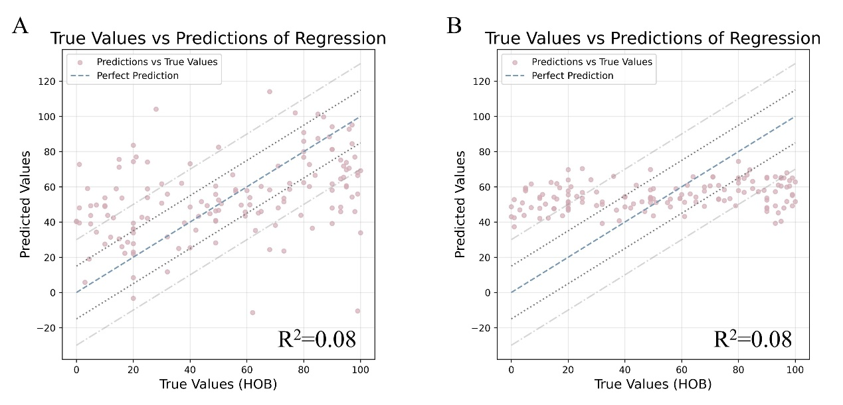
Fig. S1. The predicted HOB values vs. true values by our model without RDKit (A) and with RDKit (B).

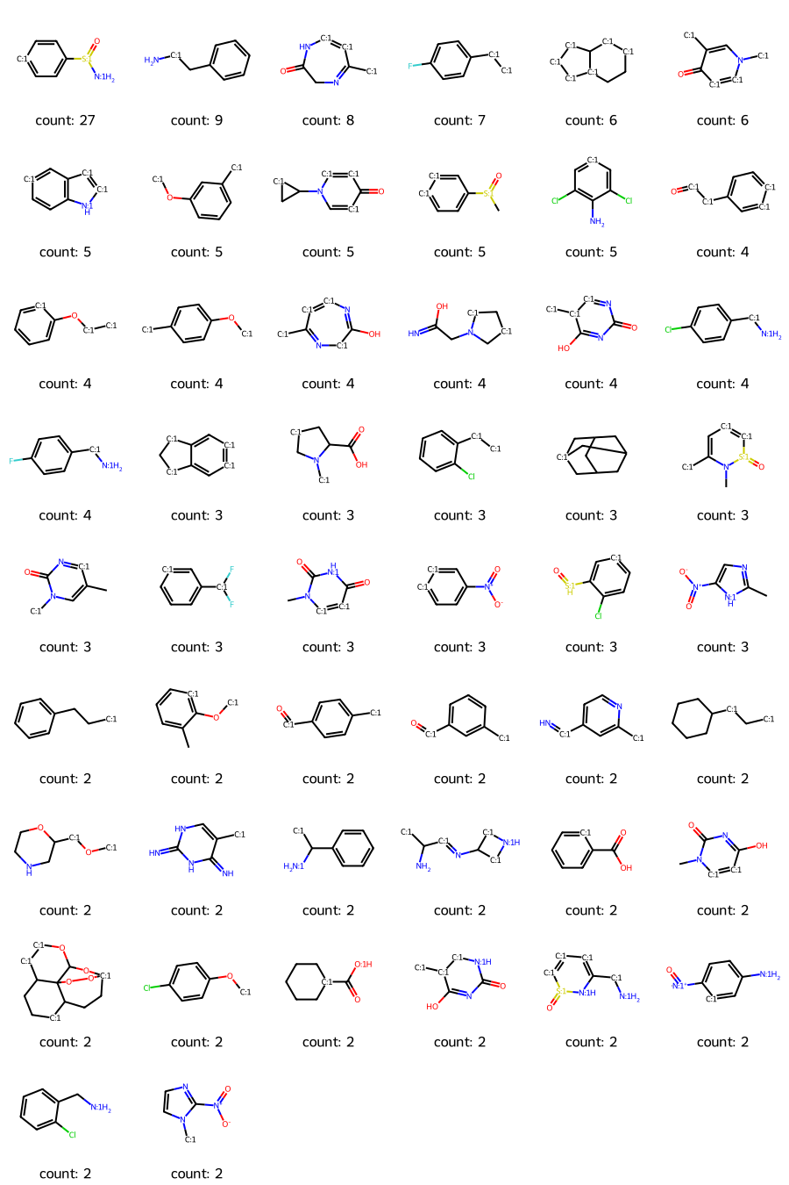
Fig. S2. The all substructures associated with HOB classification.

