Table S1
Comparison of mean biomarker levels across NHANES chemical groups. Different types of emerging contaminants (ECs) were expressed as mean.
Chemical group | Chemical | 2011/12 | 2013/14 | 2015/16 | 2017/18
Caffeine & Caffeine Metabolites (µmol/L) | 1-methyluric acid | 80.2 | 86.0 | No data | No data
Caffeine & Caffeine Metabolites (µmol/L) | 3-methyluric acid | 0.97 | 1.13 | No data | No data
Caffeine & Caffeine Metabolites (µmol/L) | 7-methyluric acid | 26.0 | 28.6 | No data | No data
Caffeine & Caffeine Metabolites (µmol/L) | 1,3-dimethyluric acid | 9.60 | 9.37 | No data | No data
Caffeine & Caffeine Metabolites (µmol/L) | 1,7-dimethyluric acid | 36.1 | 36.8 | No data | No data
Caffeine & Caffeine Metabolites (µmol/L) | 3,7-dimethyluric acid | 1.81 | 1.95 | No data | No data
Caffeine & Caffeine Metabolites (µmol/L) | 1,3,7-trimethyluric acid | 2.28 | 2.46 | No data | No data
Caffeine & Caffeine Metabolites (µmol/L) | 1-methylxanthine | 42.9 | 44.7 | No data | No data
Caffeine & Caffeine Metabolites (µmol/L) | 3-methylxanthine | 48.7 | 53.2 | No data | No data
Caffeine & Caffeine Metabolites (µmol/L) | 7-methylxanthine | 86.3 | 96.1 | No data | No data
Caffeine & Caffeine Metabolites (µmol/L) | 1,3-dimethylxanthine | 2.32 | 2.18 | No data | No data
Caffeine & Caffeine Metabolites (µmol/L) | 1,7-dimethylxanthine | 20.7 | 21.4 | No data | No data
Caffeine & Caffeine Metabolites (µmol/L) | 3,7-dimethylxanthine | 31.0 | 32.5 | No data | No data
Caffeine & Caffeine Metabolites (µmol/L) | 1,3,7-trimethylxanthine | 5.20 | 5.89 | No data | No data
Caffeine & Caffeine Metabolites (µmol/L) | 5-acetylamino-6-amino-3-methyluracil | 83.3 | 84.9 | No data | No data
Heavy Metal (µg/L) | Cobalt | No data | No data | 0.20 | 0.22
Heavy Metal (µg/L) | Blood manganese | 10.2 | 10.5 | 10.7 | No data
Heavy Metal (µg/L) | Urinary Total Arsenic | 19.2 | 14.9 | 13.7 | No data
Perchlorate, Nitrate & Thiocyanate (µg/L) | Perchlorate, urine | 4.85 | 4.63 | 4.06 | 3.85
Perchlorate, Nitrate & Thiocyanate (µg/L) | Nitrate, urine | 59921 | 58193 | 60477 | 55477
Perchlorate, Nitrate & Thiocyanate (µg/L) | Thiocyanate, urine | 2722 | 2856 | 2391 | 1944
Personal Care and Consumer Product Chemicals and Metabolites (µg/L) | Urinary Benzophenone-3 | No data | 253 | 264 | No data
 | Urinary Bisphenol A | No data | 2.76 | 2.32 | No data
 | Urinary Bisphenol S | No data | 1.44 | 1.52 | No data
 | Urinary Triclocarban | No data | 71.3 | 57.7 | No data
 | Methyl paraben | No data | 209 | 206 | No data
 | Propyl paraben | No data | 50.1 | 43.6 | No data
 | Urinary 2,4-dichlorophenol | 4.59 | 3.80 | 6.24 | No data
 | Urinary 2,5-dichlorophenol | 148 | 124 | 207 | No data
Pyrethroids, Herbicides, & Organophosphorus Metabolites (µg/L) | 2,4-dicholorphenoxyacetic acid | 0.53 | No data | 0.65 | No data
 | 3-phenoxybenzoic acid | 2.08 | No data | 2.02 | No data
 | para-Nitrophenol | 1.13 | No data | 0.98 | No data
Fluoride (µg/L) | Fluoride, Plasma | No data | 8.41 | 6.61 | No data
Fluoride (µg/L) | Fluoride, water | No data | 564 | 480 | No data
Fluoride (µg/L) | n-perfluorooctanoic acid | No data | No data | 1.81 | 1.63
Fluoride (µg/L) | n-perfluorooctane sulfonic acid | No data | No data | 5.10 | 4.75
Fluoride (µg/L) | Perfluorodecanoic acid | No data | No data | 0.26 | 0.27
Fluoride (µg/L) | Perfluorohexane sulfonic acid | No data | 0.07 | 1.61 | 1.60
Fluoride (µg/L) | Perfluorononanoic acid | No data | 0.07 | 0.78 | 0.57
Fluoride (µg/L) | Perfluoromethylheptane sulfonic acid isomers | No data | No data | 1.94 | 1.76
Nicotine Metabolites and Analogs (μg/L) | Total Cotinine, urine | No data | 1008 | 850 | 523
Nicotine Metabolites and Analogs (μg/L) | Total Hydroxycotinine, urine | No data | 1931 | 1788 | 1022

Table S2
Potential mediators for all emerging contaminants (ECs).
Emerging contaminant | Potential mediators | Mediators available in NHANES include
1,3,7-trimethyluric acid | Diet and medicines | Dietary assessment using total protein, fat, iron and calcium in the diet
1,3,7-trimethylxanthine (caffeine) | Diet and medicines | Frequency of consumption of milk, cheese and other dairy products
1,3-dimethyluric acid | Diet and medicines | Occupation data in the 2011/12, 2013/14, 2015/16 and 2017/18 waves
1,3-dimethylxanthine (theophylline) | Diet and medicines | Prescription medications
1,7-dimethyluric acid | Diet and medicines | Smoking data
1,7-dimethylxanthine (paraxanthine) | Diet and medicines | Personal care products use
1-methyluric acid | Diet and medicines
1-methylxanthine | Diet and medicines
2,4-dicholorphenoxyacetic acid | Occupation
Urinary 2,4-dichlorophenol | Diet, occupation and personal care products
Urinary 2,5-dichlorophenol | Diet, occupation and personal care products
3,7-dimethyluric acid | Diet and medicines
3,7-dimethylxanthine (theobromine) | Diet and medicines
3-methyluric acid | Diet and medicines
3-methylxanthine | Diet and medicines
3-phenoxybenzoic acid | Occupation
5-acetylamino-6-amino-3-methyluracil | Diet and medicines
7-methyluric acid | Diet and medicines
7-methylxanthine | Diet and medicines
Manganese, blood | Occupation
Cobalt | Diet
Fluoride, plasma, averaged | Water
Fluoride, water, averaged | Water
Methyl paraben | Diet, occupation and personal care products
Nitrate, urine | Diet, dairy products and water
n-perfluorooctane sulfonic acid (n-PFOS) | Occupation and personal care products
n-perfluorooctanoic acid (n-PFOA) | Occupation and personal care products
para-Nitrophenol | Occupation
Perchlorate, urine | Diet, occupation, dairy products and water
Perfluorodecanoic acid (PFDeA) | Occupation and personal care products
Perfluorohexane sulfonic acid (PFHxS) | Occupation and personal care products
Perfluorononanoic acid (PFNA) | Occupation and personal care products
Propyl paraben | Diet, occupation and personal care products
Perfluoromethylheptane sulfonic acid isomers (Sm-PFOS) | Occupation and personal care products
Thiocyanate, urine | Diet, dairy products and smoking
Total Cotinine, urine | Smoking
Total Hydroxycotinine, urine | Smoking
Urinary Total Arsenic | Water
Urinary Benzophenone-3 | Diet, occupation and personal care products
Urinary Bisphenol A | Diet, occupation and personal care products
Urinary Bisphenol S | Diet, occupation and personal care products
Urinary Triclosan | Diet, occupation and personal care products

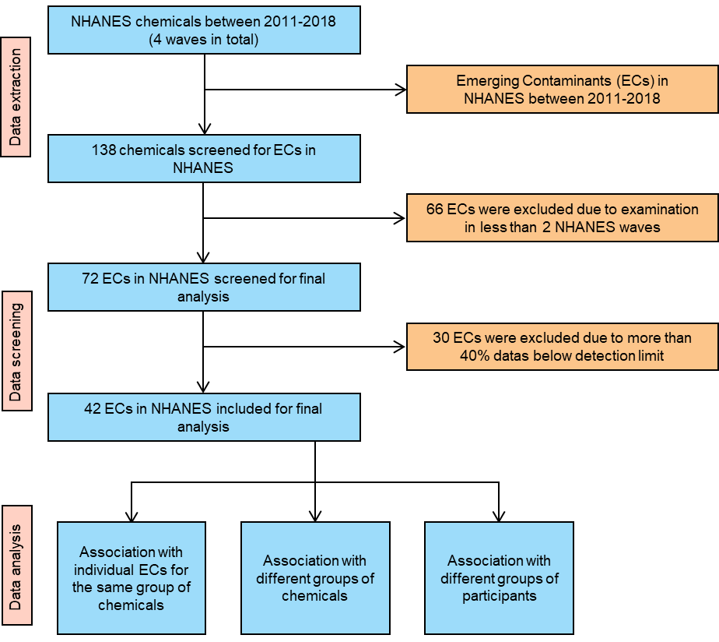
Figure S1 Flowchart of chemicals

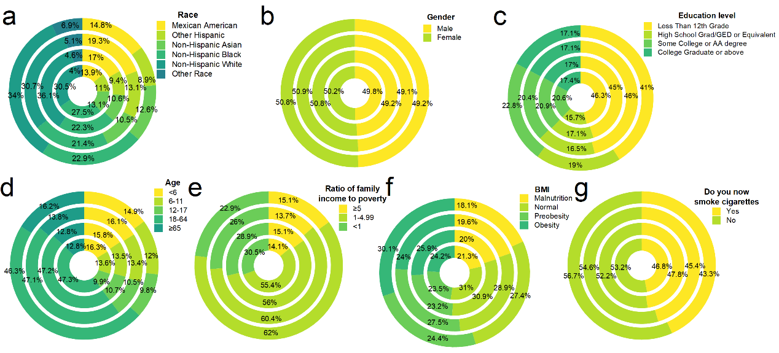
Figure S2 Circular diagrams showing the study participants composition. The seven circular diagrams are respectively about the population race, gender, education level, age, poverty-to-income ratio (PIR), body mass index (BMI) and smoking quantity.

