Supporting Information
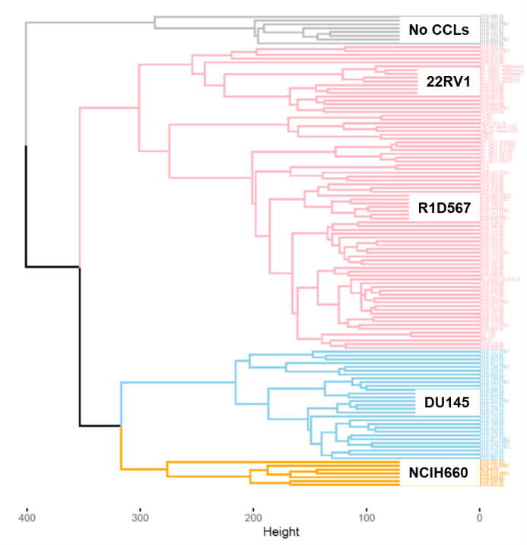
Figure S1: Hierarchical clustering of transcriptomes of SU2C/PC-WC patient tumors and 10 prostate cancer cell lines and their derivatives. A representative cell line from each cluster is highlighted in the boxes.

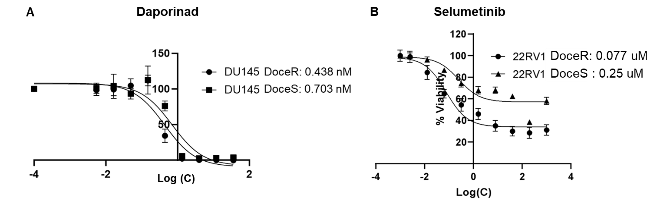
Figure S2: Dose-response curves constructed from WST absorbance data for daporinad (A) and selumetinib (B) in docetaxel resistant and sensitive clones of DU145 and 22RV1, respectively.

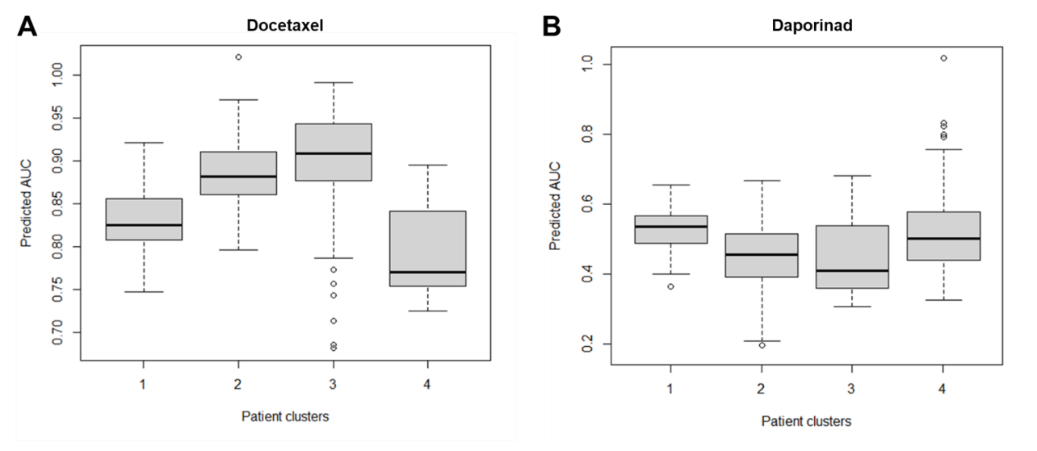
Figure S3: Oncopredict imputed drug sensitivities of SU2C-EC patients to docetaxel (A) and daporinad (B), stratified by cluster assignment obtained from hierarchical clustering of patient transcriptomes with PC lines.

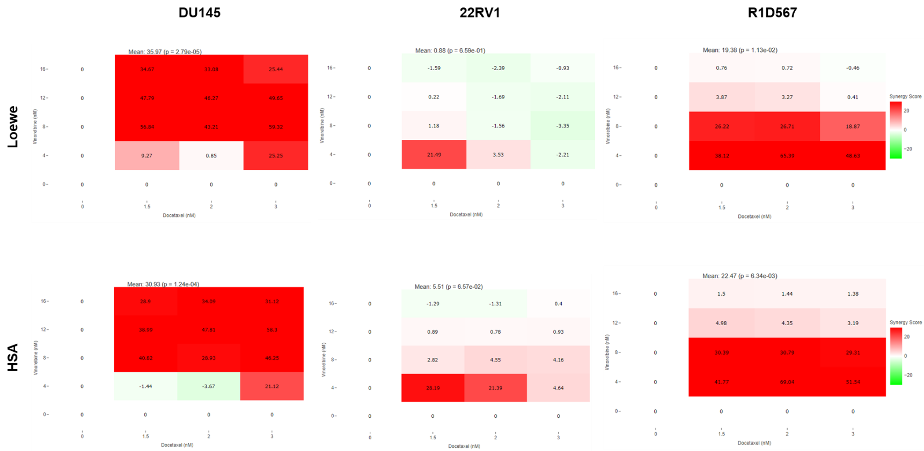
Figure S4: Synergy scores for docetaxel and vinorelbine calculated using the Loewe additivity model and Highest Single Agent (HSA) models from combination and monotherapy responses in individual cell-lines.

