Direct Identification of Yeasts from Blood Cultures and Body Fluids Using MALDI-TOF MS with Concurrent Antifungal Susceptibility Testing
Arpita Khamrai^{1#}, Snigdha Reddy^{1#}, Saikat Paul^{1, 2}, Ankita Saroya¹, Shristi Verma¹, Diksha Bhangot¹, Shivaprakash M Rudramurthy¹, Harsimran Kaur¹, Neelam Taneja¹, Anup K. Ghosh¹*
¹Department of Medical Microbiology, Postgraduate Institute of Medical Education and Research (PGIMER), Chandigarh, India
²Department of Clinical Pharmacy and Translational Science, University of Tennessee Health Science Center, Memphis, TN, USA.
# Joint first author
* Corresponding author.
Correspondence: Dr. Anup K Ghosh
Professor
Department of Medical Microbiology,
Postgraduate Institute of Medical Education and Research (PGIMER),
Chandigarh 160012, India.
Email: anupkg3@gmail.com
Tel.: +91 172 2755156.
Fax: +91 172 2744401.

Table S1 Number of samples in each grade of yeast cells per OIF.
Number of cells/OIF | Grade | Number of samples; %
<10 | 1 | 224 (35.3%)
10-20 | 2 | 191 (30.1%)
20-30 | 3 | 96 (15.2%)
>30 | 4 | 122 (19.2%)

Table S2 Haemocytometer counts comparison with Gram’ stain counts and accuracy in direct identification.
No. | Gram’s stain count | Haemocytometer | Direct ID | Culture ID
1 | >30 | 9 x 10⁶ | C. glabrata | C. glabrata
2 | <5 | 14.7 x 10⁶ | W. anomalus | W. anomalus
3 | >30 | 10 x 10⁶ | C. glabrata | C. glabrata
4 | 10-12 | 33.2x106 | C. krusei | C. krusei
5 | 11-12 | 24.7x106 | W. anomalus | W. anomalus
6 | 15-16 | 22.5x106 | C. krusei | C. krusei
7 | 15-20 | 25x106 | C. tropicalis | C. tropicalis
8 | 5-10 | 3.5x106 | C. tropicalis | C. tropicalis
9 | 4-5 | 23.7x106 | K. ohmeri | K. ohmeri
10 | >30 | Cluster | C. glabrata | C. glabrata
11 | 8-10 | 27 x 106 | C. tropicalis | C. tropicalis
12 | 7-8 | 38 x 106 | C. utilis | C. utilis
13 | 3-4 | 38.7 x 106 | C. parapsilosis | C. parapsilosis
14 | 3-4 | 42 x106 | C. utilis | C. utilis
15 | 8-10 | 35x106 | W. anomalus | W. anomalus
16 | 30-35 | 32x106 | C. utilis | C. utilis
17 | 10-15 | 20x106 | C. tropicalis | C. tropicalis
18 | 2-3 | 30x106 | C. orthopsilosis | C. orthopsilosis
19 | 4-5 | 42x106 | C. utilis | C. utilis
20 | 12-15 | 36x106 | C. utilis | C. utilis
21 | 10-15 | 60x106 | C. auris | C. auris
22 | 15-20 | 25x106 | C. utilis | C. utilis

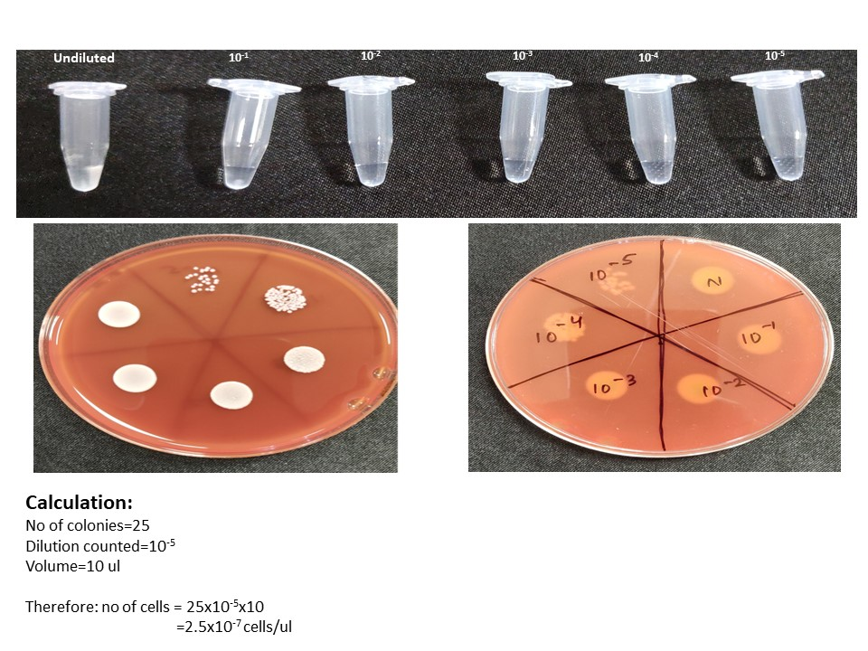
Fig. S1 Viability test result on blood agar with 5 different dilutions (10⁻¹. 10⁻². 10⁻³. 10⁻⁴ and 10⁻⁵). and undiluted (N).

Table S3 Mixed infection cases screened by Direct MALDI-TOF protocol.
SL.No | Culture ID | Direct ID | Direct ID | Identification
1 | C. tropicalis + S. epidermidis | C. tropicalis | 2.2 | Identified
2 | C. albicans + S. hemolyticus | C. albicans | 1.6 | Identified
3 | C. glabrata + S. epidermidis | C. glabrata | 2.6 | Identified
4 | C. krusei + S. epidermidis | C. krusei | 1.3 | Identified
5 | C. albicans + S. epidermidis | C. albicans | 1.95 | Identified
6 | C. krusei + S. epidermidis | C. krusei | 1.827 | Identified
7 | C. tropicalis + S. epidermidis | C. tropicalis | 2.052 | Identified
8 | C. tropicalis + S. epidermidis | C. tropicalis | 1.807 | Identified
9 | C. utilis + S. epidermidis | C. utilis | 1.925 | Identified
10 | C. parapsilosis + S. epidermidis | C. parapsilosis | 1.75 | Identified
11 | C. utilis + S. hemolyticus | S. hemolyticus | 1.79 | Not identified
12 | C. krusei + S. epidermidis | S. epidermidis | 2.07 | Not identified
13 | C. krusei + S. aureus | S. aureus | 2.27 | Not identified
14 | C. albicans + E. faecalis | E. faecalis | 1.945 | Not identified
15 | C. utilis + S. hominis | S. hominis | 2.149 | Not identified
16 | C. albicans + Acinetobacter | C. albicans | 1.6 | Identified
17 | W. anomalus + Acinetobacter | W. anomalus | 2.3 | Identified
18 | C. tropicalis + Acinetobacter | Acinetobacter | 2.01 | Not identified
19 | C. krusei + E. faecium | E. faecium | 1.994 | Not identified
20 | C. krusei + E. coli | E. coli | 2 | Not identified
21 | C. tropicalis + Klebsiella | Klebsiella | 2.1 | Not identified
22 | C. tropicalis + Klebsiella | Klebsiella | 1.7 | Not identified
23 | Trichosporon asahii + E. coli | E. coli | 2.1 | Not identified
24 | Trichosporon asahii + E. coli | E. coli | 2 | Not identified
25 | T. asahii + W. anomalus | T. asahii + W. anomalus | 1.570/1.573 | Identified
26 | T. asahii + W. anomalus | T. asahii + W. anomalus | 2.229/1.662 | Identified
27 | C. auris + C. albicans | C. auris + C. albicans | 1.790/1.416 | Identified
28 | C. guilliermondii + P.occidentalis | C. guilliermondii | 1.545 | Incomplete
29 | T. asahii + L. elongisporus | S. epidermidis | 2.029 | Not identified
30 | K. ohmeri + C. krusei | S. epidermidis | 1.838 | Not identified

