Appendix
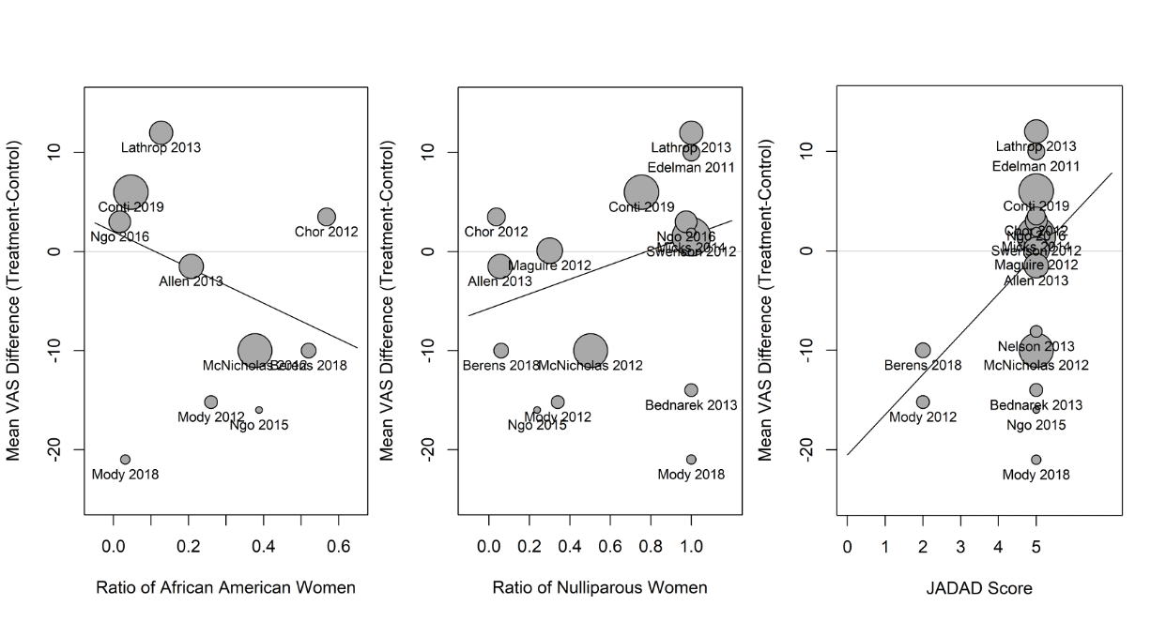
Figure s1: Bubble plots: IUD Insertion
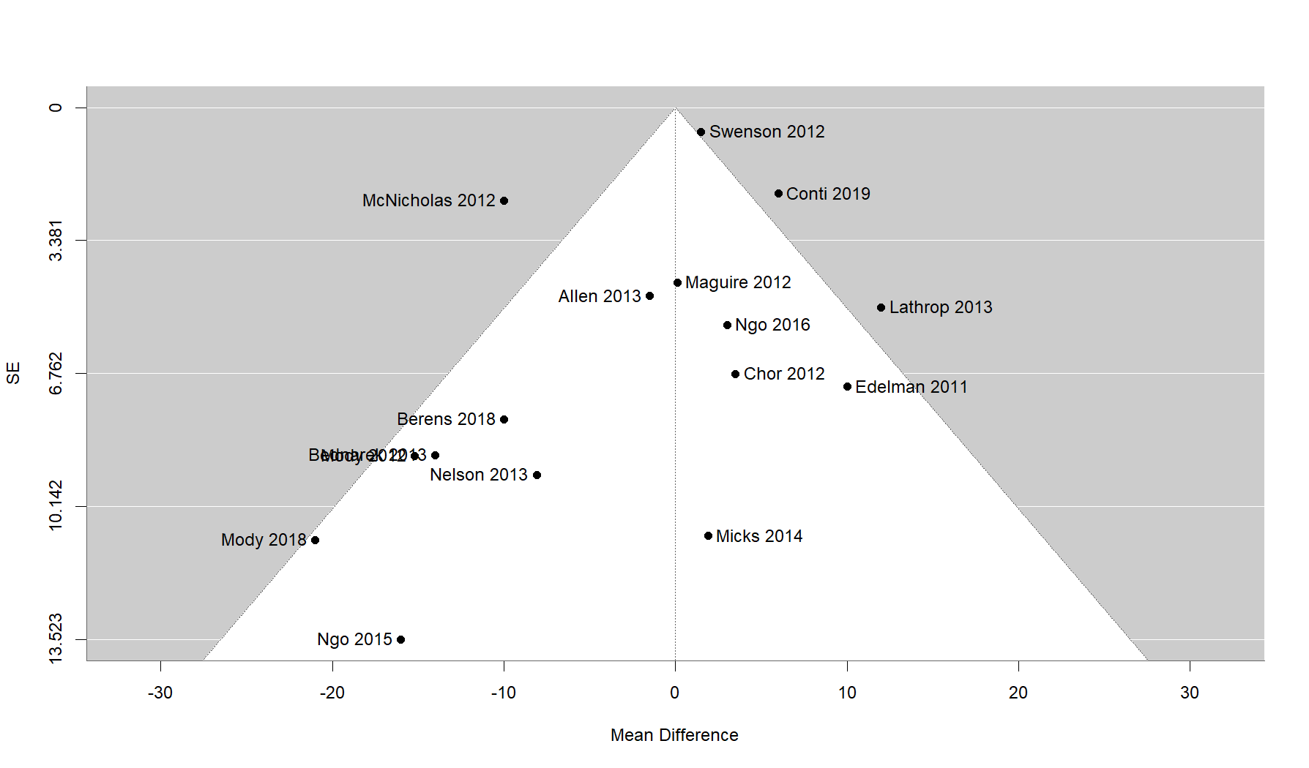Figure s2: Funnel plots: IUD Insertion
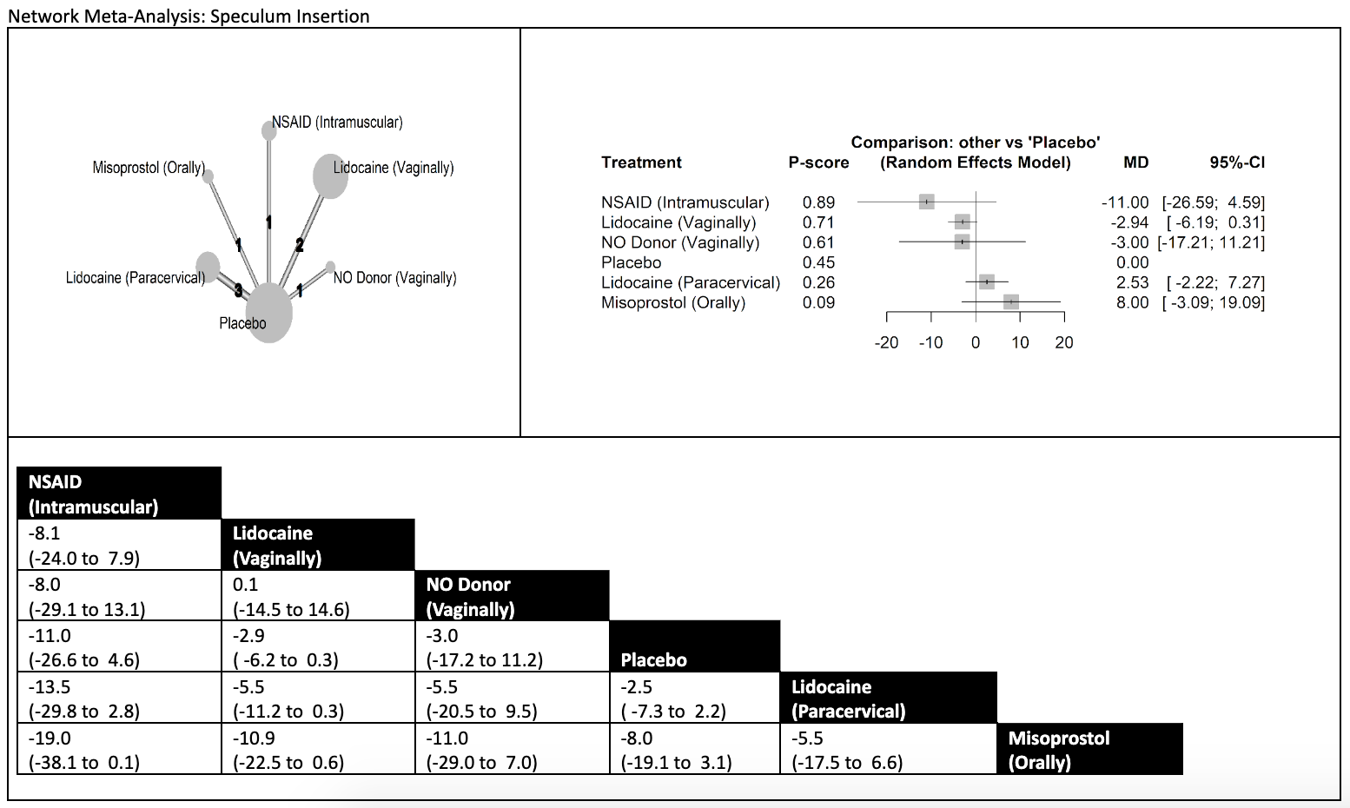
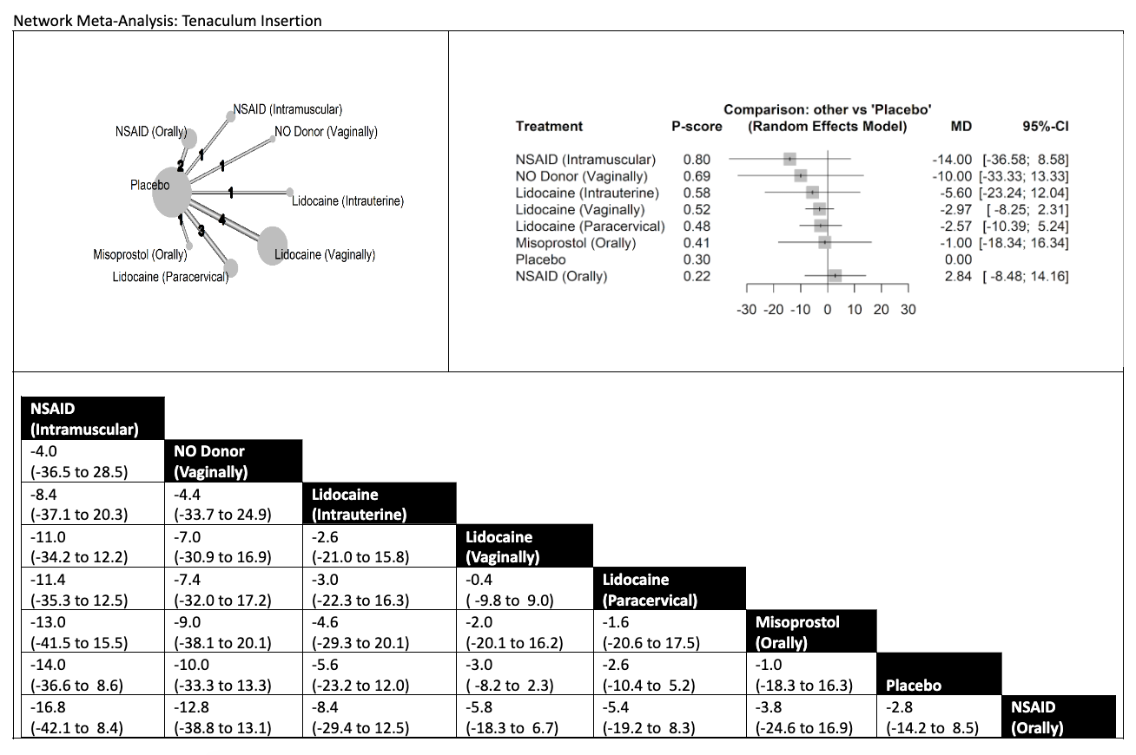
Figure s3: Network Meta-Analysis: Speculum Insertion

Figure s4: Network Meta-Analysis: Tenaculum Placement
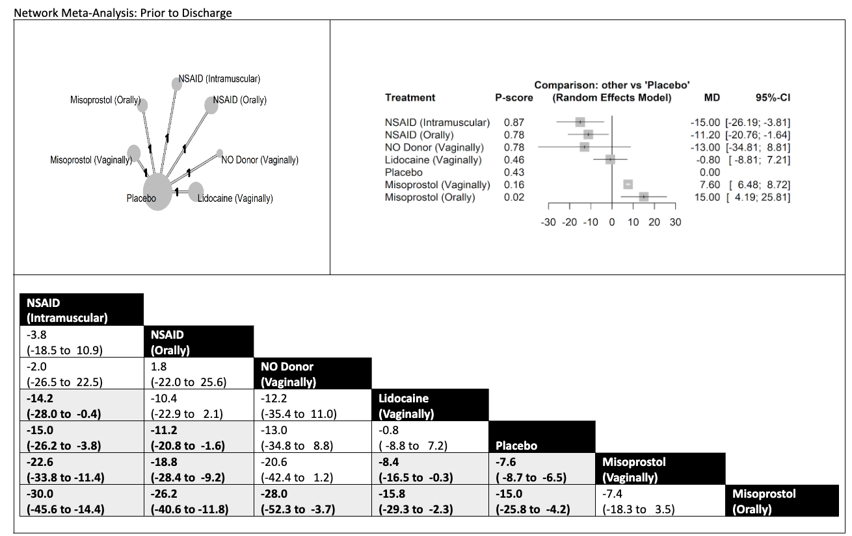
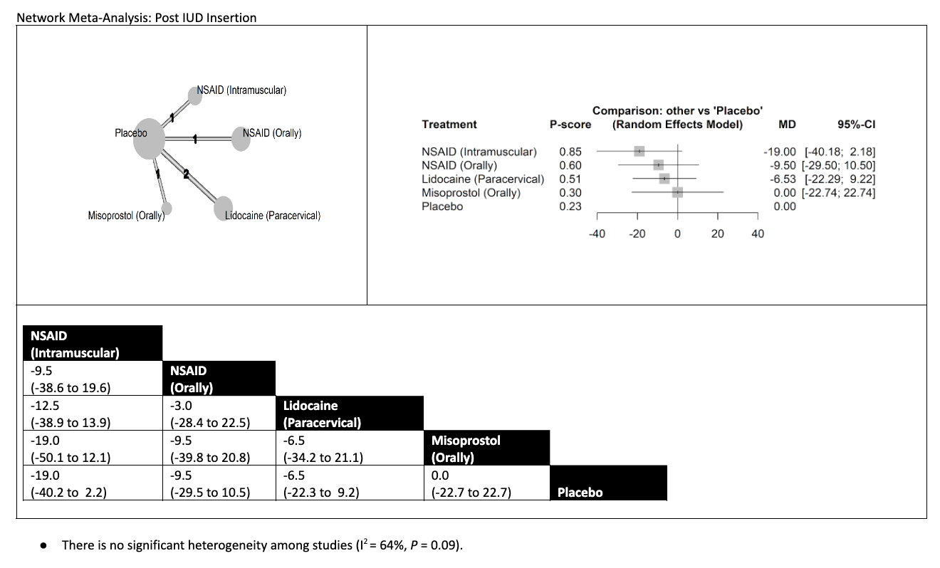
Figure s5: Network Meta-Analysis: Post IUD Insertion

Figure s6: Network Meta-Analysis: Prior to Discharge

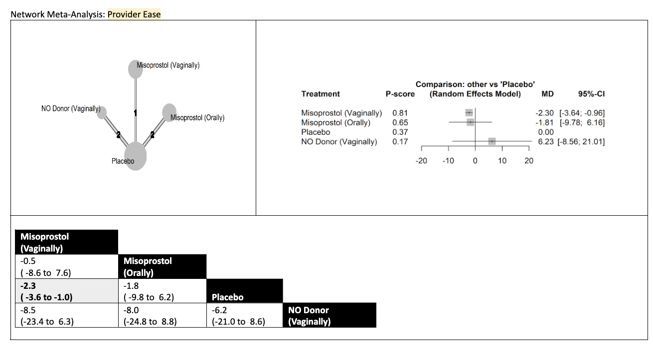
Figure s7: Network Meta-Analysis: Provider Ease
Covariate |  | Tenaculum Insertion
 |  | n | Regression Coefficient  (95% CI) | P Value | Heterogeneity Explained  By Covariate (%)
Mean Age |  | 12 | -1.3 (-2.9 to 0.1) | 0.07 | 48.7%
Ratio of Caucasian Women |  | 12 | -1.2 (-15.7 to 13.3) | 0.87 | 0.0%
Ratio of African American Women |  | 9 | -3.5 (-27.1 to 20.1) | 0.77 | 0.0%
Ratio of Hispanic Women |  | 9 | 13.6 (-3.2 to 30.4) | 0.11 | 34.6%
Ratio of Nulliparous Women |  | 12 | 3.8 (-6.9 to 14.4) | 0.49 | 0.0%
Route of Delivery |  | 13 | -- | 0.58 | 0.0%
 | Orally | 3 | reference | reference | --
 | Vaginally | 5 | -5.0 (-15.3 to 5.3) | 0.34 | --
 | Other (Intramuscular,  Intrauterine, Paracervical) | 5 | -5.6 (-16.8 to 5.7) | 0.33 | --
Premedication (e.g. ibuprofen) |  | 13 | -- | 0.97 | 0.0%
 | No | 10 | reference | reference | --
 | Yes | 3 | -0.2 (-7.2 to 6.9) | 0.97 | --
JADAD Score |  | 12 | -0.2 (-8.7 to 8.3) | 0.96 | 0.0%
VAS Pain Scale |  | 13 | -- | 0.95 | 0.0%
 | 0-100 | 8 | reference | reference | --
 | 0-10 (or 0-9) | 5 | 0.2 (-7.2 to 7.6) | 0.95 | --
Table s1: Univariate Meta-Regression: Tenaculum Placement
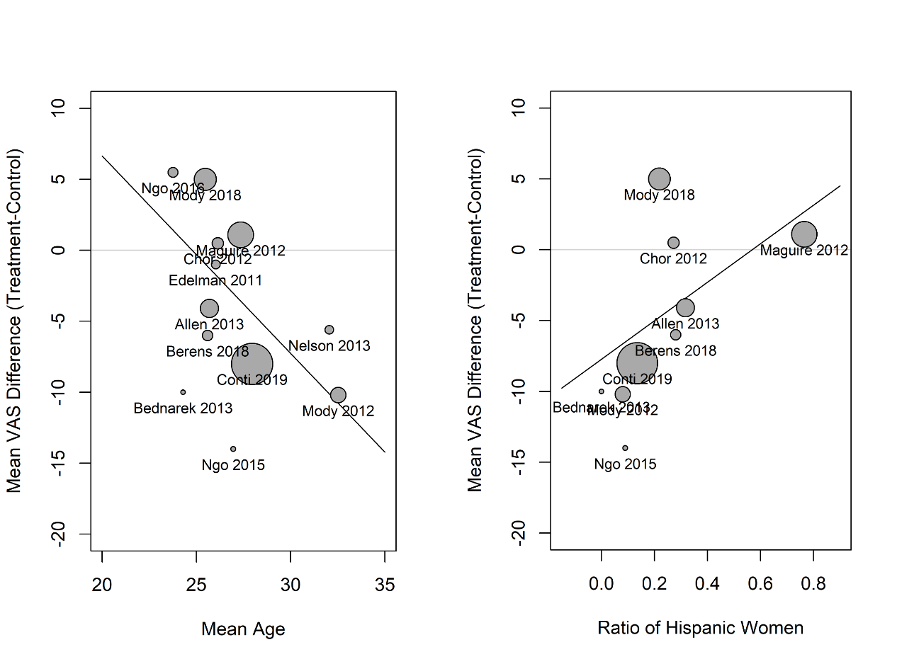

Figure s8: Bubble plots: Tenaculum Insertion
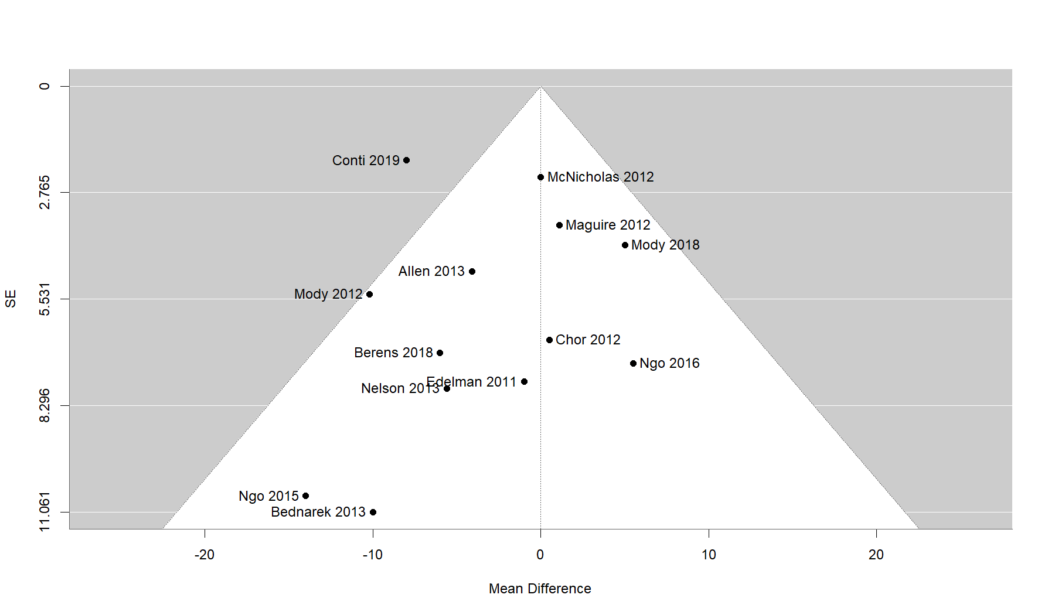
Figure s9: Funnel plot: Tenaculum Insertion

