Urban compactness and carbon emissions: global evidence over the period 1975-2020

Giorgio Musto
GREEN Bocconi
Università Bocconi

Marco Percoco
Department of Social and Political Sciences and GREEN
Università Bocconi

Extended data
Extended Data Table 1 – Associations between urban form indicators and CO₂ emissions (balanced panel)
- Residential emissions
 | (1) | (2) | (3) | (4)
GDP p.c. | 0.138*** | 0.168*** | 0.171*** | 0.172***
 | (0.047) | (0.049) | (0.049) | (0.048)
Area | 0.223***
 | (0.035)
CI |  | -0.269***
 |  | (0.039)
RI |  |  | -0.146***
 |  |  | (0.022)
SI |  |  |  | 0.179**
 |  |  |  | (0.072)
Constant | -4.700*** | -4.328*** | -4.294*** | -4.123***
 | (0.346) | (0.339) | (0.342) | (0.348)
Env. controls | Yes | Yes | Yes | Yes
Observations | 41,402 | 41,402 | 41,402 | 41,396
R² | 0.112 | 0.089 | 0.086 | 0.088
Standard errors in parentheses. * p < 0.1, ** p < 0.05, *** p < 0.01. All variables are taken in natural log terms.
- On-road transport emissions
 | (1) | (2) | (3) | (4)
GDP p.c. | 0.528*** | 0.568*** | 0.573*** | 0.574***
 | (0.150) | (0.155) | (0.155) | (0.152)
Area | 0.282***
 | (0.045)
CI |  | -0.341***
 |  | (0.077)
RI |  |  | -0.164***
 |  |  | (0.042)
SI |  |  |  | -0.207
 |  |  |  | (0.248)
Constant | -7.823*** | -7.285*** | -7.219*** | -7.286***
 | (1.194) | (1.311) | (1.328) | (1.245)
Env. controls | Yes | Yes | Yes | Yes
Observations | 15,052 | 15,052 | 15,052 | 15,051
R² | 0.772 | 0.762 | 0.760 | 0.760
Standard errors in parentheses. * p < 0.1, ** p < 0.05, *** p < 0.01. All variables are taken in natural log terms.

Extended Data Table 2 – Associations between urban form indicators and total CO₂ emissions
 | (1) | (2) | (3) | (4)
GDP p.c. | 0.400*** | 0.438*** | 0.442*** | 0.442***
 | (0.054) | (0.053) | (0.052) | (0.052)
Area | 0.253***
 | (0.030)
CI |  | -0.245***
 |  | (0.038)
RI |  |  | -0.072**
 |  |  | (0.028)
SI |  |  |  | -0.010
 |  |  |  | (0.104)
Constant | -4.687*** | -4.287*** | -4.240*** | -4.220***
 | (0.343) | (0.342) | (0.342) | (0.336)
Env. controls | Yes | Yes | Yes | Yes
Observations | 53,685 | 53,685 | 53,685 | 53,648
R² | 0.441 | 0.424 | 0.423 | 0.423
Standard errors in parentheses. * p < 0.1, ** p < 0.05, *** p < 0.01. All variables are taken in natural log terms.

Extended Data Table 3 – Associations between urban form indicators and CO₂ emissions, with country-specific time trends
- Residential emissions
 | (1) | (2) | (3) | (4)
GDP p.c. | 0.263*** | 0.284*** | 0.287*** | 0.282***
 | (0.043) | (0.046) | (0.046) | (0.047)
Global trend | -0.019*** | -0.018*** | -0.018*** | -0.015***
 | (0.002) | (0.002) | (0.002) | (0.003)
Area | 0.116***
 | (0.025)
CI |  | -0.160***
 |  | (0.030)
RI |  |  | -0.092***
 |  |  | (0.018)
SI |  |  |  | 0.324***
 |  |  |  | (0.043)
Constant | 19.914*** | 19.361*** | 19.312*** | 13.538***
 | (4.208) | (4.422) | (4.443) | (4.694)
Env. controls | Yes | Yes | Yes | Yes
Observations | 53,134 | 53,134 | 53,134 | 53,098
R² | 0.343 | 0.336 | 0.335 | 0.345
Standard errors in parentheses. * p < 0.1, ** p < 0.05, *** p < 0.01. All variables are taken in natural log terms.
- On-road transport emissions
 | (1) | (2) | (3) | (4)
GDP p.c. | 0.187* | 0.233* | 0.240* | 0.239*
 | (0.104) | (0.123) | (0.125) | (0.124)
Global trend | 0.010* | 0.010 | 0.009 | 0.010
 | (0.006) | (0.006) | (0.006) | (0.006)
Area | 0.225***
 | (0.036)
CI |  | -0.335***
 |  | (0.063)
RI |  |  | -0.176**
 |  |  | (0.072)
SI |  |  |  | 0.186
 |  |  |  | (0.127)
Constant | -90.496*** | -90.011*** | -89.828*** | -92.580***
 | (11.198) | (13.101) | (13.386) | (11.956)
Env. controls | Yes | Yes | Yes | Yes
Observations | 20,000 | 20,000 | 20,000 | 19,998
R² | 0.845 | 0.837 | 0.836 | 0.836
Standard errors in parentheses. * p < 0.1, ** p < 0.05, *** p < 0.01. All variables are taken in natural log terms.

Extended Data Table 4 – Associations between urban form indicators and CO₂ emissions, one-lag Arellano-Bond estimator
- Residential emissions
 | (1) | (2) | (3) | (4)
L1.CO₂ (RES) | -0.068*** | -0.022 | -0.019 | 0.294***
 | (0.017) | (0.017) | (0.017) | (0.017)
GDP p.c. | 0.121*** | 0.153*** | 0.156*** | 0.176***
 | (0.003) | (0.003) | (0.003) | (0.003)
Area | 0.170***
 | (0.006)
CI |  | -0.174***
 |  | (0.019)
RI |  |  | -0.112***
 |  |  | (0.020)
SI |  |  |  | 0.535***
 |  |  |  | (0.014)
Constant | -3.842*** | -3.465*** | -3.445*** | -2.200***
 | (0.087) | (0.086) | (0.086) | (0.087)
Env. controls | Yes | Yes | Yes | Yes
Observations | 38,276 | 38,276 | 38,276 | 38,262
Standard errors in parentheses. * p < 0.1, ** p < 0.05, *** p < 0.01. All variables are taken in natural log terms.
- On-road transport emissions
 | (1) | (2) | (3) | (4)
L1.CO₂ (TRA) | 0.621*** | 0.619*** | 0.620*** | 0.612***
 | (0.014) | (0.015) | (0.015) | (0.016)
GDP p.c. | 0.363*** | 0.421*** | 0.428*** | 0.433***
 | (0.014) | (0.014) | (0.014) | (0.014)
Area | 0.285***
 | (0.016)
CI |  | -0.369***
 |  | (0.052)
RI |  |  | -0.184***
 |  |  | (0.055)
SI |  |  |  | -0.044
 |  |  |  | (0.047)
Constant | -5.747*** | -5.381*** | -5.342*** | -5.358***
 | (0.219) | (0.222) | (0.223) | (0.227)
Env. controls | Yes | Yes | Yes | Yes
Observations | 7,910 | 7,910 | 7,910 | 7,910
Standard errors in parentheses. * p < 0.1, ** p < 0.05, *** p < 0.01. All variables are taken in natural log terms.

Extended Data Table 5 – Regressions per quintile of the per capita residential emissions distribution
- Residential emissions
Quintiles: | 1 | 2 | 3 | 4 | 5
Area | 0.308** | 0.404*** | 0.213** | 0.151*** | 0.045
 | (0.132) | (0.083) | (0.081) | (0.036) | (0.036)
CI | -0.400*** | -0.375*** | -0.219*** | -0.162*** | -0.013
 | (0.088) | (0.077) | (0.057) | (0.038) | (0.048)
RI | -0.268*** | -0.152** | -0.110* | -0.081* | 0.041
 | (0.074) | (0.068) | (0.060) | (0.046) | (0.061)
SI | 0.221* | 0.335** | 0.325*** | 0.177* | 0.201
 | (0.120) | (0.136) | (0.105) | (0.092) | (0.149)
Standard errors in parentheses. * p < 0.1, ** p < 0.05, *** p < 0.01. All variables are taken in natural log terms. The quintiles in the distribution of the dependent variable are calculated for the year 1990. Environmental controls (temperature and precipitations) and GDP per capita are included.
(b) On-road transport emissions
Quintiles: | 1 | 2 | 3 | 4 | 5
Area | 0.682*** | 0.226*** | 0.337** | 0.210** | 0.083***
 | (0.031) | (0.009) | (0.062) | (0.094) | (0.005)
CI | -0.566** | -0.226*** | -0.200* | -0.143 | -0.091
 | (0.103) | (0.009) | (0.059) | (0.335) | (0.060)
RI | -0.370** | -0.024 | -0.054 | 0.185 | -0.083
 | (0.072) | (0.014) | (0.050) | (0.249) | (0.090)
SI | 0.876*** | 0.551*** | 0.470** | -0.298** | -0.176***
 | (0.055) | (0.037) | (0.093) | (0.106) | (0.044)
Standard errors in parentheses. * p < 0.1, ** p < 0.05, *** p < 0.01. All variables are taken in natural log terms. The quintiles in the distribution of the dependent variable are calculated for the year 2000. Environmental controls (temperature and precipitations) and GDP per capita are included.

Extended Data Table 6 – Summary statistics per continent
 | Africa | Asia | Europe | North America | Oceania | South America | World
N. of cities (2020) | 2,133 | 6,677 | 1,125 | 703 | 79 | 718 | 11,435
LIC | 38% | 4% | 0% | 0% | 0% | 0% | 9%
LMIC | 57% | 48% | 8% | 7% | 13% | 2% | 40%
UMIC | 5% | 43% | 24% | 39% | 29% | 91% | 37%
HIC | 0% | 5% | 69% | 54% | 58% | 7% | 14%
Population | 224,146 | 282,846 | 267,019 | 387,931 | 333,892 | 353,932 | 282,386
Area | 37 | 44 | 62 | 144 | 176 | 66 | 53
CI | 0.69 | 0.65 | 0.64 | 0.60 | 0.55 | 0.65 | 0.65
RI | 0.68 | 0.64 | 0.66 | 0.63 | 0.56 | 0.66 | 0.65
SI | 0.42 | 0.48 | 0.39 | 0.36 | 0.36 | 0.34 | 0.44
CO₂ p.c. | 0.61 | 2.00 | 4.41 | 4.98 | 4.73 | 1.40 | 2.32
CO₂ p.c. (RES) | 0.11 | 0.21 | 0.83 | 1.23 | 0.45 | 0.13 | 0.34
CO₂ p.c. (TRA) | 0.03 | 0.15 | 0.38 | 0.93 | 0.70 | 0.17 | 0.25
GDP p.c. | 2,372 | 6,292 | 18,022 | 26,561 | 25,219 | 8,494 | 8,938
Temperature | 23.60 | 19.97 | 10.10 | 17.66 | 19.12 | 21.39 | 19.27
Precipitations | 955 | 1,234 | 715 | 1,088 | 1,563 | 1,296 | 1,125
Note: CI = Compactness Index; RI = Range Index; SI = Sprawl Index.

Extended Data Table 7 – Correlation matrix for the main regressors
 | GDP p.c. | Area | CI | RI | SI
GDP p.c. | 1.000
Area | 0.332*** | 1.000
CI | -0.323*** | -0.413*** | 1.000
RI | -0.137*** | -0.158*** | 0.752*** | 1.000
SI | -0.224*** | -0.163*** | 0.104*** | -0.037*** | 1.000
Observations | 83,201

Extended Data Figure 1 – Heterogeneous effects of urban form indicators across income classes
(a) Total area | (b) Compactness Index
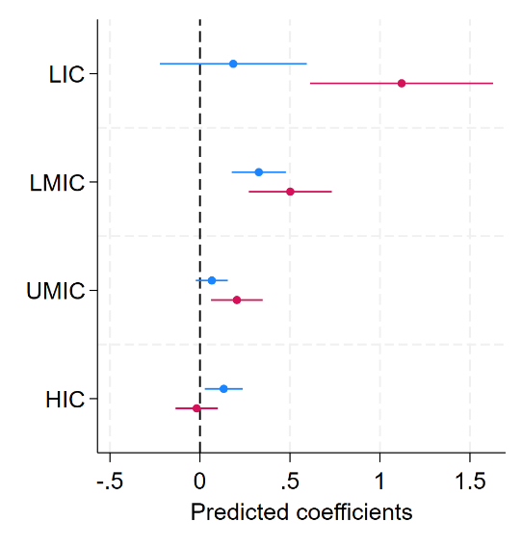 | 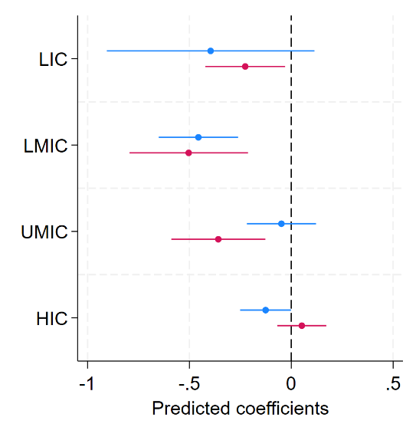
(c) Range Index | (d) Sprawl Index
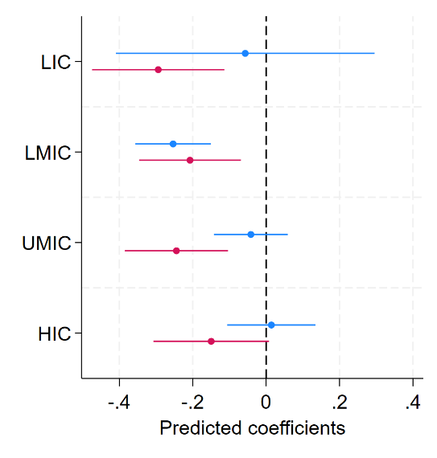 | 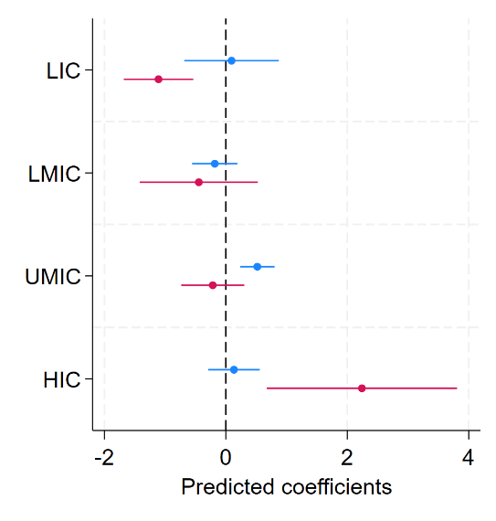
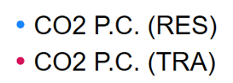
Note: the bands represent 95% confidence intervals around the coefficients.

Extended Data Figure 2 – World map of urban centres and CO₂ emissions per capita (residential sector) in 2020
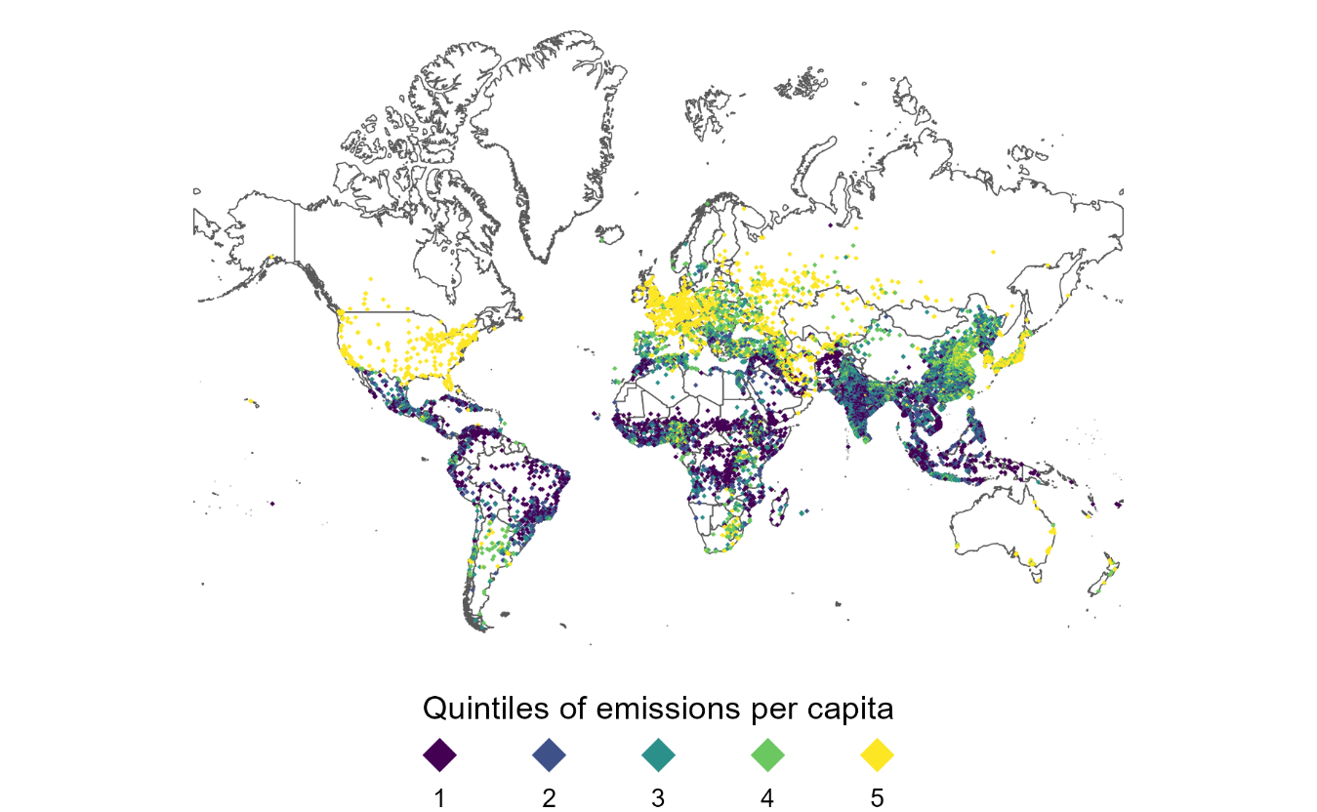

Extended Data Figure 3 – Evolution over time of urban form indicators by continent
- Area | - Compactness Index
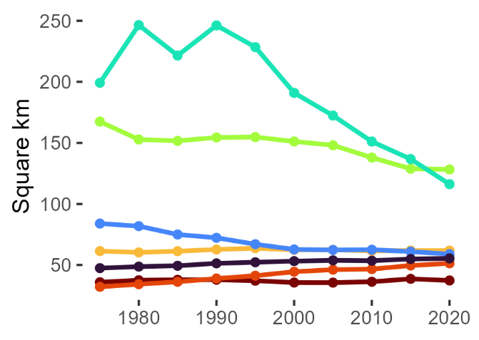 | 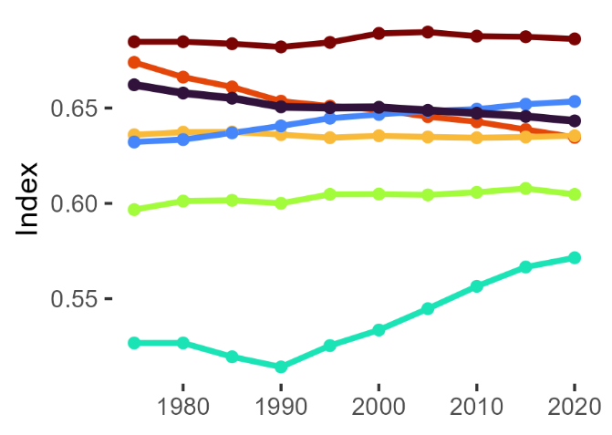
- Range Index | - Sprawl Index
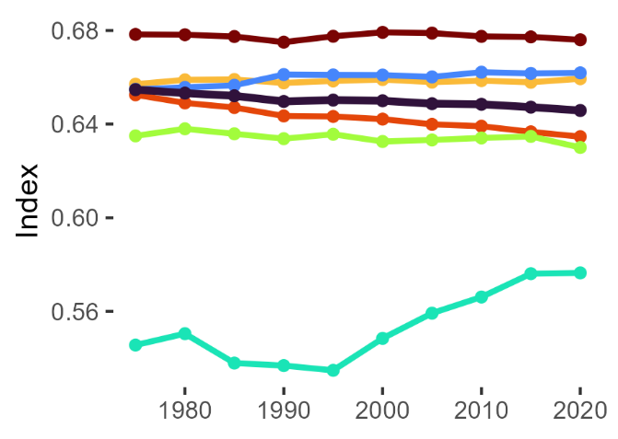 | 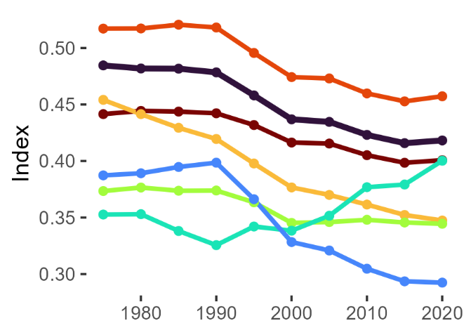
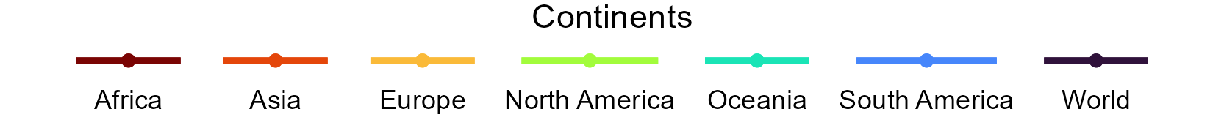

Supplementary information
The analysis of urban form and CO₂ emissions of the residential (heating and cooling for buildings) and on-road transport sectors is based on different spatial data sources, joined together using tools available in the R programming language. The starting point for these data consists of the urban boundaries identified following the Degree of Urbanization definition (where cities are defined based on a population threshold of at least 50,000 inhabitants and population density of at least 1,500 inhabitants per square km). To obtain the boundaries, we use the GHS-SMOD raster dataset, which codes 1 square km pixels based on whether they belong to rural or urban clusters, and assigns a specific code to pixels falling within the “Degree of Urbanization” population and density thresholds (1). We polygonise continuous raster pixels classified as “urban centres” and obtain spatial vector data on the boundaries of each of these entities. Supplementary Information Figure 1 maps the polygonization process for a sample region, the greater Paris area in France, for our reference year, 2020 (the GHS-SMOD data cover the entire world at 5 years intervals between 1975 and 2020, and we repeat the same process each year). Supplementary Information Figure 2 shows the changes in resulting boundaries across time periods, from 1975 to 2020, for two random cities in the sample.
To assign cities to corresponding information on CO₂ emissions, population, GDP and climate variables (temperatures and precipitations) each year, we proceed with a spatial join of the different data sources available and listed in Supplementary Information Table 1. For the merge, the polygons data on urban centres obtained starting from the GHS-SMOD raster data represents the master database, to which the raster information on other variables is joined. Before implementing the merge, the raster and the polygons data need to be projected spatially to the same Coordinate Reference System (CRS): we generally choose to re-project the polygons data to the same CRS as the raster data, which generally use the WGS84 projection, so we repeat this process for each spatial join. The only exceptions are information on population and built-up surface, which use the same CRS as our data on urban centres, and whose merge requires no re-projection. Supplementary Information Figure 3 shows the spatial juxtaposition of the urban boundaries and the raster data on on-road transport CO₂ emissions (taken as an example) in 2020, again for the Paris greater region. We match each polygon to the overlapping raster pixels, and we compute the share of raster cell surface that intersects the urban centre (the “coverage fraction”). This share will be equal to 1 for cells entirely inside the urban centre: in Supplementary Information Figure 3, for instance, the raster pixel highlighted with an arrow has a value of emissions of 37,513 tonnes. Being entirely contained in the Paris urban centre, it is assigned weight 1 in the computation. Finally, we sum together all the emissions values within the polygon boundaries, multiplied by the weights corresponding to the coverage fraction values. We thus come up with estimates of values of the raster variables (e.g. emissions, GDP, etc.) within the territory of the urban centre. The assumption being made to aggregate the raster data at the urban level is that the values of raster variables are uniformly distributed across the surface occupied by the raster pixel. This assumption is more believable for climate variables such as temperature and precipitations, while it becomes more problematic for CO₂ or GDP, whose values are clearly more concentrated where human activity is stronger. Nevertheless, the method allows for consistency in the way we estimate key variables across cities and provides us with an overview of urban socio-economic variables. Furthermore, for data at a higher resolution the bias due to the merge is reduced, even though estimates may be less accurate precisely because of the more pronounced spatial down-scaling. For information on population and built-up surface, the match with the urban boundaries is most reliable as the sources come from the same wider GHSL data project and share the same CRS and high resolution of 1 km.
Time trends for CO₂ emissions and ancillary variables obtained from the merge are displayed in Supplementary Information Figure 4, illustrating how urban population, share of built-up surface, per capita GDP and CO₂ emissions evolved over the time span of our sample. Finally, we also assign to each urban centre information on the corresponding municipality, region and country using the Global Administrative Boundaries (GADM) database (2). In this case, the spatial join is performed between two spatial vector datasets with polygon geometry, and the boundaries of polygons in the two datasets do not necessarily coincide. A city defined using the Degree of Urbanization criterion may in fact overlap the boundaries of different administrative-level municipalities. To merge the data, we assign to each urban centre the administrative unit with the largest overlapping surface, and the corresponding region, country, continent and country income class.

Supplementary Information Table 1 – Sources used for the construction of the data
Data Sources | Resolution | Years | Type of spatial join | Main Variables
GHS-SMOD 2023 (1) | 1 km | 1975-2020 (5 years intervals) | Master data | Urban boundaries
GHS-POP 2023 (3) | 1 km | 1975-2020 (5 years intervals) | Sum within urban boundaries | Population
GHS-BUILT 2023 (4) | 1 km | 1975-2020 (5 years intervals) | Sum within urban boundaries | Built-up surface: total, residential, non-residential (m²)
EDGAR v7.1 (5; 6) | 0.1 degrees (approx. 11.1x11.1 km at the equator) | 1970-2021 (yearly) | Weighted sum of emissions over urban boundaries | CO₂ emissions for heating and cooling of buildings, from  on-road transport and total (tonnes)
CRU TS v4.07 (7) | 0.5 degrees (approx. 56x56 km at the equator) | 1901-2021 (yearly) | Weighted mean within urban boundaries | Temperature (°C) and precipitations (mm)
Gridded data on GDP (8) | 5 arcmin (approx. 9x9 km at the equator) | 1990-2015 (yearly) | Weighted sum over urban boundaries | GDP (PPP, 2011 USD)
GADM Dataset (2) | Geo-referenced boundaries of administrative units | 2022 | The name of the administrative unit with largest overlapping surface was joined | Names of admin. units (country name, province name, municipality name)

Supplementary Information Figure 1 – Polygonization of GHS-SMOD raster data for urban centres
(a) GHS-SMOD raster data | (b) Polygonized raster data
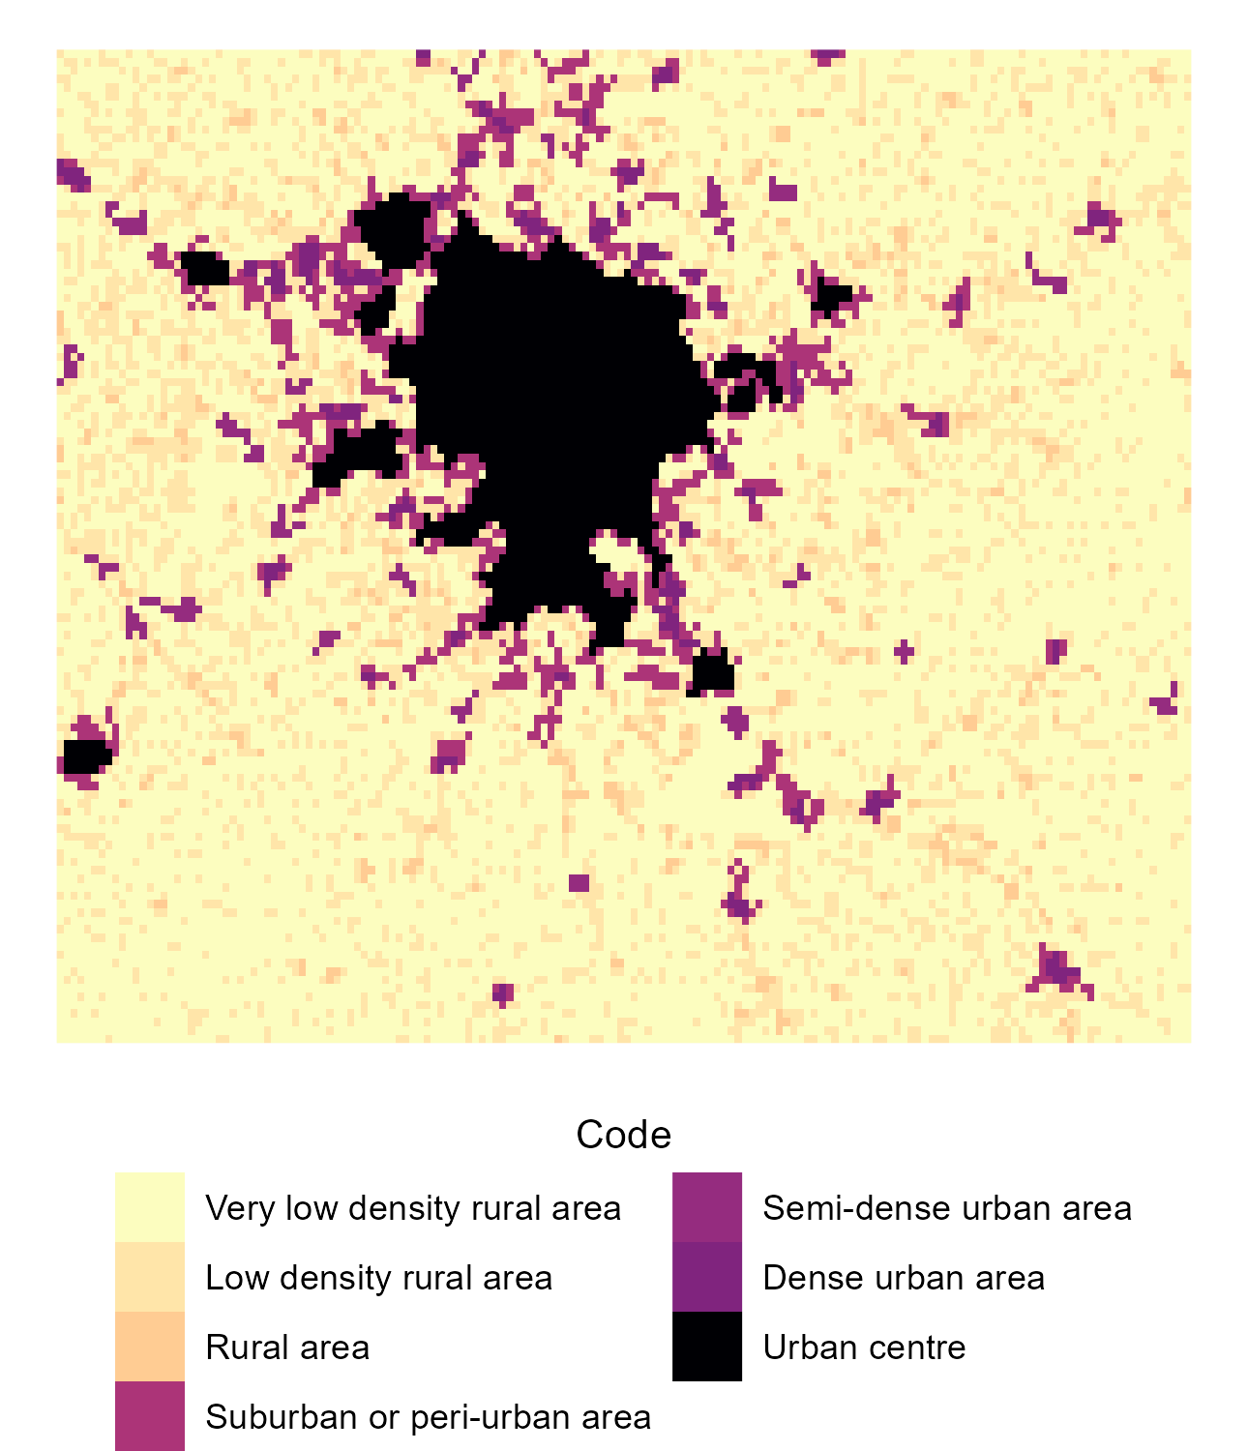 | 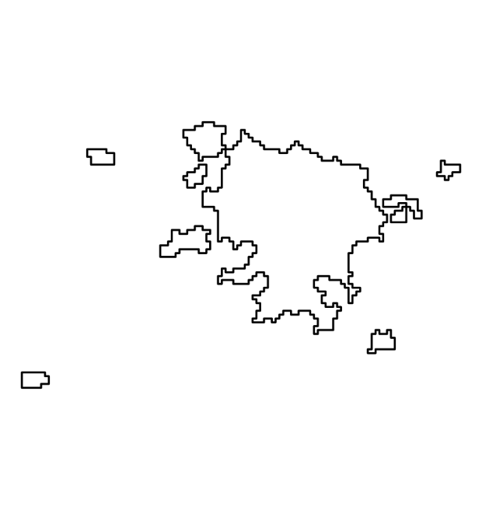

Supplementary Information Figure 2 – Changes in urban boundaries at selected time periods for two cities in the sample
(a) Berlin, Germany | (b) Havana, Cuba
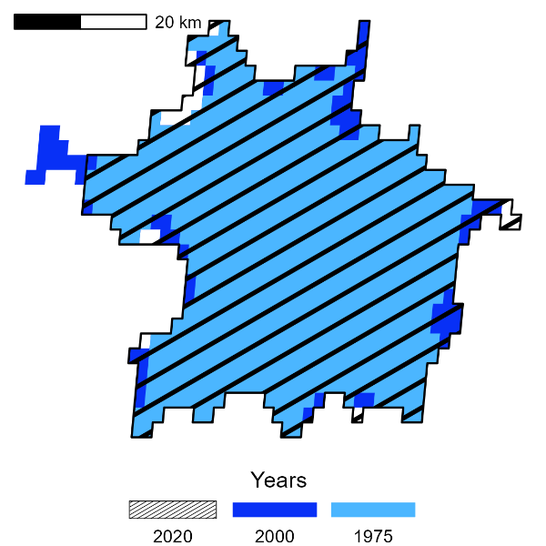 | 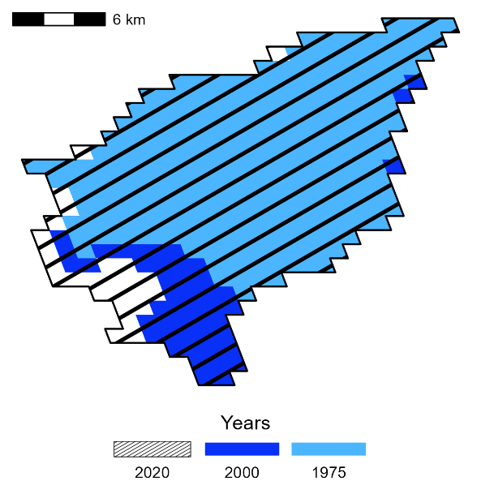
Supplementary Information Figure 3 – Spatial juxtaposition of the boundaries of urban centres and on-road transport CO₂ emissions data in 2020 for the Paris region
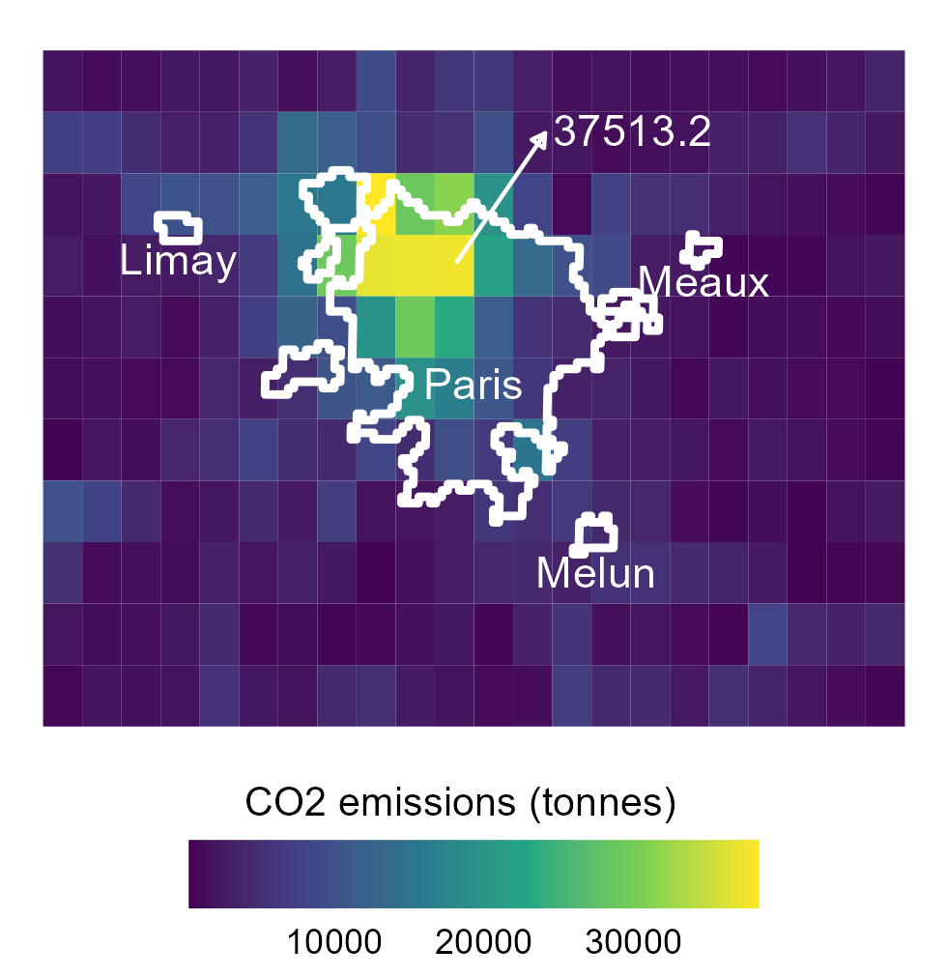

Supplementary Information Figure 4 –
- Population | - Share of residential built-up surface
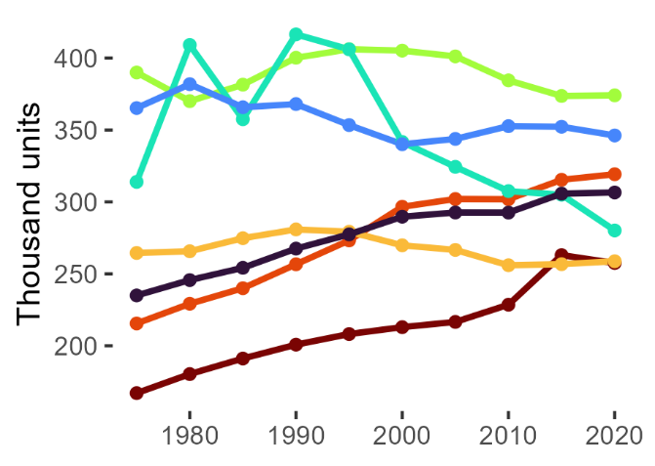 | 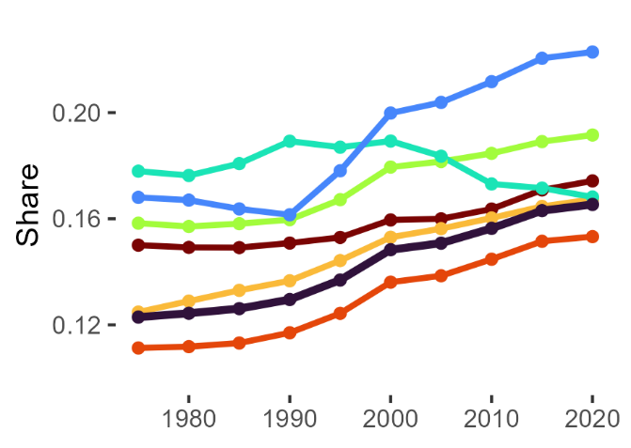
- GDP per capita | - CO₂ emissions per capita
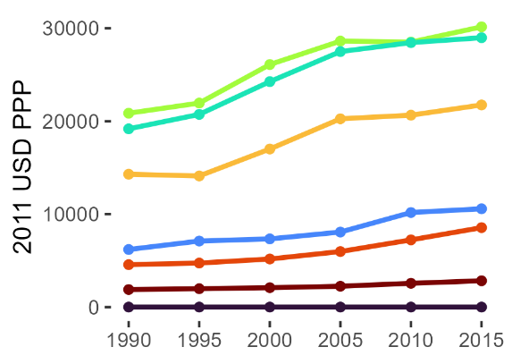 | 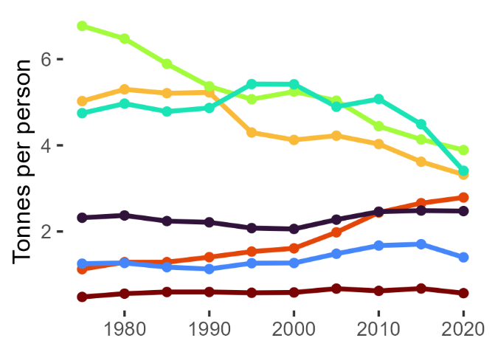
- CO₂ emissions per capita (residential) | - CO₂ emissions per capita (transport)
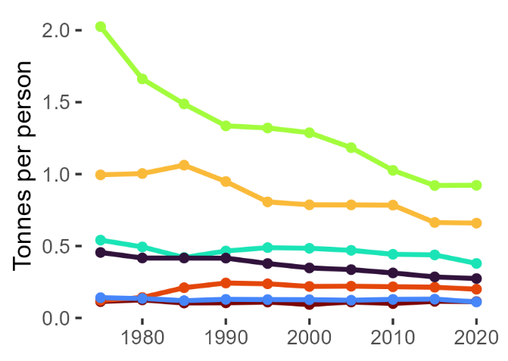 | 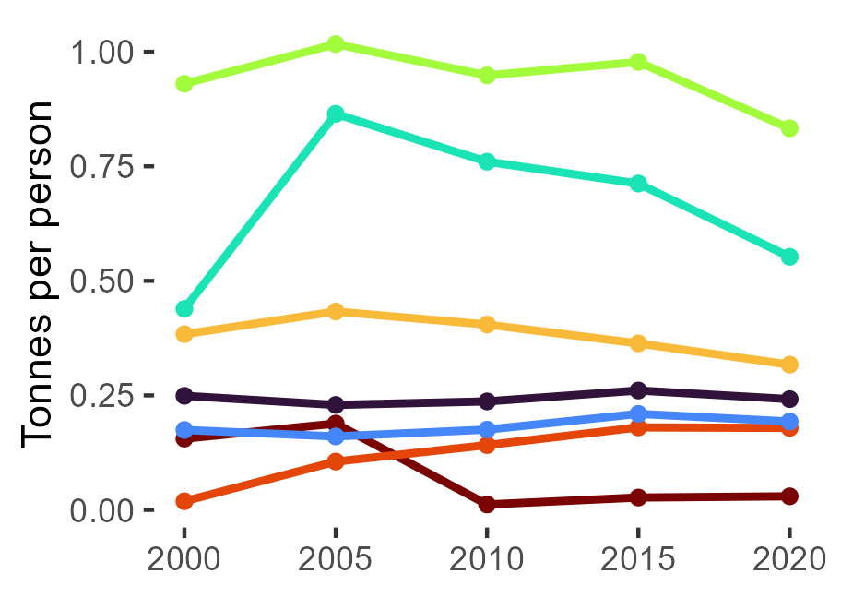

References
1. Pesaresi, Martino, et al. GHS settlement grid, updated and refined REGIO model 2014 in application to GHS-BUILT R2018A and GHS-POP R2019A, multitemporal (1975-1990-2000-2015), R2019A. s.l. : European Commission, Joint Research Centre (JRC), 2019.
2. University of California, Berkeley. Global administrative areas (boundaries), Version 4.1. 2022.
3. Schiavina, Marcello, et al. GHS-POP R2023A - GHS population grid multitemporal (1975-2030). s.l. : European Commission, Joint Research Centre (JRC), 2023.
4. GHS-BUILT-S R2022A - GHS built-up surface grid, derived from Sentinel2 composite and Landsat, multitemporal (1975-2030). Pesaresi, M e Politis, P. 2023, European Commission, Joint Research Centre (JRC).
5. Gridded emissions of air pollutants for the period 1970-2012 within EDGAR v4. 3.2. Crippa, Monica, et al. 4, 2018, Earth System Science Data, Vol. 10, p. 1987-2013.
6. EDGAR v4. 3.2 Global Atlas of the three major greenhouse gas emissions for the period 1970-2012. Janssens-Maenhout, Greet, et al. 3, 2019, Earth System Science Data, Vol. 11, p. 959-1002.
7. Version 4 of the CRU TS monthly high-resolution gridded multivariate climate dataset. Harris, Ian, et al. 1, s.l. : Nature Publishing Group, 2020, Scientific data, Vol. 7, p. 1-18.
8. Gridded global datasets for gross domestic product and Human Development Index over 1990-2015. Kummu, Matti, Taka, Maija e Guillaume, Joseph HA. 1, s.l. : Nature Publishing Group, 2018, Scientific Data, Vol. 5, p. 1-15.

