Supplementary Information

High Entropy Engineered Polymer Blends with Enhanced Dielectric Properties and High Temperature Stability

Xin Qi¹, Xuankai Huang², Nasima Kanwal², Bijoy Das¹, Anthony Phillips², Dimitrios Papageorgiou¹, Haixue Yan¹, Emiliano Bilotti³, and Michael John Reece¹*

¹ School of Engineering and Materials Science
Queen Mary University of London
Mile End Road, London E1 4NS, UK

² School of Physical and Chemical Sciences
Queen Mary University of London
Mile End Road, London E1 4NS, UK

³ Department of Aeronautics
Imperial College London
Exhibition Road, London SW7 2AZ, UK

*Corresponding author:
Michael John Reece (m.j.reece@qmul.ac.uk)

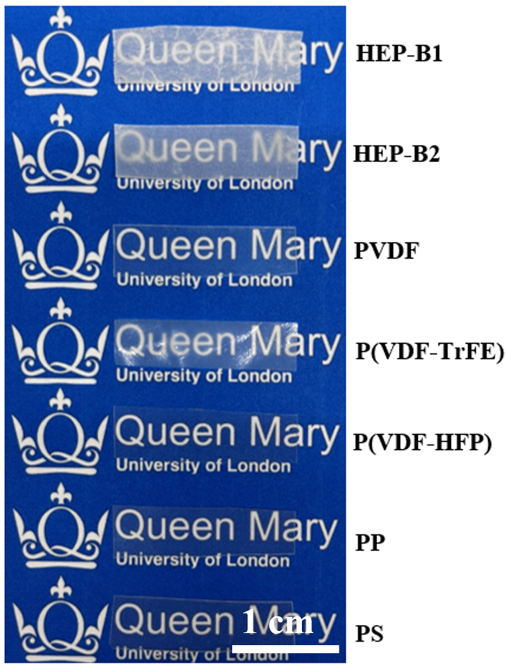
Figure S1. Optical images of polymer films.
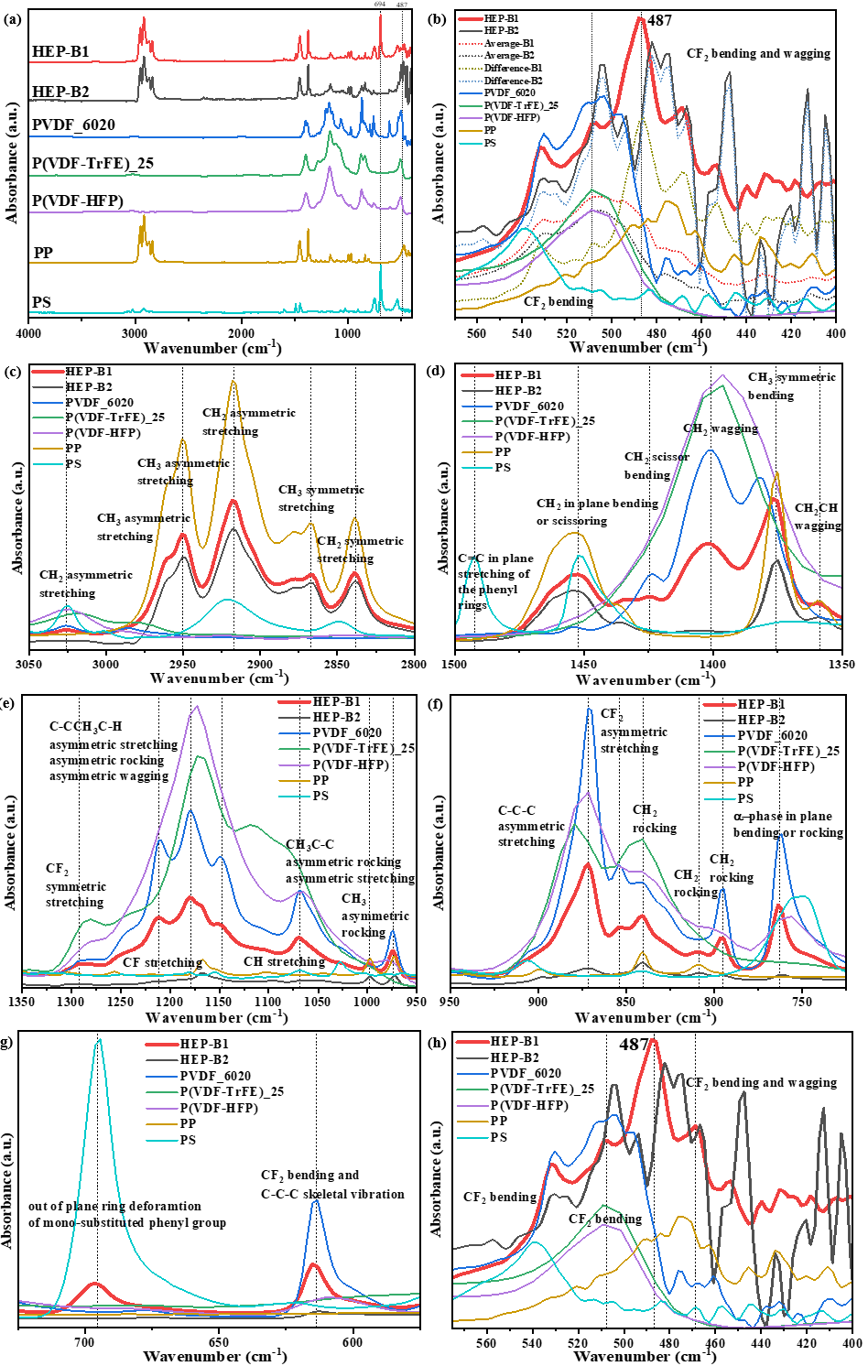
Figure S2. (a)-(h) FTIR of HEP-B1, HEP-B2 polymer blends and individual polymers.
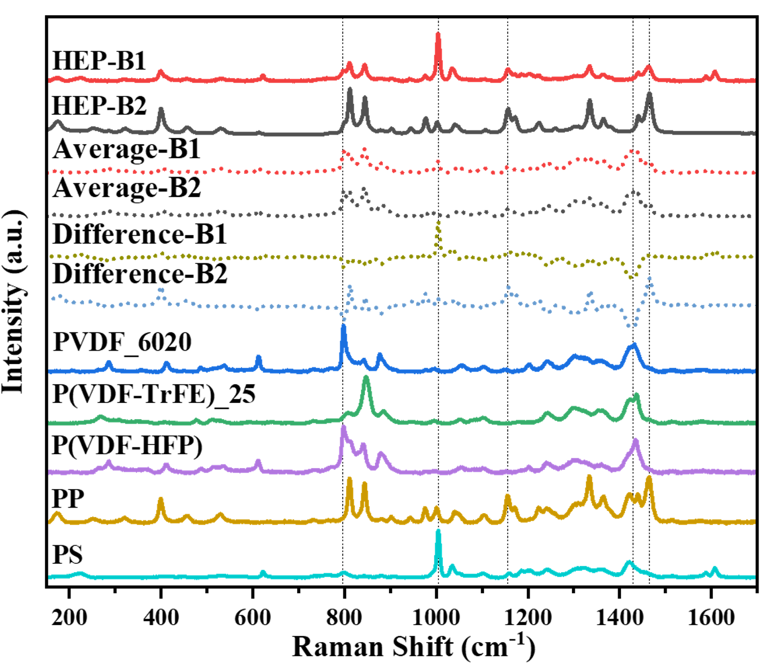
Figure S3. Raman data of HEP-B1, HEP-B2 polymer blends and individual polymers.

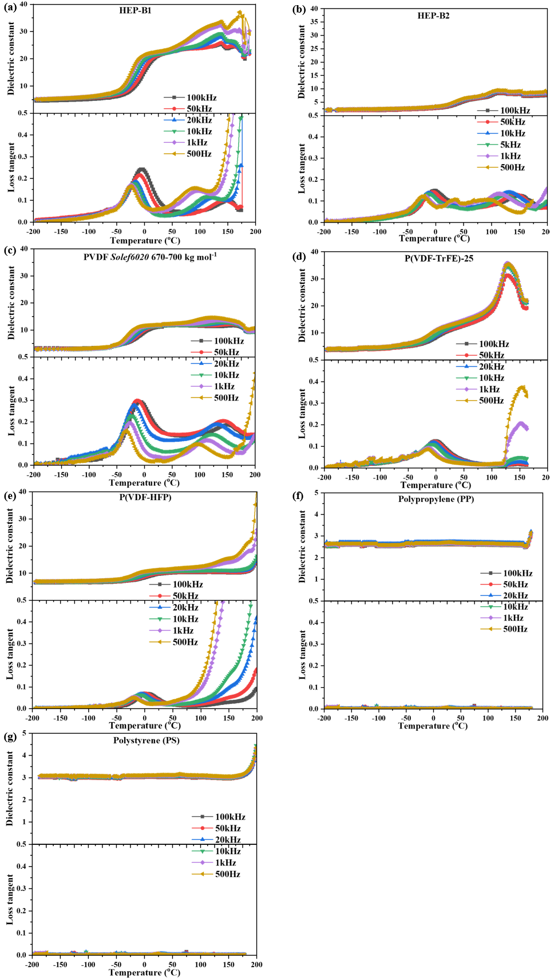
Figure S4. Temperature dependence of dielectric properties of HEP-B1 and HEP-B2 polymer blends and individual polymers for a range of different frequencies.

