SUPPLEMENTARY APPENDIX

POST PROCEDURAL ANTICOAGULATION AFTER PERCUTANEOUS CORONARY INTERVENTION IN PATIENTS WITH ST-SEGMENT ELEVATION MYOCARDIAL INFARCTION : A SYSTEMATIC REVIEW AND META-ANALYSIS

Ricardo Fonseca Oliveira Suruagy Motta¹, Everton Victor Belmiro da Silva², Tarek Castro Fayyat³, Karlos Daniell Araújo dos Santos⁴, Leonardo Galvão de Oliveira Oldra⁵, Gabriele Sevilhano Milanesi⁵, Victor Costa Guido Santos ¹ , Fernanda Mel Costa Moraes¹, Christian Ken Fukunaga⁶ ,Vitor Leão Durães², Pedro Antonio, Bruno Noschang Blaas, Wilton Francisco Gomes⁹

¹ Faculty of Medicine, Cesmac University Center, Maceió/AL, Brazil
² Faculty of Medicine, Federal University of Pernambuco, Recife/PE, Brazil
³ Faculty of Medicine, Positivo University, Curitiba/PR, Brazil
⁴ Faculty of Medicine, Federal University of Roraima, Boa Vista/RR, Brazil
⁵ Faculty of Medicine, Anhembi Morumbi University, São Paulo/SP, Brazil
⁶ Department of Medicine, FMABC University Center, São Paulo/SP, Brazil
⁷ Department of Medicine, Federal University of Uberlandia, Minas Gerais, Brazil
⁸ Department of Cardiology, Institute Dante Pazzanese of Cardiology, São Paulo/SP, Brazil
⁹ Department of Cardiology, Institute of Neurology and Cardiology of Curitiba – INC Hospital – Curitiba, PR – Brazil

SUMMARY

Supplemental Methods 1. PRISMA 2020 Main Checklist 4-5
Supplemental Methods 2. PRISMA Abstract Checklist 6
Supplemental Figure 1. Funnel Plots 8-14
Supplemental Figure 1A. Funnel Plot for All-cause death 8
Supplemental Figure 1B. Funnel Plot for Cardiac death 9
Supplemental Figure 1C. Funnel Plot for Reinfarction 10
Supplemental Figure 1D. Funnel Plot for Stent Thrombosis 11
Supplemental Figure 1E. Funnel Plot for Stroke 12
Supplemental Figure 1F. Funnel Plot for Bleeding 13
Supplemental Figure 1G. Funnel Plot for Major Adverse Cardiovascular Events (MACE) 14

Supplemental Figure 2. Leave-One-Out Sensitivity Analysis 15-18
Supplemental Figure 2A. Leave-One-Out Plot for All-cause death 15
Supplemental Figure 2B. Leave-One-Out Plot for Cardiac death 15
Supplemental Figure 2C. Leave-One-Out Plot for Reinfarction 16
Supplemental Figure 2D. Leave-One-Out Plot for Stent Thrombosis 17
Supplemental Figure 2E. Leave-One-Out Plot for Stroke 17
Supplemental Figure 2F. Leave-One-Out Plot for Bleeding 18
Supplemental Figure 2G. Leave-One-Out Plot for Major Adverse Cardiovascular Events (MACE) 18

Supplemental Figure 3. Risk of Bias - ROBINS I of Included Studies 19
Figure 3A. "Traffic light" plot of the domain-level judgments for each study
Figure 3B. Summary of overall weighted bar plot of risk-of-bias judgments within each bias domain

Supplemental Figure 4. Risk of Bias - RoB 2.0 of Included Studies 20
Figure 4A. "Traffic light" plot of the domain-level judgments for each study
Figure 4B. Summary of overall weighted bar plot of risk-of-bias judgments within each bias domain

Supplemental Methods 1. PRISMA 2020 Main Checklist
Topic | No. | Item | Location where item is reported
TITLE
Title | 1 | Identify the report as a systematic review. | Pg. 1
ABSTRACT
Abstract | 2 | See the PRISMA 2020 for Abstracts checklist | Pg. 3-4
INTRODUCTION
Rationale | 3 | Describe the rationale for the review in the context of existing knowledge. | Pg. 5
Objectives | 4 | Provide an explicit statement of the objective(s) or question(s) the review addresses. | Pg. 5
METHODS
Eligibility criteria | 5 | Specify the inclusion and exclusion criteria for the review and how studies were grouped for the syntheses. | Pg. 6
Information sources | 6 | Specify all databases, registers, websites, organizations, reference lists and other sources searched or consulted to identify studies. Specify the date when each source was last searched or consulted. | Pg. 6,7
Search strategy | 7 | Present the full search strategies for all databases, registers, and websites, including any filters and limits used. | Pg, 6,7
Selection process | 8 | Specify the methods used to decide whether a study met the inclusion criteria of the review, including how many reviewers screened each record and each report retrieved, whether they worked independently, and if applicable, details of automation tools used in the process. | Pg.7
Data collection process | 9 | Specify the methods used to collect data from reports, including how many reviewers collected data from each report, whether they worked independently, any processes for obtaining or confirming data from study investigators, and if applicable, details of automation tools used in the process. | Pg. 7,8
Data items | 10a | List and define all outcomes for which data were sought. Specify whether all results that were compatible with each outcome domain in each study were sought (e.g., for all measures, time points, analyses), and if not, the methods used to decide which results to collect. | Pg. 7
 | 10b | List and define all other variables for which data were sought (e.g., participant and intervention characteristics, funding sources). Describe any assumptions made about any missing or unclear information. | Pg. 6,7
Study risk of bias assessment | 11 | Specify the methods used to assess risk of bias in the included studies, including details of the tool(s) used, how many reviewers assessed each study and whether they worked independently, and if applicable, details of automation tools used in the process. | Pg. 8
Effect measures | 12 | Specify for each outcome the effect measure(s) (e.g., risk ratio, mean difference) used in the synthesis or presentation of results. | Pg. 8
Synthesis methods | 13a | Describe the processes used to decide which studies were eligible for each synthesis (e.g., tabulating the study intervention characteristics and comparing against the planned groups for each synthesis (item 5)). | Pg. 7
 | 13b | Describe any methods required to prepare the data for presentation or synthesis, such as handling of missing summary statistics, or data conversions. | Pg 6,7
 | 13c | Describe any methods used to tabulate or visually display results of individual studies and syntheses. | Pg. 6
 | 13d | Describe any methods used to synthesize results and provide a rationale for the choice(s). If meta-analysis was performed, describe the model(s), method(s) to identify the presence and extent of statistical heterogeneity, and software package(s) used. | Pg, 8
 | 13e | Describe any methods used to explore possible causes of heterogeneity among study results (e.g., subgroup analysis, meta-regression). | Pg. 7-8, 11 + Supplementary File Figures 1-2
 | 13f | Describe any sensitivity analyses conducted to assess robustness of the synthesized results. | Pg. 11 + Supplementary File Figures 1-2
Reporting bias assessment | 14 | Describe any methods used to assess risk of bias due to missing results in a synthesis (arising from reporting biases). | Pg. 8
Certainty assessment | 15 | Describe any methods used to assess certainty (or confidence) in the body of evidence for an outcome. | NA
RESULTS
Study selection | 16a | Describe the results of the search and selection process, from the number of records identified in the search to the number of studies included in the review, ideally using a flow diagram. | Figure 1
 | 16b | Cite studies that might appear to meet the inclusion criteria, but which were excluded, and explain why they were excluded. | Figure 1
Study characteristics | 17 | Cite each included study and present its characteristics. | Table 1
Risk of bias in studies | 18 | Present assessments of risk of bias for each included study. | Supplementary Figure 3
Results of individual studies | 19 | For all outcomes, present, for each study: (a) summary statistics for each group (where appropriate) and (b) an effect estimate and its precision (e.g., confidence/credible interval), ideally using structured tables or plots. | Pg. 9-11
Results of syntheses | 20a | For each synthesis, briefly summarize the characteristics and risk of bias among contributing studies. | Pg. 9-12
 | 20b | Present results of all statistical syntheses conducted. If meta-analysis was done, present for each the summary estimate and its precision (e.g., confidence/credible interval) and measures of statistical heterogeneity. If comparing groups, describe the direction of the effect. | Pg. 9-11
 | 20c | Present results of all investigations of possible causes of heterogeneity among study results. | Pg. 11
 | 20d | Present results of all sensitivity analyses conducted to assess the robustness of the synthesized results. | Supplemental Figure 1-2
Reporting biases | 21 | Present assessments of risk of bias due to missing results (arising from reporting biases) for each synthesis assessed. | Supplementary Figure 3
Certainty of evidence | 22 | Present assessments of certainty (or confidence) in the body of evidence for each outcome assessed. | NA
DISCUSSION
Discussion | 23a | Provide a general interpretation of the results in the context of other evidence. | Pg. 13
 | 23b | Discuss any limitations of the evidence included in the review. | Pg. 13-15
 | 23c | Discuss any limitations of the review processes used. | Pg. 13-15
 | 23d | Discuss implications of the results for practice, policy, and future research. | Pg 15
OTHER INFORMATION
Registration and protocol | 24a | Provide registration information for the review, including register name and registration number, or state that the review was not registered. | PROSPERO; CRD420251001549
 | 24b | Indicate where the review protocol can be accessed, or state that a protocol was not prepared. | Pg. 2-3
 | 24c | Describe and explain any amendments to information provided at registration or in the protocol. | Pg.2-3
Support | 25 | Describe sources of financial or non-financial support for the review, and the role of the funders or sponsors in the review. | None
Competing interests | 26 | Declare any competing interests of review authors. | Pg. 1
Availability of data, code and other materials | 27 | Report which of the following are publicly available and where they can be found template data collection forms; data extracted from included studies; data used for all analyses; analytic code; any other materials used in the review. | NA
Abbreviations: MS, manuscript; sup., supplement.
Supplemental Methods 2. PRISMA Abstract Checklist

Topic | No. | Item | Reported?
TITLE
Title | 1 | Identify the report as a systematic review. | Yes
BACKGROUND
Objectives | 2 | Provide an explicit statement of the main objective(s) or question(s) the review addresses. | Yes
METHODS
Eligibility criteria | 3 | Specify the inclusion and exclusion criteria for the review. | Yes
Information sources | 4 | Specify the information sources (e.g., databases, registers) used to identify studies and the date when each was last searched. | Yes
Risk of bias | 5 | Specify the methods used to assess risk of bias in the included studies. | Yes
Synthesis of results | 6 | Specify the methods used to present and synthesize results. | -
RESULTS
Included studies | 7 | Give the total number of included studies and participants and summarize relevant characteristics of studies. | -
Synthesis of results | 8 | Present results for main outcomes, preferably indicating the number of included studies and participants for each. If meta-analysis was done, report the summary estimate and confidence/credible interval. If comparing groups, indicate the direction of the effect (i.e., which group is favored). | Yes
DISCUSSION
Limitations of evidence | 9 | Provide a brief summary of the limitations of the evidence included in the review (e.g., study risk of bias, inconsistency and imprecision). | -
Interpretation | 10 | Provide a general interpretation of the results and important implications. | Yes
OTHER
Funding | 11 | Specify the primary source of funding for the review. | None
Registration | 12 | Provide the register name and registration number. | Yes

Supplemental Figure 1. Funnel Plots
Supplemental Figure 1A. Funnel Plot for All-cause death

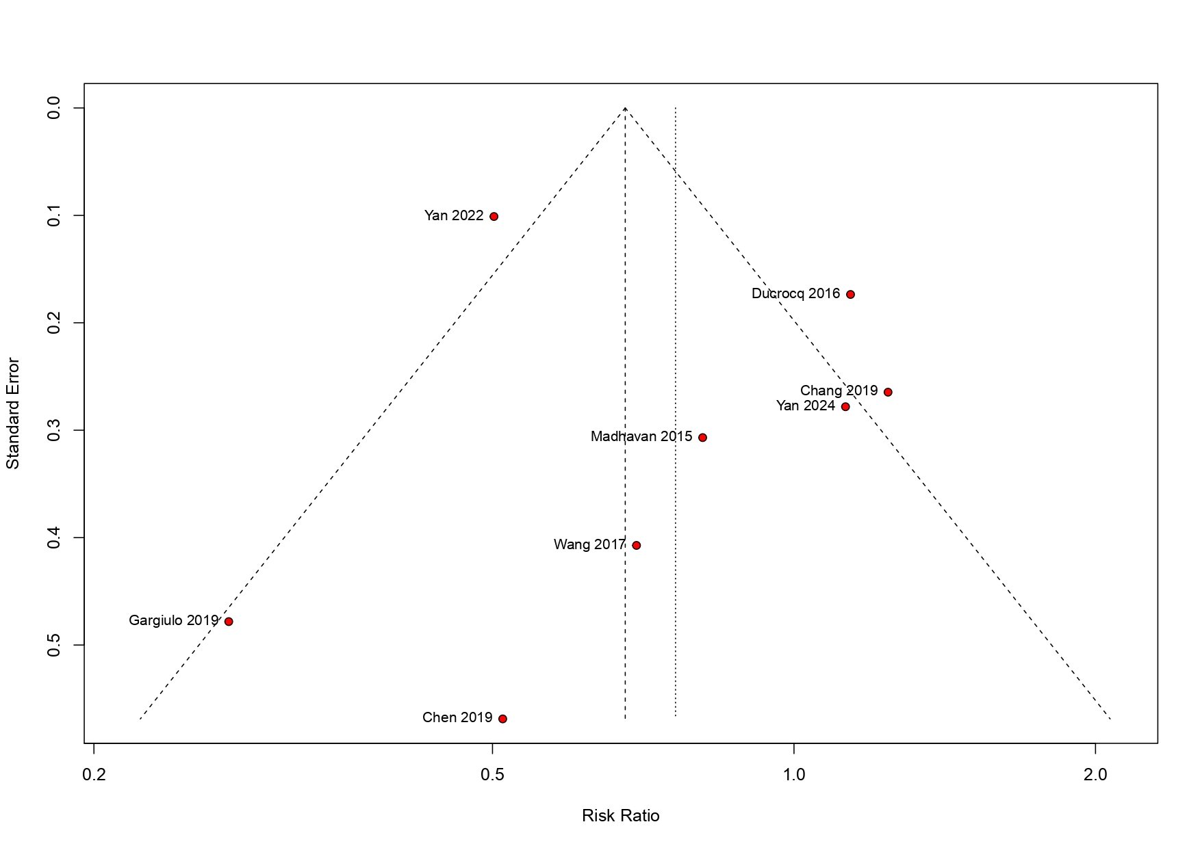
Supplemental Figure 1B. Funnel Plot for Cardiac Death
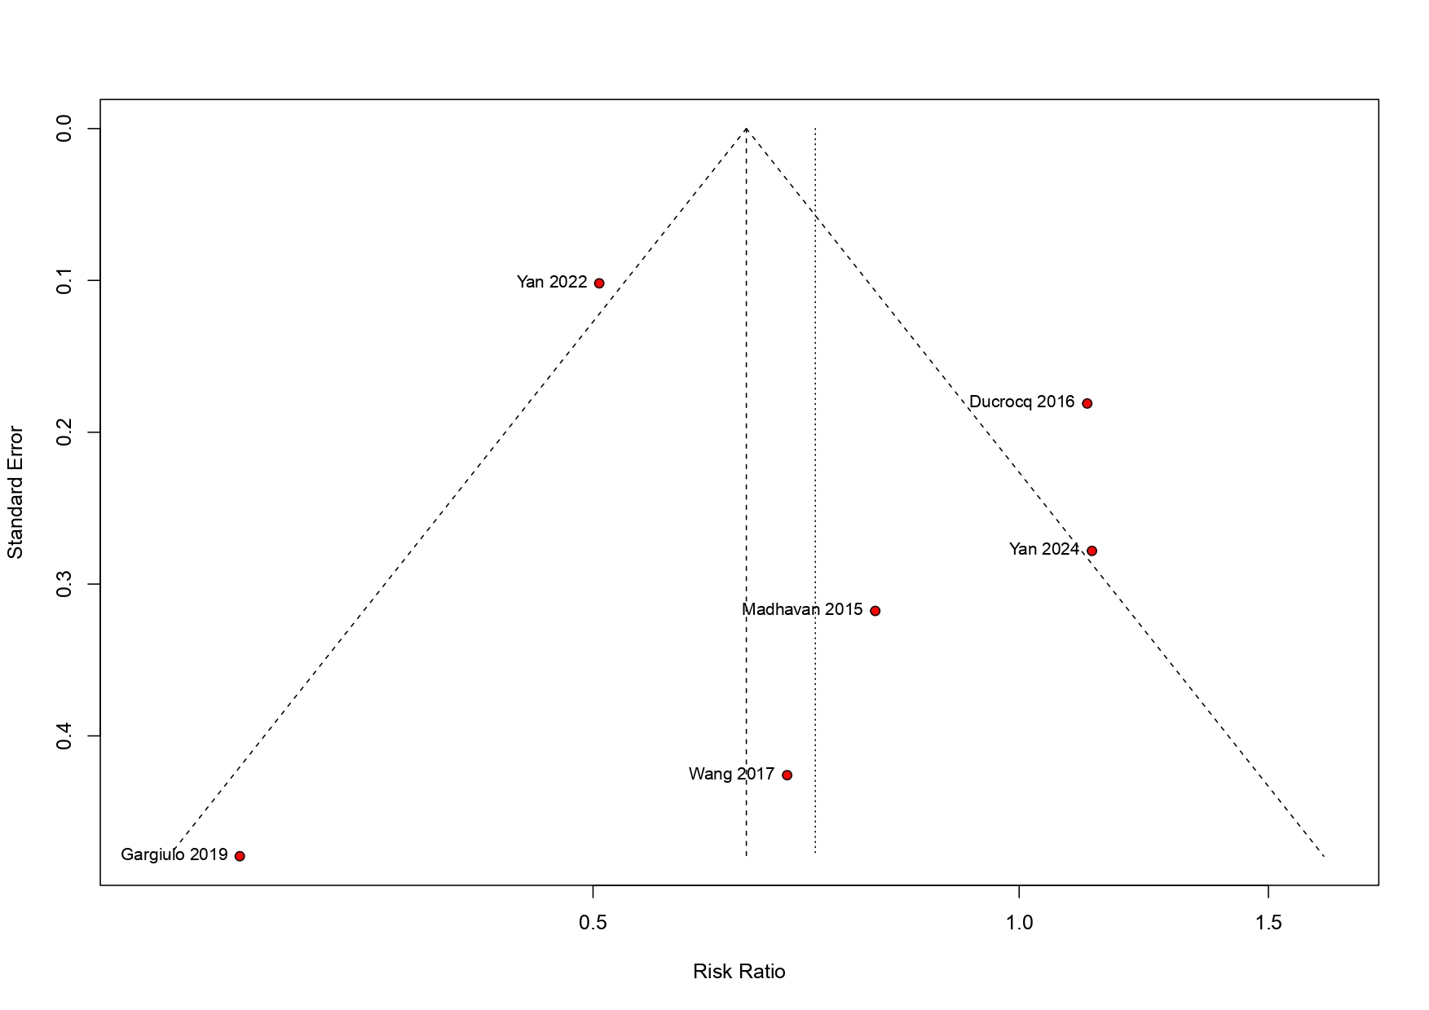
Supplemental Figure 1C. Funnel Plot for Reinfarction
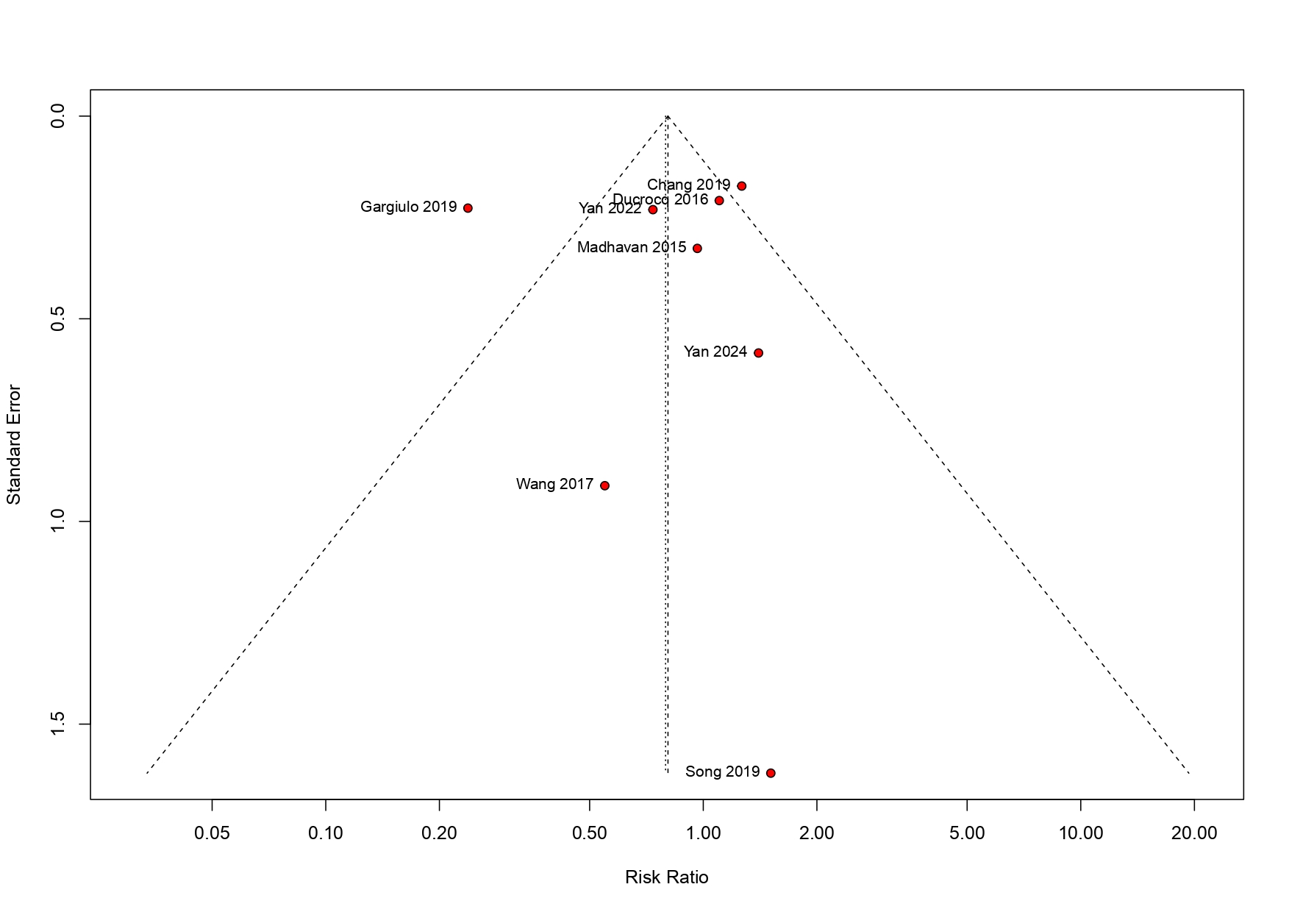

Supplemental Figure 1D. Funnel Plot for Stent Thrombosis
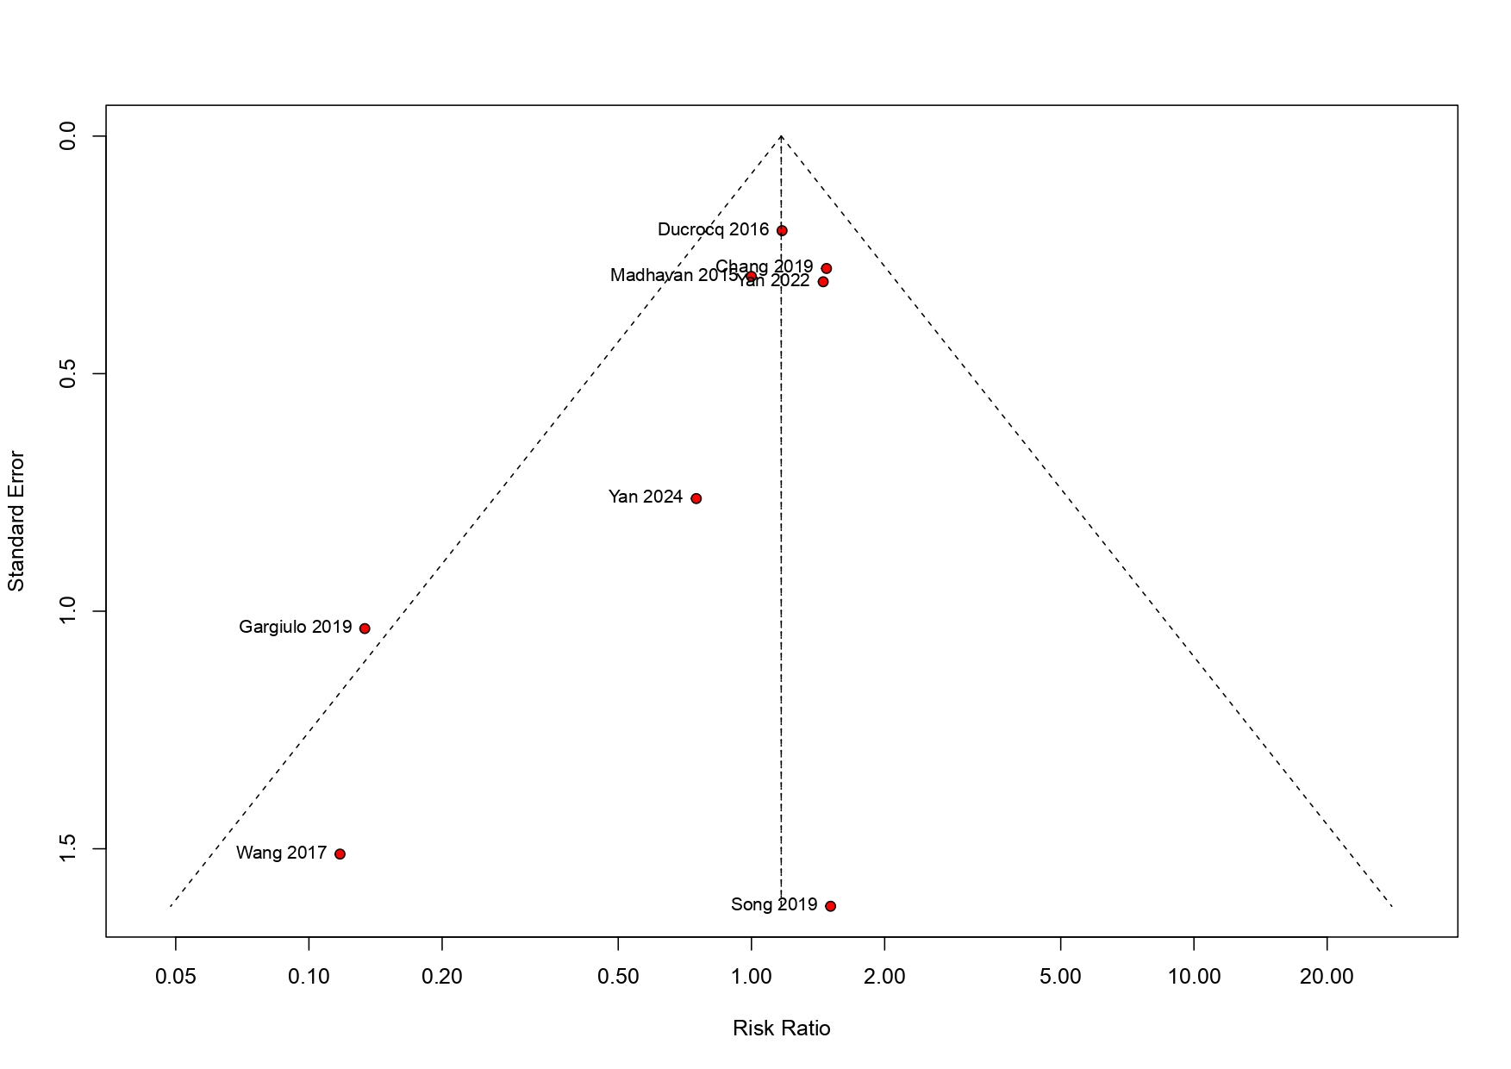

Supplemental Figure 1E. Funnel Plot for Stroke
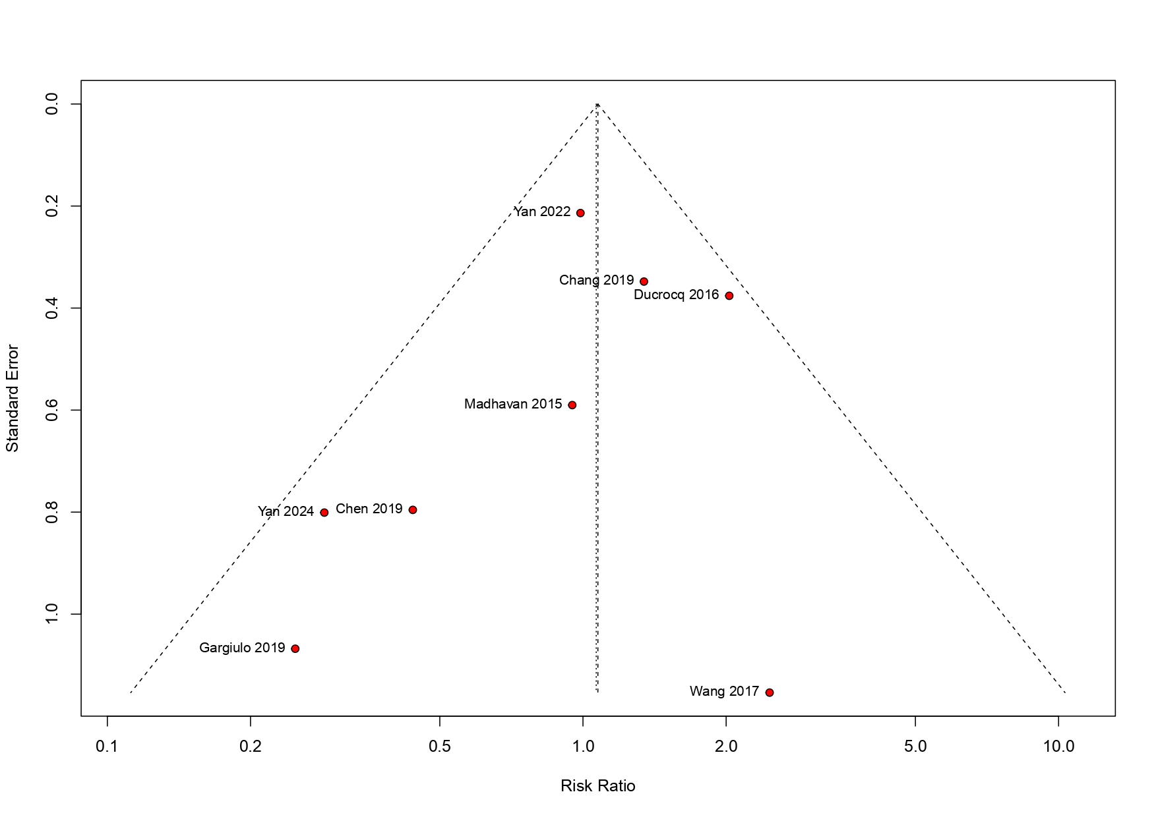

Supplemental Figure 1F. Funnel Plot for Bleeding
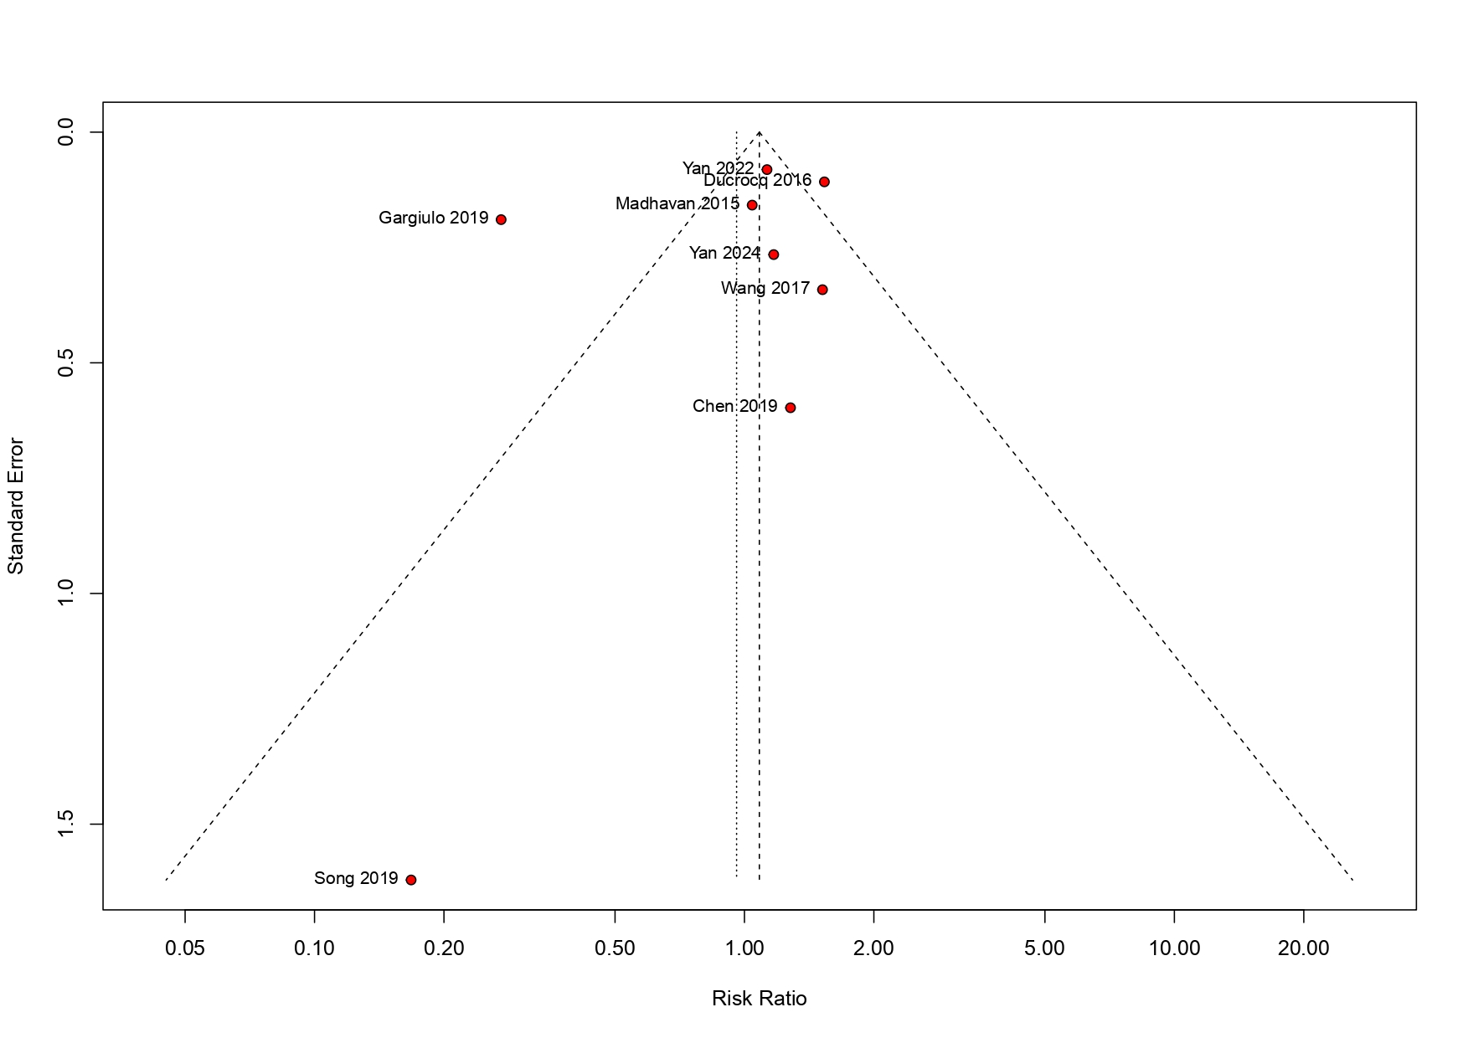

Supplemental Figure 1G. Funnel Plot for Major Adverse Cardiovascular Events (MACE)
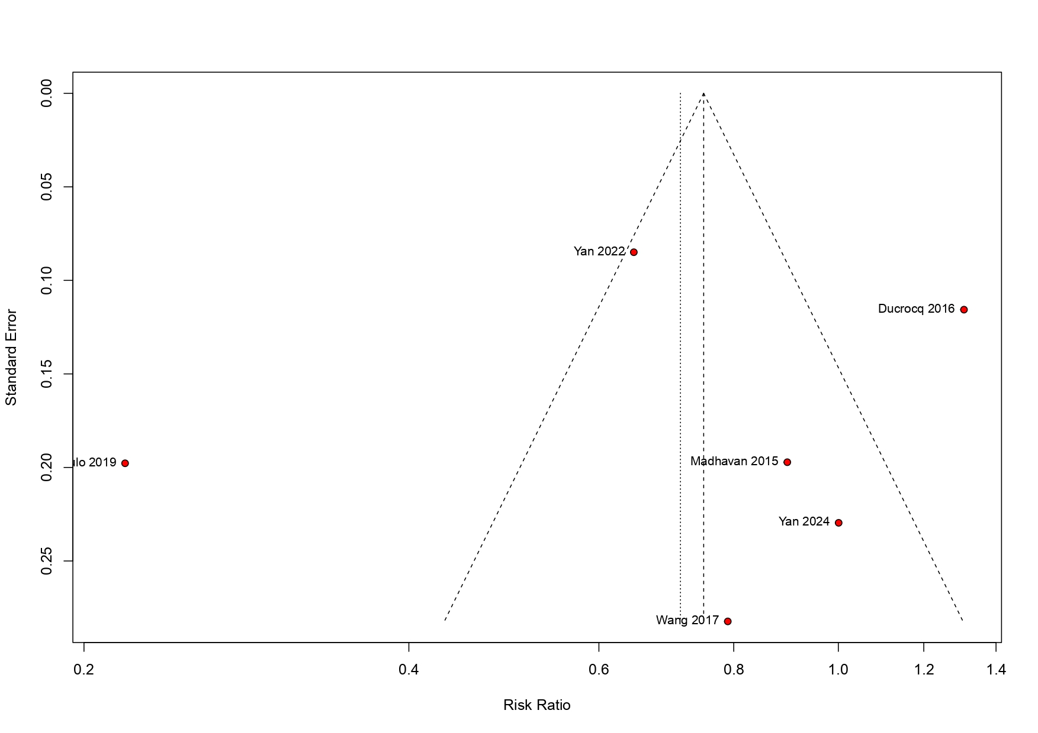
Supplemental Figure 2. Leave-One-Out Sensitivity Analysis
Supplemental Figure 2A. Leave-one-out for All-cause death
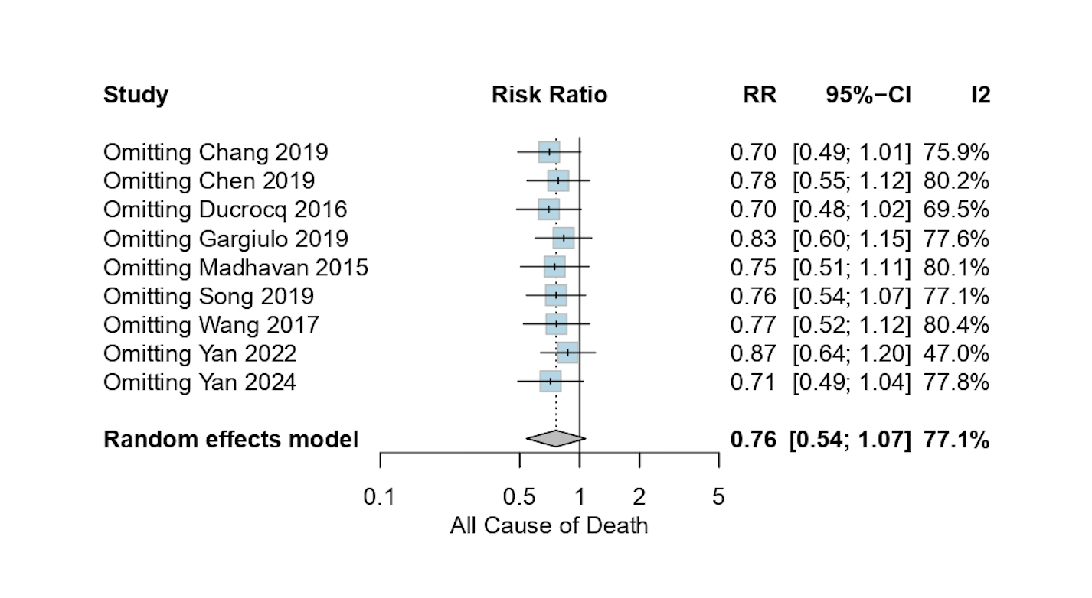
Supplemental Figure 2B. Leave-one-out for Cardiac Death
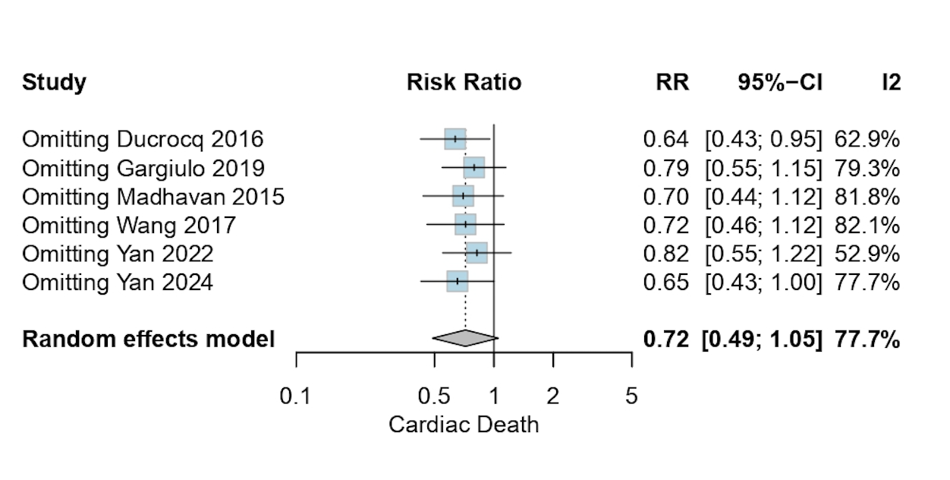

Supplemental Figure 2C. Leave-one-out for Reinfarction
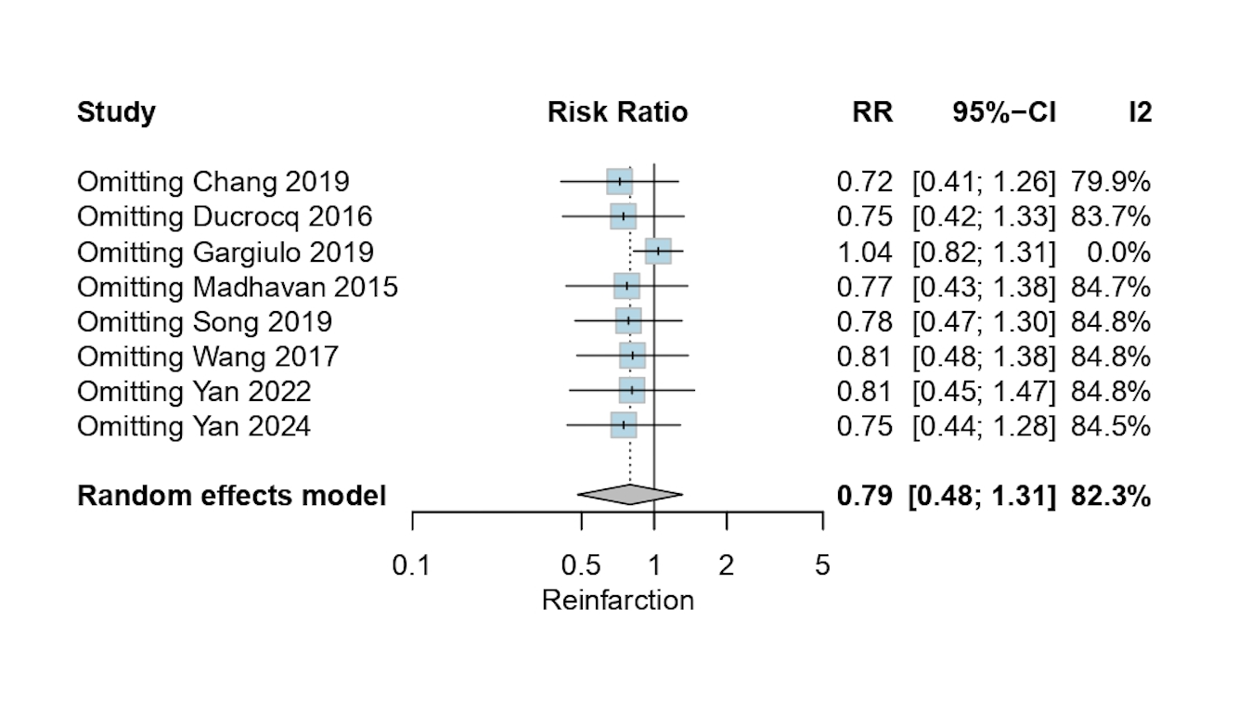
Supplemental Figure 2D. Leave-one-out for Stent Thrombosis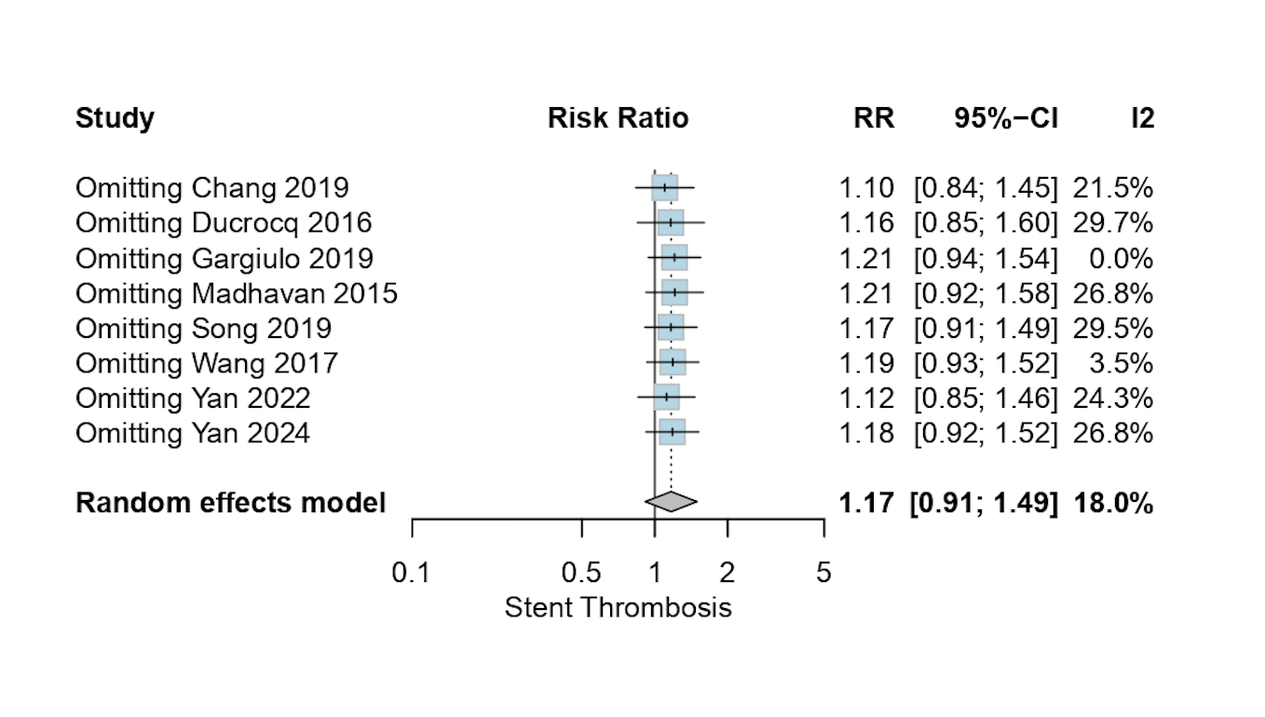
Supplemental Figure 2E. Leave-one-out for Stroke
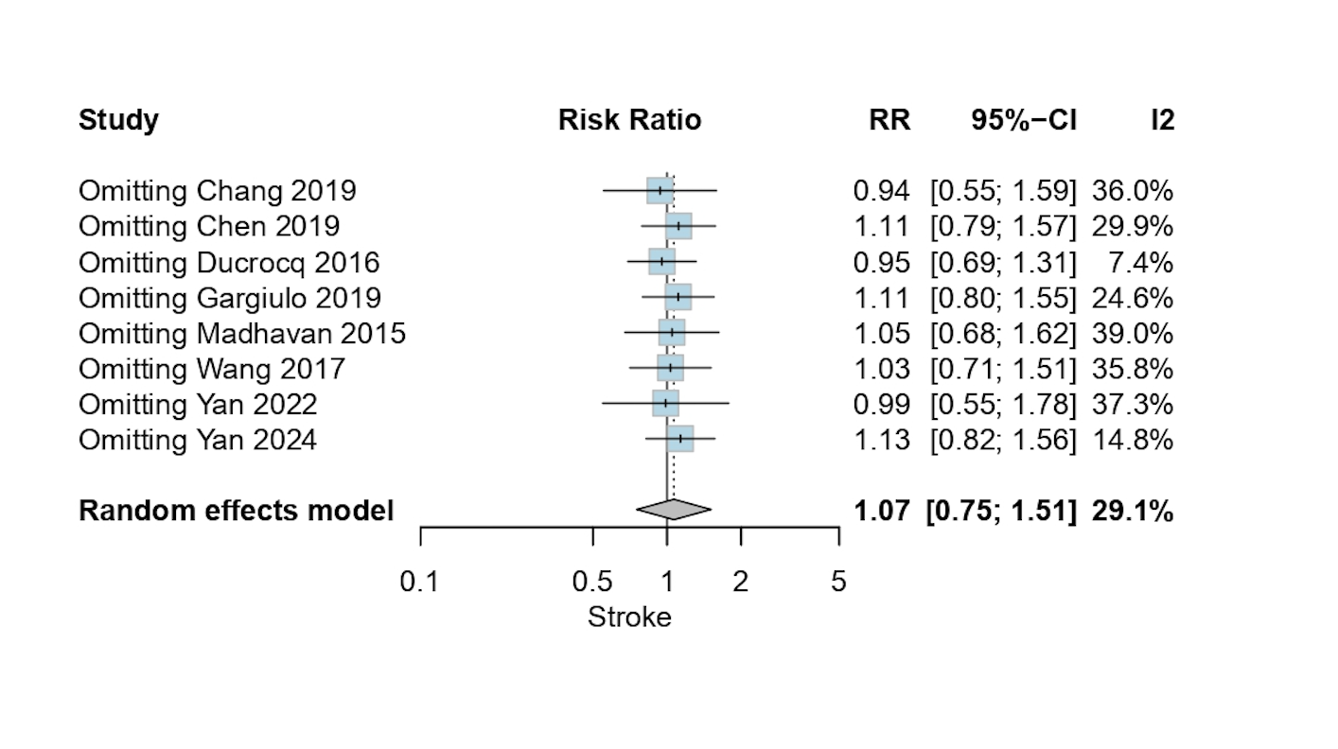
Supplemental Figure 2F. Leave-one-out for Bleeding
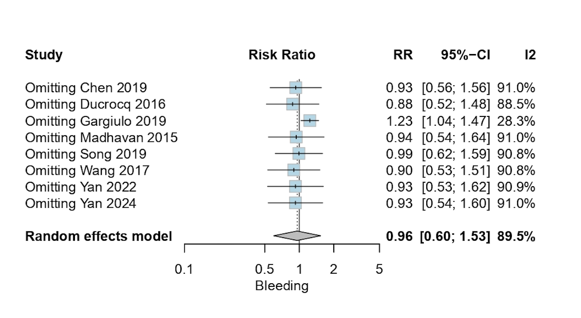Supplemental Figure 2F. Leave-one-out for Major Adverse Cardiovascular Events (MACE)
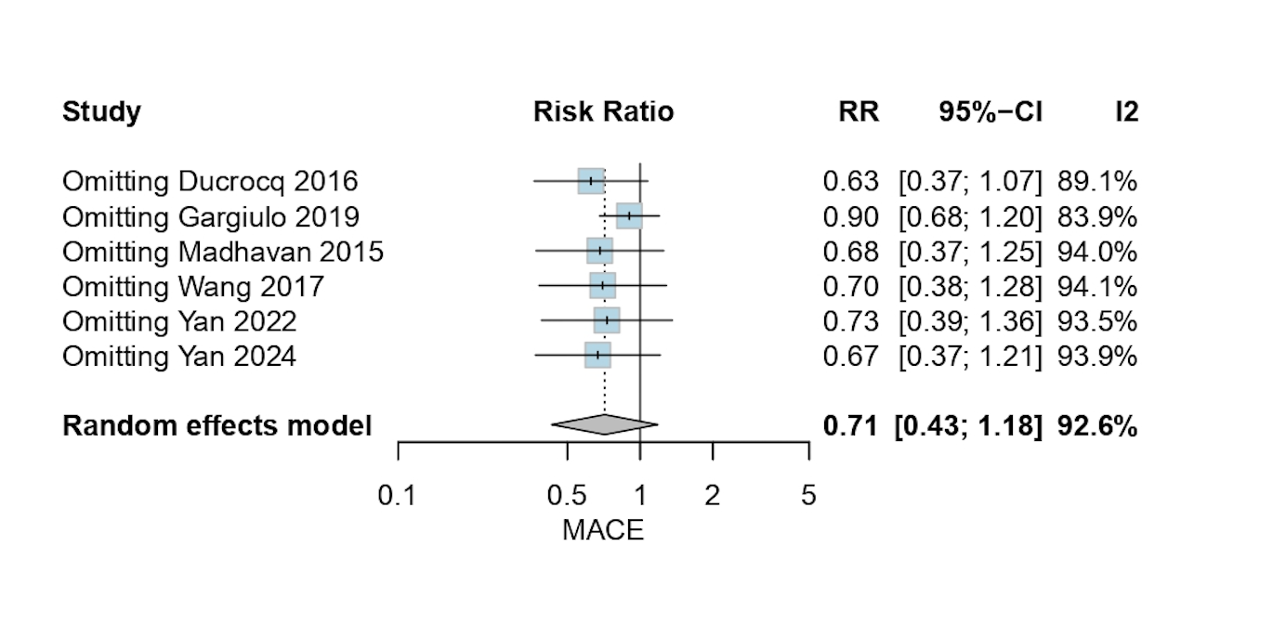

Supplemental Figure 3. Risk of Bias- ROBINS-I of Included Studies

Figure 3A. "Traffic light" plot of the domain-level judgments for each study
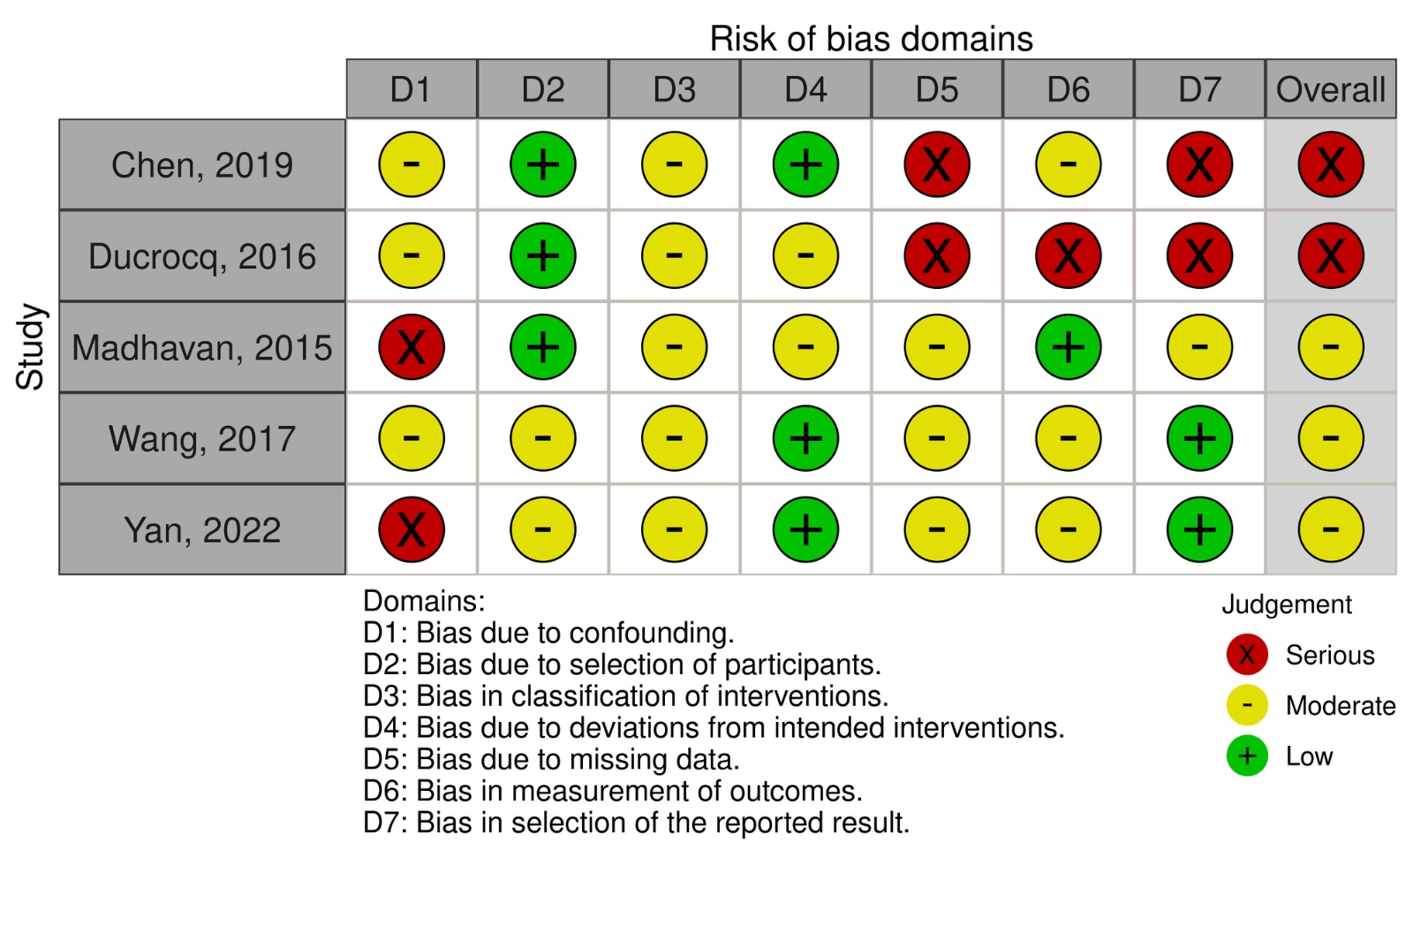

Figure 3B. Summary of the overall weighted bar plot of risk-of-bias judgments within each bias domain
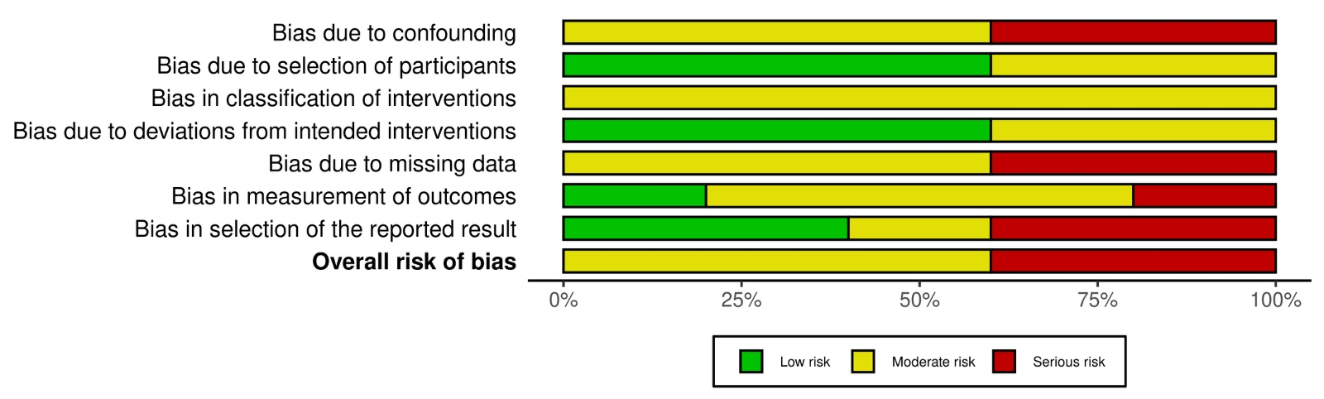

Supplemental Figure 4. Risk of Bias - RoB 2.0 of Included Studies
Figure 4A. "Traffic light" plot of the domain-level judgments for each study

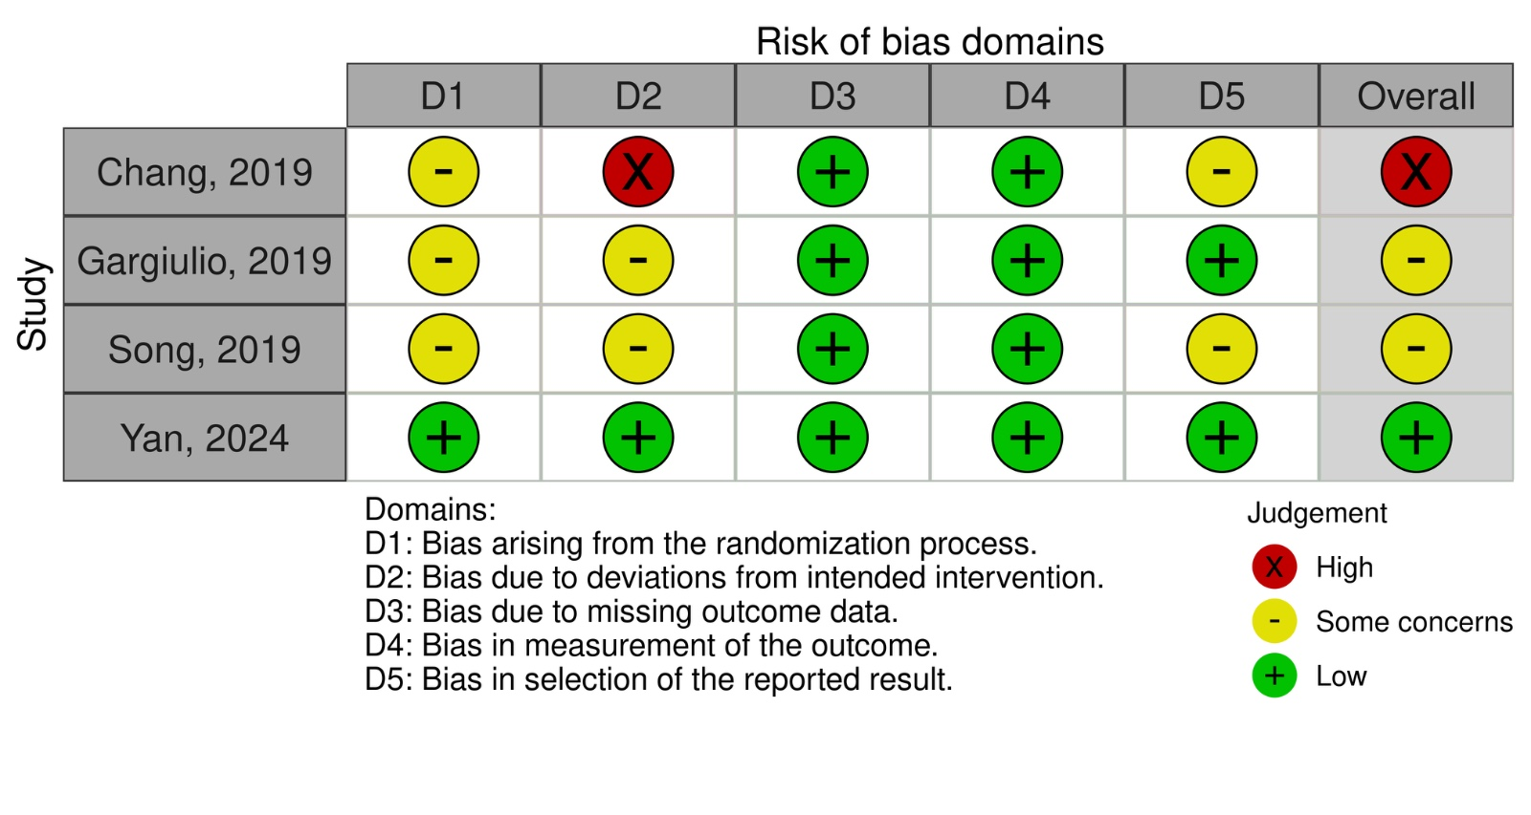

Figure 4B. Summary of the overall weighted bar plot of risk-of-bias judgments within each bias domain
