Suppplementary figures
Fig S1. a: Immunofluorescence detection of the expression of EMT markers (E-cadherin and N-cadherin) in MSLN-knockdown pancreatic cancer cells.

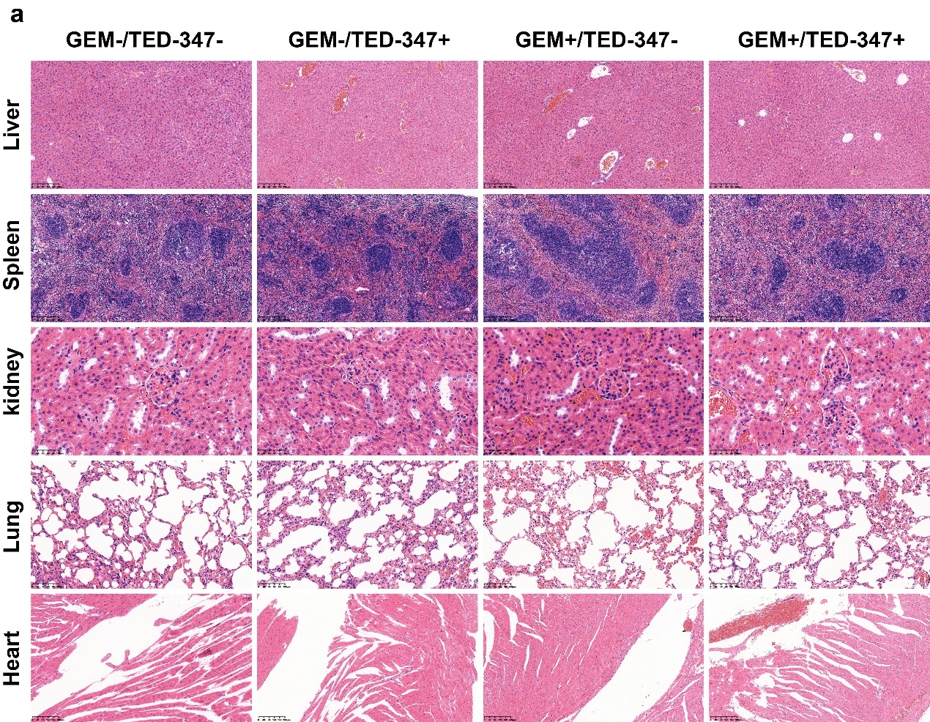
Fig S2. Effect of combination of TED-347 and gemcitabine on morphological structure of internal organs in mice. a: No significant abnormalities were found in the internal organs of each group after administration. The tissue structure of liver, spleen, kidney, lung and heart was observed by HE staining. No obvious structural abnormality, tissue exudation and inflammatory infiltration were found in all organs. The nucleus was not wrinkled and the cytoplasm was not vacuolated.

