Supplementary 1 Univariate Analysis of Factors Associated with 28-Day Mortality
Item | HR(95%CI) | P value
Age | 1.0030 (0.9968,1.0092) | 0.345
Sex | 1.0057 (0.8388,1.2058) | 0.951
BMI | 0.9758 (0.9567,0.9953) | 0.015
MI | 0.7791 (0.5659,1.0726) | 0.126
CHF | 0.7989 (0.6310,1.0115) | 0.062
Cerevascular_dis | 0.8219 (0.6010,1.1238) | 0.219
PVD | 0.8741 (0.5526,1.3826) | 0.565
Dementia | 0.6893 (0.4052,1.1729) | 0.170
DM | 0.7887 (0.6522,0.9539) | 0.014
HTN | 0.7300 (0.6117,0.8711) | < 0.001
COPD | 0.6980 (0.4927,0.9890) | 0.043
CCI | 1.0778 (1.0396,1.1174) | < 0.001
MAP | 0.9868 (0.9811,0.9924) | < 0.001
Phosphate | 1.0864 (1.0515,1.1225) | < 0.001
Hb | 0.9544 (0.9157,0.9947) | 0.027
BUN | 1.0022 (0.9994,1.0051) | 0.117
Creatinine | 0.9047 (0.8488,0.9644) | 0.002
Alb | 0.6558 (0.5570,0.7722) | < 0.001
CRP | 1.0008 (1.0000,1.0016) | 0.052
BAR | 1.0092 (1.0037,1.0147) | < 0.001
MV_CRRT | 1.6707 (1.3131,2.1257) | < 0.001
APACHE II score | 1.0302 (1.0189,1.0417) | < 0.001
SOFA score | 1.1619 (1.1310,1.1936) | < 0.001
BMI (Body Mass Index at ICU admission),MI (Myocardial Infarction),CHF (Congestive Heart Failure),Cerebrovascular_dis ( Cerebrovascular Disease),PVD ( Peripheral Vascular Disease),DM (Diabetes Mellitus),HTN ( Hypertension),COPD ( Chronic Obstructive Pulmonary Disease),CCI ( Charlson Comorbidity Index),MAP (Mean Arterial Pressure),Phosphate (CRRT initiation 0 h),HB(Hemoglobin), BUN (Blood Urea Nitrogen),Alb(Serum albumin),CRP (C-Reactive Protein),BAR(Blood Urea Nitrogen to Serum Albumin Ratio),MV_CRRT (Mechanical Ventilation during CRRT)
Supplementary Figure1 Restricted Cubic Spline Analysis of the BUN/Alb Ratio (BAR) and 28-Day Survival Status (STATUS28)

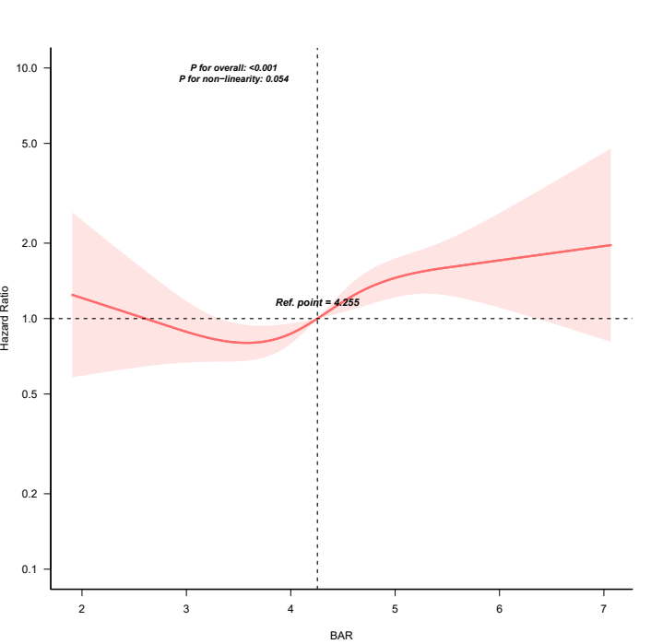
This hazard ratio plot, constructed using restricted cubic spline regression, illustrates the association between the blood urea nitrogen to albumin ratio (BAR) and 28-day all-cause mortality in patients with sepsis-associated acute kidney injury undergoing CRRT. The knots were placed at the 5th, 35th, 65th, and 95th percentiles of BAR. The reference point was set at a BAR value of 4.255. The solid red line represents the estimated hazard ratio, while the shaded red area indicates the 95% confidence interval. The dashed horizontal line at HR = 1.0 represents the null association. The overall association between BAR and mortality was statistically significant (P < 0.001), with no evidence of non-linearity (P for non-linearity = 0.054). The plot displays the central 99.5% of the BAR distribution.

