Supporting information

Impact of Sarcopenia on Chemotherapy-triggered Exacerbation of Interstitial Lung Disease in Patients with Non-small Cell Lung Cancer
Ryota Kikuchi*, Hiroyuki Takoi, Mayuko Ishiwari, Kazutoshi Toriyama, Yuta Kono, Yuki Togashi, Shinji Abe

Supplementary Figure 1. Bilateral psoas major muscle (green area) at the third lumber vertebral level
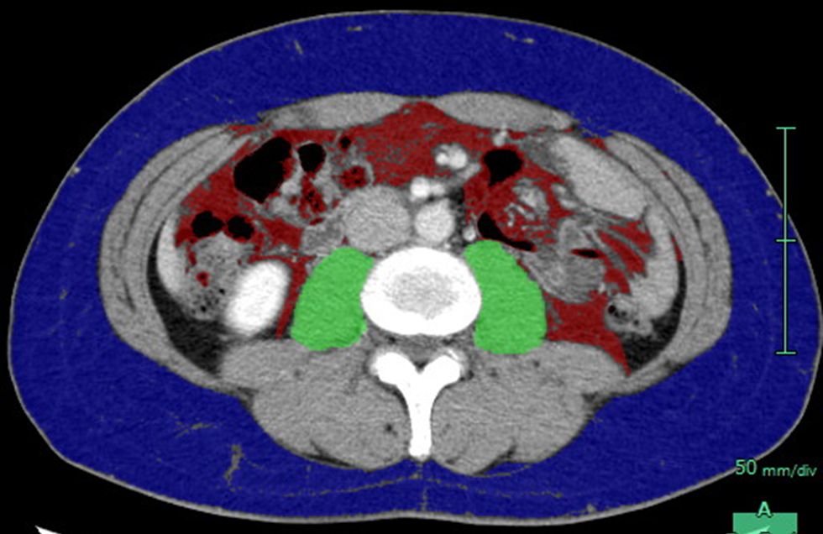

Supplementary Table S1. Frequency of chemotherapy regimens during the clinical course
First line  (n = 74) | N | Second line  (n =46) | N | Third line  (n = 16) | N | Fourth line  (n = 6) | N | Fifth line  (n = 3) | N
CBDCA + PTX with/without BEV | 39 | DOC | 21 | DOC+RAM | 3 | Nivolumab | 2 | S1 | 1
CDDP/CBDCA + PEM with/without BEV | 18 | PEM | 12 | DOC | 3 | VNR | 1 | Nivolumab | 1
CBDCA + Nab-PTX | 10 | S1 | 5 | Nivolumab | 3 | Nab-PTX | 1 | DOC | 1
CBDCA + S1 | 4 | Pembrolizumab | 3 | PEM | 2 | DOC | 1
CDDP/CBDCA + VNR | 2 | CBDCA+ETP | 2 | S1 | 2 | S1 | 1
CDDP + ETP | 1 | Nivolumab | 1 | Nab-PTX | 1
 |  | VNR | 1 | VNR | 1
 |  | CBDCA+PTX | 1 | Atezolizumab | 1
N, number; CBDCA, carboplatin; PTX, paclitaxel; BEV, bevacizumab; CDDP, cisplatin; PEM, pemetrexed; Nab-PTX, nanoparticle albumin-bound paclitaxel; VNR, vinorelbine; ETP, etoposide; DOC, docetaxel; RAM, ramucirumab.

Supplementary Table S2. Frequency of first line chemotherapy regimens stratified according to sarcopenia status
 | Number (%) |  | p-value
 | No sarcopenia | Sarcopenia
Regimens | 35 | 39
CBDCA + PTX  with/without BEV | 18 (51.4%) | 21 (53.8%) | 0.835
CDDP/CBDCA + PEM  with/without BEV | 9 (25.7%) | 9 (23.0%) | 0.792
CBDCA + nab-PTX | 5 (14.7%) | 5 (12.8%) | 0.854
Others | 3 (8.5%) | 4 (10.2%) | 0.805
CBDCA, carboplatin; PTX, paclitaxel; BEV, bevacizumab; CDDP, cisplatin; PEM, pemetrexed; Nab-PTX, nanoparticle albumin-bound paclitaxel. Others: CBDCA + S1 (n = 4), CBDCA + vinorelbine (n = 2), CBDCA + etoposide (n = 1).

