Early Detection and Risk Assessment of Dysgraphia in Sinhala-Speaking Children Using a Multi-Modal Machine Learning Approach

Sandushi Weraduwa ^{[0009-0009-1937-0179]}, PPG Dinesh Asanka ^{[0000-0002-3433-5533]},
Thilini V. Mahanama ^{[0000-0003-0536-0040]}
Department of Industrial Management, Faculty of Science,
University of Kelaniya,
Sri Lanka

Corresponding author(s). E-mail(s): sulaksh-im19112@stu.kln.ac.lk
Contributing authors: dasanka@kln.ac.lk ; thilinim@kln.ac.lk ;
These authors contributed equally to this work

Author Note:
Funding: The research conducted did not receive any external funding.
Conflict of Interest: The authors confirm that no conflict of interest is involved.
Submission history:
This manuscript is currently under review at Springer Nature SN journal

Acknowledgement: I would like to extend my heartfelt appreciation to Dr. G. Wijesuriya, Director of Lady Ridgeway Hospital, for granting permission to conduct the necessary data collection for this study. My deepest gratitude goes to Consultant Dr. Swarna Wijeathunge for her invaluable guidance and support during the data collection process. Additionally, I am sincerely grateful to Mr. Geegange Indika Kumara, Principal of MR/Ganethanna Uparathana Vidyalaya, and Mrs. Wasantha Nilmini Warnasooriya for their cooperation and for allowing data to be gathered from the students. Finally, I am immensely thankful to the students and their parents, whose participation was vital to the success of this research.
All Appendices for ethical clearance of the research for Data Collection
Dysgraphic Children’s Data: We began data collection by obtaining approval from the ethical committee at the Lady Ridgway Hospital, after presenting the main research objectives and receiving their endorsement. Upon approval, specialists gathered retrospective data, following strict protocols to handle sensitive patient information.
Non-Dysgraphic Children’s Data: Additionally, we secured consent from the school principal, teachers, and parents before collecting data from normal school children from the MR/Ganethanna Uparathana Primary School. We created and distributed an information letter detailing the purpose and process to ensure all parties were well informed. The letters below demonstrate the ethical clearance we obtained, ensuring adherence to the required protocols.
1.For Data Collection for dysgraphic children.

- Informed consent was obtained from legal guardians -Ethical Approval Letter for the Data Collection form Lady Ridgway Hospital

All data from dysgraphic children were collected under the supervision of Swarna Wijeatunge, from the Child and Adolescent Mental Health Service at Lady Ridgway Hospital, with her approval.
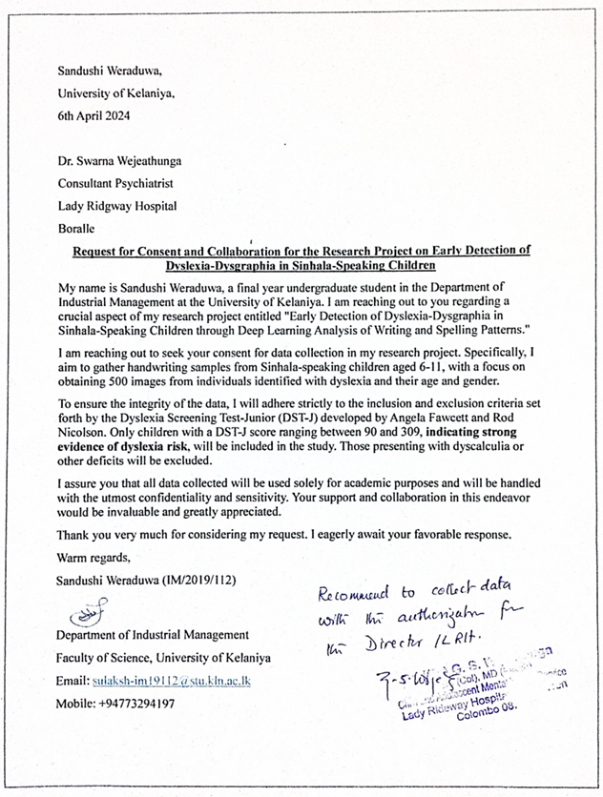

Figure 1-Ethical Approval Letter for the Data Collection form Lady Ridgway Hospital

2. For Data Collection for non- dysgraphic children.

All data from normal children were collected from MR/Ganethanna Uparathana Primary School with the approval of the principal, Mr. Geeganage Kumara Indika.

- Consent letter from the principal for collecting handwritings for the students in MR/ Ganethanna Uparathana Primary School.
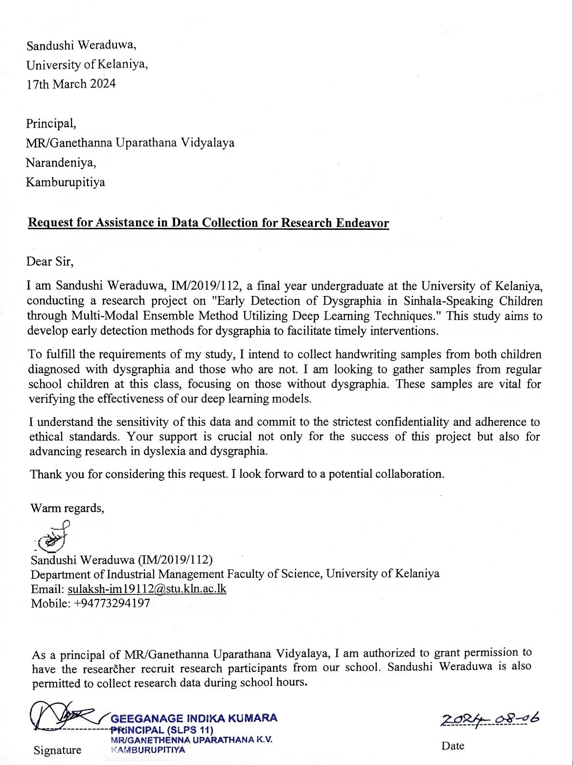

Figure 2-Consent letter from the principal
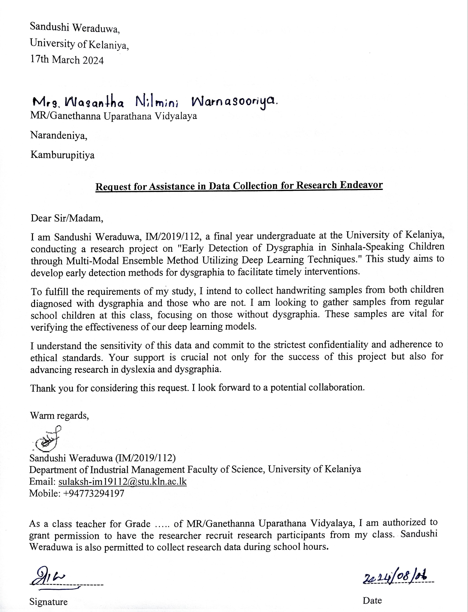
- Consent Letter from the class teacher for data collection
Figure 3-Consent Letter from the class teacher
- Written informed consent was obtained from the parents-Consent Letter from one of the parents for data collection from their child.
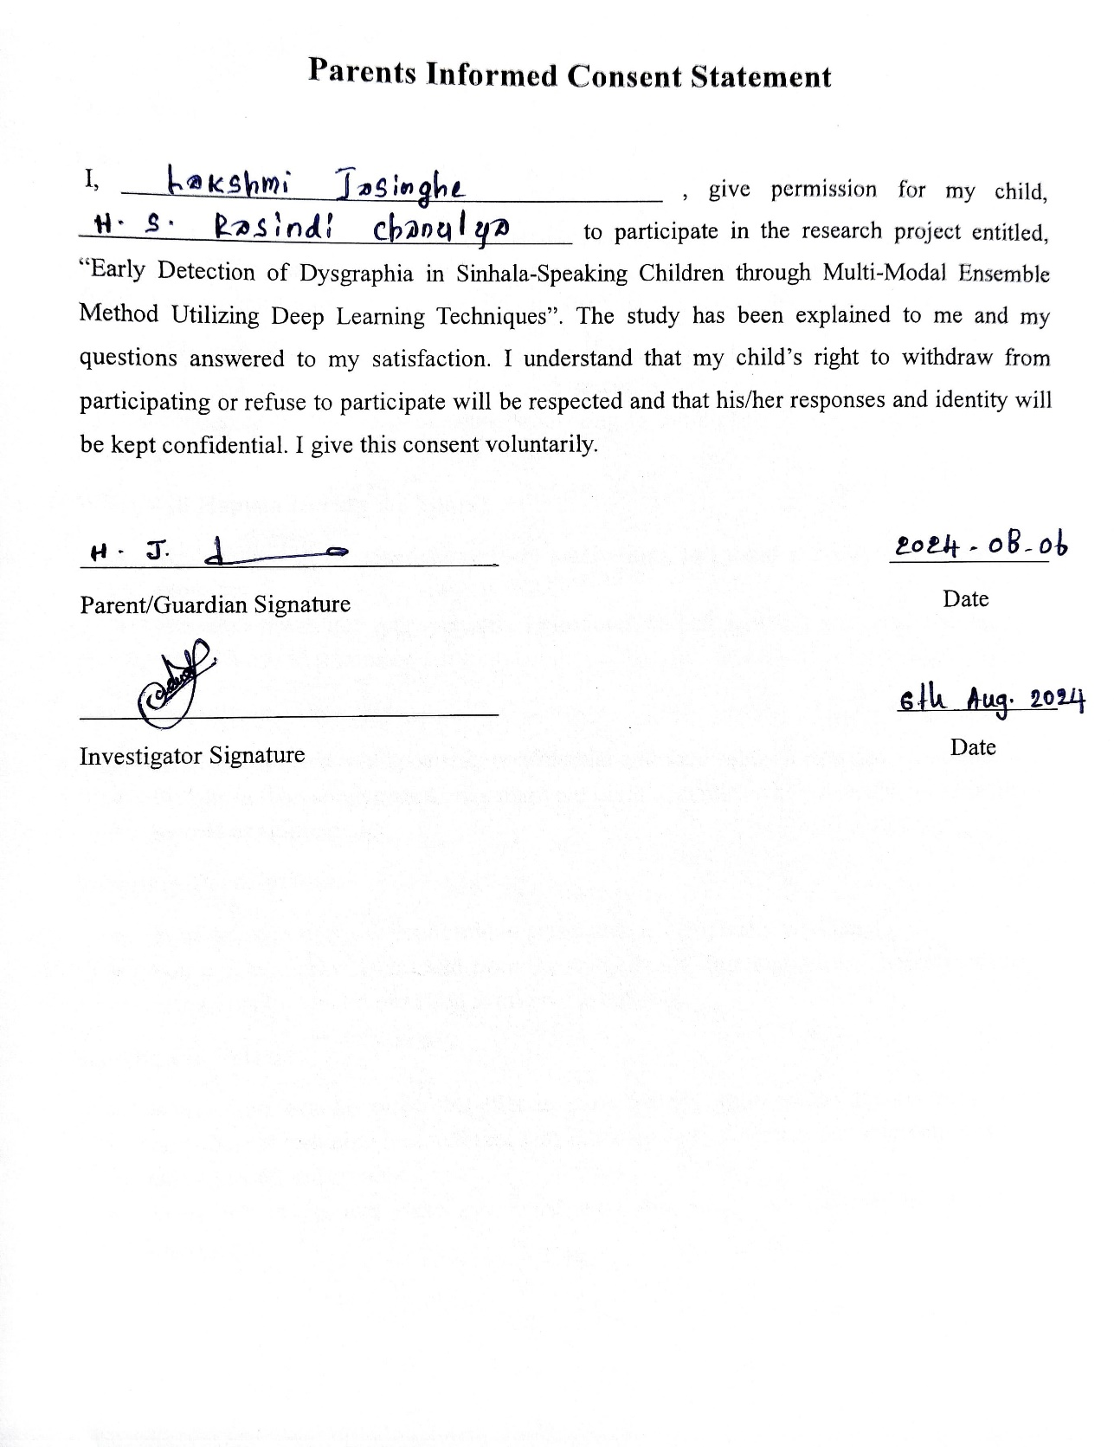
Figure 4- Consent Letter from one of the parents

Sinhala Translation for the Consent letter for parents.
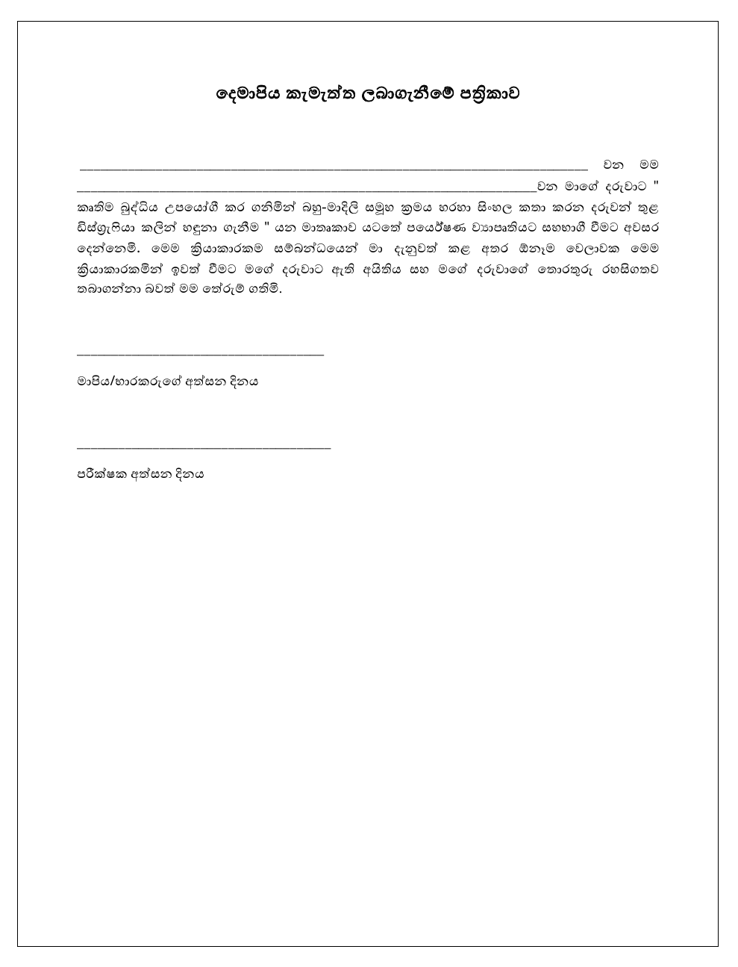
Figure 5-Sinhala Translation of the Consent Letter
- Information letters that were distributed for the parents to get a clear idea of the data collection and research.
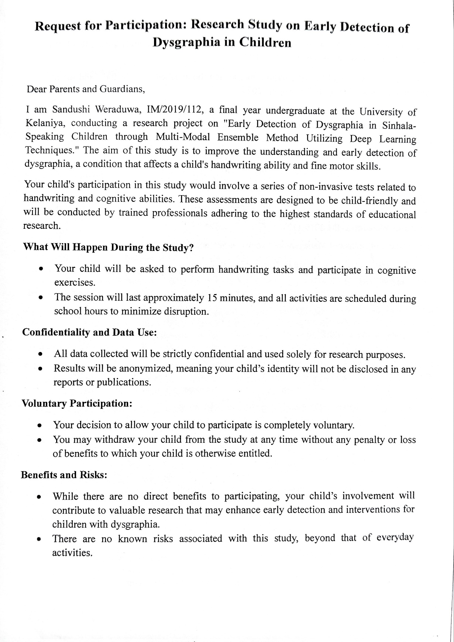
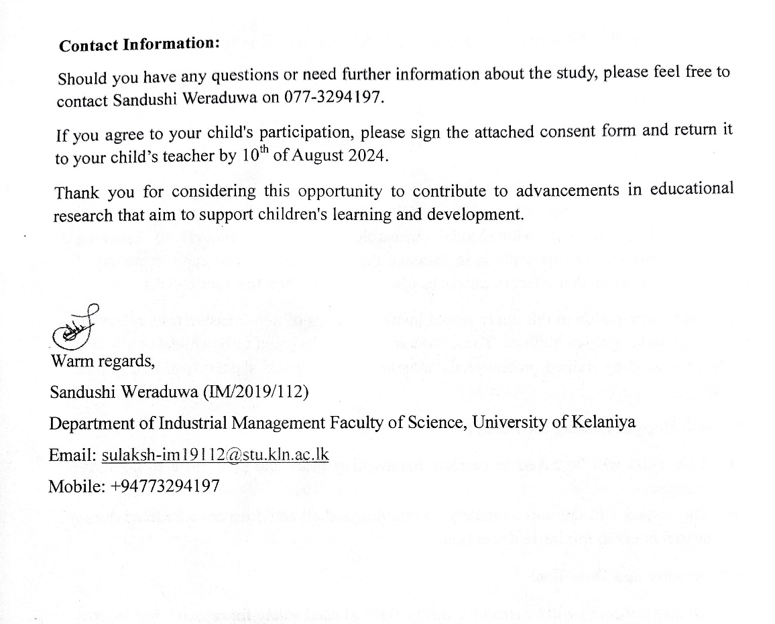
Figure 6-Information letter

Sinhala Translation of the Information Letter
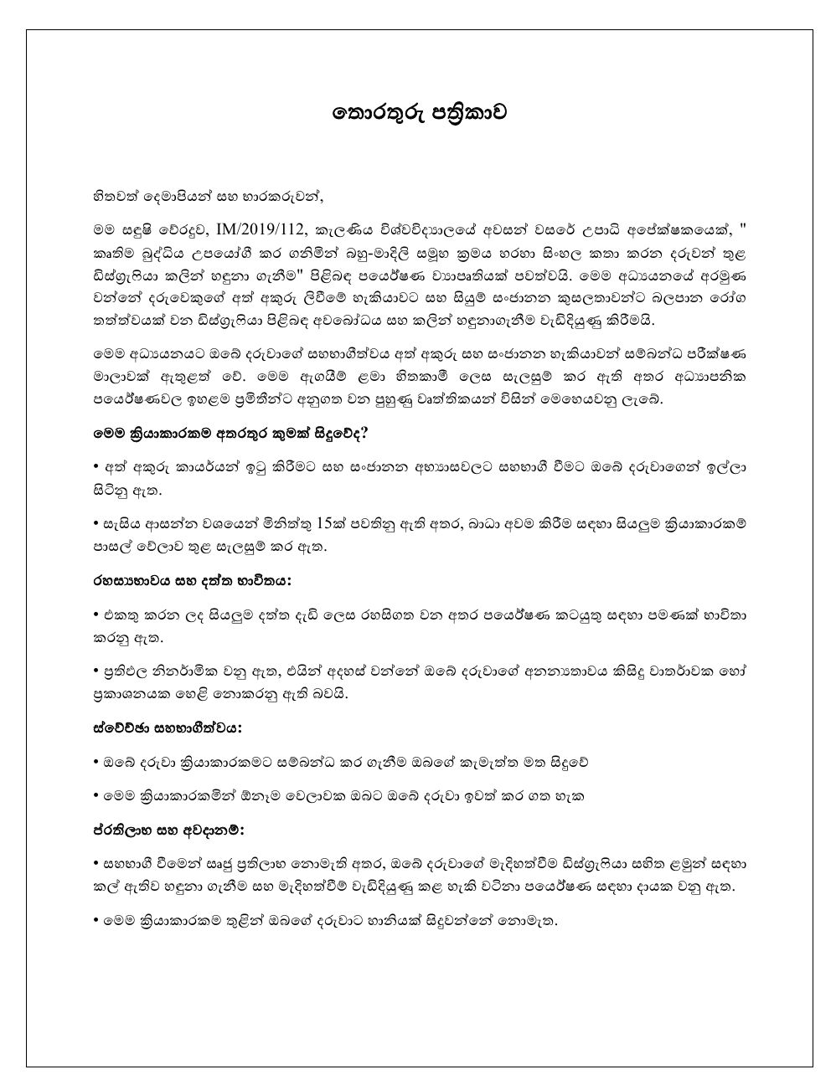

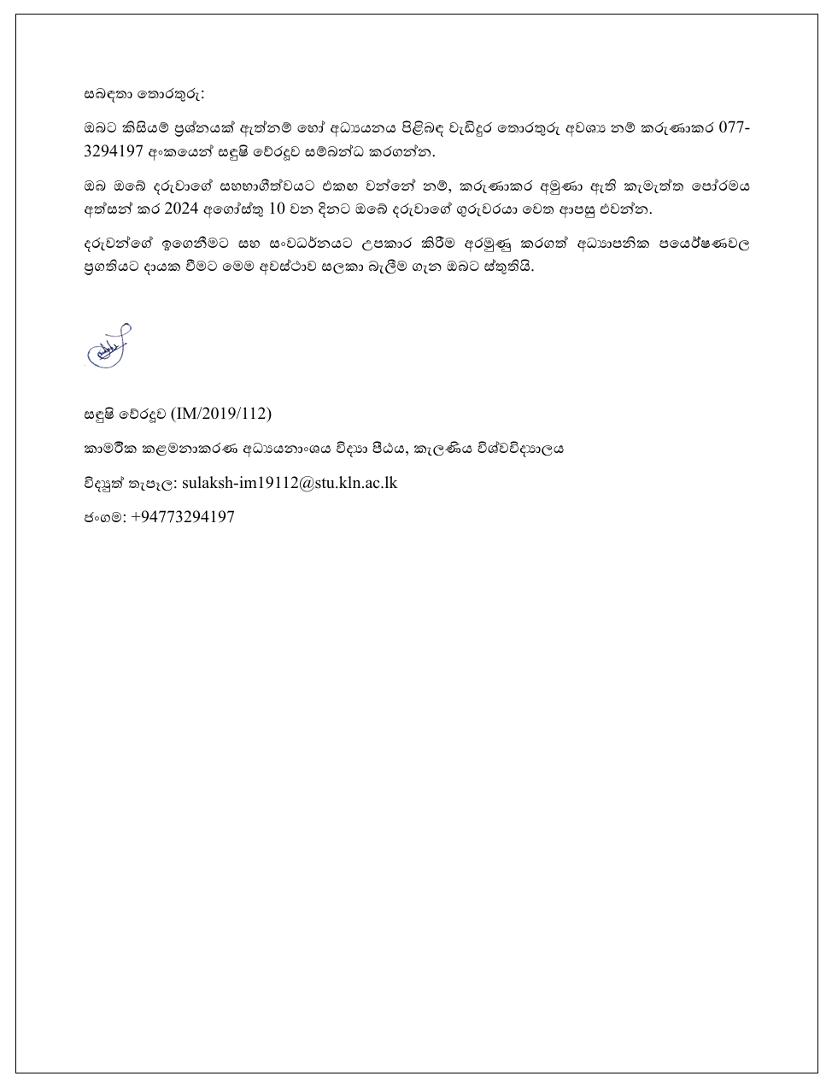
Figure 7-Sinhala Translation of the information letter

Author contributions
All authors contributed to the study conception and design. Material preparation, data collection, and analysis were performed by Sandushi Weraduwa. The first draft of the manuscript was written by Sandushi Weraduwa, who also led the revisions based on feedback from co-authors named PPG Dinesh Asanka and Thilini V. Mahanama. Sandushi Weraduwa is the principal author of this paper. All authors read and approved the final manuscript.

