Supporting information

Architecture engineering of one body nanostructured catalyst: layer-by-layer adornment of multiple nanocatalysts on silica nanorod arrays for hydrogenation of nitroarenes

Kootak Hong^{1,+}, Jun Min Suh^{1,+}, Tae Hyung Lee¹, Seeram Ramakrishna², Rajender S. Varma^{3,}*, Ho Won Jang^{1,}*, and Mohammadreza Shokouhimehr^{1,}*

¹Department of Materials Science and Engineering, Research Institute of Advanced Materials, Seoul National University, Seoul 08826, Republic of Korea.
²Faculty of Mechanical Engineering, National University of Singapore, 117574, Singapore.
³Regional Centre of Advanced Technologies and Materials, Palacký University, Šlechtitelů 27, 783 71 Olomouc, Czech Republic.

Corresponding Authors
varma.rajender@epa.gov (R.S.V.), hwjang@snu.ac.kr (H.W.J.), mrsh2@snu.ac.kr (M.S.)

+ K.H., J.M.S., contributed equally to this work.

Heterogeneous reduction of substituted nitroarenes
The reduction of nitroarenes was performed in a glass flask. In a typical procedure, v-SiO₂ NRs@Pd nanostructured catalyst (1 mol%) was immersed in H₂O (20 mL). Then, a nitroarenes compound (0.1 mmol), NaBH₄ (0.12 mol%) and a small stirring bar were added to the glass flask. The reaction mixture was stirred at room temperature for 1.5 h under air atmosphere. After completion of the reaction, the v-SiO₂ NRs@Pd nanostructured catalyst was drawn out from the reaction mixture by tweezers, rinsed with ethanol, and reused in the next cycle.

Heterogeneous Suzuki cross-coupling reactions
Suzuki reactions were expedited using v-SiO₂ NRs@Pd nanostructured catalyst in a round-bottom flask containing dimethylformamide (DMF)/H2O (5:1) solvent. Aryl halide (0.1 mmol), phenylboronic acid (0.12 eq.), K₂CO₃ (1.5 eq.), and a small stirring bar were added to the flask immersed in an oil bath (100 °C). The reaction mixtures were stirred under air atmosphere for adequate time to obtain the expected biphenyl products.

Fig. S1. XPS analysis of (a) survey, (b) Si, and (c) O present in v-SiO2 NRs@Pd
nanostructured catalyst.
Fig. S2. (a) Cross-sectional FESEM image of v-SiO₂ NRs@Pd/Au nanostructured catalyst. (b-e) EDS element maps of (b) Si, (c) O, (d) Au, and (e) Pd of v-SiO₂ NRs@Pd/Au nanostructured catalyst. HRTEM images of (f) Au and (g) Pd existing in v-SiO₂ NRs@Pd/Au nanostructured catalyst. XPS analysis of (h) Au and (i) Pd in v-SiO₂ NRs@Pd/Au nanostructured catalyst.

Fig. S3. Cross-sectional FESEM image of v-SnO₂ NRs@Pd nanostructured catalyst.

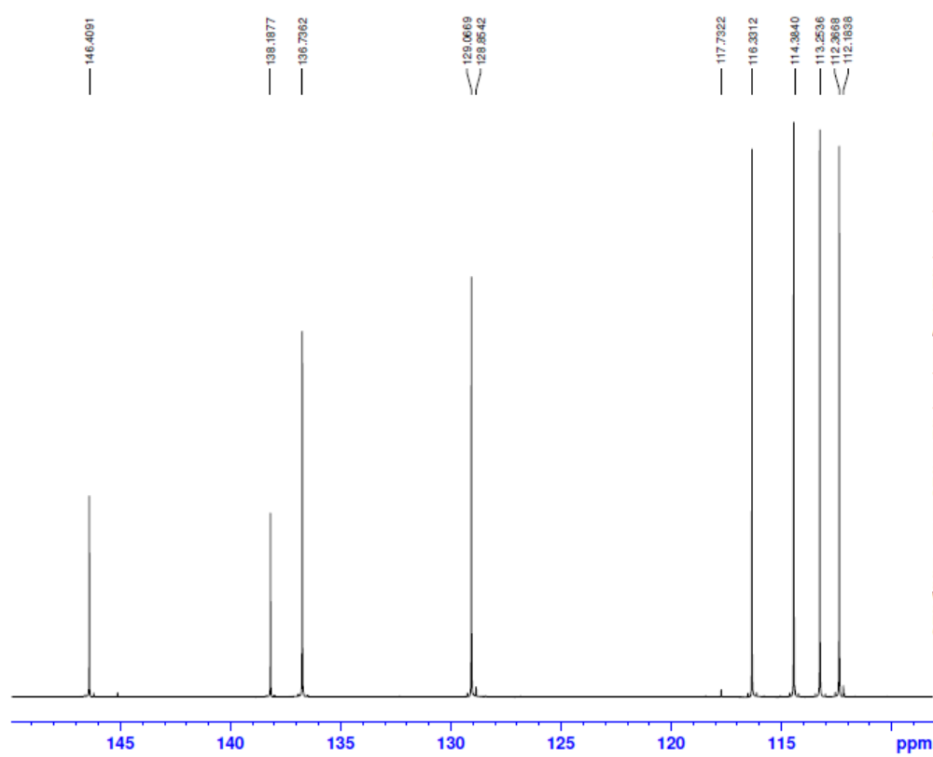
Fig. S4. C-13 NMR spectrum of 3-vinylbenzenamine (Table 1, entry).

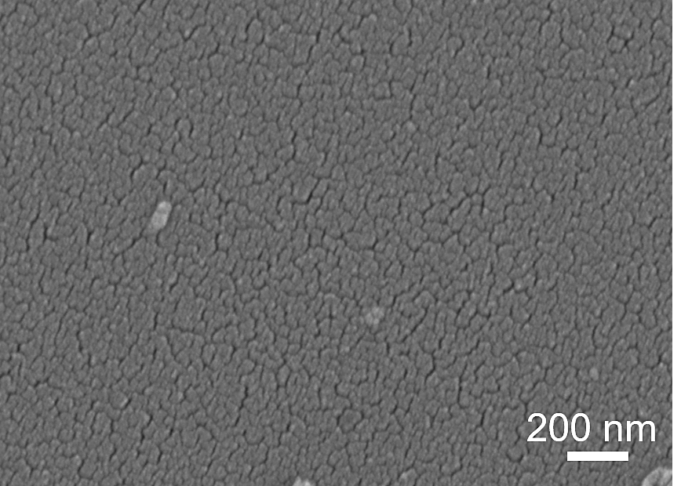
Fig. S5. FESEM image of Pd NPs deposited directly on silicon wafer.

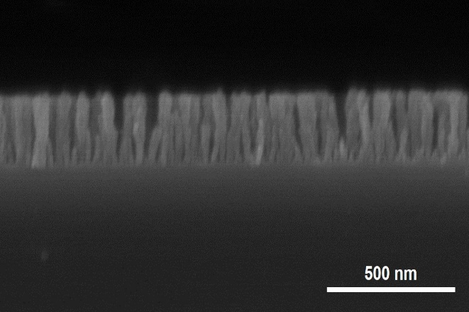
Fig. S6. Cross-sectional FESEM image of ~200 nm v-SiO₂ NRs@Pd nanostructured catalyst.

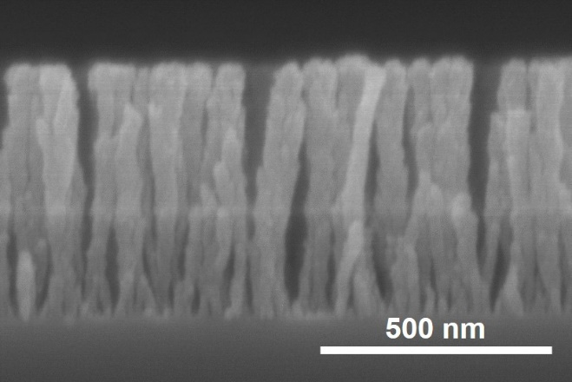
Fig. S7. Cross-sectional FESEM image of ~600 nm v-SiO₂ NRs@Pd nanostructured catalyst.

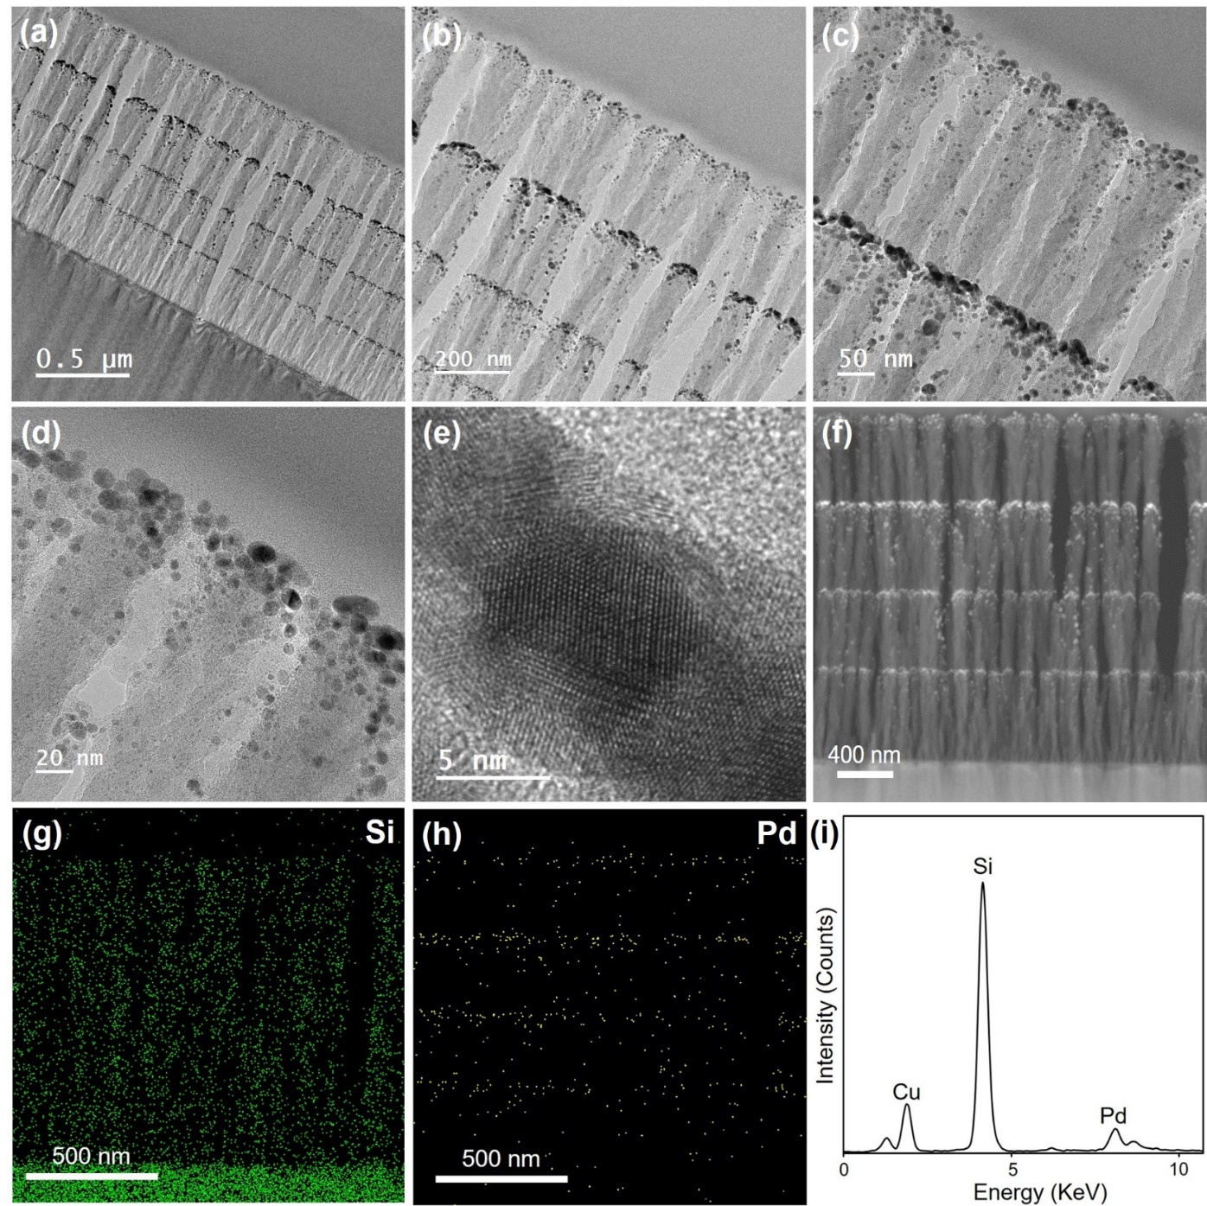
Fig. S8. (a-e) Cross-sectional TEM and HRTEM images, and (F) STEM image of recycled v-SiO₂ NRs@Pd nanostructured catalyst. (g) Si, and (h) Pd elemental mapping of recycled v-SiO₂ NRs@Pd nanostructured catalyst. (i) EDX spectrum of recycled v-SiO₂ NRs@Pd nanostructured catalyst.

Table S1. Heterogeneous reduction of nitrobenzene catalyzed by different nanostructured catalyst.

Entry | Nanostructured catalyst | Yields (%)ª
1 | Pd NPs on silicon wafer | 15
2 | Pd NPs on ~200 nm SiO₂ NRs | 35
3 | Pd NPs on ~600 nm SiO₂ NRs | 58
4 | v-SiO₂ NRs@Pd catalyst | 99

Reaction conditions: Nitrobenzene (0.1 mmol), NaBH₄ (0.12 mmol), nanostructured catalyst (1 mol% Pd), H₂O (20 mL), room temperature, and 1.5 h. ª Yields were determined by GC-MS.

