Supplementary data
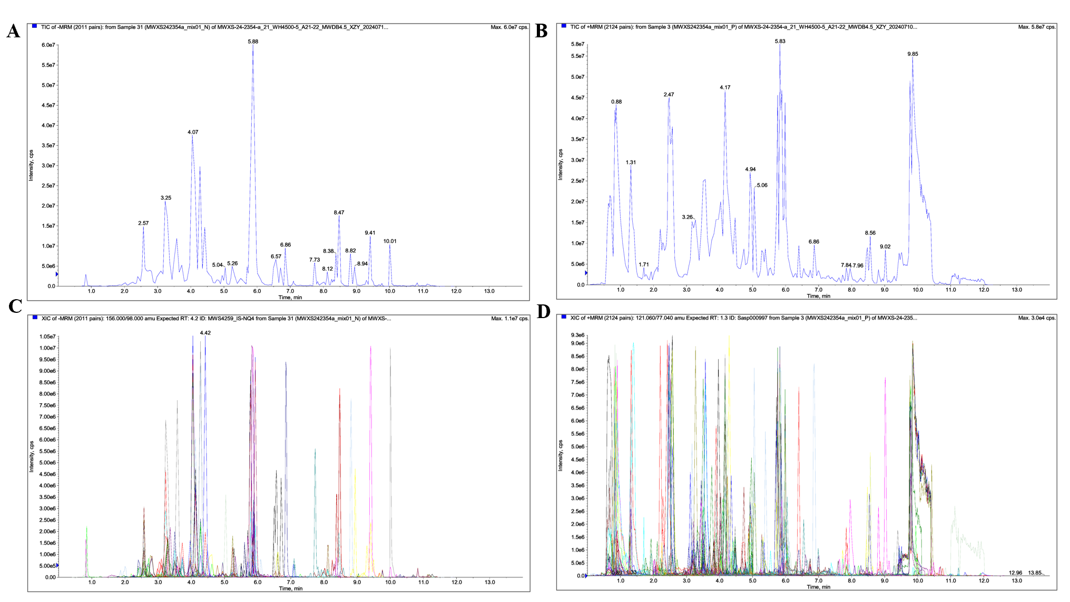
Fig. S1. A-B mean the total ionscurrent (TIC) of the mixed QC samples, A represents the negative ion pattern, B represents the positive ion pattern. C-D mean the MRM metabolite detection multimodal map (multi-species extracted ion chromatogram, XIC), where C represents the negative ion mode, D represents the positive ion mode. The abscissa is the retention time (RT) of the metabolite detection, and the ordinate is the ion current intensity of the ion detection (the intensity unit is cps, count per second).
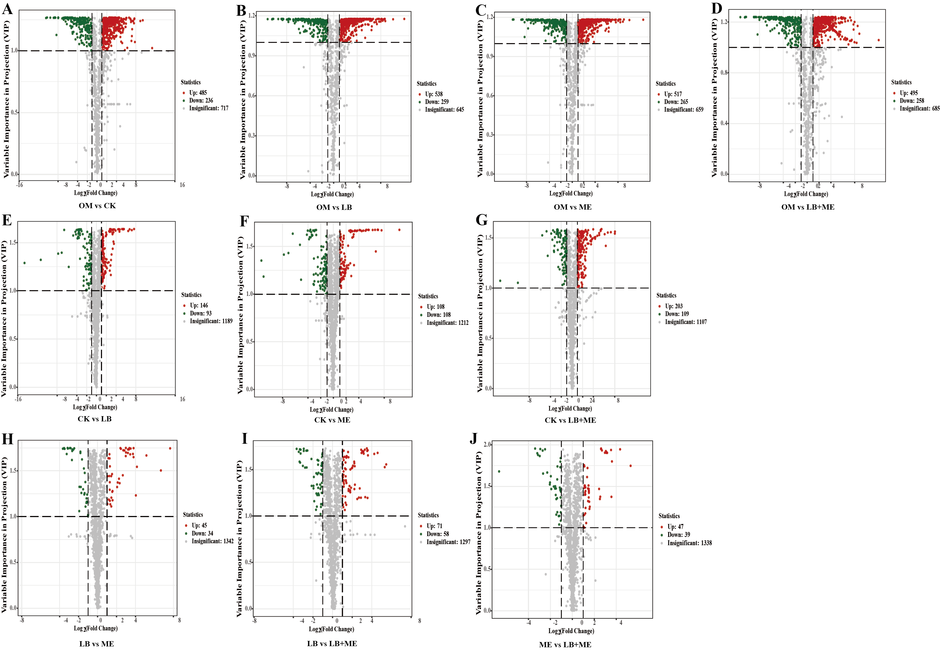
Fig. S2. Volcano plots for differentially accumulated metabolite levels in whole plant corn silage. OM vs CK (A), OM vs LB (B), OM vs ME (C), OM vs LB+ME (D), CK vs LB (E), CK vs ME (F), CK vs LB+ME (G), LB vs ME (H), LB vs LB+ME (I), ME vs LB+ME (J), LB vs ME vs LB+ME (K). Green dots represent downregulated differentially accumulated metabolites; red dots represent upregulated differentially accumulated metabolites, and grey dots represent non-differentially accumulated metabolites. The abscissa represents the logarithm (log2FC) of the difference in the relative content of a metabolite in two groups of samples. VIP+FC+P-value filter: The ordinate represents the significance level of the difference (-log10 P-value), and the size of the dot represents the VIP value. Under the VIP +FC filter: The ordinate represents the VIP value.

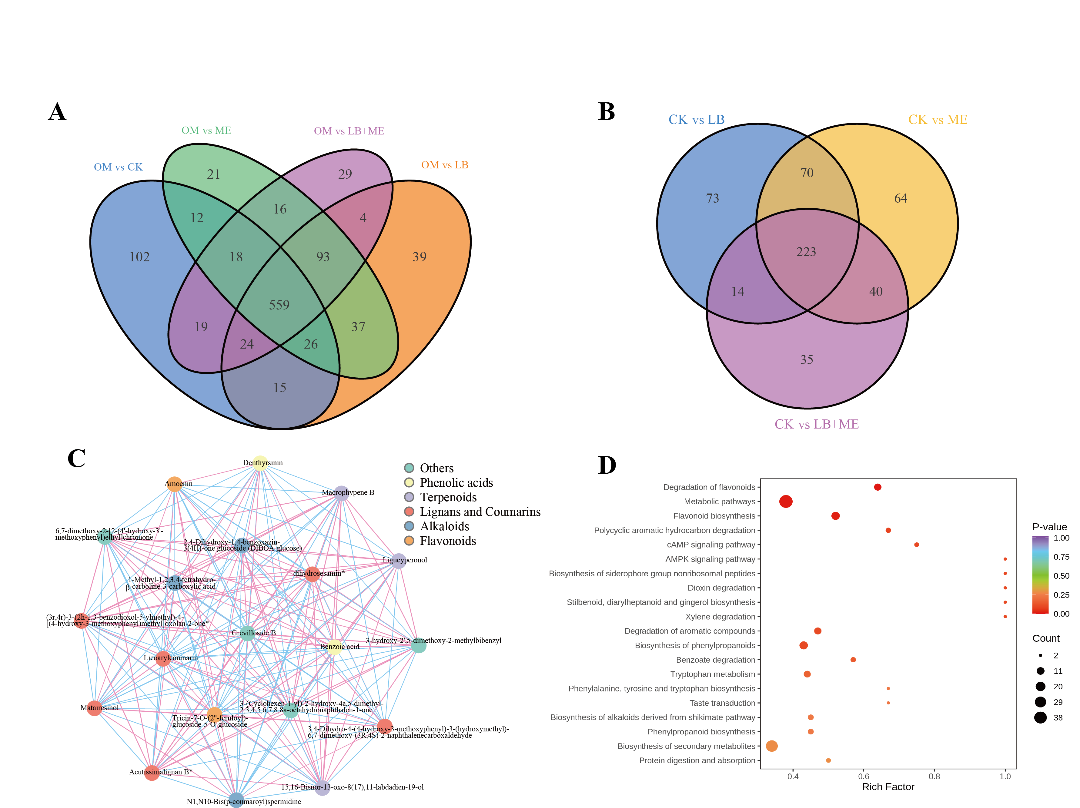
Fig. S3 A: Wayne diagram of 4 treatments of WCS compared to OM. B: Wayne diagram of WCS additive treatment group. C: Differential metabolite correlation network diagram of WCS. D. Differential metabolite enrichment pathways of WCS.

