Supplementary figures

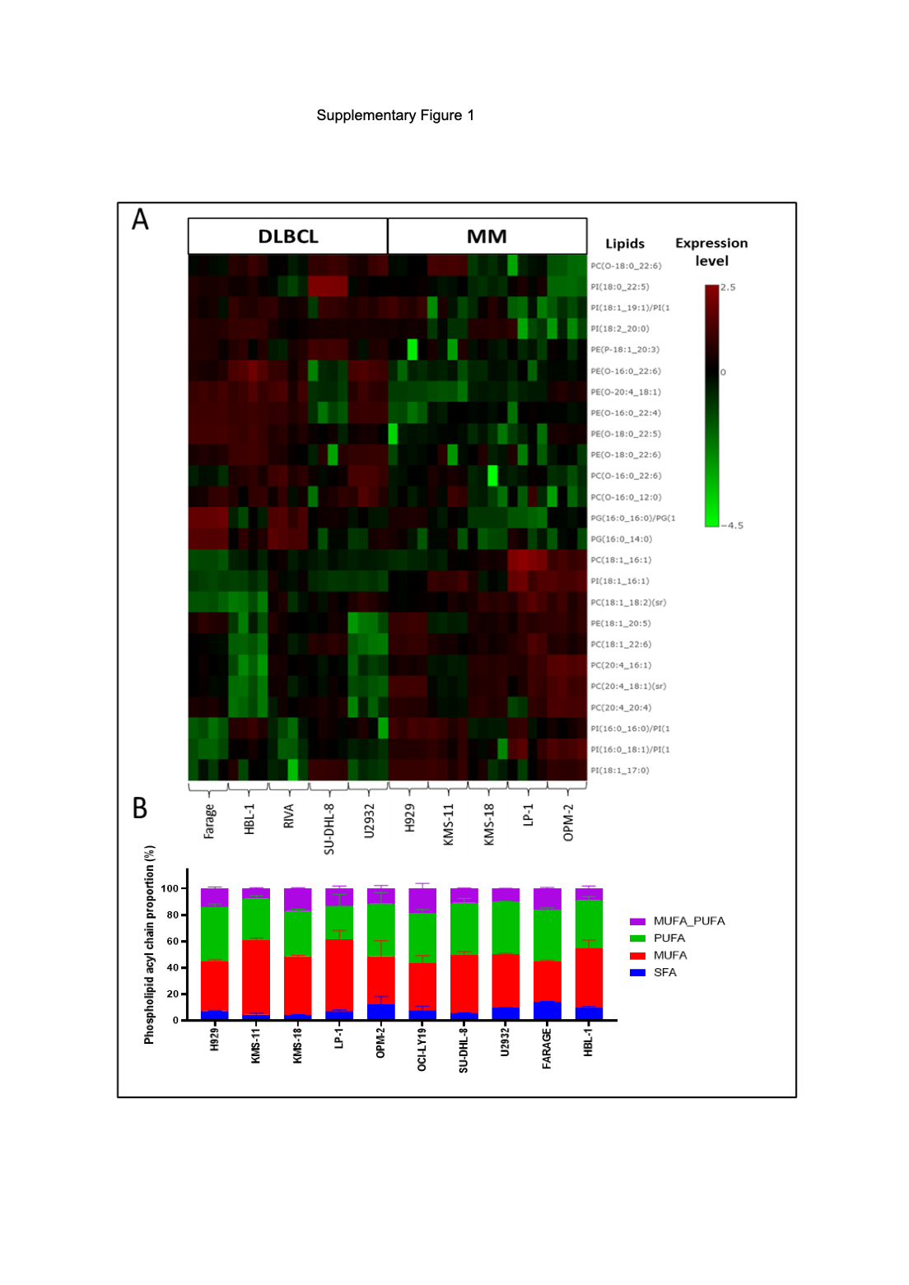
Supplementary Figure 1. Fatty acid expression patterns in MM and DLBCL cell lines.
(A) Lipidomics analysis of 5 DLBCL (Farage, HBL-1, RIVA, SU-DHL-8, U2932) and 5 MM (H929, KMS-11, KMS-18; LP-1, OPM-2) cell lines. Heatmap of the 25 most differentially expressed lipids between the MM and DLBCL lines. (B) Relative proportions of each PL acyl chain present in the MM and DLBCL cell lines. Data are the mean of a minimum of 4 biological replicates. PC, phosphatidylcholine; PE, phosphatidylethanolamine; PG, phosphatidylglycerol; PI, phosphatidylinositol; MUFA, monounsaturated fatty acid; PUFA, polyunsaturated fatty acid; SFA, saturated fatty acid.

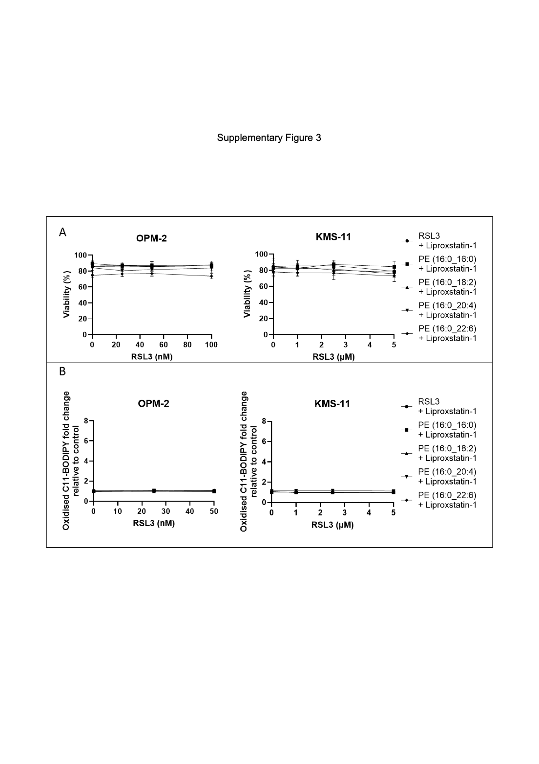
Supplementary Figure 2. Liproxstatin-1 inhibits cell death and lipid ROS induced by PUFA and RSL3.
(A) OPM-2 and KMS-11 cells were cultured with 20 μM PE lipids and the indicated concentrations of RSL3 with liproxstatin-1 for 24 hours. Cell viability was assessed using annexin V/PI staining and flow cytometry. (B) OPM-2 and KMS-11 cells were cultured with 20 μM PE lipids and the indicated concentrations of RSL3 with liproxstatin-1 for 24 hours. Lipid ROS levels were assessed by flow cytometry in cells stained with oxidised C11 BODIPY. Data are the mean ± standard deviation of duplicate measurements from 3 independent experiments. PE, phosphatidylethanolamine.

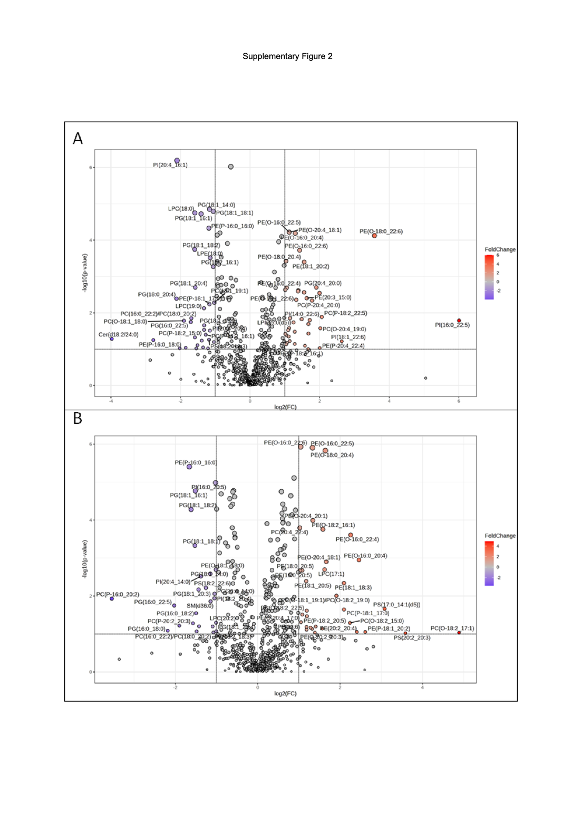
Supplementary Figure 3. Oleic acid displaces PUFA in phospholipids in OPM-2 and KMS-11 cells.
(A) Volcano plot (direction of comparison OPM-2/OPM-2 + PE (16:0_18:1)) combining results from Fold Change (Threshold 2.0) Analysis and t-tests (P-value threshold 0.1) generated using MetaboAnalyst. (B) Volcano plot (direction of comparison KMS-11/KMS-11 + PE (16:0_18:1)) combining results from Fold Change (Threshold 2.0) Analysis and t-tests (P-value threshold 0.1) generated using MetaboAnalyst. Data are the mean of a minimum of 4 biological replicates. LPC, Lysophosphatidylcholine; PC, phosphatidylcholine; PE, phosphatidylethanolamine; PG, phosphatidylglycerol; PI, phosphatidylinositol. PS, phosphatidylserine;

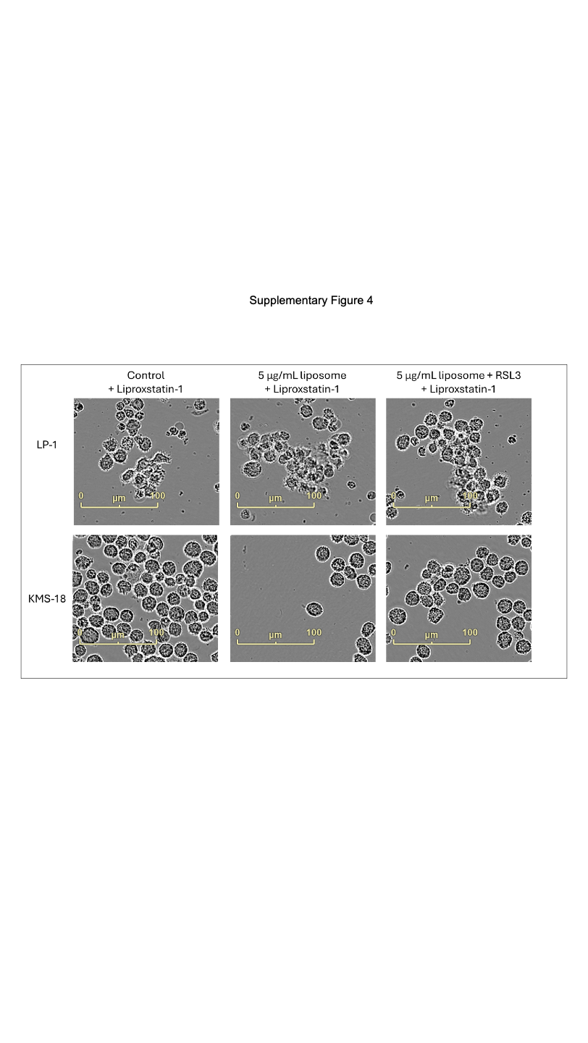
Supplementary Figure 4. Liproxstatin-1 inhibits morphological changes induced by liposomes encapsulating RSL3.
MM cells were cultured for 24 hours with 15 μg/mL liposomes that either did or did not contain RSL3, in addition to liproxstatin-1. Images were acquired at 24 hours using an IncuCyte S3 live cell analysis system at 20X magnification.

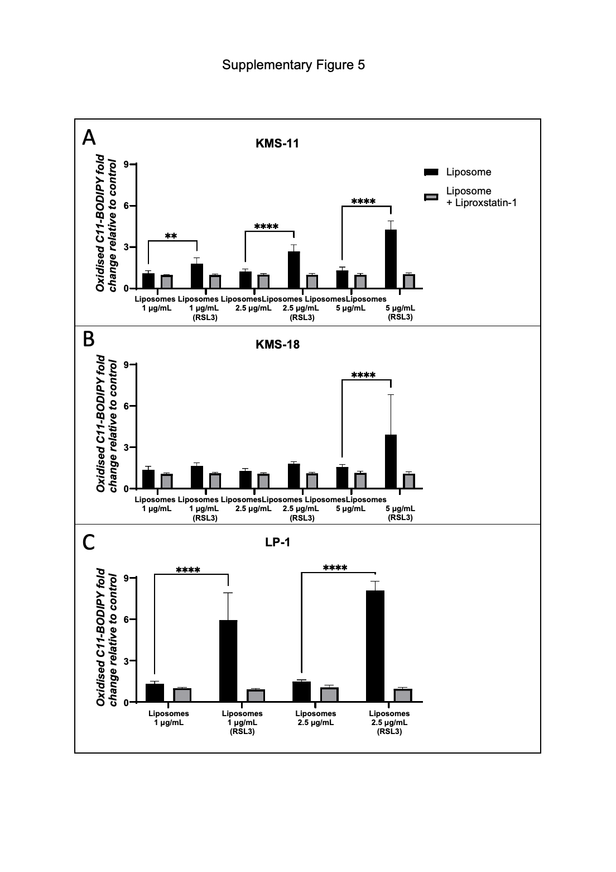
Supplementary Figure 5. Liposomes containing RSL3 induce greater lipid ROS in MM cell lines compared to liposomes alone.
(A) KMS-11, (B) KMS-18 and (C) LP-1 MM cells were cultured with the indicated concentrations of either liposomes alone or liposomes containing RSL3 for 2 hours. Lipid ROS levels were assessed by flow cytometry in cells stained with C11 BODIPY. Data are the mean ± standard deviation of duplicate measurements from 3 independent experiments using two-way ANOVA for statistical analysis (*P<0.05, **P<0.01, ***P<0.001, **** P<0.0001).

