Appendix
Table A.1. Waste heat temperatures in various processes with temperature levels and waste heat fluctuation characteristics.
Industrial Process | Exhaust gas temperature (°C) | Waste heat carrier | Waste heat fluctuation time
Aluminum reverberatory furnace | 1100–1200 | Mass flow and temperature | Minutes – hours
Nickel refining furnace | 1370–1650 | Mass flow and temperature | Minutes – hours
Copper reverberatory furnace | 900–1090 | Mass flow and temperature | Minutes – hours
Glass oven without regenerator | 900–1300 | Mass flow and temperature | Minutes – hours
Basic oxygen furnace | 1200 | Mass flow and temperature | Minutes – hours
Iron- and steelmaking | 1450–1550 | Mass flow and temperature | Minutes – hours
Steel electric arc furnace | 1370–1650 | Mass flow and temperature | Minutes – hours
Glass melting furnace | 1300–1540 | Mass flow and temperature | Minutes – hours
Steel heating furnace | 930–1040 | Mass flow and temperature | Minutes – hours
Copper reverberatory furnace | 900–1090 | Mass flow and temperature | Minutes – hours
Glass oven without regenerator | 900–1300 | Mass flow and temperature | Minutes – hours
Iron cupola | 820–980 | Mass flow and temperature | Minutes – hours
Cooper refining furnace | 760–820 | Mass flow and temperature | Minutes – hours
Reheating furnace without regenerator | 700–1200 | temperature | Minutes – hours
Hydrogen plants | 650–980 | temperature | Minutes
Fume incinerators | 650–1430 | temperature | Minutes – hours
Coke oven | 650–1000 | temperature | Minutes – hours
Glass oven with regenerator | 600–800 | Mass flow | Minutes
Cement kiln | 450–620 | Mass flow | Minutes
Melting oven | 400–700 | temperature | Minutes
Gas turbine exhaust | 370–540 | temperature | Minutes
Reciprocating engine exhaust | 320–590 | temperature | Minutes
Reheating furnace with regenerator | 300–600 | Mass flow | Minutes
Blast furnace stoves | 250–300 | Mass flow | Minutes
Drying and baking ovens | 230–590 | temperature | Minutes
Steam boiler exhaust | 230–480 | temperature | Minutes
Steam boiler | 200–300 | temperature | Minutes
Coke oven | 190 | temperature | Minutes
Container glass melting | 160–200 | temperature | Minutes
Container glass melting | 140–160 | temperature | Minutes
Flat glass melting | 160–200 | temperature | Minutes
Flat glass melting | 140–160 | temperature | Minutes
Ceramic kiln | 150–1000 | temperature | Minutes – hours
Drying, baking, and curing ovens | 90–230 | temperature | Minutes

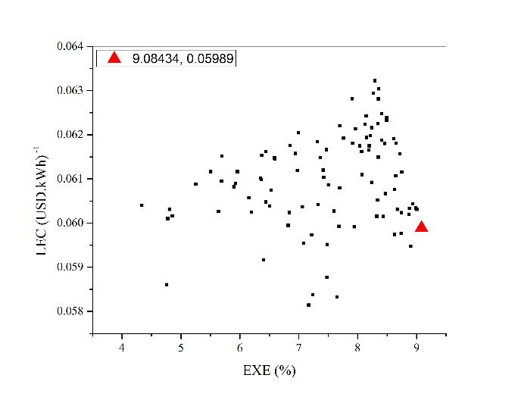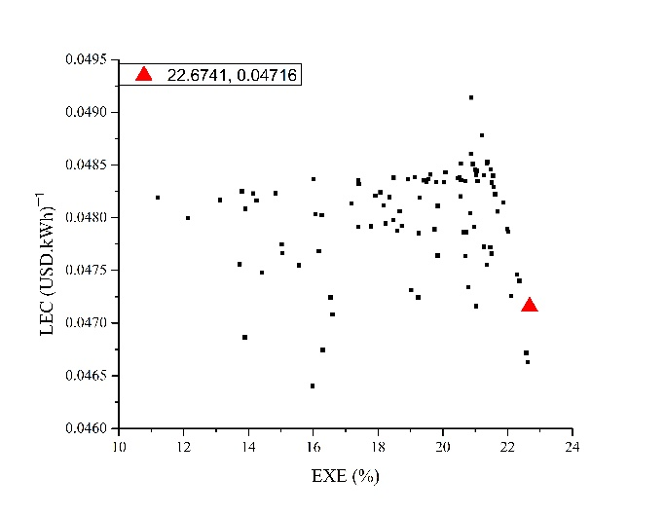(a) Butane (b) Butane
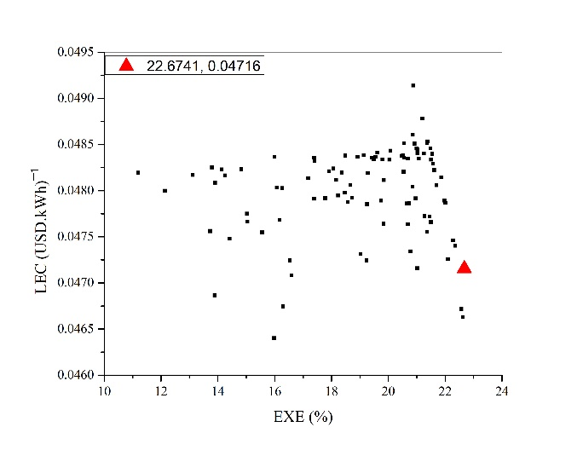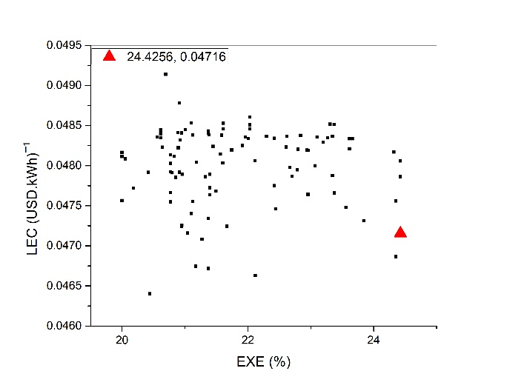
(a) Heptane (b) Heptane
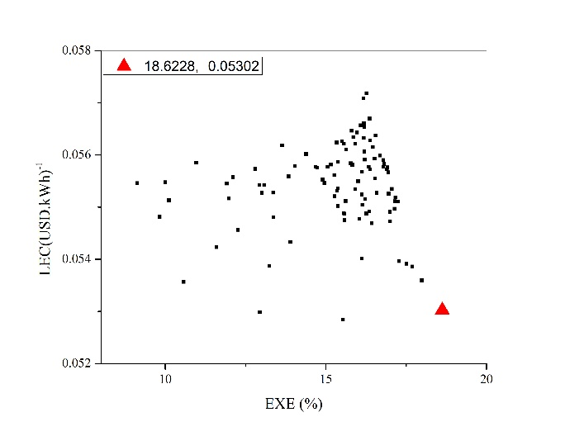
(a) Hexane (b) Hexane
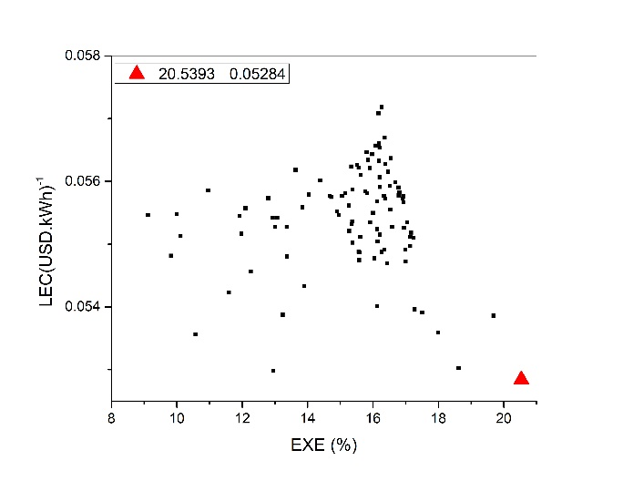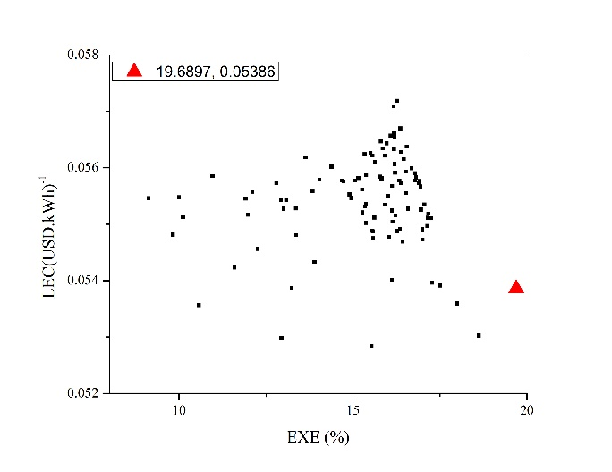
(a) Ipentane (b) Ipentane
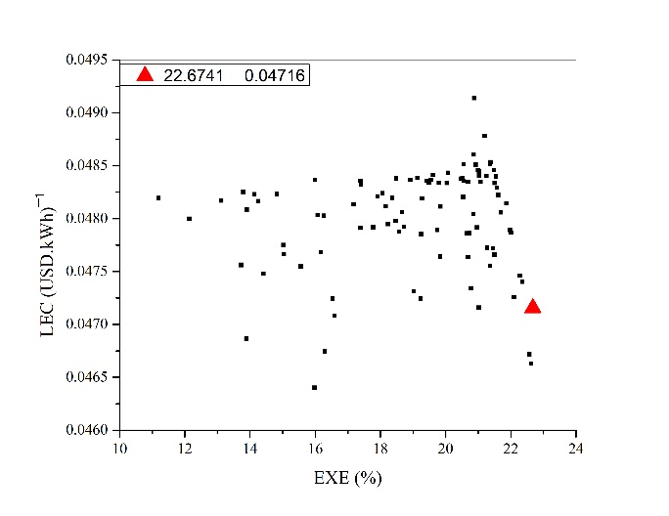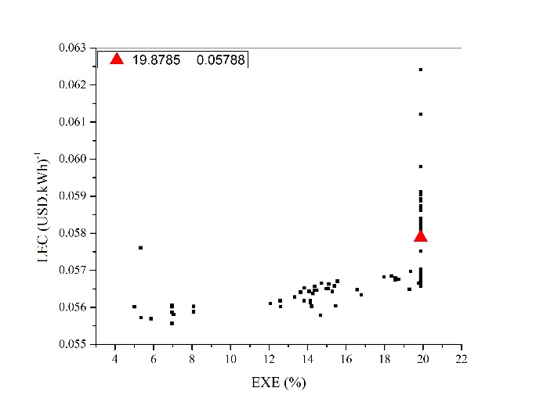
(a) Neopentane (b) Neopentane
(a) R134a (b) R134a
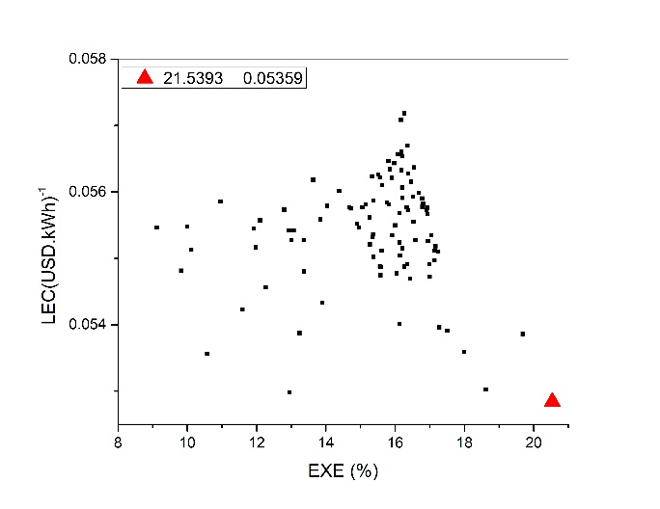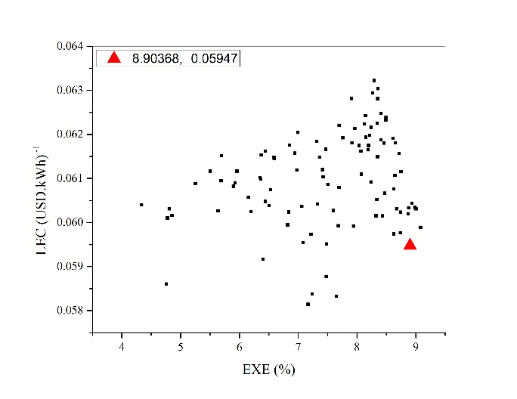
(a) R-245b (b) R-245b
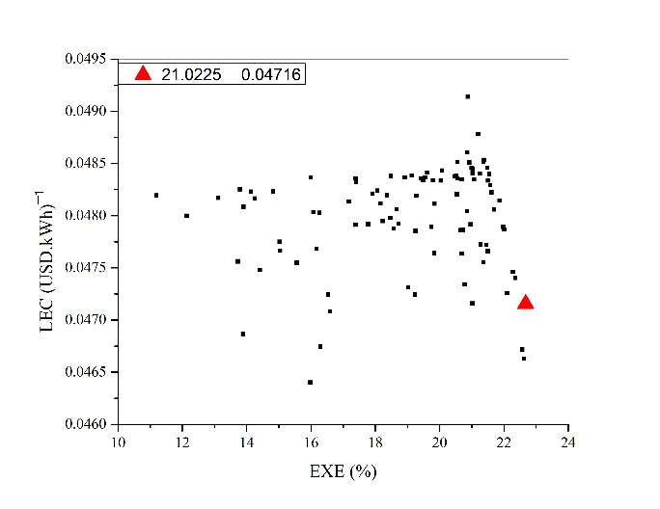
(a) Toluene (b) Toluene
Figure. A. 1. Optimal compromise solution on the Pareto frontiers of eight working fluid candidates (a) ORC and (b) RORC

