Supplemental information

Title
Integration of biomimetic organoid-on-chip and 2D models advances the mechanistic understanding of STEAP3-mediated regulation in intestinal viral infection

Authors:
Yi-Wen Chen^{1,2,3}, Huan-Jung Chiang^{4,5}, Kuan-Ting Liu^{4,6}, Chun-Wei Kao¹, Shan-Ren Xie¹, Chao-Ming Su¹ and Yu-Yin Shih^{1,4*}

Affiliations:
1. Research & Development Center for x-Dimensional Extracellular Vesicles, China Medical University Hospital, Taichung, 404332, Taiwan
2. Department of Bioinformatics and Medical Engineering, Asia University, Taichung, 41354, Taiwan
3. Graduate Institute of Biomedical Sciences, China Medical University, Taichung, 406040, Taiwan
4. Research Center for Emerging Viral Infections, College of Medicine, Chang Gung University, Taoyuan, 33302, Taiwan
5. Department of Medical Biotechnology & Laboratory Science, College of Medicine, Chang Gung University, Taoyuan, 33302, Taiwan
6. Department of Microbiology & Immunology, School of Medicine, Stanford University, Stanford, CA, 94305, USA

*Corresponding author: ami8824@gmail.com

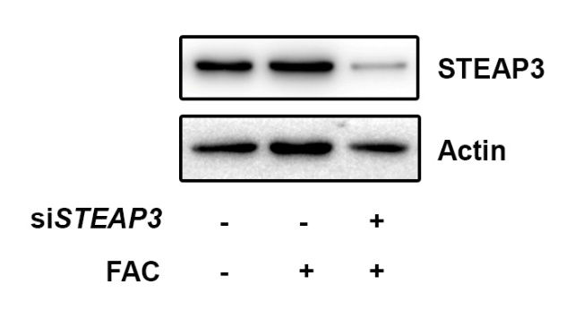

Suppl Fig. 1 Expressional levels of STEAP3 protein in Caco-2 cells transfected with or without siSTEAP3 siRNA in the presence or absence of FAC (100 µM).

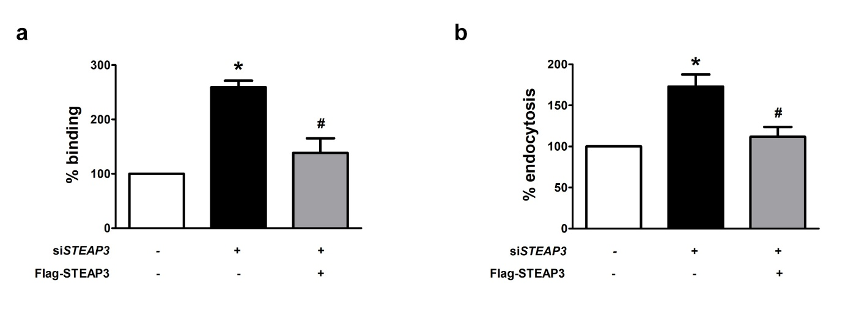
Suppl Fig. 2 Rescue of increased viral entry in STEAP3-deficient RD cells by reconstitution of STEAP3 expression. Cells were knockdown with siRNA for 24 h and then transfected with pIRES2-Flag-STEAP3 for an additional 24 h. Virus binding (A) and internalization assays (B) were conducted. *p < 0.05 compared to siControl-transfected cells without overexpression of STEAP3. #p < 0.05 versus siSTEAP3-transfected cells without overexpression of STEAP3 using the student’s t-test. All data are shown as the mean (± s.d.).

.

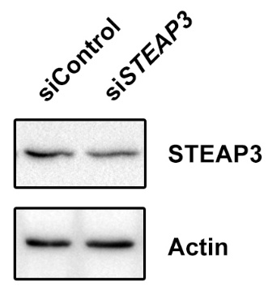

Suppl Fig. 3 STEAP3 expression in Caco-2 cells knockdown with siRNA targeting to control or STEAP3.

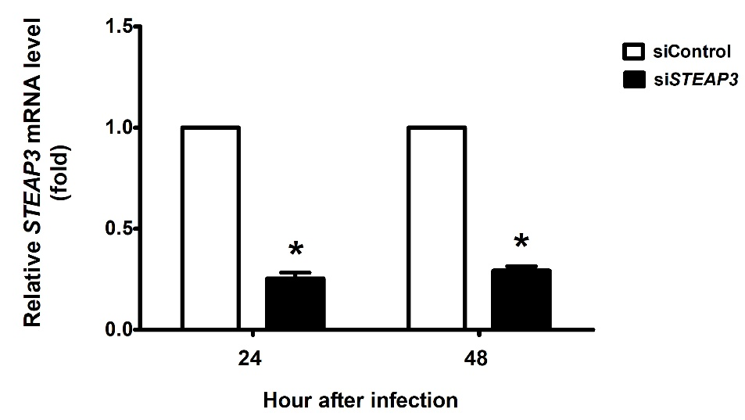

Suppl Fig. 4 The expression level of STEAP3 mRNA in calu-3 cells transfected with siControl or siSTEAP3 for 24 and 48 h. *p< 0.05 versus siControl-transfected cells using the student’s t-test. All data are shown as the mean (± s.d.).

Uncropped and unprocessed blots are presented in Fig. 1B.

Uncropped and unprocessed blots are presented in Fig. 3.

Uncropped and unprocessed blots are presented in Fig. 4.

Uncropped and unprocessed blots are presented in Fig. 5F.

