Supplementary Online Content

Multimodal Prediction of Future Depressive Symptoms in Adolescents

Supplemental Methods
Participants. Participants with a neurodevelopmental disorder that would interfere with study tasks were also excluded from the study. Given the neuroimaging component of this study, participants were also excluded if they had any magnetic resonance imaging (MRI) contraindications: a cardiac pacemaker, aneurysm clip, brain stimulator, cochlear implant, implanted drug pump, metal fragment in the eye, metal shrapnel in the body, metallic surgical hardware near the head / neck, braces, certain tattoos with metallic ink, a copper IUD, transdermal skin patch, claustrophobia, or a known pregnancy validated through a positive urine pregnancy test. Additional exclusion criteria included clinical or laboratory evidence of hypothyroidism, presence of serious medical or neurological illness (e.g., seizures), and any previous loss of consciousness greater than 2 minutes.
Ecological Momentary Assessment: Participants were asked to rate the extent to which they were feeling several emotions immediately before they started the assessment on a 5-point Likert scale, ranging from 1, “Very slightly or not at all,” to 5, “Extremely.” Participants’ positive affect (PA) included responses for the following emotions: “happy,” “interested,” and “excited.” Participants’ negative affect (NA) included responses for: “sad,” “nervous,” and “angry.” Mean PA and NA were measured by averaging the three PA and NA variables, respectively. Several affect dynamic measures previously linked to depression were also included: the variability in PA and NA were measured using the standard deviation (SD) and mean square successive difference (MSSD; [1–4]), and we also included temporal dependency (autocorrelation; [5]) of PA and NA as a measure of emotional inertia.
Neuroimaging data acquisition: MRI data were acquired with 3.0 T Siemens MRI scanners, either using a Tim Trio with 32-channel head choil (n=11, of which 7 from one study and 4 from the other) or a MAGNETOM Prisma with 64-channel head choil (remaining participants). Scanning parameters for all sequences were similar regardless of scanner model, unless otherwise noted. Anatomical data were acquired using a T1-weighted multi-echo magnetization prepared rapid gradient echo (MEMPRAGE) pulse sequence: voxel size = 1 × 1 × 1.3 mm (1.3 x 1 x 1.3 in the Trio sequence), repetition time (TR) = 2,530 ms, echo time (TE) = 3.3 ms, flip angle (FA) = 7°, and inversion time (TI) = 1,100 ms. Functional data were acquired using a multiband sequence: voxel size = 2.5 × 2.5 × 2.5 mm, TR = 720 ms, TE = 30 ms, FA = 66°, FOV = 212 mm, and multiband accelerator factor = 6. A magnitude and phase difference field maps sequences were acquired using the following parameters: voxel size = 3.3 x 3.3 x 2.5 mm, TR = 1.250 ms, TEs = 10.0 and 12.46 ms, FA = 60°, FOV = 212 mm.
Neuroimaging fMRI Reward Task: During the MRI scan session, participants completed four runs (approximately 6 min and 15 secs each run) of a fMRI Reward Task [6], a slow event-related card guessing game that assesses neural responses during reward anticipation (learn of the possibility of receiving a reward) and reward outcome (reward receipt) [6–8]. Specifically, participants were asked to guess whether a card presented at the next trial would be higher or lower compared to a value shown on the screen (3 sec), viewed a fixation cross (0.5 - 7 sec) before and after being cued about the type of trial (either reward, loss, neutral , or mixed, 1 sec), and were provided a feedback regarding their guess (either win, loss, or neutral, 1 sec). There were 32 trial-blocks in each run. Each run consisted of 8 win outcomes from the reward anticipation trials (n=4) and mixed anticipation trials (n=4), 8 losses from neutral anticipation trials, 8 from no-change outcome trials (i.e. incorrect reward trial no-win, correct loss trial avoid loss). Trials were shown in pseudo-random order with predetermined outcomes. Correct trials received $1 while incorrect trials (i.e., losses) deducted $0.50.
Neuroimaging data processing: MRI data processing was conducted in SPM12 (http://www.fil.ion.ucl.ac. uk/spm/). Data were segmented, realigned and unwarped, corrected for susceptibility distortions using field maps, slice-time corrected, co-registered, normalized to Montreal Neurological Institute (MNI) space, resampled to 2 mm isotropic voxels, and smoothed with a 4 mm full-with half-maximum Gaussian filter. Volumes outliers were identified using the Artifact Detection Toolbox (http://www.nitrc.org/projects/artifact_detect/) and defined as volumes with mean intensity >3 S.D. and/or with composite motion >1 mm compared to the previous volume. Outliers were included as separate regressors in individual participant’s first level model. Following data preprocessing, individual contrast images were used to create second-level random effects models via one-sample t-tests for (1) the anticipation of reward > anticipation of a neutral outcome (no chance to win money) from the anticipation phase and (2) the reward receipt (win money) > neutral (no money won) from the outcome phase. Mean beta weights for the medial PFC (mPFC) and bilateral striatum (nucleus accumbens, caudate, and putamen) regions of interest (ROIs) were extracted for each contrast [8].
Factor Analysis
We conducted two exploratory factor analyses (EFA) to examine factors underlying the depression questionnaire (MFQ and CESD) items at baseline, in an effort to determine which depression features, if any, were most predictive of future depressive symptoms. EFA was selected rather than a principal components analysis because the former is the most appropriate method for identifying multidimensional constructs, whereas the latter is most appropriate for data reduction [9]. The number of factors was chosen based on the outcomes of the scree test and the cumulative variance explained in the baseline questionnaire score matrix. Once the factor model is fit, the latent score for each factor is subsequently extracted for each individual. We investigated the correlation between each factor at baseline and the depression outcome at 3 months follow-up (Supplementary Figure 6).
Nested Cross-Validation. This procedure uses different data to tune model parameters (inner loop of the CV) and evaluate model performance (outer loop), thus avoiding information leak and model overfitting. Data preprocessing steps (e.g., scaling, imputation, and PCA feature extraction) were performed within each training fold to ensure that information from the test data was never used during model training. Within the inner loop, a model is trained on each training set, then the performance score is maximized in selecting optimal hyperparameters over the validation set. In the outer loop, the model is fit on the whole outer training fold and tested on the left-out data from the outer fold. This is repeated across all outer folds, and the pooled unseen test predictions from the outer folds are compared against the true results for the outer test folds and the results concatenated, providing measures of predictive performance across the whole dataset, including R squared (R2), root mean squared error (RMSE) and mean absolute error (MAE). We used 10 folds for both inner and outer loops. We used the nestedcv package [10] for model training and validation based on this procedure. To eliminate the randomness in sample splitting, we repeated the nested CV procedure 30 times and reported the mean values of performance metrics from the repetitions in Table 2 (also see Figure 3). Missing data were addressed using multiple imputation by chained equations (MICE), conducted once prior to model training for computational efficiency. The resulting completed dataset was then used as input for all subsequent analyses (i.e., imputation was performed once prior to nested cross-validation).
Feature Importance: SHAP values have been used to understand how specific features affect the prediction by evaluating how changing that feature impacts the model’s output [11]. It provides a mechanism for determining feature importance, as well as the marginal contribution of each input variable to the model’s prediction at the individual level, represented as the individual values positioning on the x axis of the right panel of Figure 4. Specifically, an individual feature’s SHAP value can be interpreted as that feature’s partial association with the outcome when controlling for all other input features in the model.

Supplementary Figures

Supplementary Figure 1: Concurrent correlation between depressive symptoms and other predictors at baseline. (a) Correlation coefficient, (b) p-values.

(a)
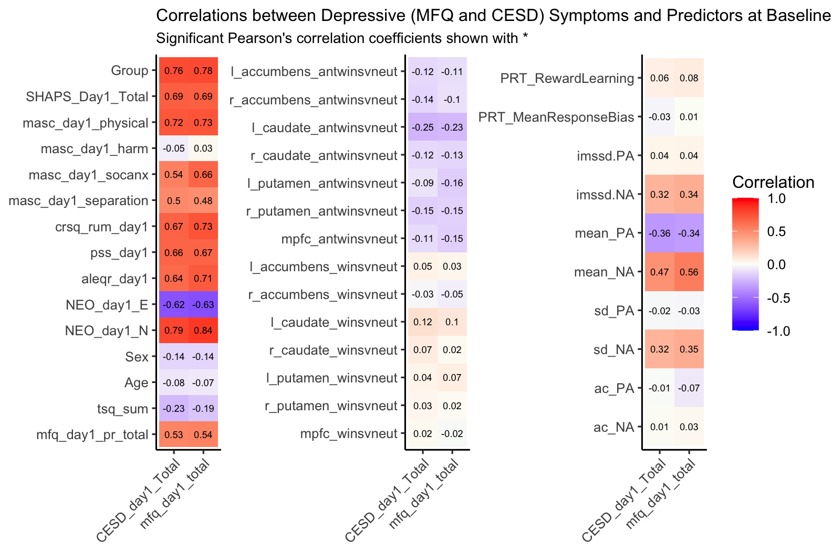
(b)
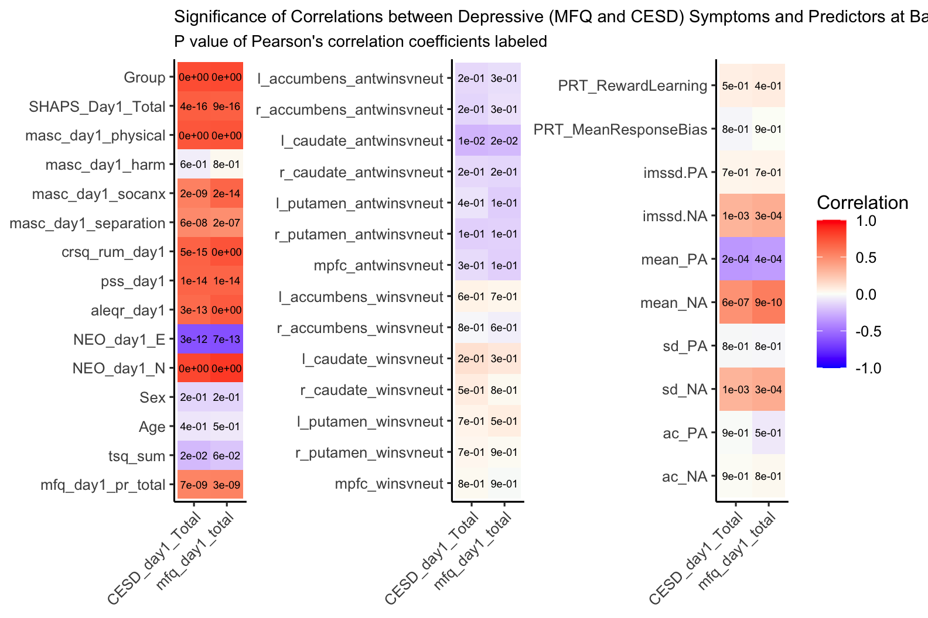

Supplementary Figure 2: Correlation between outcomes (CESD and MFQ at 3 months) and all predictors at baseline. Significance level is indicated by *.
* <0.05, ** <0.01, ***<0.001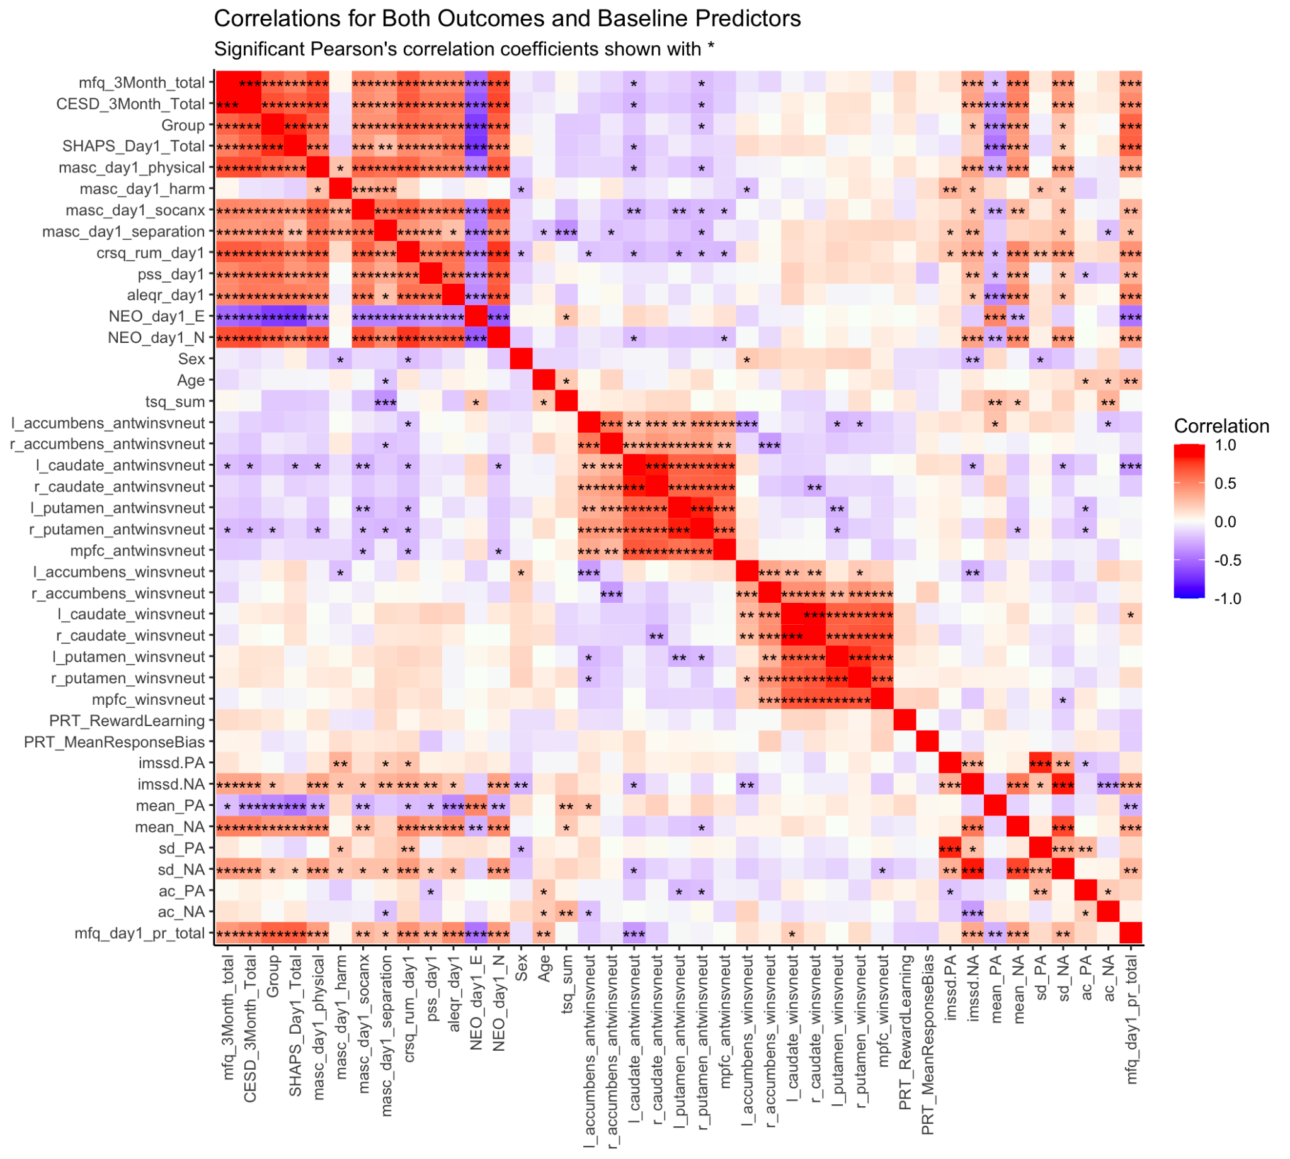

Supplementary Figure 3: Cumulative variance explained by the top principal components.

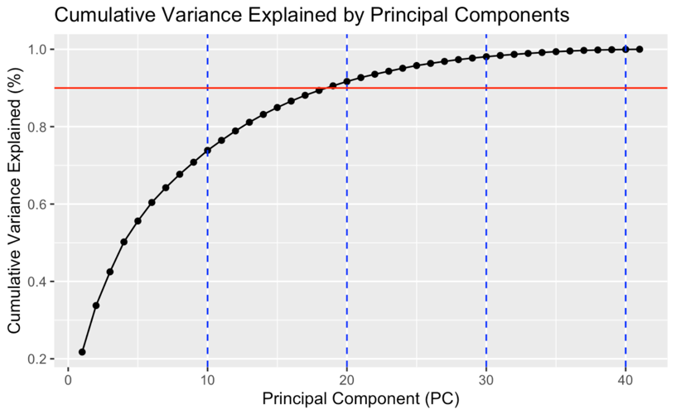

Supplementary Figure 4: Feature loadings of the first 5 PC used in the best performing model (linear regression with the first 5 PCs for prediction of CES-D).

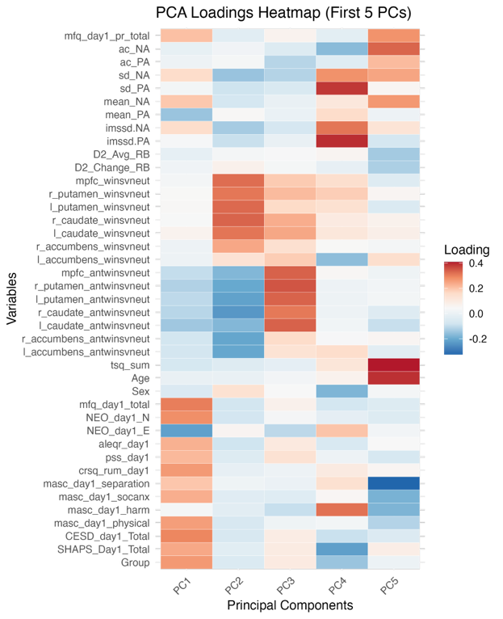
Supplementary Figure 5: SHAP values for top 9 features (highest mean absolute SHAP values) in predicting depressive symptoms at 3 months follow-up based on Random Forest model trained on raw features, with (a) CESD or (b) MFQ as the outcome measure. The x-axis corresponds to the value of the variable, and the y-axis corresponds to the SHAP value. A high-feature value with a corresponding high SHAP value represents a point that strongly, positively influences the model’s prediction of depression symptom variability.

(a)
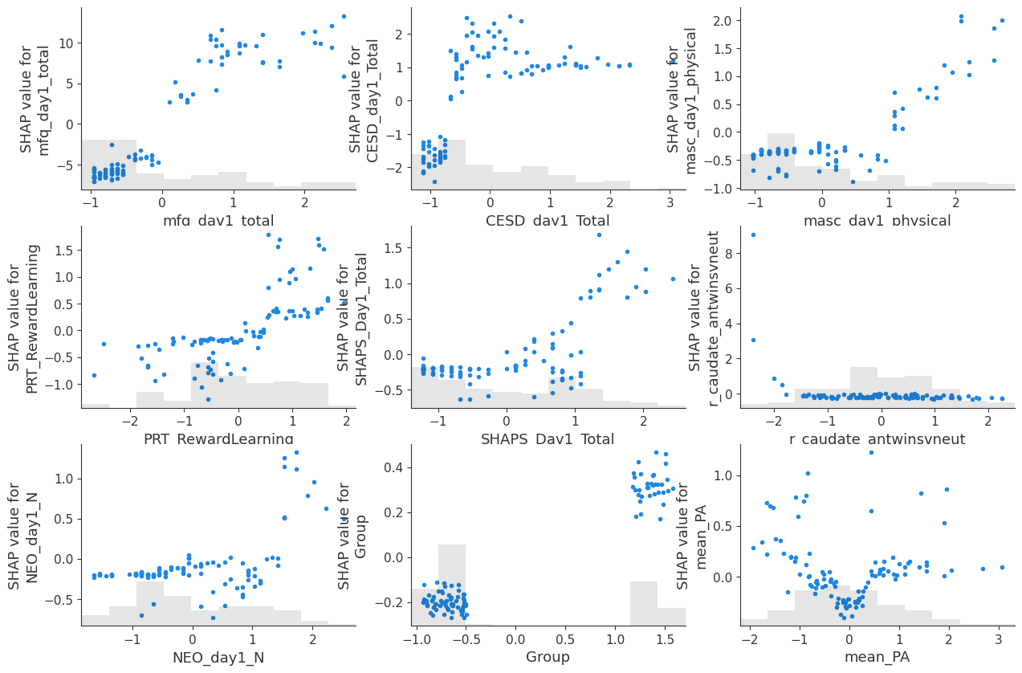
(b)
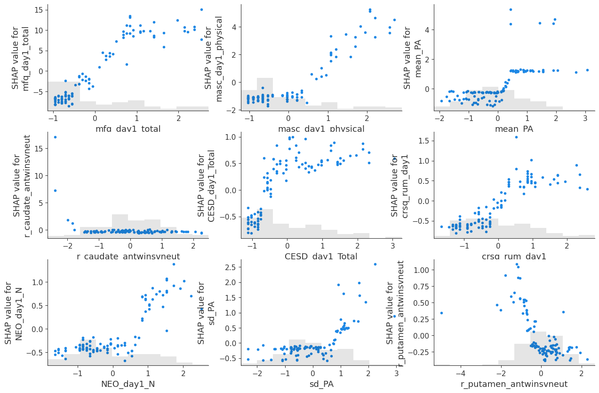

Supplementary Figure 6: Factor analysis of baseline (a) CESD and (b) MFQ. (Top) Factor loadings. (Bottom) correlation between each factor at baseline with the total score at 3 months.

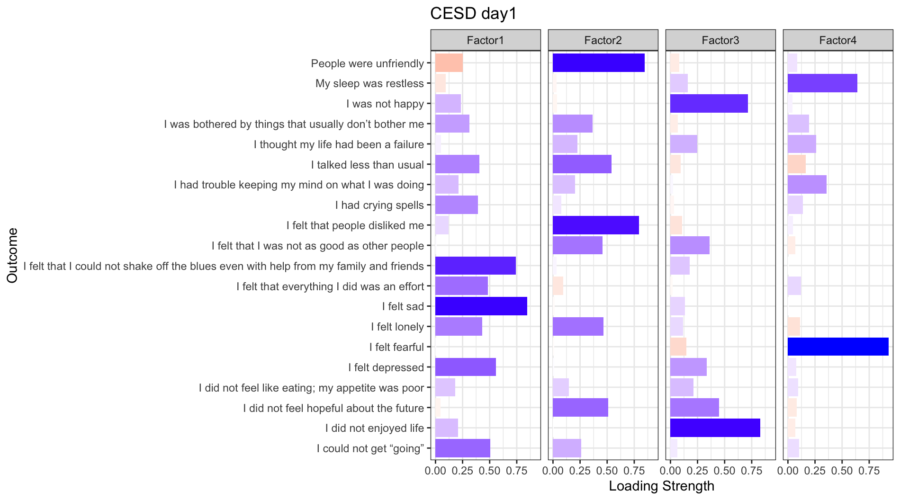
CESD
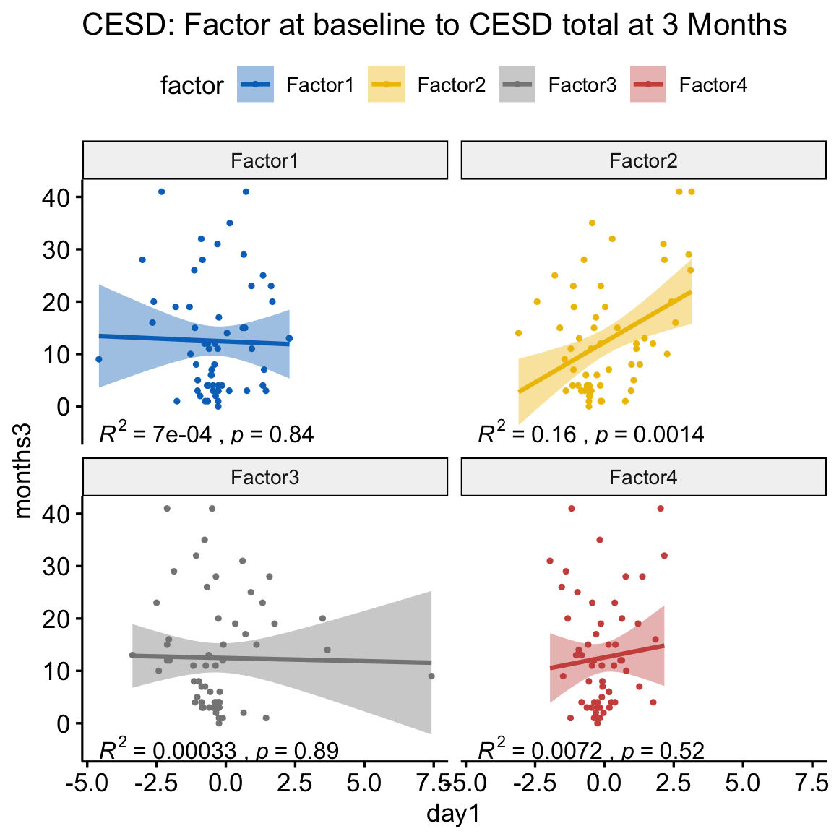

MFQ
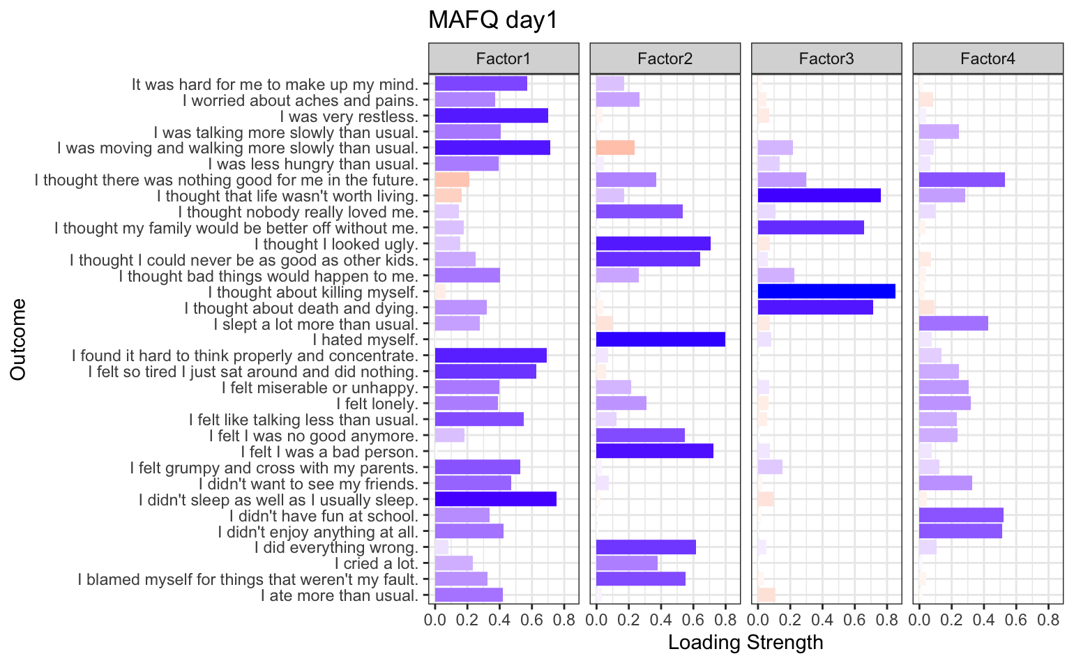
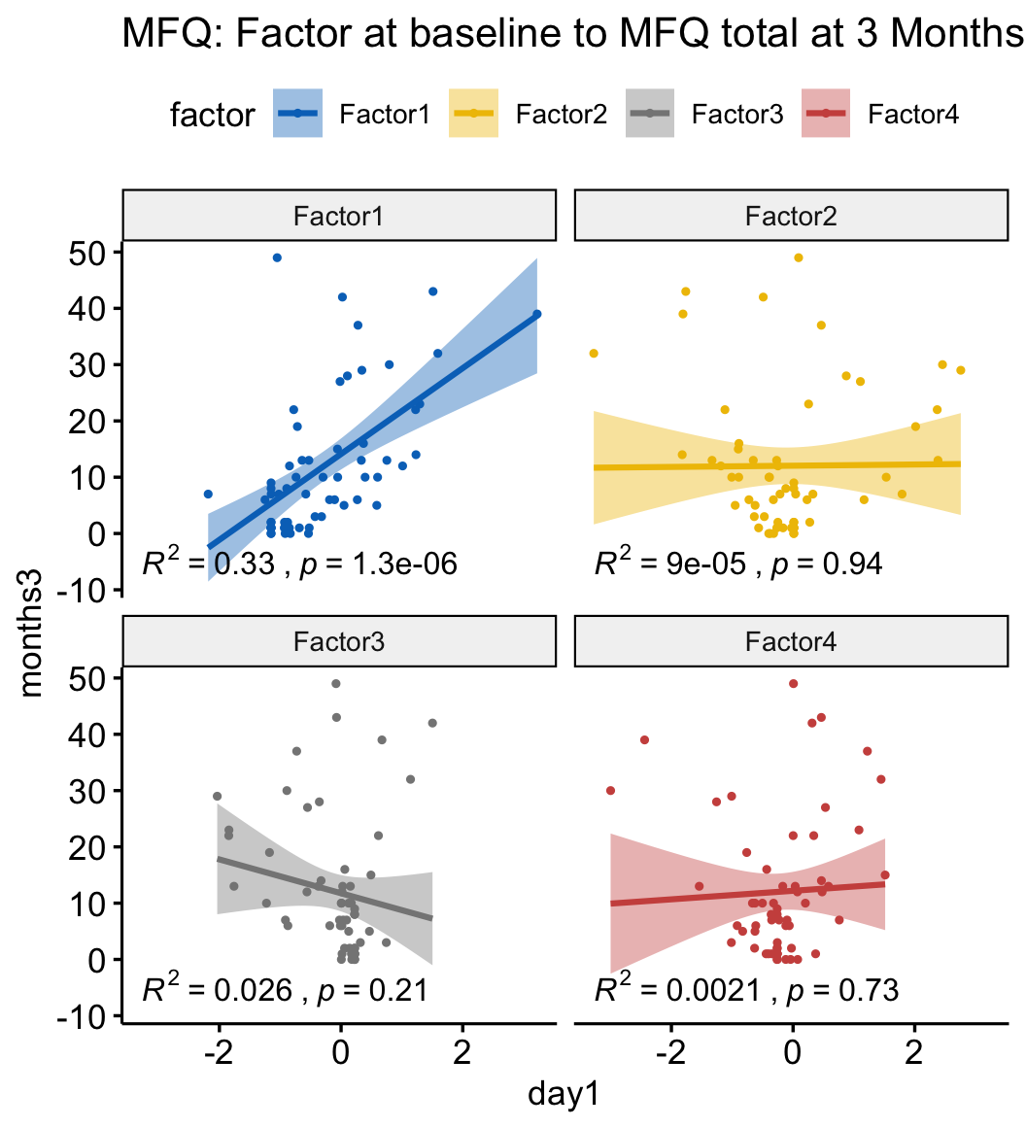

References
1. Smit A, Helmich MA, Bringmann L, Oldehinkel A, Wichers M, Snippe E. Critical slowing down in momentary affect as early warning signal of impending transitions in depression. 2022.
2. van de Leemput IA, Wichers M, Cramer AOJ, Borsboom D, Tuerlinckx F, Kuppens P, et al. Critical slowing down as early warning for the onset and termination of depression. Proc Natl Acad Sci U S A. 2014;111:87–92.
3. Wichers M, Groot PC, Psychosystems EG EWS Group. Critical Slowing Down as a Personalized Early Warning Signal for Depression. Psychother Psychosom. 2016;85:114–116.
4. Wichers M, Smit AC, Snippe E. Early Warning Signals Based on Momentary Affect Dynamics can Expose Nearby Transitions in Depression: A Confirmatory Single-Subject Time-Series Study. J Pers-Oriented Res. 2020;6:1–15.
5. Kuppens P, Allen NB, Sheeber L. Emotional inertia and psychological maladjustment. Psychol Sci. 2010;21:984–991.
6. Forbes EE, Hariri AR, Martin SL, Silk JS, Moyles DL, Fisher PM, et al. Altered striatal activation predicting real-world positive affect in adolescent major depressive disorder. Am J Psychiatry. 2009;166:64–73.
7. Murray L, Israel ES, Balkind EG, Pastro B, Lovell-Smith N, Lukas SE, et al. Multi-modal assessment of reward functioning in adolescent anhedonia. Psychol Med. 2022:1–10.
8. Webb CA, Murray L, Tierney AO, Forbes EE, Pizzagalli DA. Reward-related predictors of symptom change in behavioral activation therapy for anhedonic adolescents: a multimodal approach. Neuropsychopharmacology. 2023;48:623–632.
9. Jolliffe IT, editor. Principal Component Analysis and Factor Analysis. Princ. Compon. Anal., New York, NY: Springer; 2002. p. 150–166.
10. Lewis MJ, Spiliopoulou A, Goldmann K, Pitzalis C, McKeigue P, Barnes MR. nestedcv: an R package for fast implementation of nested cross-validation with embedded feature selection designed for transcriptomics and high-dimensional data. Bioinforma Adv. 2023;3:vbad048.
11. Lundberg SM, Lee S-I. A unified approach to interpreting model predictions. Proc. 31st Int. Conf. Neural Inf. Process. Syst., Red Hook, NY, USA: Curran Associates Inc.; 2017. p. 4768–4777.

