Neuropilin 1 (NRP1) conveys SEMA3A signals to restrict physiological angiogenesis

Marco Spreafico¹, Elena Guzzolino^{1,2}, Francesca Fanuele^{1,3}, Gaia Gestri⁴, Carlotta Tacconi^{1,5}, Sara Palermo¹, Matilde Tricco¹, Valeria Catroppa¹, Laura Denti^{6,7}, Caroline Pellet-Many⁸, Christiana Ruhrberg⁶, Alessandro Fantin^{1,*}

¹ University of Milan, Department of Biosciences, Via G. Celoria 26, 20133, Milan, Italy.
² Current affiliation: Institute of Clinical Physiology, National Research Council (IFC-CNR), Florence, Italy.
³ Current affiliation: Adaptive Immunity Laboratory, Istituto di Ricovero e Cura a Carattere Scientifico (IRCCS) Humanitas Research Hospital, Rozzano, Italy.
⁴ UCL Department of Cell and Developmental Biology, University College London, Gower Street, London WC1E 6BT, UK.
⁵ Current affiliation: Università Vita-Salute San Raffaele, Via Olgettina, 58, 20132 Milano, Italy.
⁶ UCL Institute of Ophthalmology, University College London, 11-43 Bath Street, London EC1V 9EL, UK.
⁷ Current affiliation: The Francis Crick Institute, 1 Midland Rd, London, NW1 1AT, UK.
⁸ Department of Comparative Biomedical Sciences, Royal Veterinary College, Royal College Street, London NW1 0TU, UK.

* Corresponding author:
Professor Alessandro Fantin, Department of Biosciences, University of Milan, Via G. Celoria 26, 20133, Milan, Italy; Email: alessandro.fantin@unimi.it; Tel: +39 02 503 14952

Methods
Zebrafish lines
Zebrafish (Danio rerio) were maintained according to international (EU Directive 2010/63/EU) and national guidelines (Italian decree No 26 of the 4th of March 2014, UK Home Office guidelines). Tg(fli1a:EGFP)^{y1} [1], Tg(kdrl:EGFP)^{s843} [2], Tg(kdrl:Hsa.HRAS-mCherry)^{s896} (abbreviated to Tg(kdrl:mCherry) in the main text) [3], Tg(fli1:nlsEGFP)^{y7}(abbreviated to Tg(fli1:nEGFP) in the main text) [4], nrp1a^{sa1485} (Zebrafish Mutation Project, Sanger Centre, Cambridge, UK) and nrp1b^{fh278} (Zebrafish Tilling Project) zebrafish strains were used. Embryos were staged as described in Kimmel et al. [5] and raised in fish water (0.01%Instant Ocean, 0.01% sodium bicarbonate, 0.019% calcium sulphate, 0.1% Methylene Blue) at 28 °C in Petri dishes, according to established techniques. Embryonic ages are expressed in hours post fertilization (hpf) and days post fertilization (dpf). Embryos were anesthetized with 0.016% tricaine (Ethyl 3-aminobenzoate methanesulfonate salt, Sigma-Aldrich) before proceeding with experimental protocols. When needed, 0.003% 1-phenyl-2-thiourea (PTU, Sigma-Aldrich) was added to fish water to prevent pigmentation. For imaging purpose, embryos were fixed in 4% PFA in PBS overnight at 4°C and then they were dehydrated by methanol scale.
Genotyping
To assess the genotype of nrp1a^{sa1485} and nrp1b ^{fh278} adult fish, tail fin clipping was performed. Fin clips were digested in lysis buffer (5mM Tris-HCl pH 7.5, 1mM EDTA pH 8.0, 0.65 Tween-20, 0.6% glycerol in H₂O) with 1 mg/ml Proteinase K (Sigma-Aldrich) at 55°C for 4 hours. To assess the genotype of nrp1a^{sa1485} and nrp1b ^{fh278} embryos, either whole 2 dpf embryos or 5 dpf embryo tails were lysed with 20 μl of G1 buffer (25 mM NaOH, 0.2 mM EDTA) at 98°C for 15 min and then lysis was stopped by adding 20 μl of G2 buffer (40 mM Tris-HCl pH 5.5) The genotype of nrp1a^{sa1485} fish was assessed by KASP (Kompetitive Allele Specific PCR) assay, using the KASP TF V4.0 2X Mastermix Std ROX TF kit (LGC Genomics) with specific nrp1a primers and probes (KBD Assay, LGC genomics) according to manufacturer’s instructions on a CFX Connect Real-Time PCR Detection System (Bio-Rad). The genotype of nrp1b^{fh278} fish was assessed by PCR using the following primers: nrp1b wt FW 5’-AATAGGAGTATCCACATGCTGCTTATAA-3’; nrp1b wt REV 5’-GTAGTCGGAGGTGAATTTGATGACTA-3’; nrp1b mut FW 5’-CTCCGATTATCTCTAGTGGAAACTCATA-3’; nrp1b mut REV 5’-TTAAAGACCATATGTTTGTCTTTGTGTG-3’. 10 μl reactions were assembled including 0.1 μM nrp1b wt FW, 0.1 μM nrp1b wt REV, 0.5 μM nrp1b mut FW, 0.05 μM nrp1b mut REV and 2 μl of DNA using the WonderTaq kit (EuroClone) according to manufacturer’s instruction. PCR was performed for 40 cycles with T_{ann} at 51°C and 20 seconds extension time. PCR products were run on a 2.5% agarose gel.
Morpholino (MO) injections
Tg(kdrl:EGFP) zebrafish embryos were injected at 1-4 cell stage with nrp1a(/b) translation blocking MO 5'-GAATCCTGGAGTTCGGAGTGCGGAA-3' (nrp1a(/b)-MO, Gene Tools, previously published as a nrp1a-MO) [6, 7], nrp1b splicing blocking MO 5’-TATACCTGTACGGTGTATCTCATAG-3’ (nrp1b-MO, Gene Tools) [8] and sema3ab splicing MO 5’-AAATGTGTCTTACCGTTGAGCCATC-3’MO (sema3ab-MO, Gene Tools) [9], either alone or in combination, by using a PV850 microinjector (World Precision Instrument). An equal concentration of standard control MO 5'-CCTCTTACCTCAGTTACAATTTATA-3' (Std-MO, Gene Tools) was injected in control embryos.
Embryo transplant
Cells from Tg(fli1a:EGFP) embryos injected with either Std-MO or 0.6 pmol/e of nrp1a(/b) MO were collected from the donor’s animal pole and transplanted into the host’s lateral margin zone of blastula-stage Tg(kdrl:mCherry) embryos, as previously done [10], and analysed at 36 hpf.
RT-qPCR
Total RNA was extracted from 20 pooled zebrafish embryo tails at 28 hpf by using TRIzol reagent (Invitrogen) followed by purification with Total RNA Miniprep kit (Monarch), according to the manufacturer’s instructions. 1 μg total RNA was used to perform reverse transcription (RT) reaction with the High-Capacity cDNA Reverse Transcription kit (Applied Biosystems). 10 μl qPCR reactions were prepared with 2 μl of a 1:10 dilution of RT products and 0.25 μM primers and performed using the Luna Universal qPCR Master Mix (New England Biolabs), according to the manufacturer’s instructions, on a CFX Connect Real-Time PCR Detection system (BioRad). The following primers were used: soluble flt1 (sflt1) FW 5’-TCCGTCCCAATTTACCATTCC-3’ and sflt1 REV 5’-TCTTGGGTGGCTGGATGAG-3’ [11]; membrane-bound flt1 (mflt1) FW 5’-CCGGTGCTGCTTGGAAATCT-3’ and mflt1 REV 5’-CCCTCTGATTGGTGGCTTGA-3’; kdrl FW 5’-CCATGTTGGACTGCTGGCATGG-3’ and kdrl REV 5’-GTAGTGCTTTCCCTCCTGCTGC-3’; cdh5 FW 5’-TGCTAAGCCTCAAAGTGCCTC-3’ and cdh5 REV 5’-CGGTTCTCTTCAACAGCCCTT-3’; eef1a1l1 FW 5’-CTGGAGGCCAGCTCAAACAT-3’ and eef1a1l1 REV 5’-ATCAAGAAGAGTAGTACCGCTAGCAT-3’.
Whole mount in situ hybridization (WISH)
To synthetize sema3aa and sema3ab probes, RT was performed as described in the RT-qPCR section and cDNA was amplified by PCR reaction using the following primers: sema3aa FW 5’-CAGATTTAGGGACCGTTCTG-3’; sema3aa-T7 REV: 5’-CGTAATACGACTCACTATAGGGGCTTCTTCTCTCGCTTCCAA-3’; sema3ab FW 5’-CTACAACACCACGATGAGGC-3’; sema3ab-T7 REV: 5’-CGTAATACGACTCACTATAGGGGATCTGGCTGGTGTGTGATT-3’. PCR reactions were performed using the OneTaq® Quick-Load® 2X Master Mix with Standard Buffer (New England Biolabs) and 2 μl of a 1:10 dilution of RT products. PCRs were conducted setting 35 cycles with T_{ann} at 54 and 55°C for sema3aa and sema3ab, respectively. Probes were synthetized using T7 RNA polymerases kit (Promega) and digoxigenin (DIG) RNA labelling mix (Roche). WISH was carried out as previously described (https://zfin.atlassian.net/wiki/spaces/prot/pages/369265015/Thisse+Lab+-+In+Situ+Hybridization+Protocol+-+2010+update). Digital images of all embryos were captured using a stereomicroscope equipped with digital camera with LAS Leica Imaging software (Leica). Some embryos were cryosectioned following WISH and imaged with a Nanozoomer S60 (Hamamatsu) slide scanner.
Cell culture and transfection
Cells were grown at 37°C in a humidified 5% CO₂ incubator. HEK-293T cells were cultured in DMEM (EuroClone) supplemented with 10% fetal bovine serum (FBS, EuroClone), 1% L-glutammine (EuroClone) and 1% Antibiotic-Antimycotic solution (EuroClone) and transfected with 2.5 μg of plasmid encoding either AP (Alkaline Phosphatase) only or SEMA3A-AP [12] using Lipofectamine 2000 (Invitrogen) according to the manufacturer’s instructions. Transfected HEKs were grown for three days and then they were selected by a three day-treatment with 1 mg/ml Zeocin (Invitrogen). HUVECs were cultured in EGM2 medium with supplements (Promocell) in plates coated with 10 μg/ml human plasma fibronectin (Merck Millipore) and transfected with 30 nM SMARTpool siRNA targeting NRP1 (Dharmacon) or Silencer® negative control siRNA (Applied Biosystems) using Lipofectamine RNAIMAX (Invitrogen), according’s to manufacturer instructions. 40,000 transfected HUVECs were plated on 13mm cover glasses in 24-well plates the day after transfection. At 48 hours after HUVEC transfection, 40,000 zeocin-selected HEKs were added to HUVECs in each well. Co-culture was maintained for 24 hours. In each independent experiment, each condition was performed in triplicate. For imaging purpose, cells were fixed in 4% PFA in PBS for 10 minutes at room temperature.
Western blotting
To extract total protein from zebrafish embryos, at least 30 whole embryos at 2 dpf or heads from 5 dpf larvae were pooled and suspended in deyolking buffer (0.5x Ginzburg Fish Ringer: 55mM NaCl, 1.8 mM KCl, 1.25 mM NaHCO₃, 1.25 mM CaCl₂) to remove yolk sac, washed with PBS and lysed with RIPA buffer (50 mM Tris-HCl pH 8.0, 150 mM NaCl, 0.1% SDS, 0.5% sodium deoxycholate, 1% TRITON X-100). Samples were sonicated, centrifuged at 4°C for 10 minutes at 16,000 g and then supernatants were collected. To extract protein from HUVECs, cells were lysed with RIPA buffer, incubated on ice for 30 minutes, centrifuged at 4°C for 10 minutes at 16,000 g and then supernatants were collected. Total proteins were quantified using the Quantum Protein BCA protein assay kit (Euroclone). 10 μg of total protein were heat-denatured and separated by SDS-PAGE using a Novex 4-12% Tris-Glycine Plus Wedge Well gel (Invitrogen) and then blotted on a nitrocellulose membrane by using the iBlot2 NC Regular Stack kit (Invitrogen) and an iBlot2 Dry Blotting System (Invitrogen). Membranes were blocked in 5% milk PBS-T (0.1% TWEEN-20 in PBS) for 1 hour at room temperature and incubated with primary antibody diluted in 5% BSA PBS-T overnight at 4°C. Membranes were then incubated with secondary antibody diluted in 5% milk PBS-T for 1 hour at room temperature. Protein bands were detected by using LiteAblot ECL kits (Euroclone). Primary antibodies were rabbit anti-NRP1 1:1000 (Abcam EPR3113), rabbit anti-αβ-tubulin 1:1000 (Cell Signaling Technology #2148) and mouse anti-β-actin 1:1000 (Cell Signaling Technology #3700). Secondary antibodies were goat anti-rabbit HRP-linked (Cell Signaling Technology #7074) and horse anti-mouse HRP-linked (Cell Signaling Technologies #7076).
Immunofluorescence
For zebrafish immunofluorescence, methanol-stored 28 hpf Tg(kdrl:Hsa.HRAS-mCherry);Tg(fli1:nlsEGFP) zebrafish embryos were rehydrated, permeabilized with 10 μg/ml Proteinase K for 20 minutes, post-fixed with 4% PFA in PBS for 20 minutes at room temperature, then incubated in blocking solution (10% donkey serum, 1% DMSO, 0.5% Triton X-100 in PBS) for 1 hour at room temperature. Embryos were then incubated with rabbit anti-phospho histone H3 (Ser10) antibody 1:400 (Merck Millipore, 06-570) in blocking solution overnight at 4°C. The following day embryos were incubated with Cy5 donkey anti-rabbit antibody 1:500 (Jackson ImmunoResearch, 711-175-152) in blocking solution overnight at 4°C.
For cell immunofluorescence, fixed cells were incubated in blocking solution (10% donkey serum, 0.1% Triton X-100 in PBS) for 1 hour at room temperature, then incubated overnight at 4°C with mouse anti-PECAM1 1:50 (Biosite, JC/70A) primary antibody diluted in blocking solution. The following day cells were incubated with FITC donkey anti-mouse 1:200 (Jackson ImmunoResearch 715-096-150) secondary antibody together with phalloidin-TRITC 1:400 (Sigma-Aldrich) diluted in blocking solution for 2 hours at room temperature, then incubated in 0.5 μg/ml DAPI stain (Cell Signaling Technology) for 10 minutes at room temperature.

Confocal imaging
For zebrafish experiments, embryos were mounted in 1% low-melting agarose in PBS. Images were acquired using a laser scanning confocal microscope (Nikon). For live imaging experiments, 26 hpf zebrafish embryos were mounted in 1% low-melting agarose in 0.016% tricaine fish water and incubated at 27°C o/n. Images were taken every 20 min by using a spinning disk confocal microscope (Nikon) and Imaris (Oxford Instruments) was then used for image processing and movie generation.
For cell imaging, cells were mounted on microscope slides using Mowiol (Sigma-Aldrich) and three images per replicate were acquired using a laser scanning confocal microscope (Nikon).

Image analysis
sema3aa and sema3ab expression in the dorsal and ventral myotomes of the same embryo was performed by measuring pixel mean grey values in regions-of-interest (ROIs) of the same size with Fiji software (https://imagej.net/software/fiji/) after transforming WISH captures in black-and-white inverted images.
Gap areas in cell culture experiments were quantified with Fiji by selecting the PECAM1 channel (green) for each image and measuring the area not covered by HUVECs with the “Analyze particles” tool by setting 2000-infinity as size range.
Statistical analysis
Statistical analyses were performed with Prism 7 (GraphPad Software). To determine if two data sets were significantly different, we first assessed data Gaussian distribution by Shapiro–Wilk normality test. Then, when comparing two datasets, we used unpaired or paired two-tailed Student’s t test for normally distributed samples and Mann-Whitney test when samples were not normally distributed. When comparing more than two datasets without a parametric distribution, Kruskal–Wallis followed by Dunn’s multiple comparisons test was used, whereas 2-way ANOVA was used if including 2 independent variables. A p value < 0.05 was considered significant. In each graph, error bars represent the standard deviation of the mean (SD), as indicated in each figure legend together with the statistical test used, the p value range and sample numerosity.

Supplementary Figures
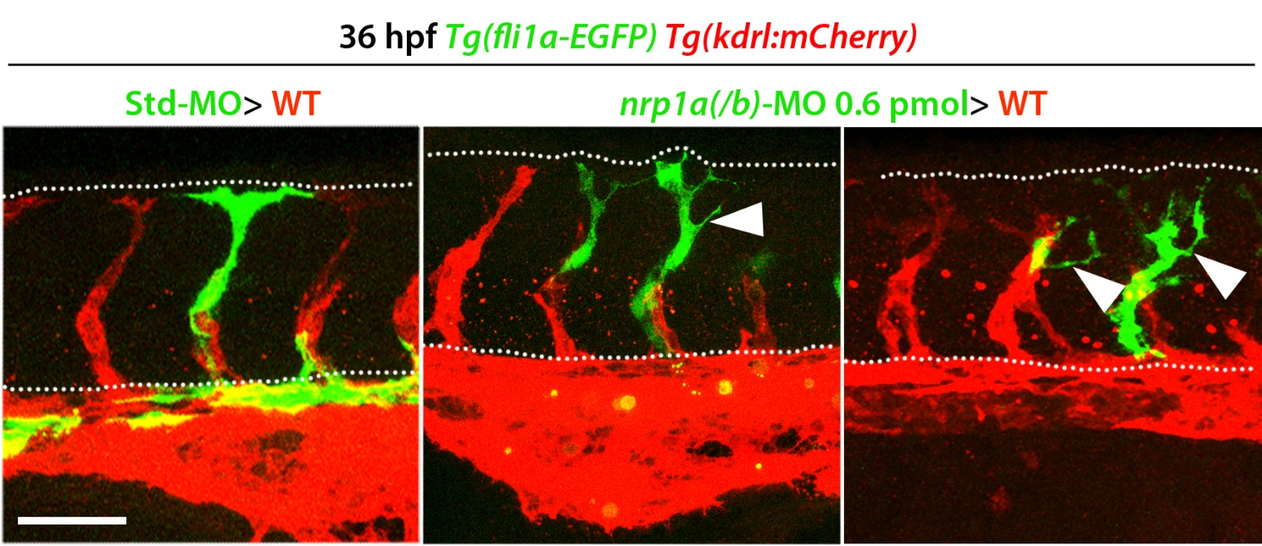
Figure S1. Mosaic targeting of nrp1a(/b) results in ISVs that reach the dorsal side of the trunk but ectopically sprout across the somite region.
Analysis of chimeric Tg(fli1a:EGFP);Tg(kdrl:mCherry) zebrafish embryos generated by transplanting cells from Tg(fli1a:EGFP) donor embryos injected with Std-MO (left panel) or 0.6 pmol/e of nrp1a(/b)-MO (central and right panels) into Tg(kdrl:mCherry) host embryos. Representative maximum-intensity projections of confocal z stacks through embryo trunks at 36 hpf; arrowheads indicate ectopic sprouts in the somites. Scale bar: 50 µm.

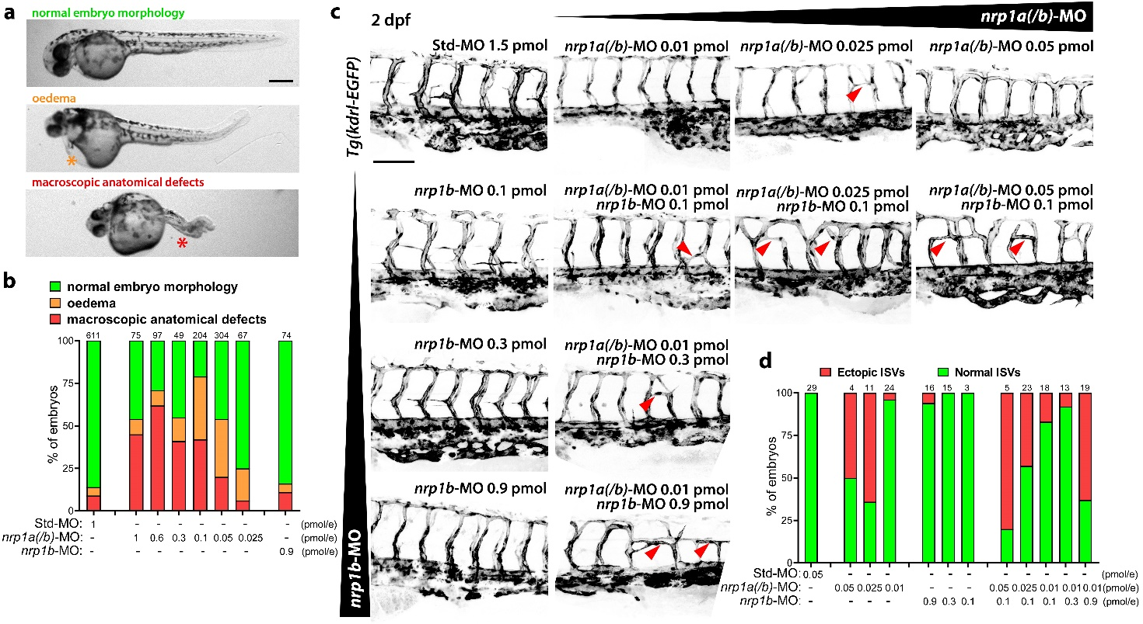
Figure S2. Morpholino dose titration based on macroscopic morphological defects and the presence of ectopic ISVs.
(a-d) Analysis of Tg(kdrl:EGFP) zebrafish embryos that were injected at 1-4 cell stage with control standard (Std)-MO versus nrp1a(/b)-MO, nrp1b-MO and combined nrp1a(/b)-MO/nrp1b-MO at the indicated doses. (a) Representative pictures of zebrafish embryos with normal morphology, oedema or macroscopic anatomical defects. (b) Scoring for unspecific MO toxicity. (c) Representative maximum-intensity projections of confocal z stacks through embryo trunks at 2 dpf. (d) Quantification of ectopic ISV penetrance. Scale bars: 250 µm in (a), 100 µm in (c). Numbers above histograms in (b) and (d) indicate the sample size of each group; e, embryo.

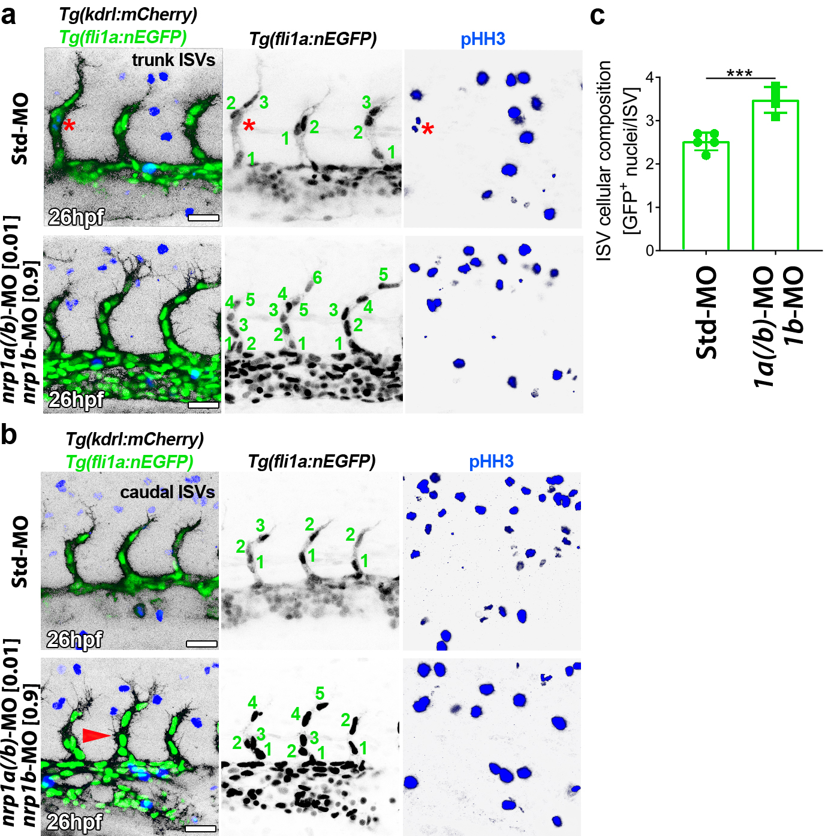
Figure S3. Nrp1 knockdown results in increased EC number within each ISV.
(a-c) Trunk vascularisation analysis of Tg(kdrl:mCherry);Tg(fli1a:nEGFP) zebrafish embryos that were injected at 1-4 cell stage with control standard (Std)-MO versus combined nrp1a(/b)-MO/nrp1b-MO at the indicated doses. Representative maximum-intensity projections of confocal z stacks through the central (a) or caudal (b) part of the embryo trunks at 26 hpf following immunostaining for pHH3 (blue channel); red arrowhead and asterisk indicate an example of ectopic ISV sprout and EC mitosis, respectively; scale bars: 20 µm. (c) Quantifications of EC number per fully extended ISV; graph shows mean ± SD; each data point represents the value of a single embryo (n ≥ 4); ***, P < 0.001, unpaired Student-t test.

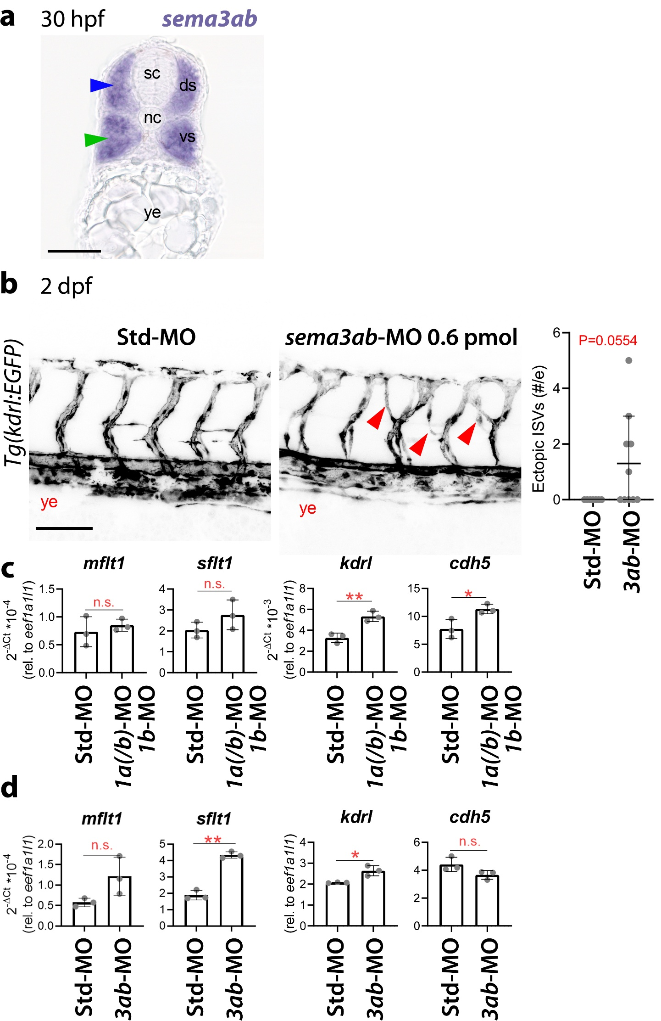
Figure S4. Nrp1 and Sema3a prevent ectopic ISV sprouting across the somite region independently of sFlt1.
(a) Representative picture of 20 µm cryosections through zebrafish embryos at 30 hpf following whole mount in situ hybridisation using antisense probes for sema3ab. Green and blue arrowheads indicate expression of sema3ab transcripts in the ventral and dorsal somites, respectively; ds, dorsal somite; nc, notochord; sc, spinal cord; vs, ventral somite; ye, yolk extension; scale bar: 50 µm.
(b) Analysis of Tg(kdrl:EGFP) zebrafish that were injected at 1-4 cell stage with control Std-MO versus sema3ab-MO at the indicated dose. Representative maximum-intensity projections of confocal z stacks through embryo trunks at 2 dpf (left) and corresponding quantification of ectopic ISVs (right). Red arrowheads indicate examples of ectopic ISVs; ye, yolk extension; scale bar: 100 µm. The graph shows mean ± SD; each data point represents the value of a single embryo; n ≥ 7 embryos; P = 0.0554, Mann-Whitney test.
(c,d) RT-qPCR expression analysis of transcripts for membrane-bound (mflt1) and soluble Flt1 (sflt1), kdrl and cdh5 normalized to eef1a1l1 in 28 hpf zebrafish embryos injected at 1-4 cell stage with Std-MO versus combined nrp1a(/b)-MO (0.01 pmol/embryo)/nrp1b-MO (0.9 pmol/embryo) (c) or sema3ab-MO (0.6 pmol/embryo) (d); expression levels are shown as mean ± SD; each data point represents the value of a pool of 20 embryos from one independent experiment (n = 3 independent experiments); e, embryo; n.s., not significant, P > 0.05; *, P < 0.05; **, P < 0.01, paired Student-t test.

Movie M1.
Representative time-lapse movie assembled from maximum-intensity projections of confocal z stacks from Tg(kdrl:mCherry);nrp1a^{-/-};nrp1b^{+/-} zebrafish trunks starting from 26 hpf.

Movie M2.
Representative time-lapse movie assembled from maximum-intensity projections of confocal z stacks from Tg(kdrl:mCherry);nrp1a^{-/-};nrp1b^{-/-} zebrafish trunks starting from 26 hpf.

Movie M3.
Representative time-lapse movie assembled from maximum-intensity projections of confocal z stacks from Tg(kdrl:mCherry);Tg(fli1a:nEGFP);nrp1a^{+/-};nrp1b^{+/-} zebrafish trunks starting from 26 hpf.

Movie M4.
Representative time-lapse movie assembled from maximum-intensity projections of confocal z stacks from Tg(kdrl:mCherry);Tg(fli1a:nEGFP);nrp1a^{-/-};nrp1b^{-/-} zebrafish trunks starting from 26 hpf.

References
1. Lawson, N.D. and B.M. Weinstein, In vivo imaging of embryonic vascular development using transgenic zebrafish. Dev Biol, 2002. 248(2): p. 307-18.
2. Jin, S.W., et al., Cellular and molecular analyses of vascular tube and lumen formation in zebrafish. Development, 2005. 132(23): p. 5199-209.
3. Chi, N.C., et al., Foxn4 directly regulates tbx2b expression and atrioventricular canal formation. Genes Dev, 2008. 22(6): p. 734-9.
4. Roman, B.L., et al., Disruption of acvrl1 increases endothelial cell number in zebrafish cranial vessels. Development, 2002. 129(12): p. 3009-19.
5. Kimmel, C.B., et al., Stages of embryonic development of the zebrafish. Dev Dyn, 1995. 203(3): p. 253-310.
6. Lee, P., et al., Neuropilin-1 is required for vascular development and is a mediator of VEGF-dependent angiogenesis in zebrafish. Proc Natl Acad Sci U S A, 2002. 99(16): p. 10470-5.
7. Hillman, R.T., et al., Neuropilins are positive regulators of Hedgehog signal transduction. Genes Dev, 2011. 25(22): p. 2333-46.
8. Wang, L., D. Mukhopadhyay, and X. Xu, C terminus of RGS-GAIP-interacting protein conveys neuropilin-1-mediated signaling during angiogenesis. FASEB J, 2006. 20(9): p. 1513-5.
9. Torres-Vazquez, J., et al., Semaphorin-plexin signaling guides patterning of the developing vasculature. Dev Cell, 2004. 7(1): p. 117-23.
10. Cavodeassi, F., et al., Early stages of zebrafish eye formation require the coordinated activity of Wnt11, Fz5, and the Wnt/beta-catenin pathway. Neuron, 2005. 47(1): p. 43-56.
11. Wild, R., et al., Neuronal sFlt1 and Vegfaa determine venous sprouting and spinal cord vascularization. Nat Commun, 2017. 8: p. 13991.
12. Vieira, J.M., Q. Schwarz, and C. Ruhrberg, Selective requirements for NRP1 ligands during neurovascular patterning. Development, 2007. 134(10): p. 1833-43.

