Supplementary Table 1. List of fruits and vegetables with high flavonoids content.

Fruits | Vegetables
strawberry, lemon, red apple, kumquat, grape, orange, mulberry, blueberry, hawthorn, plum, pomegranate, longan, peach, cranberries, waxberries, mango, cherry, kiwi fruit, pomelo | douban, radish Leaves, broccoli, sweet pepper, sweet potato leaf, watercress, mulberry anise leaf, lotus root, ginger, eggplant, cabbage, sweet potato, chili (spicy, yellow), celery, onions (white, purple), hawthorn leaves, sesame vegetable, perilla, coriander leaves, white radish

Supplementary Table 2. General information of enrolled cases.

 |  | control group（n=15） | diet group（n=15）
Age (years) |  | 55.06±13.08 | 54.40±9.75
BMI (kg/m²) |  | 22.62±3.55 | 22.90±3.32
TNM stage (n) | Ⅰ | 0 | 1
TNM stage (n) | Ⅱ | 1 | 1
TNM stage (n) | Ⅲ | 5 | 5
TNM stage (n) | Ⅳ | 9 | 8

Supplementary Figure 1. Behavioral experiment (OFT animal model 1)
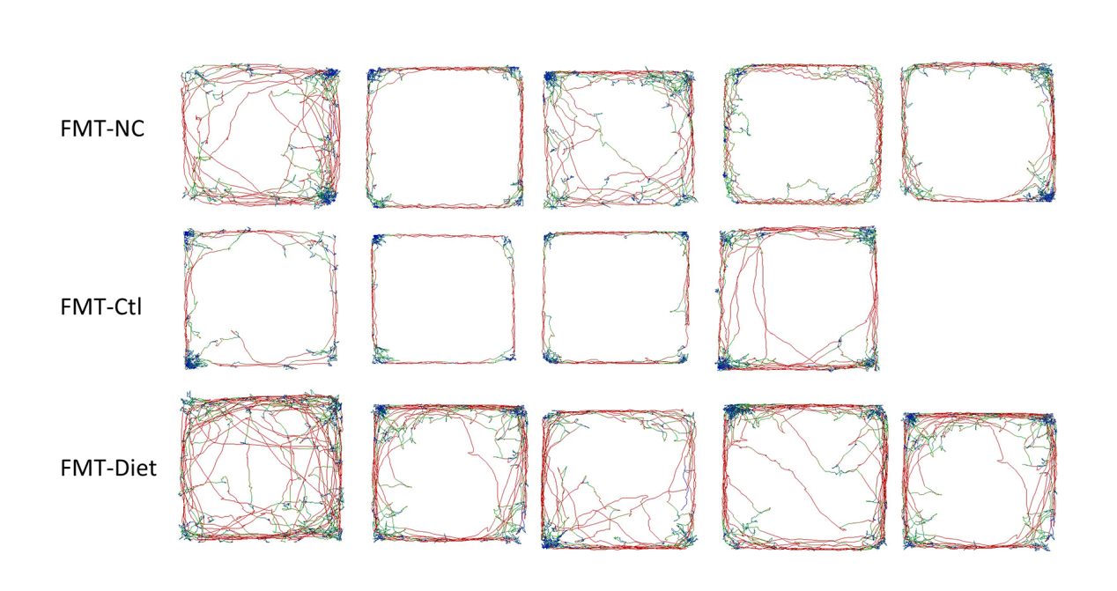

Supplementary Figure 2. Behavioral experiment (OFT animal model 2)

