Phosphorus Transformations and Leaching Potential in Rewetting Drained Peatlands: Exploring the Influence of Land Use and Temperature
Atif Muhmood^{a,b}, Haonan Guoª, Lorenzo Puglieseª, Shubiao Wu^{a*}

ªDepartment of Agroecology, Aarhus University, Blichers Alle 20, 8830 Tjele, Denmark
^{b}Institute of Soil Chemistry & Environmental Sciences, AARI, Pakistan

Corresponding author: E-mail address: wushubiao@agro.au.dk

Supporting materials: 9 pages, 4 Figures, 2 Tables

Figure S1. Scheme of sequential phosphorus (P) analysis process

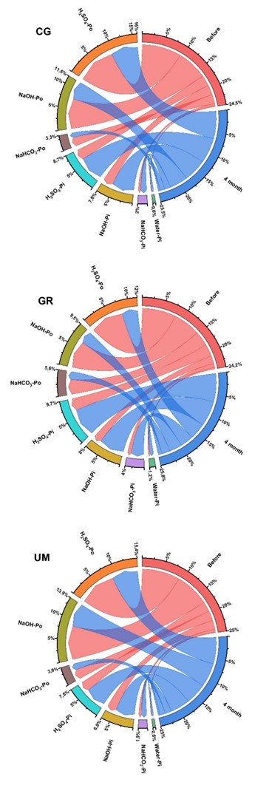
Figure S2. Trend of change in the contents of phosphorus (P) in different fractions in soils under various land uses (CG= cut grass, GR= grazing, UM= unmanaged) after four months of rewetting at 10°C
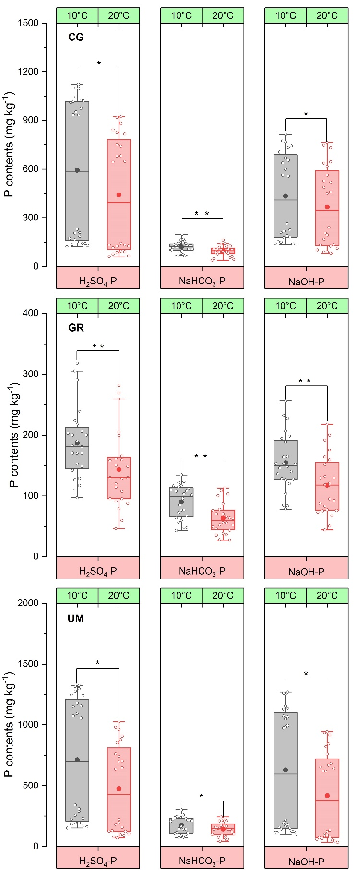
Figure S3. Variation in the contents of organic phosphorus (P_{o}) fractions in soils under various land uses (CG=cut grass, GR= grazing, UM=unmanaged) after four months of rewetting under varying temperature
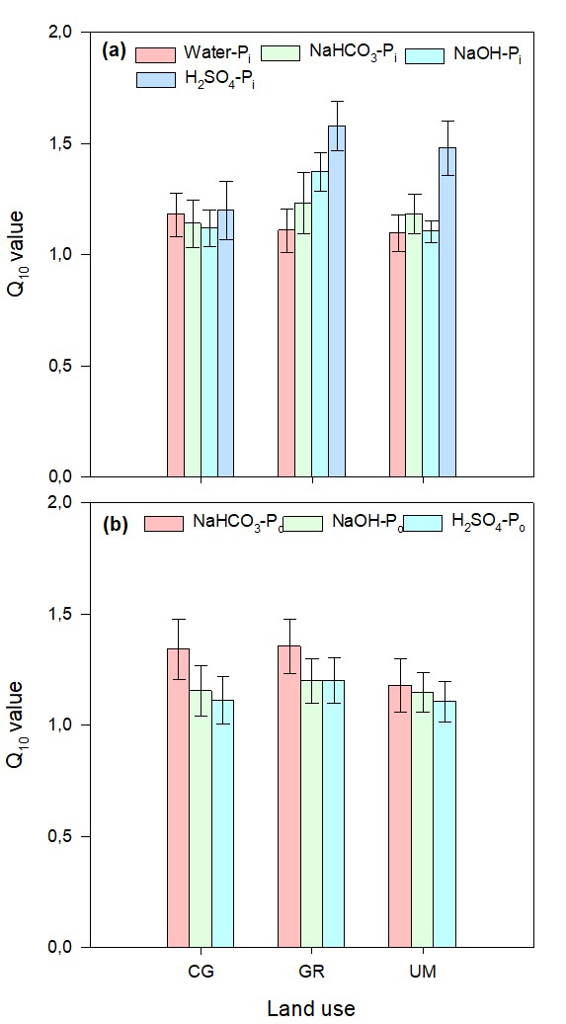
Figure S4. Temperature sensitivity quotient (Q10) values for different phosphorus inorganic (a) and organic (b) fractions in soils under different land uses (CG= cut grass, GR= grazing, UM= unmanaged) after rewetting

Table S1. Contents of different P fractions (inorganic and organic) in soils under different land under varying rewetting time at 20 °C
Location | Land use |  | Time | Water-P_{i} | BD P_{i} | Alkali P_{i} | Acid P_{i} | Total P_{i} | BD P_{o} | Alkali P_{o} | Acid P_{o} | Total P_{o} | Total P
Skals | CG | 0 |  | 10.32 | 57.80 | 237.9 | 256.4 | 562.5 | 218.9 | 869.2 | 1273 | 2362 | 2924
Skals | CG | 1 |  | 22.61 | 119.7 | 453.7 | 484.9 | 1086 | 146.8 | 747.5 | 1023 | 1918 | 3004
Skals | CG | 2 |  | 28.97 | 138.68 | 562.1 | 594.0 | 1323 | 114.7 | 632.8 | 942 | 1690 | 3013
Skals | CG | 3 |  | 35.67 | 144.0 | 647.0 | 683.4 | 1510 | 98.5 | 534.9 | 863.3 | 1496 | 3007
Skals | CG | 4 |  | 40.51 | 154.0 | 721.1 | 734.4 | 1647 | 91.0 | 465.6 | 757.0 | 1313 | 2951
Skals | GR | 0 |  | 13.65 | 30.78 | 85.42 | 116.7 | 246.5 | 156.8 | 274.1 | 380.6 | 811.6 | 1058
Skals | GR | 1 |  | 21.85 | 78.44 | 189.8 | 210.4 | 500.5 | 108.2 | 202.9 | 269.8 | 581.0 | 1081
Skals | GR | 2 |  | 25.38 | 110.2 | 232.1 | 308.5 | 676.2 | 78.33 | 166.2 | 174.7 | 419.3 | 1095
Skals | GR | 3 |  | 28.40 | 113.2 | 275.4 | 386.8 | 803.8 | 58.26 | 123.7 | 132.9 | 314.9 | 1118
Skals | GR | 4 |  | 33.13 | 121.2 | 319.7 | 419.1 | 893.2 | 46.65 | 84.9 | 105.4 | 237.0 | 1130
Skals | UM | 0 |  | 14.31 | 71.68 | 356.1 | 378.4 | 820.5 | 286.7 | 1344 | 1437 | 3069 | 3889
Skals | UM | 1 |  | 28.45 | 115.4 | 493.3 | 574.8 | 1212 | 248.4 | 1122 | 1289 | 2659 | 3871
Skals | UM | 2 |  | 33.69 | 132.9 | 591.5 | 765.7 | 1524 | 219.2 | 1019 | 1132 | 2371 | 3894
Skals | UM | 3 |  | 37.88 | 143.6 | 674.8 | 868.9 | 1725 | 172.5 | 936.3 | 1033 | 2141 | 3866
Skals | UM | 4 |  | 42.14 | 150.9 | 740.5 | 927.9 | 1861 | 152.4 | 855.5 | 961 | 1969 | 3830
Nørre | CG | 0 |  | 12.54 | 39.01 | 155.6 | 167.4 | 374.6 | 131.5 | 321.2 | 264.4 | 717.1 | 1092
Nørre | CG | 1 |  | 16.48 | 68.51 | 234.5 | 254.9 | 574.4 | 106.2 | 212.4 | 178.7 | 497.4 | 1084
Nørre | CG | 2 |  | 21.62 | 88.14 | 306.7 | 320.2 | 736.7 | 86.6 | 140.9 | 136.8 | 364.4 | 1101
Nørre | CG | 3 |  | 33.95 | 106.5 | 342.1 | 362.4 | 844.9 | 62.75 | 107.8 | 92.82 | 263.5 | 1108
Nørre | CG | 4 |  | 38.15 | 121.6 | 355.3 | 382.7 | 897.8 | 46.66 | 92.7 | 86.81 | 226.2 | 1124
Nørre | GR | 0 |  | 13.31 | 37.23 | 57.44 | 102.8 | 210.8 | 110.0 | 214.3 | 226.3 | 550.6 | 761.4
Nørre | GR | 1 |  | 29.14 | 85.18 | 114.1 | 156.7 | 385.2 | 78.27 | 132.6 | 171.5 | 382.5 | 767.8
Nørre | GR | 2 |  | 34.33 | 118.8 | 182.7 | 207.8 | 543.7 | 56.27 | 98.53 | 126.5 | 281.6 | 825.4
Nørre | GR | 3 |  | 39.56 | 125.1 | 235.6 | 267.6 | 668.0 | 42.27 | 75.84 | 98.73 | 216.8 | 884.6
Nørre | GR | 4 |  | 40.90 | 136.2 | 256.7 | 302.7 | 736.5 | 38.27 | 56.84 | 67.26 | 162.3 | 898.8
Nørre | UM | 0 |  | 15.43 | 47.87 | 66.72 | 86.99 | 217.0 | 163.7 | 228.2 | 297.6 | 689.6 | 906.6
Nørre | UM | 1 |  | 36.95 | 97.03 | 115.7 | 155.3 | 404.9 | 145.6 | 162.6 | 233.2 | 541.4 | 946.4
Nørre | UM | 2 |  | 40.33 | 123.4 | 179.4 | 188.9 | 532.1 | 108.1 | 119.6 | 176.6 | 404.3 | 939.4
Nørre | UM | 3 |  | 43.29 | 142.4 | 225.4 | 235.3 | 636.4 | 76.46 | 94.35 | 149.4 | 320.1 | 956.5
Nørre | UM | 4 |  | 45.28 | 151.5 | 241.8 | 260.8 | 699.3 | 67.3 | 74.4 | 109.2 | 251.0 | 950.3
Time= months, Water-P_{i}= water extractable inorganic P in mg kg⁻¹, BD-P_{i} = sodium bicarbonate extractable inorganic P in mg kg⁻¹, Alkali-P_{i}= NaOH extractable inorganic P in mg kg⁻¹, Acid P_{i} = H₂SO₄ extractable inorganic P in mg kg⁻¹, BD-P_{o} = sodium bicarbonate extractable organic P in mg kg⁻¹, Alkali-P_{o}= NaOH extractable organic in mg kg⁻¹, Acid P_{o} = H₂SO₄ extractable organic P in mg kg⁻¹

Table S2. Contents of different P fractions (inorganic and organic) in soils under different land under varying rewetting time at 10 °C
Location | Land use | Time | Water-Pi | BD Pi | Alkali Pi | Acid Pi | Total Pi | BD Pi | Alkali Pi | Acid Pi | Total Po | Total P
Skals | CG | 0 | 10.32 | 57.80 | 237.9 | 256.4 | 562.5 | 218.9 | 869.2 | 1273 | 2362 | 2924
Skals | CG | 1 | 18.76 | 85.52 | 342.3 | 423.2 | 869.7 | 175.2 | 784.7 | 1107 | 2066 | 2936
Skals | CG | 2 | 23.89 | 106.0 | 462.9 | 537.5 | 1130 | 146.2 | 727.5 | 1029 | 1903 | 3034
Skals | CG | 3 | 31.22 | 109.7 | 524.3 | 640.8 | 1306 | 129.4 | 653.8 | 988.6 | 1771 | 3077
Skals | CG | 4 | 34.48 | 119.1 | 566.9 | 682.6 | 1403 | 109.3 | 572.5 | 954.8 | 1636 | 3039
Skals | GR | 0 | 13.65 | 30.78 | 85.42 | 116.7 | 246.5 | 156.8 | 274.1 | 380.7 | 811.6 | 1058
Skals | GR | 1 | 15.33 | 65.12 | 156.4 | 186.4 | 423.2 | 124.6 | 238.5 | 304.8 | 667.8 | 1091
Skals | GR | 2 | 19.74 | 83.05 | 215.3 | 244.7 | 562.9 | 108.9 | 196.4 | 226.9 | 532.3 | 1095
Skals | GR | 3 | 25.07 | 94.72 | 240.0 | 266.4 | 626.2 | 116.2 | 155.8 | 198.6 | 470.5 | 1096
Skals | GR | 4 | 30.22 | 117.6 | 250.4 | 288.5 | 686.7 | 97.59 | 131.5 | 168.2 | 397.2 | 1084
Skals | UM | 0 | 14.31 | 71.68 | 356.1 | 378.4 | 820.5 | 286.7 | 1344 | 1438 | 3069 | 3889
Skals | UM | 1 | 18.64 | 86.11 | 461.5 | 494.9 | 1061 | 263.0 | 1261 | 1312 | 2836 | 3897
Skals | UM | 2 | 21.65 | 111.0 | 518.3 | 588.6 | 1239 | 244.4 | 1140 | 1255 | 2639 | 3879
Skals | UM | 3 | 34.31 | 125.4 | 613.9 | 658.7 | 1432 | 226.8 | 1064 | 1163 | 2454 | 3886
Skals | UM | 4 | 38.05 | 129.3 | 685.7 | 726.5 | 1579 | 212.3 | 984.7 | 1085 | 2271 | 3891
Nørre | CG | 0 | 12.54 | 39.01 | 155.62 | 167.4 | 374.6 | 131.5 | 321.2 | 264.4 | 717.1 | 1092
Nørre | CG | 1 | 16.47 | 58.51 | 184.5 | 224.8 | 484.3 | 126.2 | 236.4 | 214.7 | 577.4 | 1081
Nørre | CG | 2 | 21.62 | 78.14 | 247.7 | 260.2 | 607.7 | 110.6 | 190.9 | 166.8 | 468.3 | 1076
Nørre | CG | 3 | 33.95 | 96.48 | 288.0 | 290.4 | 708.9 | 88.73 | 157.8 | 148.9 | 395.5 | 1104
Nørre | CG | 4 | 38.15 | 114.6 | 315.2 | 310.7 | 778.8 | 75.66 | 141.1 | 129.8 | 346.5 | 1125
Nørre | GR | 0 | 13.31 | 37.23 | 57.44 | 102.8 | 210.8 | 110.0 | 214.3 | 226.3 | 550.6 | 761.4
Nørre | GR | 1 | 23.47 | 58.51 | 94.5 | 143.8 | 320.3 | 86.25 | 165.4 | 184.7 | 436.3 | 756.7
Nørre | GR | 2 | 26.62 | 78.14 | 156.7 | 176.2 | 437.7 | 72.5 | 145.9 | 156.8 | 375.4 | 813.2
Nørre | GR | 3 | 32.95 | 96.48 | 178.0 | 196.4 | 503.9 | 62.74 | 107.8 | 132.9 | 303.5 | 807.4
Nørre | GR | 4 | 36.18 | 114.6 | 205.3 | 220.7 | 576.8 | 52.66 | 96.76 | 123.8 | 273.2 | 850.8
Nørre | UM | 0 | 15.42 | 47.87 | 66.72 | 86.99 | 217.0 | 163.8 | 228.2 | 297.6 | 689.6 | 906.6
Nørre | UM | 1 | 20.34 | 76.90 | 104.4 | 135.5 | 337.2 | 150.3 | 186.9 | 259.5 | 596.8 | 934.8
Nørre | UM | 2 | 31.30 | 94.47 | 146.0 | 165.8 | 437.6 | 121.2 | 157.1 | 216.2 | 494.6 | 932.2
Nørre | UM | 3 | 39.63 | 109.1 | 183.3 | 203.7 | 530.5 | 91.31 | 130.8 | 187.8 | 410.0 | 940.6
Nørre | UM | 4 | 45.10 | 116.8 | 206.7 | 246.3 | 610.0 | 84.57 | 113.2 | 145.3 | 343.1 | 954.0
Time= months, Water-P_{i}= water extractable inorganic P in mg kg⁻¹, BD-P_{i} = sodium bicarbonate extractable inorganic P in mg kg⁻¹, Alkali-P_{i}= NaOH extractable inorganic P in mg kg⁻¹, Acid P_{i} = H₂SO₄ extractable inorganic P in mg kg⁻¹, BD-P_{o} = sodium bicarbonate extractable organic P in mg kg⁻¹, Alkali-P_{o}= NaOH extractable organic in mg kg⁻¹, Acid P_{o} = H₂SO₄ extractable organic P in mg kg⁻¹

