Supplementary Information

Aggravation of CoVID-19 infections due to air pollutant concentrations in Indian cities

Table ST1: Details of population, population density, growth rate and total area in tier-1 cities
City Name | Population | Density  (per km²) | Growth rate  (since 2015) | Total area (km²)
Ahmedabad | 8,059,441 | 9990 | 2.54% | 464
Bengaluru | 12,326,532 | 17386 | 3.98% | 709
Chennai | 10,971,108 | 25754 | 2.54% | 426
Delhi | 30,290,936 | 20412 | 3.21% | 1484
Hyderabad | 10,004,144 | 15391 | 2.84% | 650
Kolkata | 14,850,066 | 72439 | 0.59% | 205
Mumbai | 20,411,274 | 33850 | 1.11% | 603
Pune | 6,629,347 | 5600 | 2.90% | 331

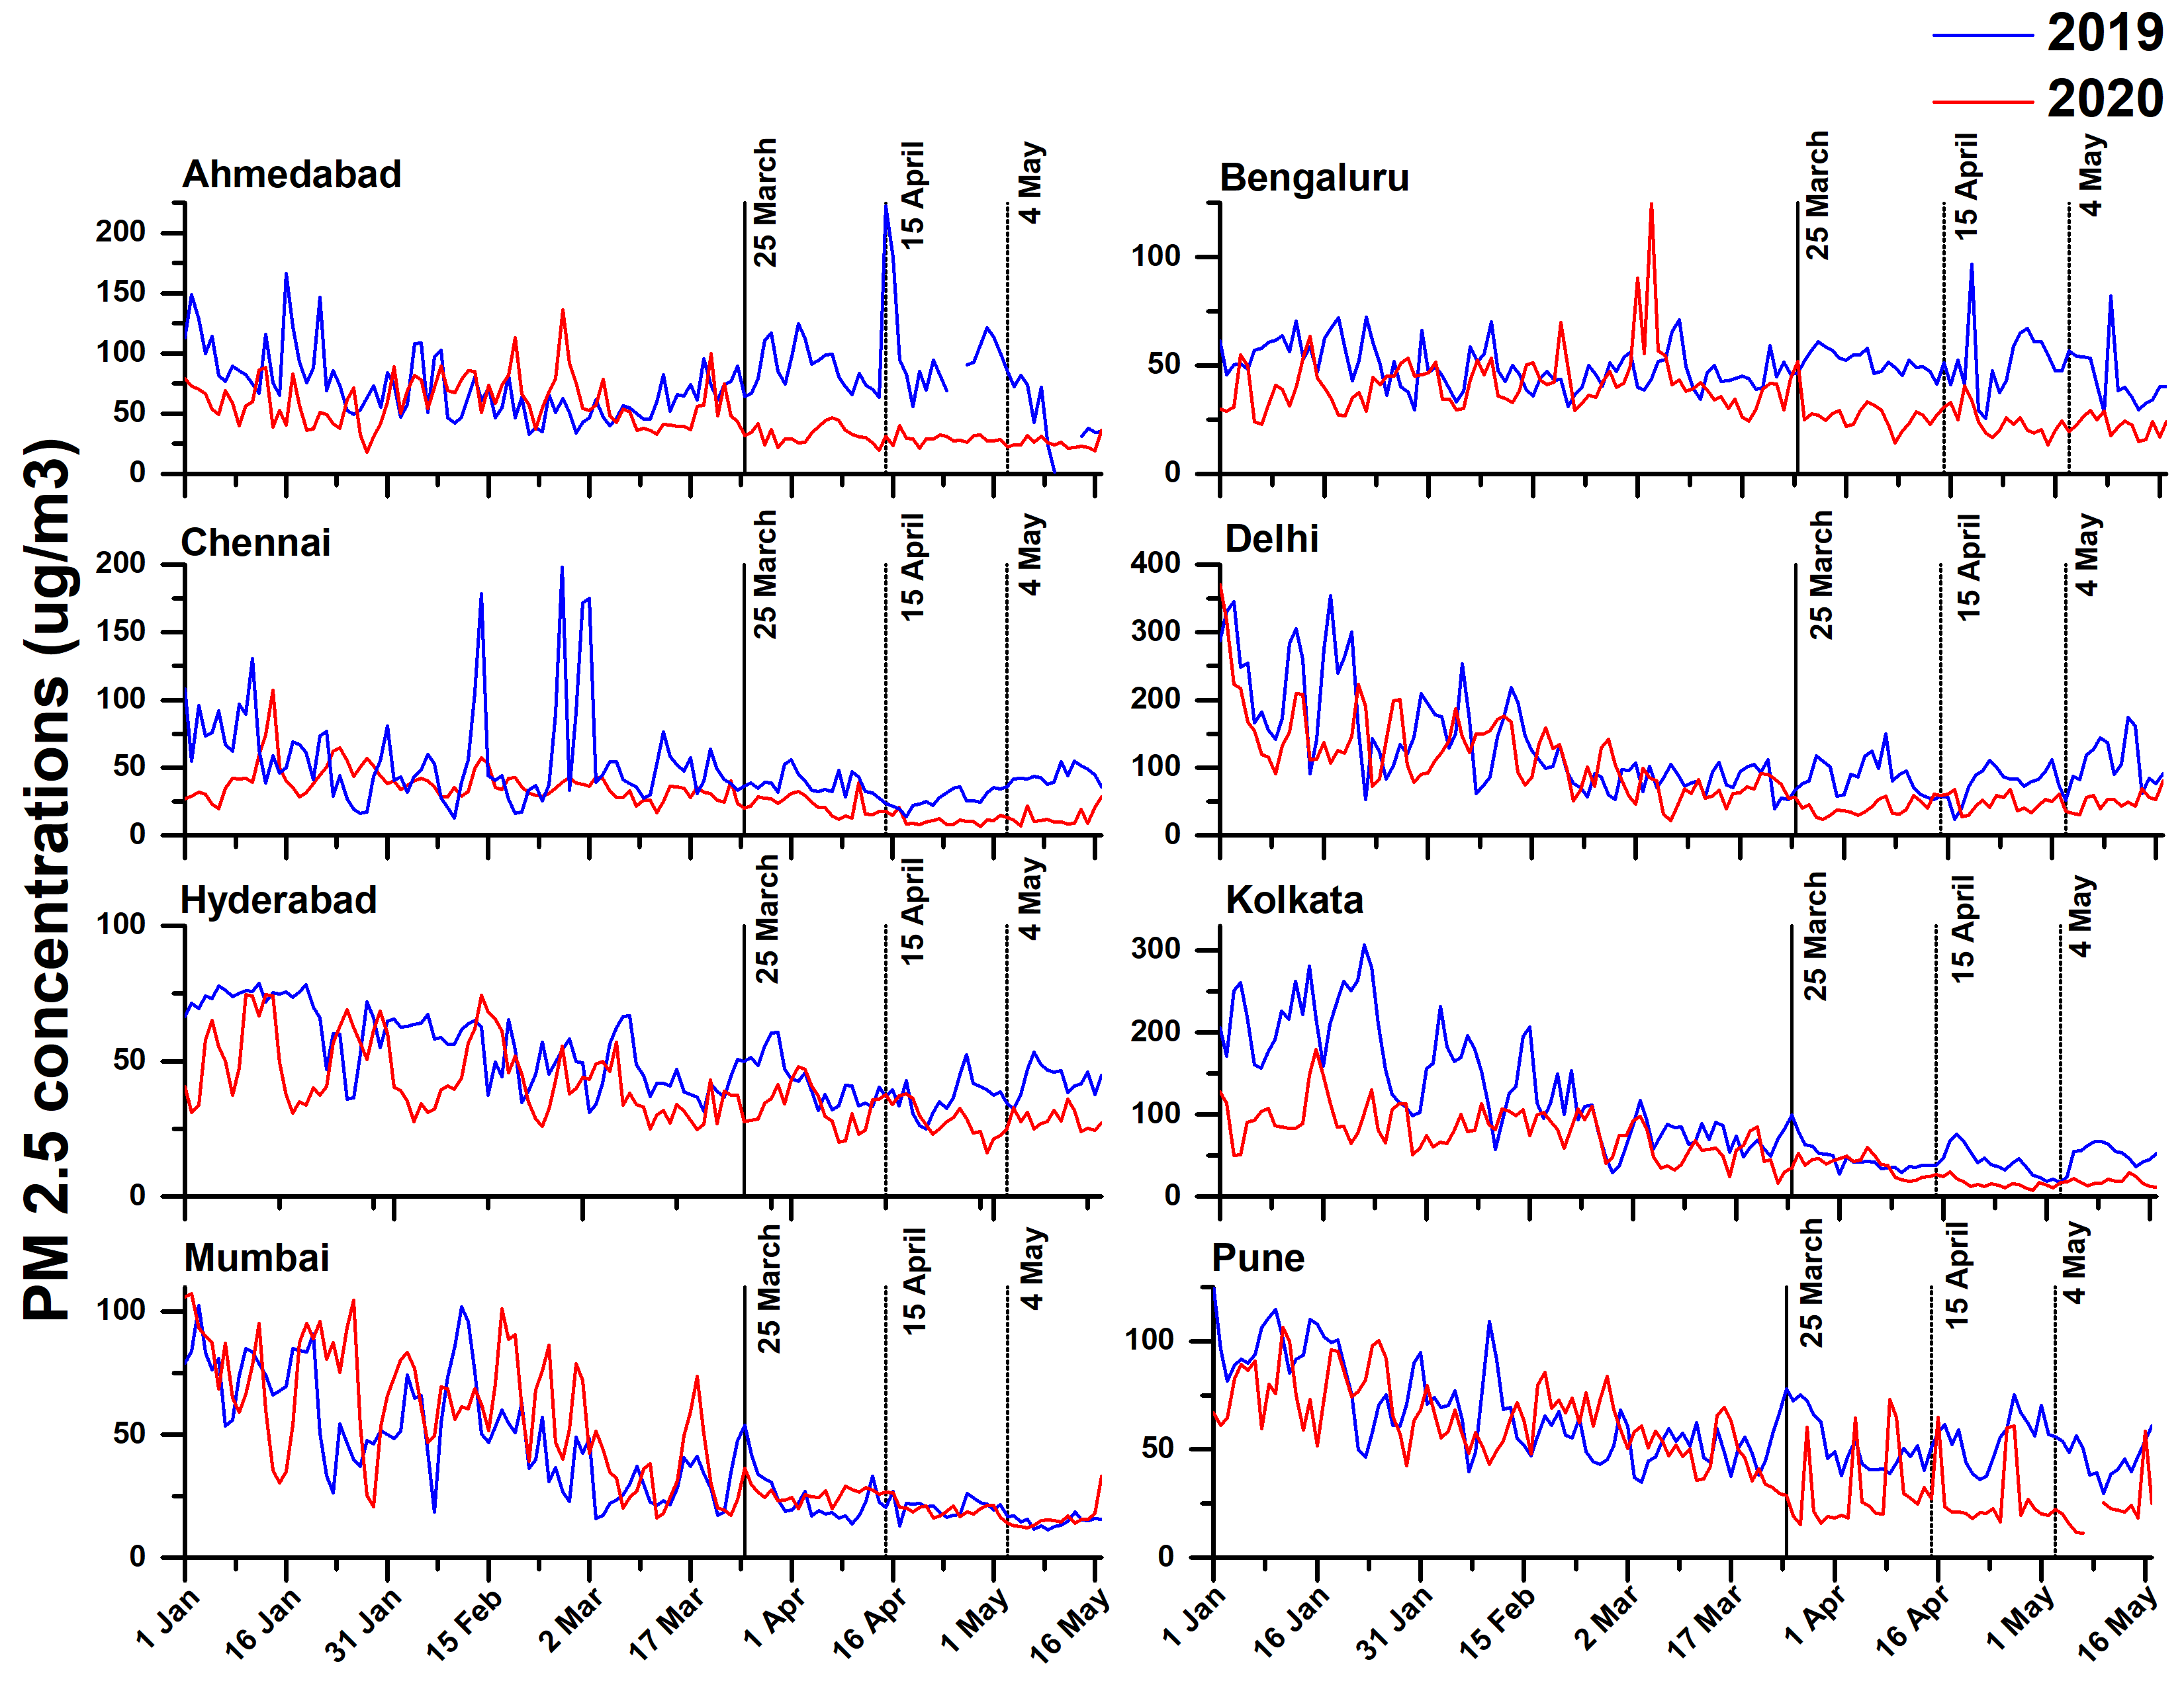
Figure S1: Comparison of PM2.5 concentration levels during the years 2019 and 2020
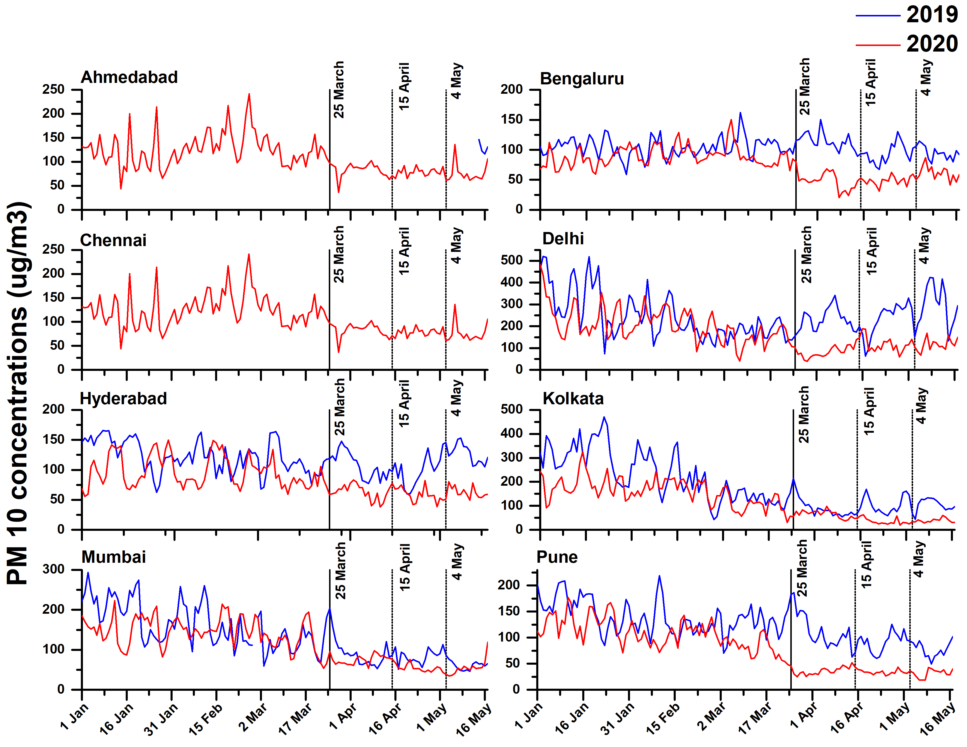
Figure S2: Comparison of PM₁₀ concentration levels during the years 2019 and 2020
Table ST2: Average data of pollutants in tier-1 cities during lockdown period (25th March – 17th May) in 2019 and 2020 with % change in concentration levels
Cities | PM₁₀ |  |  | PM_{2.5} |  |  | NO₂ |  |  | SO₂
Cities | 2019 | 2020 | % change | 2019 | 2020 | % change | 2019 | 2020 | % change | 2019 | 2020 | % change
Ahmedabad | 128.97 | 79.6 | 38.28 | 83.2 | 29.34 | 64.74 | 71.65 | 22.09 | 69.17 | 51.82 | 26.02 | 49.79
Bengaluru | 102.17 | 52.12 | 48.99 | 49.49 | 24.65 | 50.19 | 32.12 | 13.04 | 59.40 | 5.25 | 6.32 | -20.38
Chennai | N/A | 79.6 |  | 35.91 | 16.16 | 55.00 | 13.08 | 7.36 | 43.73 | 7.16 | 5.28 | 26.26
Delhi | 248.61 | 103.63 | 58.32 | 89.66 | 46.17 | 48.51 | 49.96 | 20.42 | 59.13 | 21.09 | 14.29 | 32.24
Hyderabad | 109.96 | 61.63 | 43.95 | 40.89 | 30.26 | 26.00 | 30.26 | 22.04 | 27.16 | 7.32 | 5.81 | 20.63
Kolkata | 98.63 | 47.8 | 51.54 | 46.03 | 24.92 | 45.86 | 30.09 | 10.23 | 66.00 | 5.32 | 5.36 | -0.75
Mumbai | 80.73 | 63.85 | 20.91 | 20.61 | 21.37 | -3.69 | 18.77 | 7.43 | 60.42 | 22.58 | 12.91 | 42.83
Pune | 96.08 | 35.35 | 63.21 | 51.57 | 43.87 | 14.93 | 13.41 | 16.67 | -24.31 | 27.51 | 22.75 | 17.30

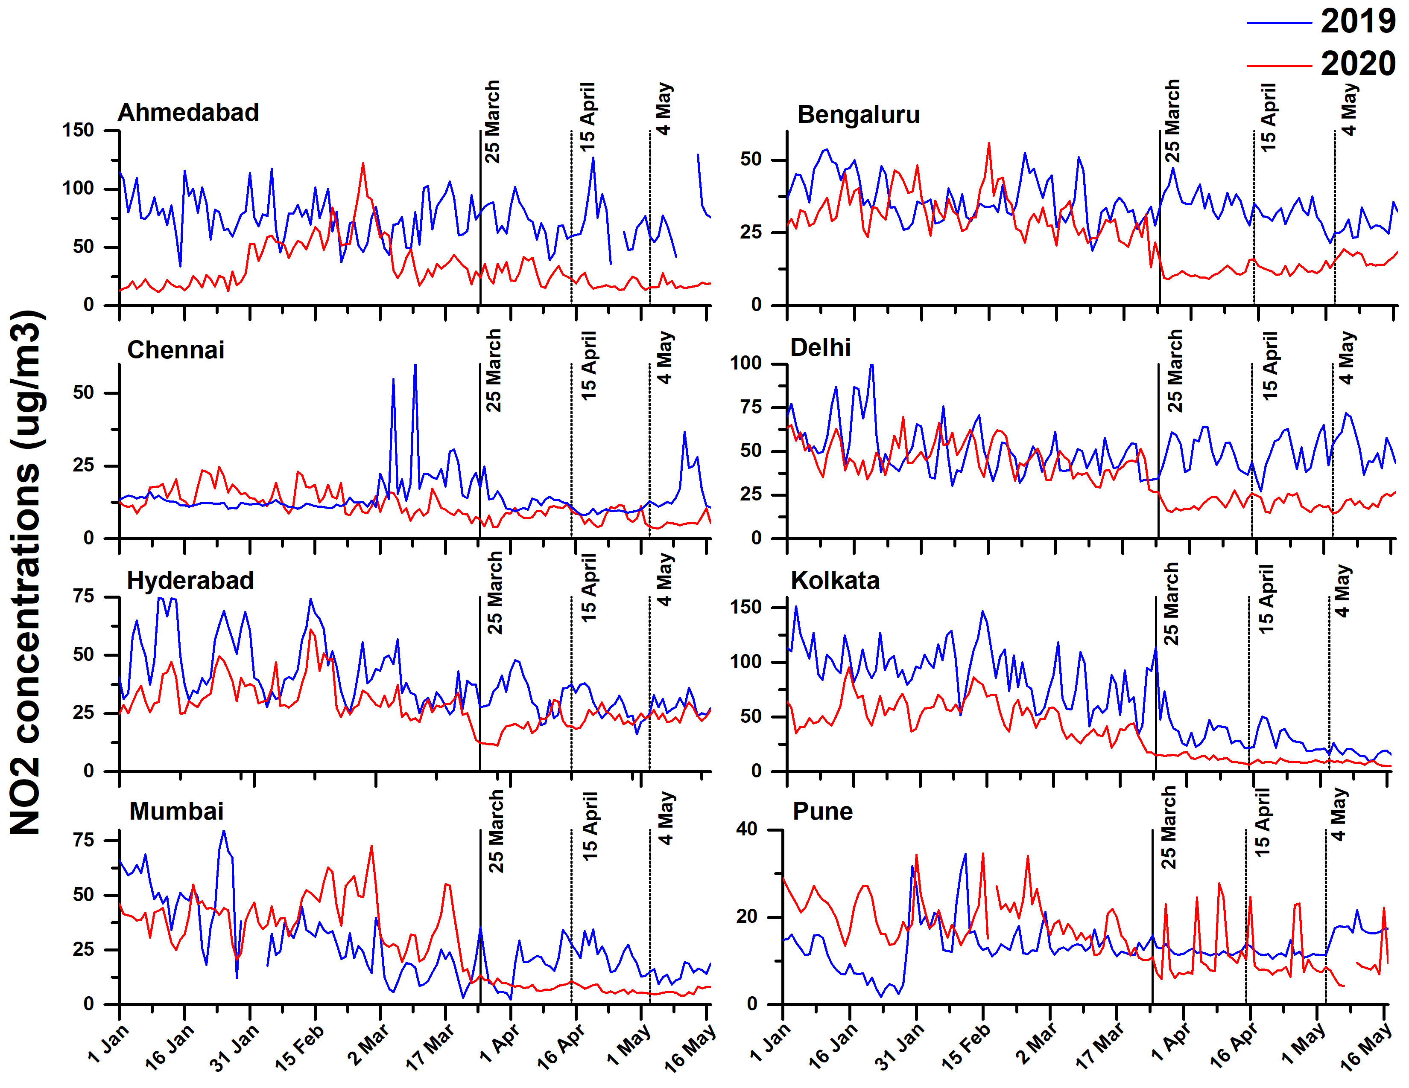
Figure S3: Comparison of NO2 concentration levels during the years 2019 and 2020

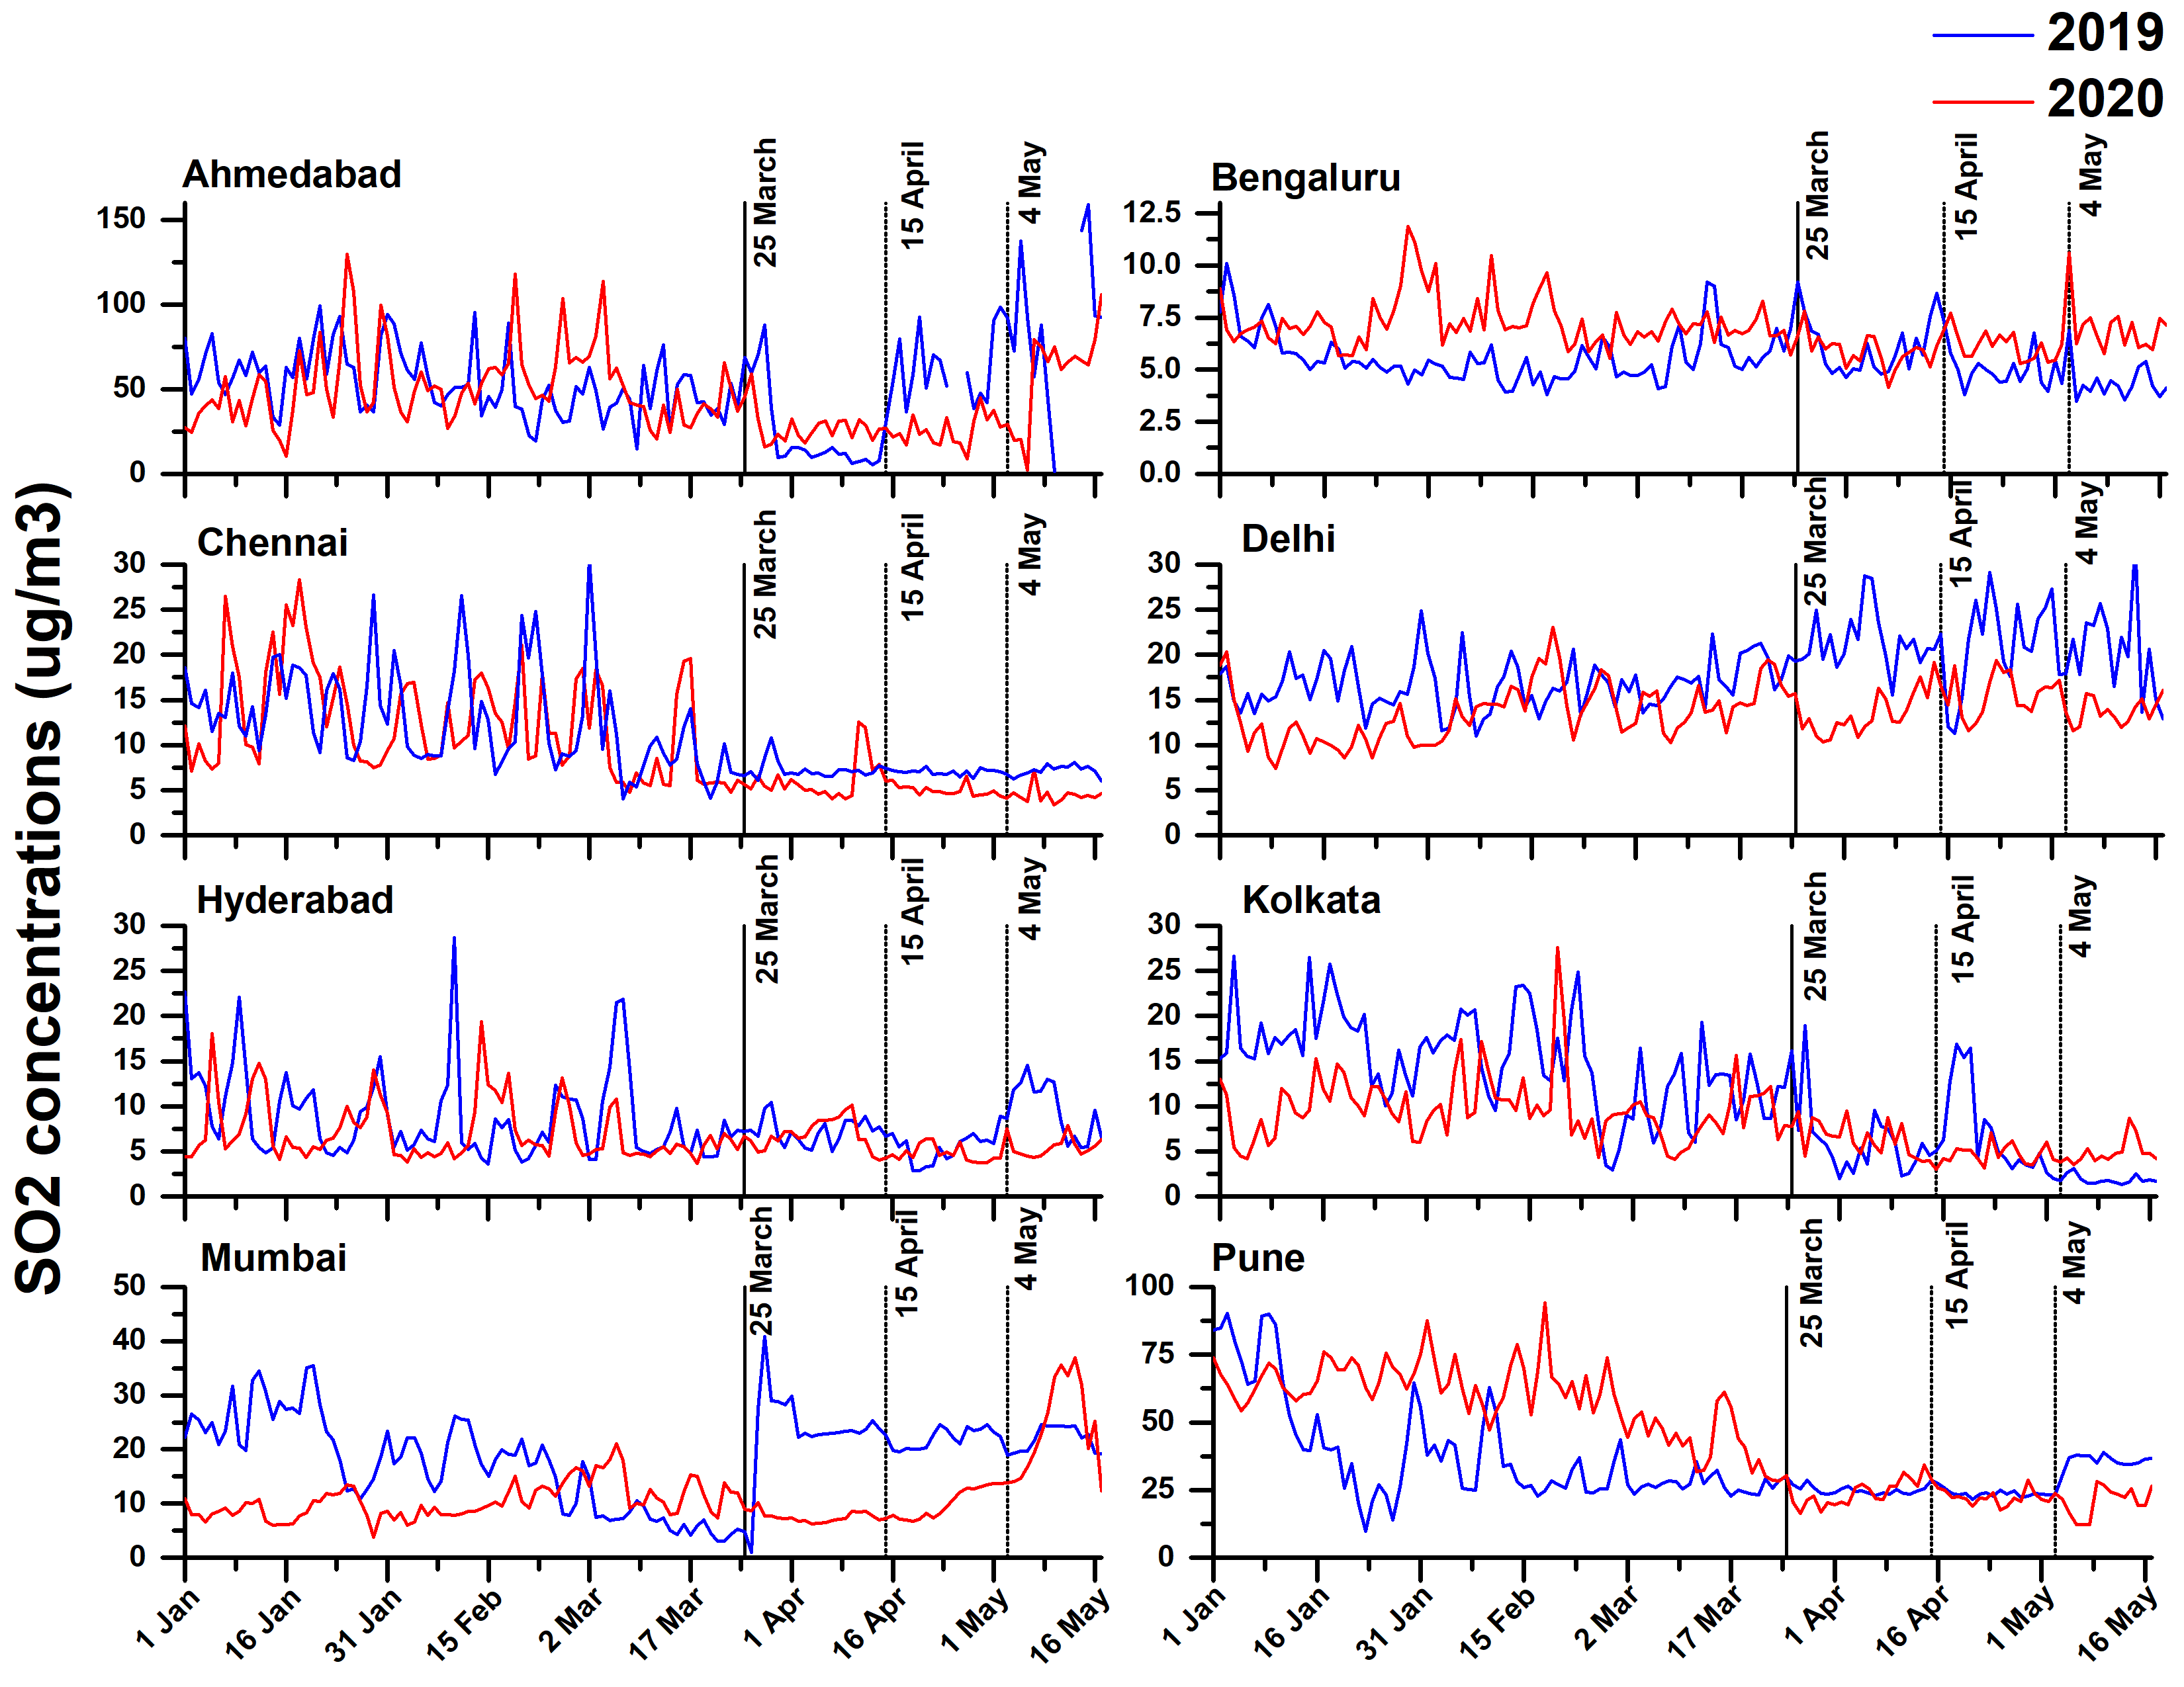
Figure S4: Comparison of SO2 concentration levels during the years 2019 and 2020

