Supplementary Information for
Linking phytoplankton phenology and carbon cycling to sea ice retreat timing in the Weddell Sea

Xiang Yang^{1,2}, Cathryn A. Wynn-Edwards ^{2,4}, Peter G. Strutton^{1,3}, Elizabeth H. Shadwick^{2,4}

¹Institute for Marine and Antarctic Studies, University of Tasmania, Hobart, TAS, Australia
²Australian Antarctic Program Partnership, Hobart, TAS, Australia
³Australian Centre for Excellence in Antarctic Science, University of Tasmania, Hobart, TAS, Australia
⁴ CSIRO, Hobart, TAS, Australia

Corresponding author: Xiang Yang (xiang.yang@utas.edu.au), ORCiD: 0000-0002-0616-0967

Table of contents
Random forest model fitting performance
Figure S1 to S7
Table S1 to S2

Random forest model fitting performance
Given the limited number of observations and the discontinuous nature of float data, we could not set aside an independent validation group, unlike shipboard studies^{1,2}. Our model performed well in reconstructing the pCO₂sw magnitude and seasonality, but was less robust compared to previous RF studies that reported R² of 0.83 and 0.95 for cross-validation^{1,2}. This discrepancy may be due to differences in the spatial and temporal resolution of float versus shipboard measurements^{1,2} (Figures 1 and S5).
We also found that the RF model performed well when using only the first four input variables (excluding TEMP), yielding a better cross-validation result of R²: 0.56 and RMSE: 21.95 μatm. However, we found a clear seasonality in the residual errors of in-situ measurements and model-derived pCO₂sw (Figure S5c; the results from using the four-parameter prediction are not shown). The model's underestimates pCO₂sw​ during winter and early spring (Figure S5c, d). As a result, we use the model that includes temperature as a predictive variable to minimize the seasonal impact as much as possible.
The observed discrepancies can also be attributed to the uncertainties associated with estimating surface ocean pCO₂ from in-situ pH³ (up to 11 μatm) and also the potential errors that existed in the float estimated results^{4–7}. Additionally, we averaged data from the upper 30 m to derive the mean pCO₂sw. This approach was intended to include more data points, particularly when profiles were collected under ice, where fewer surface measurements are available. However, this approach may have resulted in higher in-situ measurements, further contributing to the discrepancies in Figure S5.

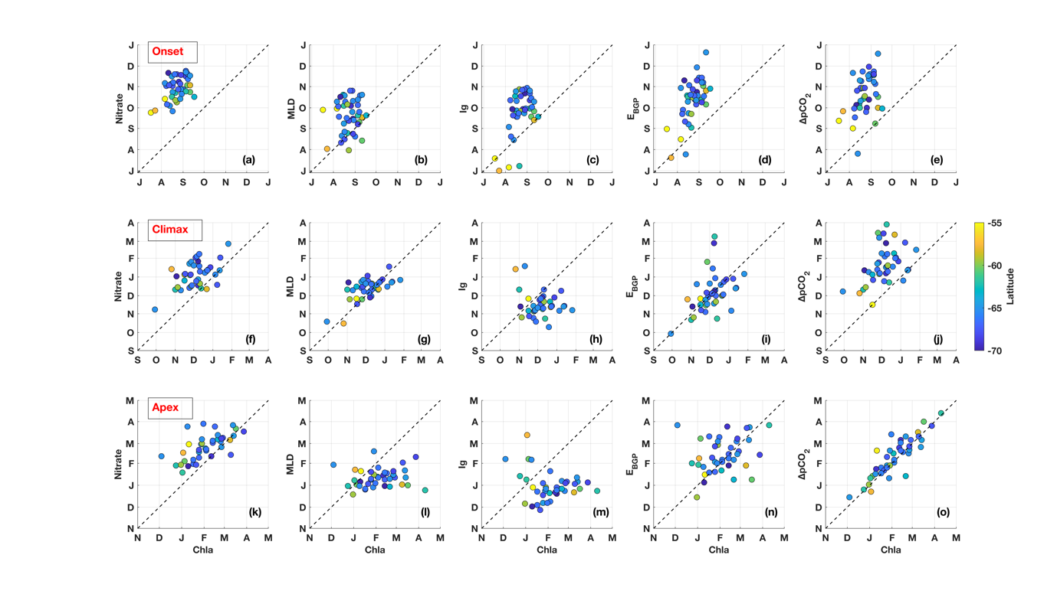
Figure S1. Comparisons of phenology timings among key biogeochemical parameters. Difference in bloom onset time from Chla (on the x-axis) against (a) nitrate (on the y-axis), (b) MLD, (c) I_{g}, (d) E_{BGP}, and (e) ΔpCO₂, colored by the latitude of the ice retreat. The climax and apex are in the second and third rows, respectively.

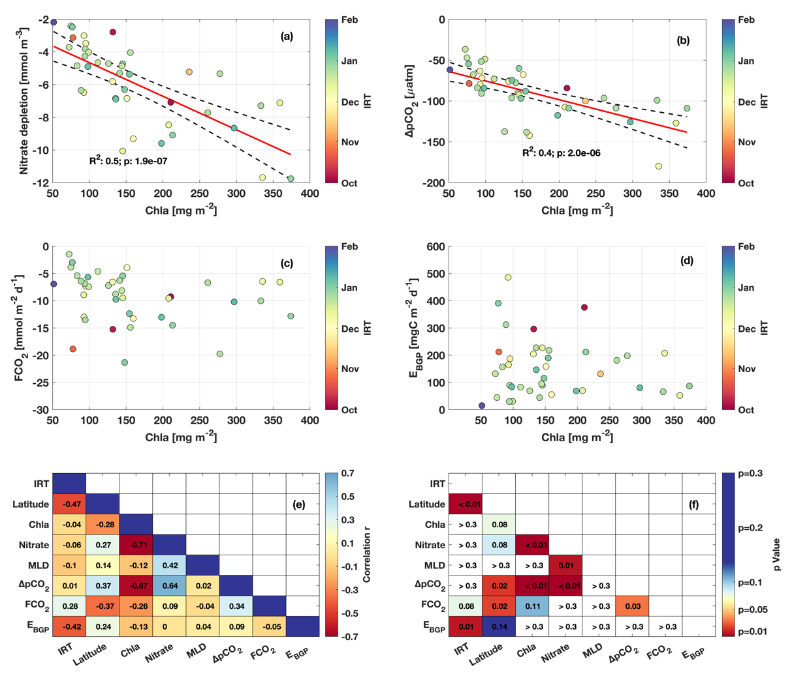
Figure S2. Relationships among changes in each parameter from onset to apex. The first four panels are (a) nitrate depletion, (b) ΔpCO₂ , (c) FCO₂ , and (d) E_{BGP} against the Chla biomass, colored by IRT. Bottom heat maps summarize the correlation test results (e) coefficient r and (f) significance value p.

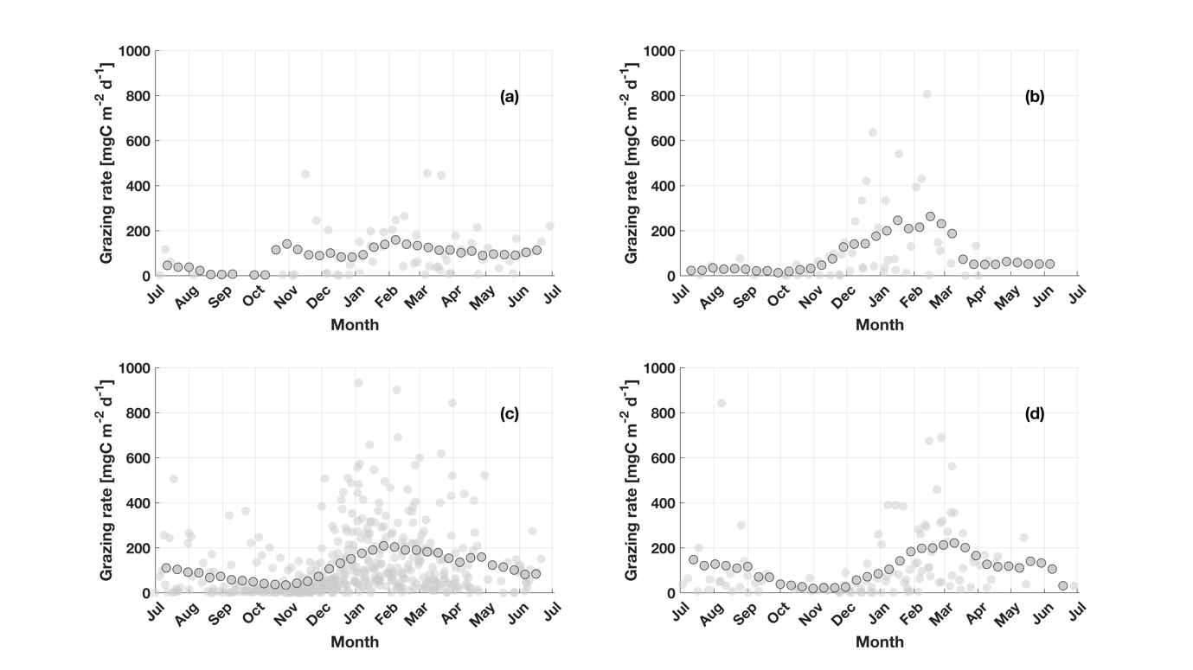
Figure S3. The grazing rate for four ice retreat timing groups: (a) October, (b) November, (c) December, and (d) January. The transparent dots are the estimates from each profile and the solid dots indicate the 60-day running smooth result for the whole group.

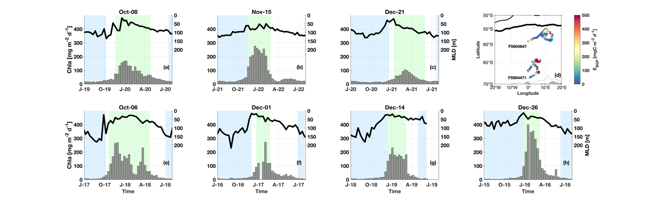
Figure S4. A case study to show the difference between early/late IRT cases, supplementary for Fig.4. The MLD is shown in the top of each panel (right y-axis). Chla time series are shown as the grey bars at the bottom, and correspond to the left y-axis. The light blue shading indicates the ice cover period, the green shading indicates the productive season, and white background indicates the OWP.
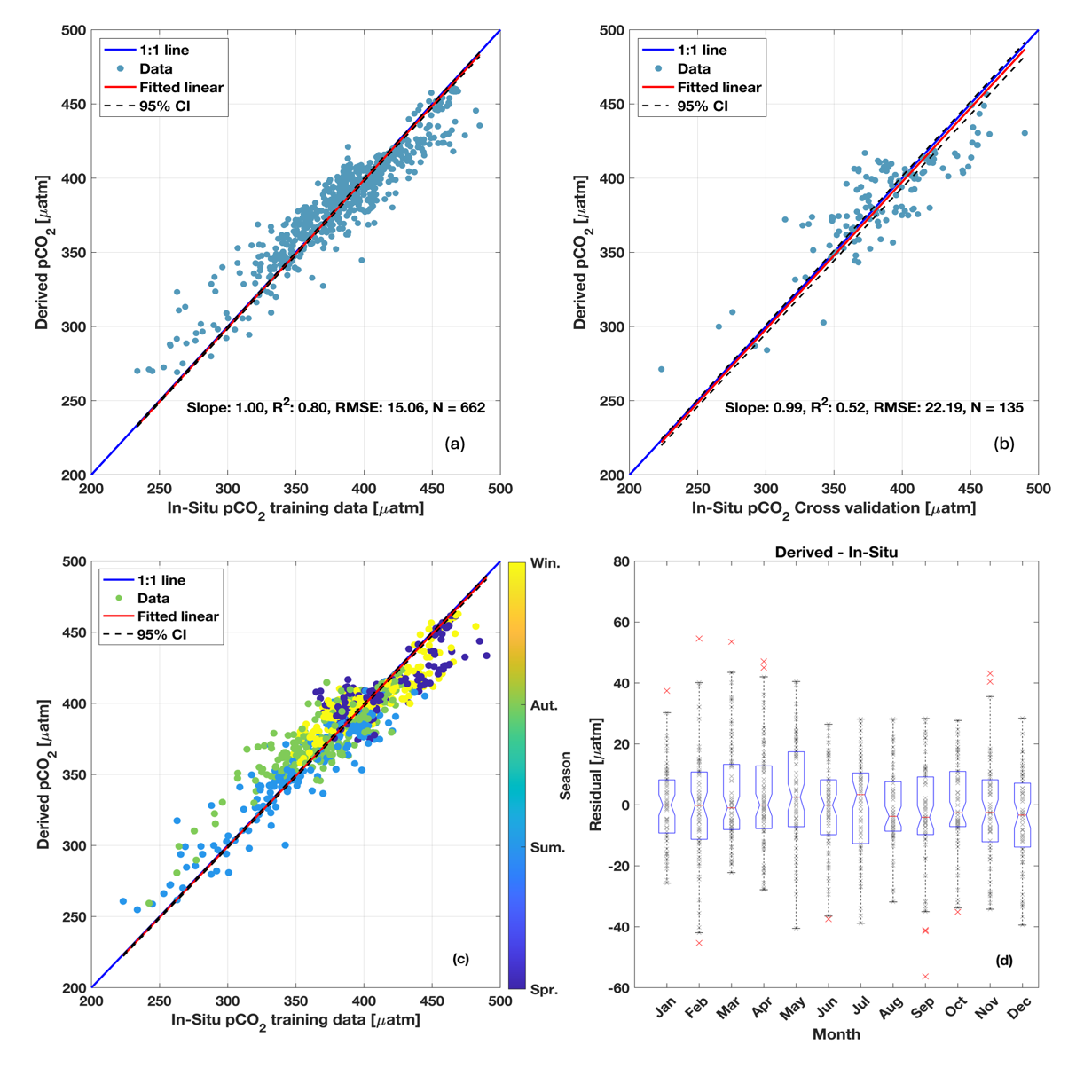
Figure S5. The performance of the RF model in retrieving sea surface pCO₂. (a) model training group, (b) model cross-validation group, and (c) residual between the RF model derived value (algorithm applied to the whole data set, N = 797) and the in-situ measurements, colored by the seasons. (d) Difference between the RF model derived pCO₂ with the in-situ pCO₂ along the month.

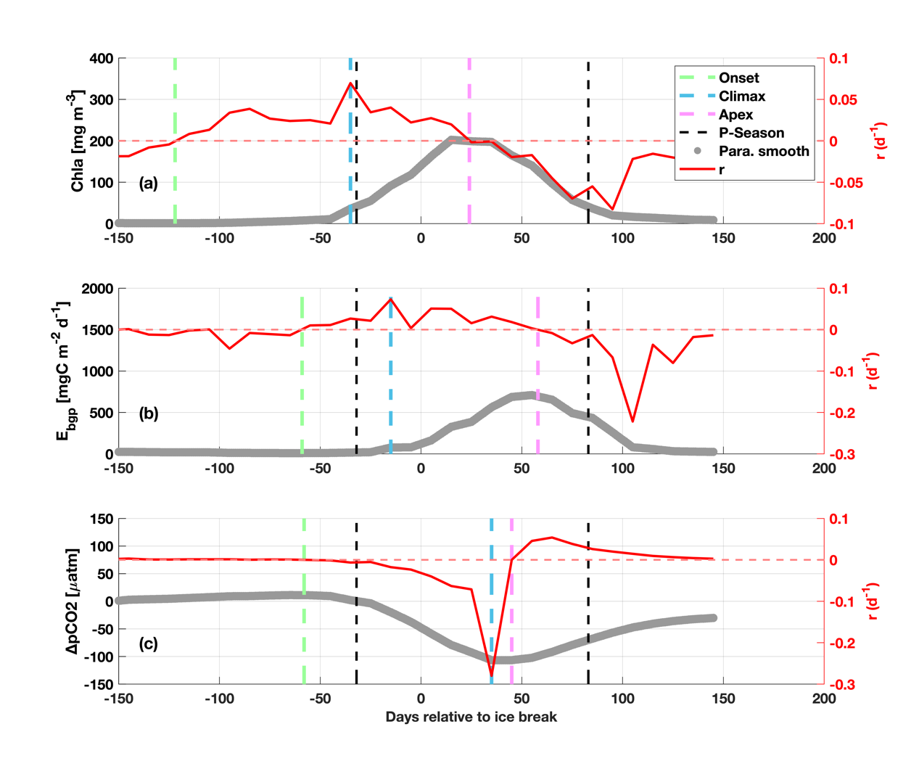
Figure S6. Example of phenology identification. (a) Chla, (b) E_{BGP}, and (c) ΔpCO₂ using a seasonal cycle from float (WMO ID F5905995) from 2021 to 2022. The thick grey line indicates the smoothed variable and the red line represents the rate of change (r). The onset is shown as the green dashed line, the climax with light blue, the apex with magenta, and the productive season (based on Chla) is shown as the period within the black dashed lines.
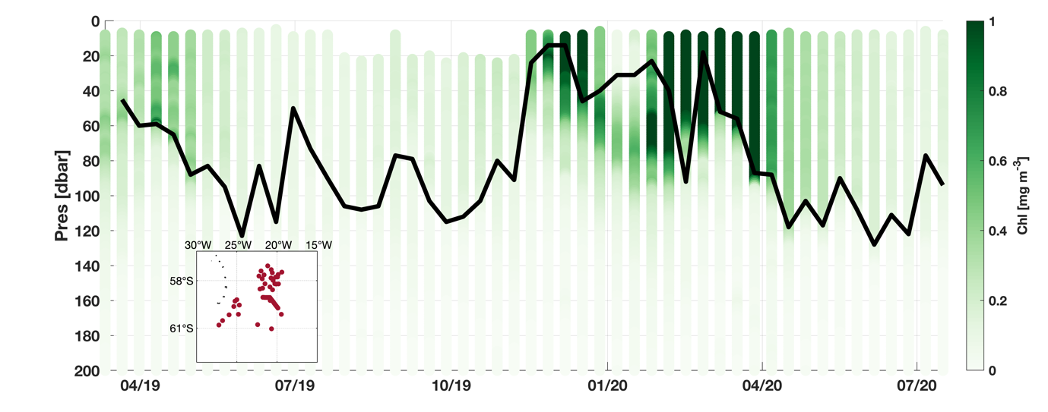
Figure S7. Vertical Chla concentration transect of float WMO ID 5906006. The black line represents the MLD. The small map shows the float location

Table S1. Summary table for the average (day of year) ice retreat time, productive season, and phenology of key parameters shown in Fig.2.
 |  |  | Phenology Summary
Ice Break month | Productive season  timing |  | Parameters | Onset | Climax | Apex
October  286.3 (±11.0) | Start  270.7 (±21.5) | End  145.3 (±26.1) | Chla | 214.7 (±14.0) | 275.7 (±44.1) | 334.3 (±45.2)
October  286.3 (±11.0) | Start  270.7 (±21.5) | End  145.3 (±26.1) | Nitrate | 278.0 (±10.0) | 359.0 (±41.3) | 70 (±33.2)
October  286.3 (±11.0) | Start  270.7 (±21.5) | End  145.3 (±26.1) | MLD | 260.0 (±22.5) | 339.0 (±50.5) | 42.3 (±27.8)
October  286.3 (±11.0) | Start  270.7 (±21.5) | End  145.3 (±26.1) | E_{BGP} | 226.7 (±18.6) | 289.0 (±36.7) | 49.7 (±35.2)
October  286.3 (±11.0) | Start  270.7 (±21.5) | End  145.3 (±26.1) | ΔpCO₂ | 236.3 (±25.1) | 329.0 (±12.2) | 3.3 (±41.6)
October  286.3 (±11.0) | Start  270.7 (±21.5) | End  145.3 (±26.1) | FCO₂ | 235.0 (±27.4) | 355.7 (±50.2) | 20.0 (±55.7)
November  328 (±7.9) | Start  303.3 (±19.6) | End  126.0 (±56.2) | Chla | 220.3 (±14.6) | 311.7 (±15.3) | 5.3 (±12.1)
November  328 (±7.9) | Start  303.3 (±19.6) | End  126.0 (±56.2) | Nitrate | 282.7 (±13.2) | 358.3 (±18.8) | 36.7 (±9.9)
November  328 (±7.9) | Start  303.3 (±19.6) | End  126.0 (±56.2) | MLD | 238.3 (±23.5) | 328.3 (±33.2) | 7.0 (±14.9)
November  328 (±7.9) | Start  303.3 (±19.6) | End  126.0 (±56.2) | E_{BGP} | 240.0 (±35.4) | 311.7 (±17.2) | 48.0 (±20.2)
November  328 (±7.9) | Start  303.3 (±19.6) | End  126.0 (±56.2) | ΔpCO₂ | 273.0 (±13.7) | 355.0 (±21.0) | 5.3 (±18.8)
November  328 (±7.9) | Start  303.3 (±19.6) | End  126.0 (±56.2) | FCO₂ | 251.7 (±37.2) | 338.3 (±9.7) | 11.0 (±18.5)
December  355.1 (±7.5) | Start  330.4 (±15.4) | End  119.3 (±33.7) | Chla | 240.4 (±10.6) | 340.8 (±16.8) | 38.5 (±25.3)
December  355.1 (±7.5) | Start  330.4 (±15.4) | End  119.3 (±33.7) | Nitrate | 305.0 (±14.0) | 8.7 (±25.3) | 59.7 (±24.5)
December  355.1 (±7.5) | Start  330.4 (±15.4) | End  119.3 (±33.7) | MLD | 267.0 (±23.8) | 347.1 (±10.7) | 8.7 (±10.5)
December  355.1 (±7.5) | Start  330.4 (±15.4) | End  119.3 (±33.7) | E_{BGP} | i6 (±18.6) | 344.1 (±32.8) | 39.5 (±24.1)
December  355.1 (±7.5) | Start  330.4 (±15.4) | End  119.3 (±33.7) | ΔpCO₂ | 296.4 (±21.1) | 24.7 (±27.9) | 43.7 (±27.4)
December  355.1 (±7.5) | Start  330.4 (±15.4) | End  119.3 (±33.7) | FCO₂ | 299.2 (±27.3) | 22.1 (±26.4) | 51.3 (±28.9)
January  9.8 (±11.6) | Start  346.0 (±13.4) | End  119.3 (±23.5) | Chla | 236.6 (±12.3) | 357.8 (±23.4) | 56.1 (±16.5)
January  9.8 (±11.6) | Start  346.0 (±13.4) | End  119.3 (±23.5) | Nitrate | 315.5 (±12.9) | 20.3 (±18.9) | 65.1 (±13.3)
January  9.8 (±11.6) | Start  346.0 (±13.4) | End  119.3 (±23.5) | MLD | 263.4 (±24.9) | 362.8 (±8.9) | 24.6 (±12.7)
January  9.8 (±11.6) | Start  346.0 (±13.4) | End  119.3 (±23.5) | E_{BGP} | 300.8 (±29.3) | 349.0 (±17.9) | 60.5 (±19.0)
January  9.8 (±11.6) | Start  346.0 (±13.4) | End  119.3 (±23.5) | ΔpCO₂ | 324.1 (±16.1) | 39.0 (±18.2) | 57.8 (±11.3)
January  9.8 (±11.6) | Start  346.0 (±13.4) | End  119.3 (±23.5) | FCO₂ | 325.6 (±19.5) | 39.0 (±32.0) | 67.8 (±18.6)

Table S2. Results of sensitivity analysis of the ratio to convert ΔNO₃⁻ to POC.
 | ΔNO₃⁻ to POC ratio (N:C) | Mean grazing rate (mgC m⁻² d⁻¹)
Redfield et al. (1963) | 106/16 | 120.9
Anderson and Sarmiento. (1994) | 117/16 | 135.0
Coale et al. (2004) | 110/19 | 105.3

Reference list
1. Tu, Z. et al. Increase in CO₂ Uptake Capacity in the Arctic Chukchi Sea During Summer Revealed by Satellite‐Based Estimation. Geophysical Research Letters 48, e2021GL093844 (2021).
2. Huang, H. et al. Revisiting Winter Southern Ocean CO₂ Uptake Based on CALIPSO Observations. Geophysical Research Letters 51, e2024GL108335 (2024).
3. Williams, N. L. et al. Calculating surface ocean pCO₂ from biogeochemical Argo floats equipped with pH: An uncertainty analysis. Global Biogeochemical Cycles 31, 591–604 (2017).
4. Sutton, A. J., Williams, N. L. & Tilbrook, B. Constraining Southern Ocean CO ₂ Flux Uncertainty Using Uncrewed Surface Vehicle Observations. Geophysical Research Letters 48, e2020GL091748 (2021).
5. Wynn-Edwards, C. A. et al. Subantarctic pCO2 estimated from a biogeochemical float: comparison with moored observations reinforces the importance of spatial and temporal variability. Front. Mar. Sci. 10, 1231953 (2023).
6. Bushinsky, S. M. et al. Reassessing Southern Ocean Air‐Sea CO ₂ Flux Estimates With the Addition of Biogeochemical Float Observations. Global Biogeochemical Cycles 33, 1370–1388 (2019).
7. Monteiro, P. M. S. et al. Intraseasonal variability linked to sampling alias in air-sea CO₂ fluxes in the Southern Ocean: Alias in Air-Sea CO₂ Fluxes. Geophys. Res. Lett. 42, 8507–8514 (2015).

