Extended Data Fig.1 Variant allele frequency distributions of colorectal crypts. Variant allele frequency distribution for all individuals in this study. Most crypts have peaks around 0.5, indicating their monoclonality. VAF: variant allele frequency. Normal crypts, aberrant crypt foci, adenomatous polyps were labelled as normal, acf and polyp.
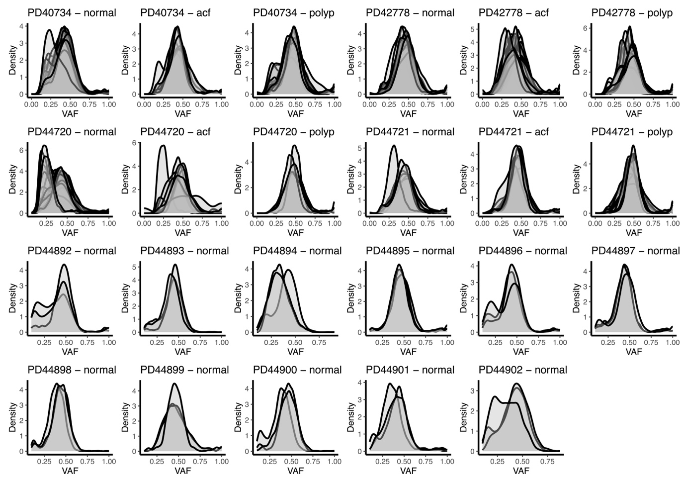

Extended Data Fig.2 Normal crypts and aberrant crypt foci (ACF) with 2nd hit APC somatic mutation in FAP patients. a, A normal crypt with APC mutation b, A cluster of clonally expanded quiescent APC mutant crypt with dilated lumen (red). Note the adjacent APC wild type crypts (green). c, A branched crypt with APC mutation and minimal regenerative changes. d, Two separate APC mutant clones observed in an aberrant crypt foci, including a branched crypt (blue) and two adjacent crypts (red) with marked regenerative changes and dilated lumen. Note the adjacent APC wild type crypts (green) also showed marked regenerative changes. e, An ACF with APC mutant branch crypt and an adjacent moderately regenerative crypt, both carrying the same APC mutation (red). Note the adjacent severely regenerative crypt but APC wild type (green). f, A type C dysplastic ACF with APC mutation (red) located adjacent to APC wild type branched crypt (green) without dysplasia. Scale bar, 100 µm.
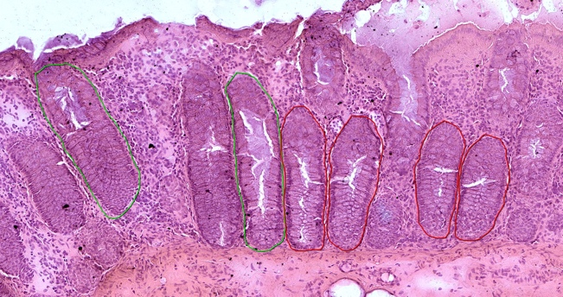
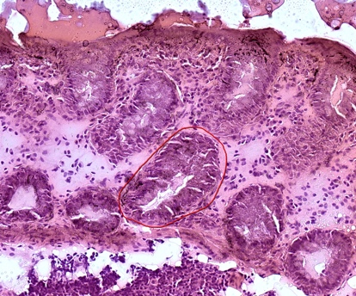
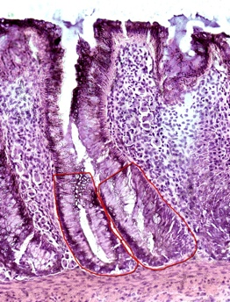
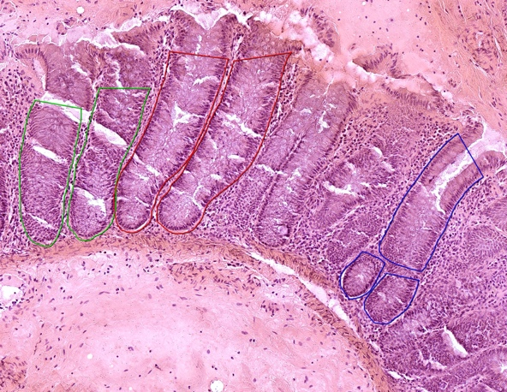
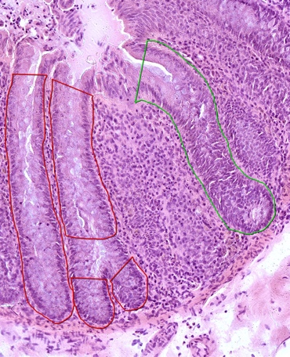
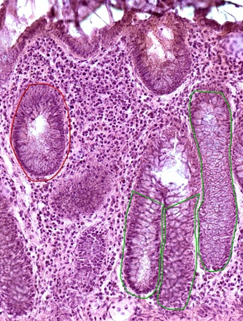
PD42778E_ACF_002 APC I231Yfs*21
PD44897b_lo001 APC R213*
Normal crypt
PD44730C_ACF-BC 002
APC T1556Nfs*3

PD42778D_ACF_007_1 *: APC N659Qfs*14
PD42778D_ACF_007_2 ^: APC R1114*
*
*
^
PD42778C_ACF-BC_003 APC W157*
PD44721I_ACF_007_1 APC Q1113*
PD44721I_ACF_007_2 APC wild type
*
*
*
*
*
*
*
*
*
*
*
a
b
c
d
e
f

Extended Data Fig.3 Multiclonal origin of adenomas from FAP. a, A diminutive polyp with the adenomatous part harbouring two APC somatic mutations and other cancer drivers (blue). Aberrant crypt foci (ACF) at the edge displayed a different APC somatic mutation and no other cancer driver (pink). A separate APC wild type ACF is also noted (green). b, A diminutive polyp comprised of 3 separate clones of APC mutation. One clone is comprised of a single APC mutant dysplastic crypt arising from a background of APC wild type ACF (green). Scale bar, 200 µm.

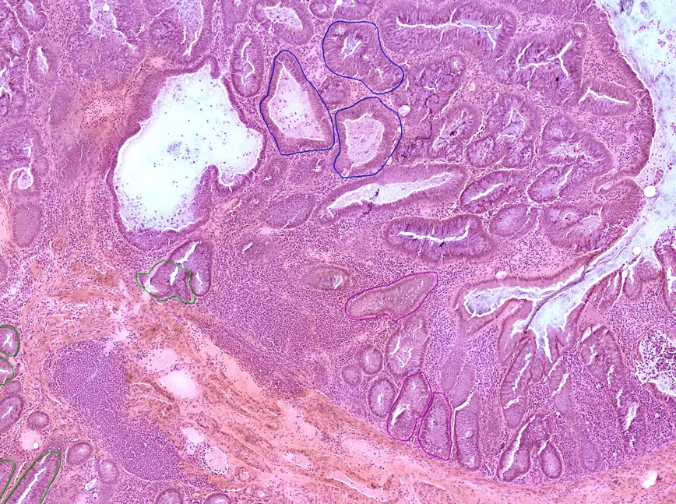
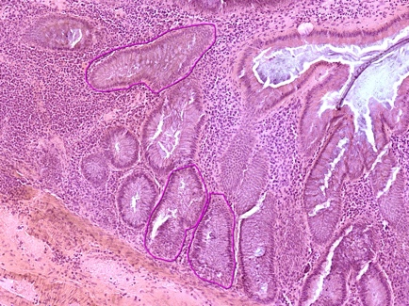
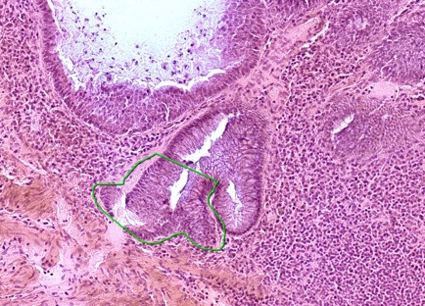
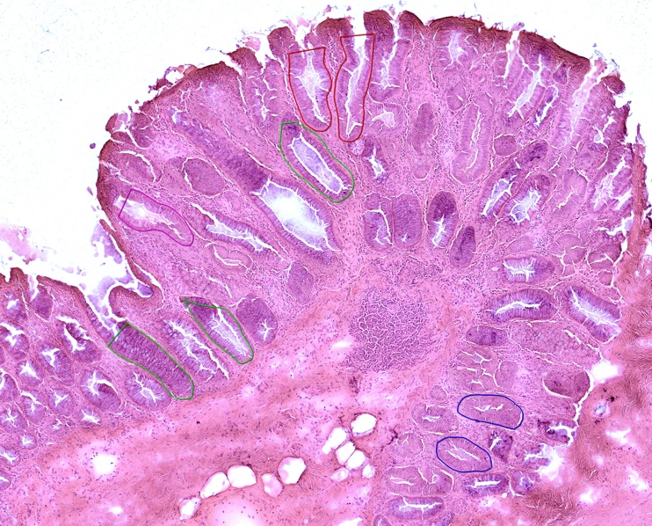
PD42778D_PLP_002 Adenoma *: APC E1408* L3040Qfs*31 PIK3CA E542K FBXW7 R479Q
PD42778D_PLP-ACF_002 ACF ^: APC R232*
*
*
*
^
^
^
^
^
^
PD40734C_PLP_007_1 *APC Q1429*
PD40734C_PLP_007_2 ^APC E1306*
PD40734C_PLP_007_3 #APC F1396Lfs*19
*
*
^
^
#
a
b

Extended Data Fig.4 Single-base substitution mutational signatures from HDP de novo extraction. X axis represents 96 categories of trinucleotide context and y axis represents the proportion. The black lines indicate 95% confidence intervals. Trinucleotide contexts that are not statistically significant are shown in light grey.
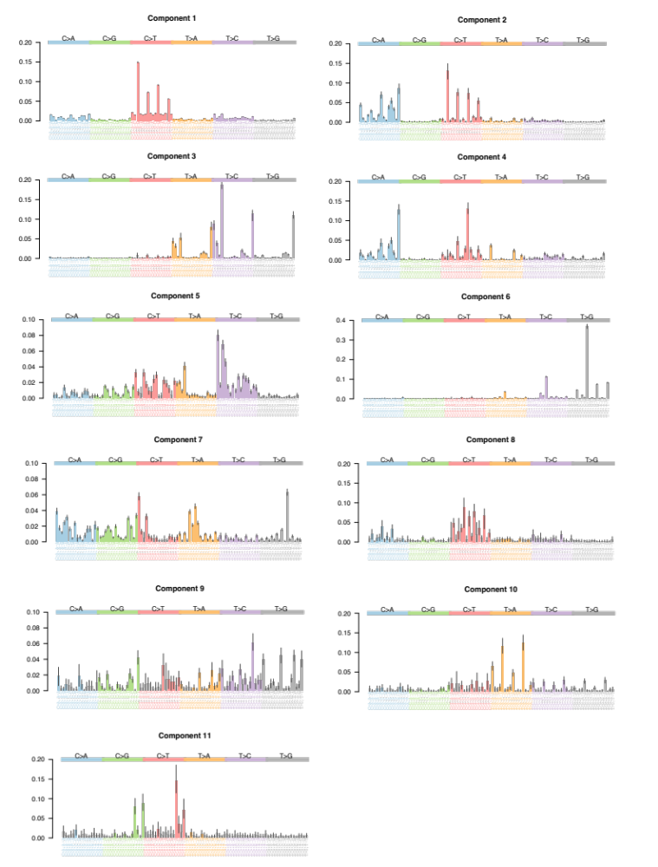

Extended Data Fig.5 Cosine similarity plot for HDP single-base substitution signatures and reference signatures. The SBSC signature extracted from a previous study³¹ was used as the SBSC reference; the APOBEC reference was made from the average spectrum of SBS2 and SBS13.
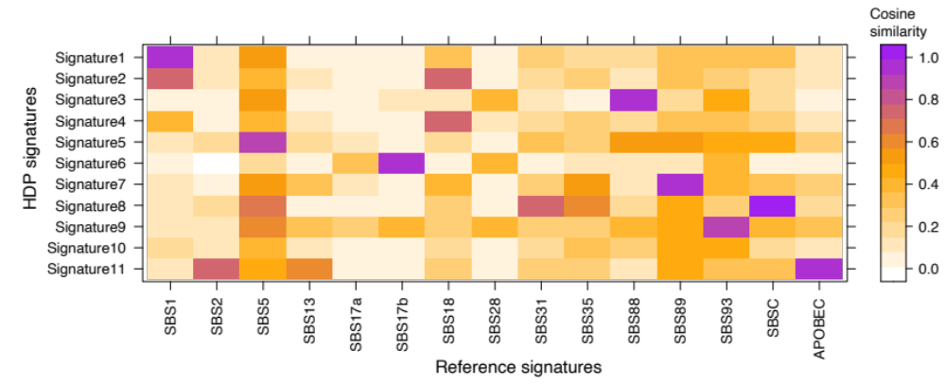

Extended Data Fig.6 Single-base substitution mutational signatures from SigproflierExtractor. X axis represents 96 categories of trinucleotide context and y axis represents the proportion.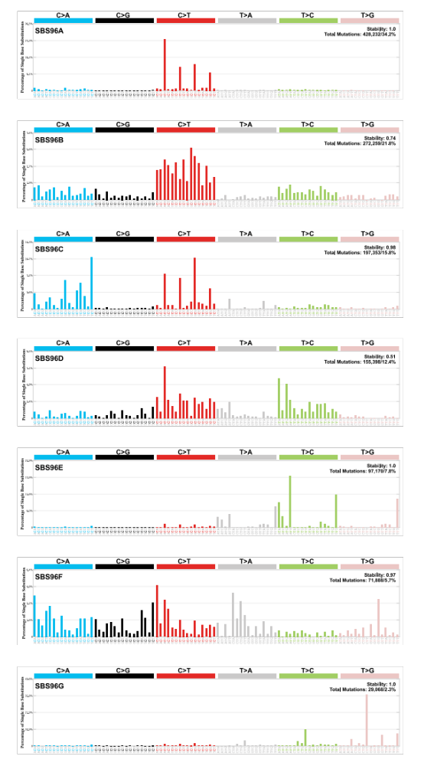

Extended Data Fig.7 Indel mutational signatures from HDP de novo extraction. X axis represents 83 categories of indel mutations and y axis represents the proportion.
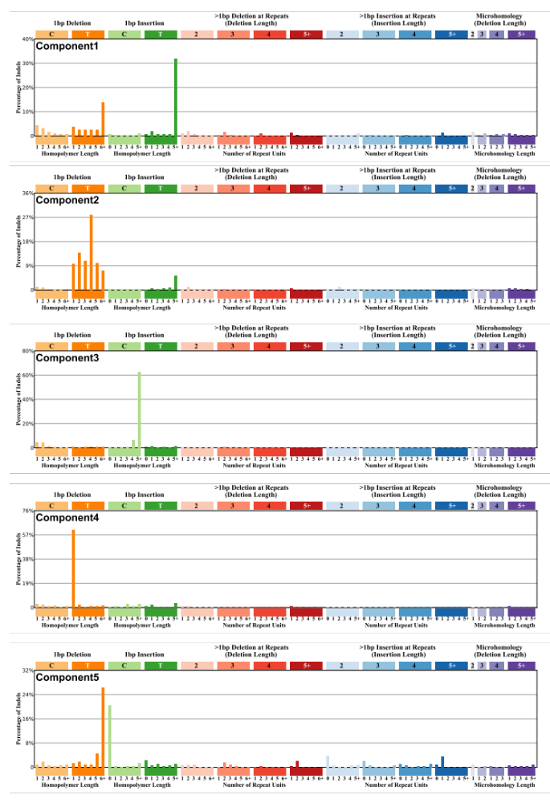
Extended Data Fig.8 Cosine similarity plot for HDP indel signatures and reference signatures. The ID_B signature extracted from a previous study³¹ was used as the IDB reference, IDA was just component3 iteself.
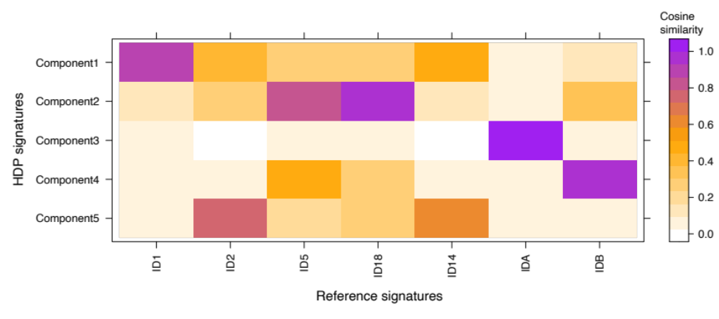

Extended Data Fig.9 Indel mutational signatures from SigprofilerExtractor. X axis represents 83 categories of indel mutations and y axis represents the proportion.
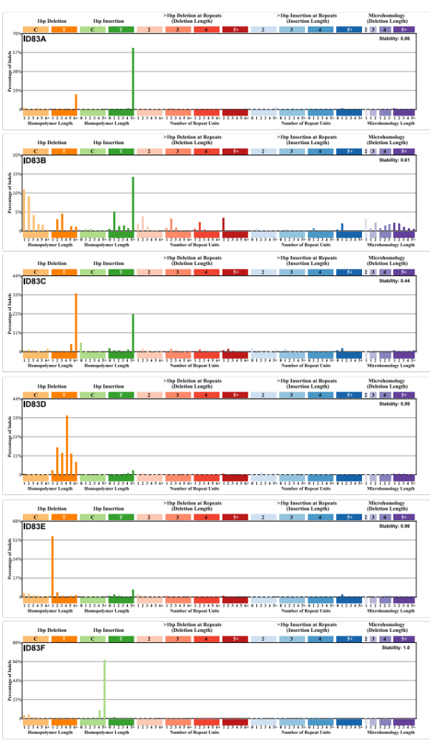
Extended Data Fig.10 Phylogenetic trees for the remaining FAP patients. Three normal crypts were cut and sequenced from 11 FAP patients aged 11-40. One microscopically normal crypt (PD44897b_lo0001) had a somatic APC truncation mutation (R213*).